Locating Subsurface Features Using Gravity and Magnetics Unit 3: Part 1 Geopark Sinkhole Gravity Lab
Andy Parsekian (University of Wyoming)

1.1 Introduction
Sinkholes are a common “hidden hazard” in many areas around the world that can lead to rapid subsidence of the ground, causing damage to buildings, infrastructure, and loss of life. Gravity measurements can be useful for evaluating sinkhole risk because gravity is sensitive to low-density areas of the subsurface.
You’ll be using data from Florida where a collapsed sinkhole is measured along a linear transect using a gravimeter, along with some previously published geologic cross-sections to assist you with interpretation.
The force of gravity at any location on Earth’s surface is determined by many combined factors including the density of the target we are seeking to measure, and also the larger-scale characteristics of the subsurface. In order to isolate the very small influence of our desired target (a void related to a sinkhole) from the larger-scale gravitational effects, we need to calculate and remove those larger-scale effects. These calculations are known as gravity corrections.

Learning Objectives
• Interpret gravity prospecting data to locate anomalies related to sinkhole hazards.
• Recognize and describe limitations and nonuniqueness in geophysical results.
• Justify interpretations of a measured dataset using physical properties and principles.
• Give examples of applications of gravity prospecting applications in your own neighborhood or region.

1.2 Data analysis procedure
For this lab, your tasks will be to (1) calculate the necessary gravity corrections, (2) apply those corrections to the provided raw data, (3) remove the local trend, (4) plot the final relative anomaly, and (5) interpret the results.
- The Excel workbook is structured so that the top left corner contains general numbers that will be used for your calculations under a green heading bar “variables.” You will enter values in these cells as you work through the lab.
- On the first tab, there are the data on the left, a place for you to calculate the corrections in the middle, and a place for you to apply the corrections and local trend on the right.
- Below the data and calculation sections is space for you to add charts and graphs.
- The full raw dataset is included in the last tab of the spreadsheet in the event that students are interested in viewing or working with it, but it is not required for this activity.

Before starting to make any calculations, review the raw data.
  - How large is the drift in the instrument compared to the data itself?
  - What is the magnitude of the largest changes in the observed gravity data?
  - Considering your answers to A and B, will the drift correction create a measurable difference in the data?

The data provided has already been drift-corrected for you; this means that the instrument variability between measurement points is already removed from the data in column H of the Excel workbook. All your calculations can be done using the drift-corrected gravity.

- First, calculate the latitude correction to all stations based on the provided equation:
$$δg_{LAT} = 0.812sin(2λ)$$Since this is a relatively small-scale survey, the latitude correction will be relatively small, but it is still important to do in order to interpret the results. You are provided with the latitude for each measurement in degrees. Reminder: Excel works in radians, so the input for lambda (λ) in the latitude correction equation needs to be converted to radians by multiplying the latitude in degrees by π/180. For example, the first row could read “=0.812*sin(2*PI()/180*B9)”.

- Next, calculate the free-air correction using the provided equation:
$δg_{FA} = 0.3087691h$
In this case, you are provided with measured elevations relative to the base, i.e., the base station is 0 m and all other points are either above or below that. For each measurement location, multiply the provided elevation (h) by the scaling factor 0.3087691.

- The final correction is the Bouguer (say: boo-GAY). To account for the difference in material below each measurement point, we multiply the density (ρ), height/elevation (H), and gravitational constant (G) by 2π:
$$δg_{B}=2πρGH$$
For this calculation, use:
G = 6.67408*10⁻¹¹ m³ kg⁻¹ s⁻² as the gravitational constant, and;
ρ = 2,670 kg/m³ for the density of the lithosphere (“slab density”).

You can enter these values as “variables” on the top left of the spreadsheet. Hint: when entering this equation, remember to use “$” before the column and row to force the variables to remain constant when you drag the equation down the column to fill-down (e.g. $B$2 for the value of G).

- Next we will calculate the Bouguer Anomaly (g_{B})—not to be confused with the Bouguer Correction that was already calculated. The Bouguer Anomaly is the observed gravity value with latitude, free-air, and Bouguer corrections applied. This is computed by starting with the drift-corrected gravity value (g_{obs}), then adding the free-air correction, subtracting the latitude correction and subtracting the Bouguer correction:
$$g_{B}=g_{obs}+ δg_{FA}-δg_{LAT}-δg_{B}$$

- Now we have the corrections applied, but the values are still at the size of the raw observed gravity measurements, ~2,530 mGal—we only need to know the relative differences. Therefore, we can normalize the values: this just means to subtract the base station’s Bouguer Anomaly value from each Bouguer Anomaly measurement point.
$$normalized g_{B}=g_{B}-g_{base station}$$

- The final gravitational effect we need to account for is known as the “local trend.” This is caused by any known or unknown major geological structure, sometimes deep below the surface. In the case of this dataset, there is a known near-surface target near the center of the transect, therefore we can look at the slope between the two ends of the transect to establish the local trend. Copy the “point along profile” distance and normalized Bouguer anomaly onto the bottom left of the workbook under the green headings. Plot these data and add a linear regression line. Delete the data points associated with the sinkhole anomaly from points along the profile starting at 80 m through 160 m. The slope and intercept from the regression calculation should automatically populate onto the appropriately labeled cells in the “variables” section on the top left.

- The Local Trend coefficient is simply the regression equation from the previous step calculated for each point along the profile in the form of y = mx+b and is automatically calculated by the workbook. [If you calculated the regression yourself, subtract the Local Trend Coefficient (column P) from the Normalized Bouguer Anomaly (column O) then plot the Bouguer-Local trend (column Q) against point along the profile (column A) so that distance is on the x-axis.]

- At this point you should have a graph on your workbook showing the Bouguer-Local trend anomaly with mGal on the y-axis and distance on the x-axis. The pattern of points should look roughly like the letter “V.”

1.3 Interpretation, limitations, and extension to other sites
- Interpretation:
  - Describe the pattern you discovered in your final figure showing the Bouguer anomaly subtracted from the local trend over the distance of the survey line. Does this match your expectations of what the anomaly would look like for a void space?
  - How would you interpret gravity anomaly values close to zero mGal? How would you interpret the anomaly values that are negative? How would you interpret the gravity anomaly values that are positive?
  - Based on the schematic subsurface cross section shown below from Parker (1992) and your results, what is your interpretation of the current subsurface structure and physical properties? Where along the profile do you expect the sinkhole to exist? What processes might have taken place in the past that resulted in this modern subsurface structure?

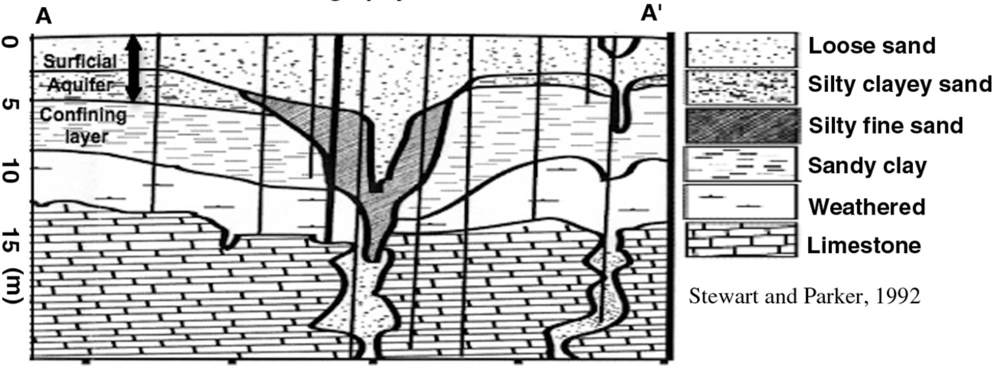
Figure 1. Subsurface cross section from Parker (1992).
  - Examine your raw gravity data and compare it with your Bouguer-Local trend data. Explain why the corrections you applied were necessary even on such a small and relatively flat survey.

- Limitations:
  - If you only had the gravity data and no other information, what would be a key challenge limiting your interpretation?
  - Explain what “nonuniqueness” means. Draw two example cross-sections using different interpretations of your results to illustrate the limitations of nonuniqueness. In your diagrams, be sure to specify spatial scales (width and depth) and physical properties (density) of the subsurface.
- Extension:
  - What are examples of density variations underground in your area that might produce a gravity anomaly if measured using a similar method to the GeoPark sinkhole dataset?
  - Can you think of any other examples of environmental targets that could result in measurable gravity anomalies?
  - Brainstorm some natural processes that might cause the local gravity to change over time. What could cause the density underground to change over the course of hours? Days? Months? Years?

1.4 Evaluation/Assessment
Please prepare a lab report that includes a summary of your procedure, an explanation of your results, and answers to each of the questions above.

