Locating Subsurface Features Using Gravity and Magnetics Unit 2: Environmental Magnetism Student Worksheet
Klaudio Peshtani and Lee Slater (Rutgers University Newark)

As you work through the sections of Unit 2, take careful note of the details in the videos and follow the instructions provided. Enter your answers in the text boxes only!

Part 1: Environmental concerns and the fundamentals of magnetism
Watch the Environmental Magnetism video until the 2:38 timestamp, then press pause (we will return to the video in Part 2.3). Use this part of the video to answer questions 1–5.
- Materials that exert their own constant magnetic field are known as _____________________________, while materials that only become magnetic when placed near a magnetic field are known as _____________________________.
- _____________________________ is the measure a material has to become magnetized in the presence of a magnetic field.
- Record the formula for magnetization and define the variables.

- Given the values provided below, calculate the volumetric magnetic susceptibility $x_{v}$ (show your work).
  - $H=360000 A/m$, $M=1200 A/m$

  - $H=180000 A/m$, $M=1200 A/m$

- For a material with induced magnetization characterized by a magnetic susceptibility $x_{v}$, if the magnetic field halves, what happens to the degree of magnetization?

Part 2: Simulating a magnetic field and exploring uses of magnetism
Use the resources linked below to answer the following questions.
- Using the magnetic force simulator (javalab.org/en/magnetic_force_en/), explain the difference of the behavior of magnetic field lines when like poles (e.g., N-N) are brought together versus when opposite poles (e.g., N-S) are brought together. (Drag magnets to move, then click and use the slider to rotate.)

- Using the NOAA US Historic Magnetic Declination Calculator (https://www.ngdc.noaa.gov/geomag/calculators/magcalc.shtml?%23ushistoric#ushistoric), enter your home address or a common location in the “Lookup Latitude/Longitude” box and select the button “Get & Add Lat/Lon,” then set the start date to 100 years ago, and the end date to this year, and select the “Calculate” button. What do you notice happening to the declination over time, and what does this represent?
- The magnetic field due to a rock formation rich in iron-bearing minerals is classified as which of the following? (Circle one right answer.)
(a) induced magnetic field
(b) local magnetic field
(c) magnetic dipole
(d) regional magnetic field
Finish watching the Environmental Magnetism video from the 2:38 timestamp then answer questions 9–14.
- In one sentence, explain how a gradiometer collects data.

- Describe how a magnetometer survey differs from a gradiometer survey.

Part 3: Creating a 2D magnetic survey plot using real data
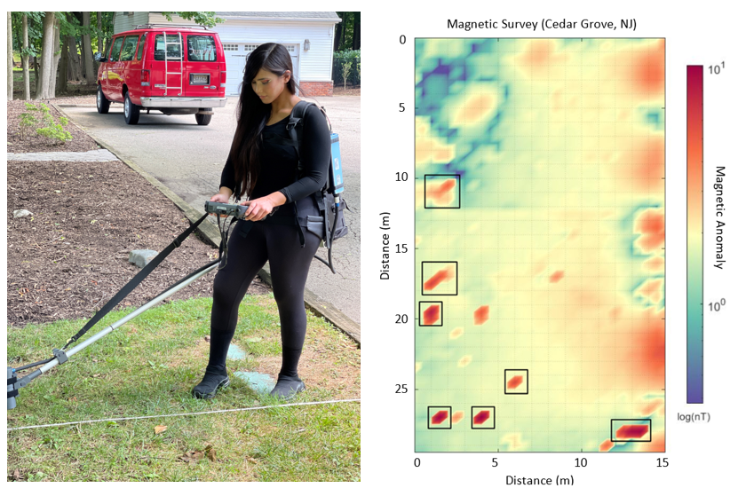
Figure 1 - Rutgers-Newark Geophysical Society member Nicolette Filippone conducting a magnetic survey using a magnetometer (left) and a fully processed magnetic survey highlighting anomalies of interest at a site in Cedar Grove, NJ (right).

- You are provided with raw magnetic survey data from an archaeological investigation performed by the students in the Rutgers-Newark Geophysical Society SEG chapter. Follow the steps in the order listed in the online-accessible Python script for real magnetic data.
- In step 5 of the script, you are asked to generate a contour plot with a color map of your choice (you cannot use the example color map ‘bone’!). Copy and paste an image of your generated 2D contour plot below.

- Using your 2D magnetic plot as a reference, describe what you observe on the survey site. Do you notice any interesting looking magnetic anomalies? Use the X and Y coordinates in your description (example response: a strong magnetic anomaly is observed at approximately 8-m (X), 20-m (Y) on the grid).
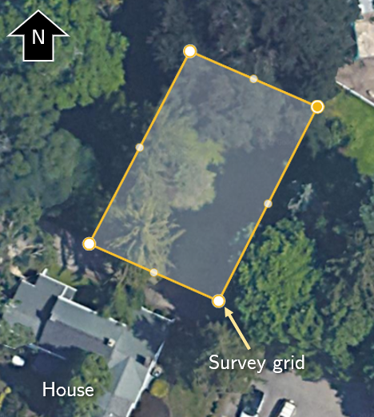
Figure 2 - Aerial view of survey site.
- The survey was performed in the garden of a historic home. The southern end of your generated magnetic survey meets the driveway of this property. Using this information, explain your reasoning on how this may affect the way you interpret this 2D magnetic survey.

Part 4: Conducing your own magnetic survey

Using your phone as a handheld magnetometer, you will conduct your own personal magnetic survey with the guidance of your instructor. Download the “phyphox” app on your phone (iOS/Google Play). Follow the directions provided by your instructor. Once the survey is completed, answer questions 15–18.

- You will now produce your own 2D magnetic survey plot using data collected from your (or your partner’s) smartphone. Follow the steps in order listed in this separate online-accessible Python script for data collected with smartphones.

- Copy and paste a screenshot of your unique 2D magnetics survey plot below. Report where you believe the strongest magnetic anomalies are located in the grid based on your results.

- Describe the difference between the magnetometer survey at Cedar Grove (Section 2.4) to the cellphone magnetometer survey you completed personally.

- Optional extension: Consider the advantages and disadvantages of using a magnetism survey to detect unmarked graves. Are there situations in which an unmarked grave may exist, but not produce a significant magnetic anomaly? If you are familiar with other near-surface geophysical surveying methods, suggest any other methods you think could be useful to supplement magnetism data for this application.

