Locating Subsurface Features Using Gravity and Magnetics Unit 1: Locating Buried Objects Using Gravity Part 3 Student Worksheet
Sarah Kruse (University of South Florida)

How do the mass and depth of a buried object affect gravity readings over the object? In this exercise you’ll answer this question three ways:
- Examining the equation for gravitational acceleration
- Plugging numbers into the equation
- Running a simulation that computes gravity profiles
In Part 3A, you’ll do the first two considering a single gravity reading directly over a buried object. Then in Part 3B, you’ll do the first and third for a gravity profile run over a buried object.
Note: Without extra or missing buried mass–a mass anomaly–the gravity readings will be the average gravity for that area. Here we use the equation for acceleration due to gravity (derived in Part 2) to compute the extra gravity g_{ex} due to excess buried mass, or loss in gravity relative to missing mass. We add these labels as subscripts: extra mass = M_{ex}, missing mass = M_{mi} etc.

Part 3A. Gravity readings directly over the object.

Exercise 1. What is the effect of increasing the amount of a buried mass M_{ex}?
Method (a): Examine the equation with words and pictures.
Larger Mass Table
Equation | $$g_{ex}=G\frac{M_{ex}}{r^{2}}$$
Words | M_{ex} = buried excess mass.  M_{ex} appears in the numerator on the right-hand side of the equation. If M_{ex} increases, the whole right hand side increases. Because the left-hand side equals the right-hand side, the left-hand side must also increase.  So if M _{ex} increases, g_{ex} increases.
Picture | 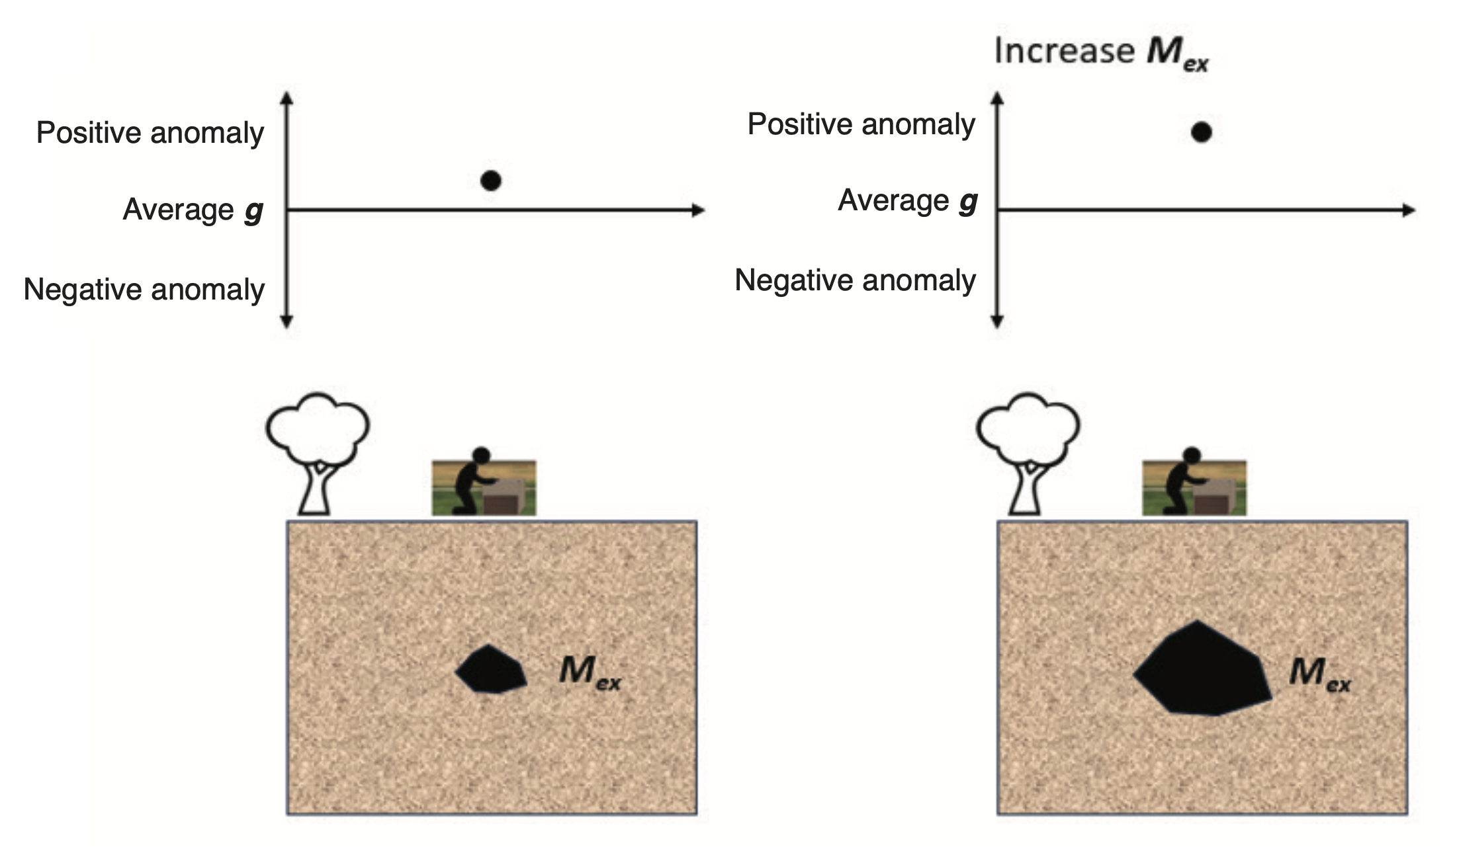

Method (b): Plug numbers into the equation.
Assume there is a hole in the ground, like a sinkhole, caused by limestone having been dissolved away. The rock that is gone creates a region of missing mass. For a hole with a 5-meter diameter, and assuming the limestone has a density of 2,100 kg/m³, we can use the formula for a sphere to calculate volume, then solve for mass using the density formula. As a result, we know that the void would create a missing mass of about -140,000 kg = -1.4 x 10⁵ kg. Assume the center of this hole is 6 meters below the ground surface. Then consider what happens if the void size grows so the missing mass is doubled. Fill in the table below by following the steps below. Don’t forget to show units when doing math!
Larger Void Table
Equation | $$g_{loss}=G\frac{M_{mi}}{r^{2}}$$
Picture | Math
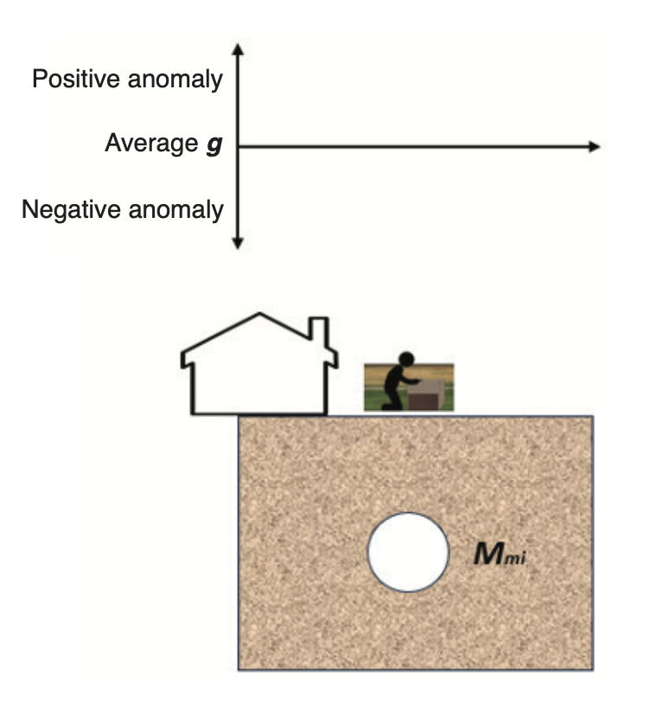 | Missing mass is -1.4 x 10⁵ kg  Depth to center = 6 m  What is loss in gravitational acceleration due to the void?  Would this be a positive or negative gravitational anomaly?
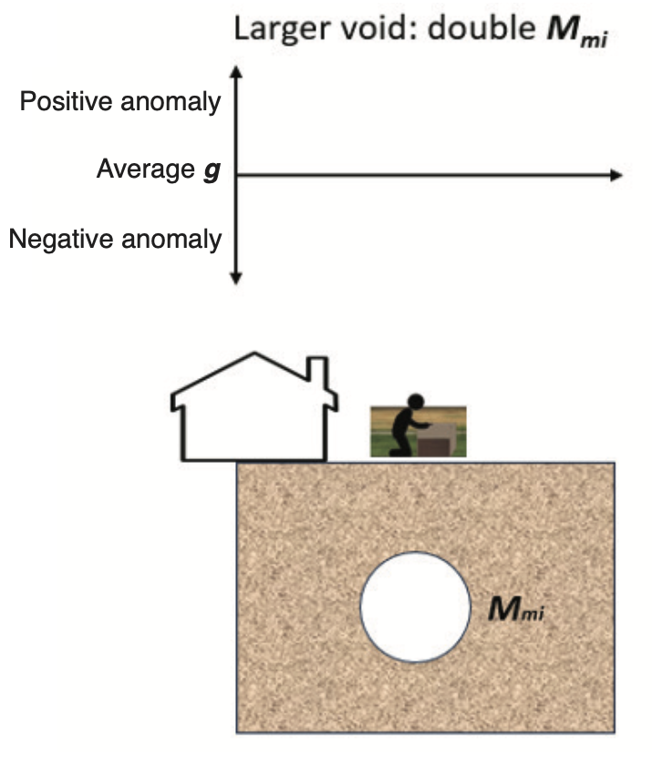 | Missing mass is now doubled.  Depth to center same = 6 m.  What is the loss in gravitation acceleration due to doubled missing mass?  Would this be a positive or negative gravitational anomaly?

- In the pictures to the left, mark approximate expected gravity reading over the center of the void for both top and bottom scenarios.
- Label the variable r on both pictures. Recall r is the distance between the object producing the gravitation acceleration and the object experiencing the acceleration, which in this case is the gravimeter.
- Compute the loss in gravitational acceleration for both scenarios. Show your work in the boxes in the right column.
- Check your answers:
  - The units of acceleration should be m/s².
  - The gravitational acceleration due to the mass of the whole Earth is 9.8 m/s². The loss in gravity due to a hole 5 meters in diameter should be at least one million (10⁶) times smaller.
  - Your answer should be negative. Why negative?

- Divide your answer for the bottom (doubled mass) scenario by the original scenario. Show your work.
Using this, describe in words how doubling the mass affects the gravitational acceleration.

Exercise 2. Now consider the effect of increasing the depth of buried excess or missing mass. (Assume no change in mass.)
Method (a): “Reading” the equation with words and pictures.

- Fill in the picture box below with the same mass, buried more deeply, and your estimate on how it would affect the gravity reading in the graph.
- Type words in the box below describing how increasing the depth of the buried mass will affect the excess gravity (see exercise above). Assume the same mass, just buried more deeply.
Deeper Mass Table
Equation | $$g_{ex}=G\frac{M_{ex}}{r^{2}}$$
Words
Picture | 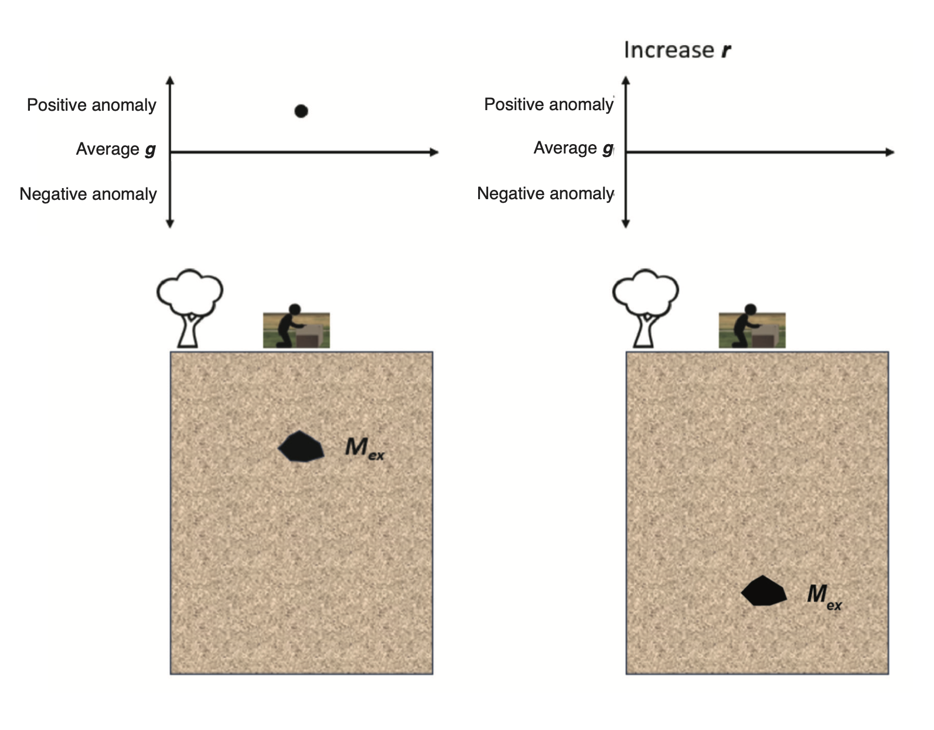

Method (b): Consider the depth effect by plugging in numbers into the equation.

Compare two sinkholes of the same size, but one is twice as deep. (Depth is measured to the center.) Fill in the table below by following the steps below.
Deeper Void Table
Equation | $$g_{loss}=G\frac{M_{mi}}{r^{2}}$$
Picture | Math
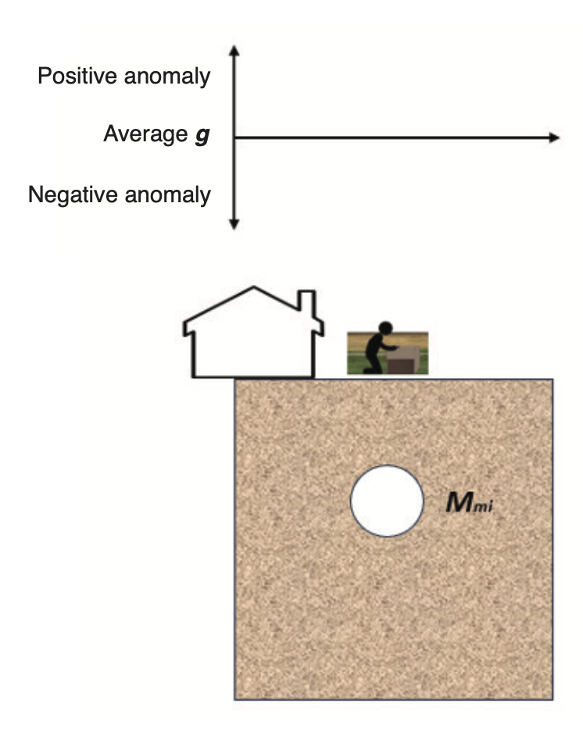 | Missing mass is -1.4 x 10⁵ kg.  Depth to center = 6 m.  What is loss in gravitational acceleration due to the void? (Can insert answer from previous sinkhole table.)  Would this be a positive or negative gravitational anomaly?
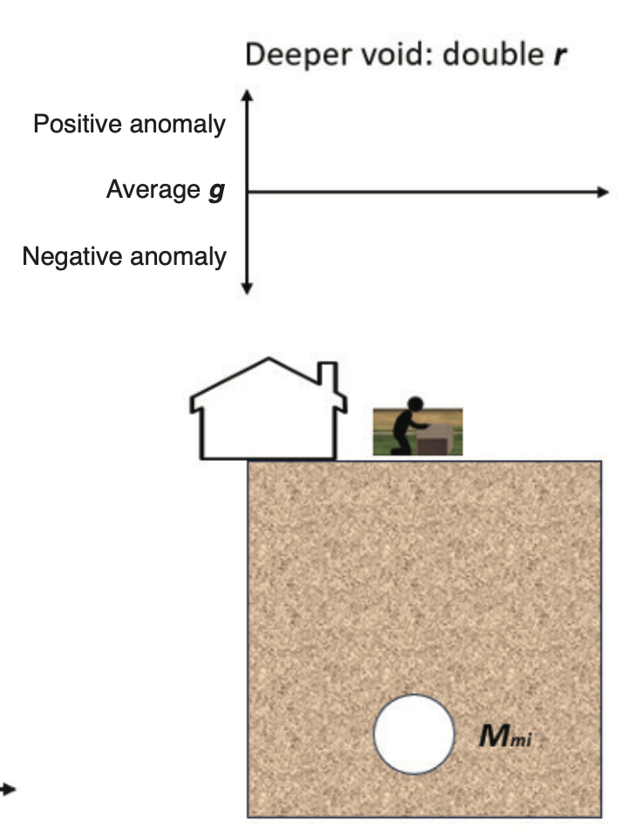 | Consider the same void, but twice as deep.  What is loss in gravitational acceleration due to a deeper void?

- In the pictures to the left, mark approximate expected gravity reading over the center of the void for both top and bottom scenarios.
- Label the variable r on both pictures.
- Find the loss in gravitational acceleration for both scenarios. Show your work in the boxes in the right column.
- Again, check your answers:
  - The units of acceleration should be m/s².
  - The gravitational acceleration due to the mass of the whole Earth is 9.8 m/s². The loss in gravity due to a hole 5 meters in diameter should be at least one million (10⁶) times smaller.
  - Did the way the number changed approximately match what you guessed when you marked data points in Step 8 above?

- Now divide your answer for the bottom (deeper void) scenario by the original scenario. Show your work.
Using this, describe in words how doubling the depth of the (missing) mass affects the gravitational acceleration.
- Notice the relative impacts of doubling the mass and doubling the depth (questions 5 and 12) are not the same.
Which property, mass or depth, has a stronger effect on the measured gravitational acceleration? Explain.
Look back at how the mass and the depth each appear mathematically in the equation for gravitational acceleration: $g=G\frac{M}{r^{2}}$ Explain why the variable you indicated earlier has a stronger effect on g.

Part 3B. How do mass and depth of the buried object influence a profile of readings over the buried object?
First consider the effect of mass.
- Review: For a buried positive (extra) mass (like an ore body), if the mass increases, does the gravity caused by the mass increase or decrease?
  - Increase
  - Decrease
- Check your answer to Question 14 against the app that shows the gravity profile over a buried mass with a polygonal shape, https://www.iris.edu/app/iguana/gravity/2d-polygon/
  - Create a polygonal shape with a higher density such that the gravity curve fits within the scale and doesn’t go beyond the limits.
  - Cut and paste your screen shot (or carefully sketch) in the Greater Mass box below.
  - Keep the same polygon shape, and reduce the density by a factor of 2, hence making the mass half as large (see Aside on Density in Part 1).
  - Cut and paste your screen shot (or carefully sketch) in the Smaller Mass box below.
  - Compare by cutting and pasting screen shots of two scenarios, one with a smaller positive mass, one with a greater positive mass, all else the same. Note: 1 mgal = 10⁻⁵ m/s².
Mass Comparison Table
Greater Mass | Smaller Mass
Paste or carefully sketch image here | Paste or carefully sketch image at the same scale here

Does your result match your answer to Question 14?

Now consider the effect of depth.

The depth of a buried object affects both the strength (or amplitude) of the peak gravity signal over the buried object and the width of the signal.
You can examine these relationships by using the gravity polygon animator to compare the same object (approximately) at different depths.
Questions 16 through 20 below will guide you to filling in the Depth Summary Table below on the effects of the depth of the buried object.
Depth Summary Table
Shallow Mass | Mass (about) Twice as Deep
Paste or carefully sketch image here | Paste or carefully sketch image at the same scale here
Peak value (mgal) | Peak value (mgal)
Half peak value (mgal) | Half peak value (mgal)
Width at half peak (km) | Width at half peak (km)

- Using the app, set the density to 1000 kg/m³. Create a narrow rectangular polygon centered on one of the distance markers, that extends from 0 (ground surface) to about half a km depth, as shown below.
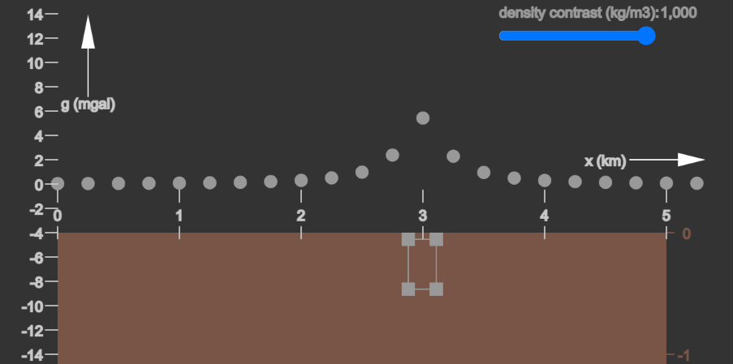
Paste/sketch the image into the Shallow Mass column into the Depth Summary Table above.
Keeping the density the same, shift the polygon corners to create (approximately) the same rectangle size, but moved downward so it runs from 0.5 km to 1 km depth. (Same mass, deeper.) Paste/sketch image into the Depth Summary Table.

- Find the peak values for both cases and write the results into the Depth Summary Table on the previous page. For the example below, the yellow line helps estimate the peak value is about 5.5 mgal.
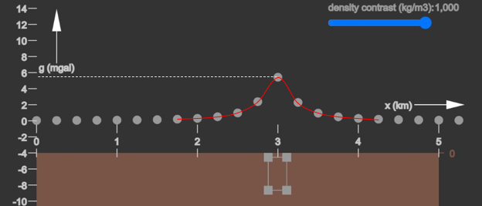

- Do your results for Question 17 about how the gravity relates to the object depth match what you wrote in the Deeper Mass Table from 3A Exercise 2? Explain.

Comparing the widths of the gravity signals for the shallow and deep cases is a bit harder to do. Scientists often do this by determining how wide the signal is at the value that is half of the peak value.

Follow the steps below to do this, while filling in your results in the Depth Summary Table.

- For each case, divide the peak value by 2 to get the half value; fill in that row in the table.
- Find the width of the signal at half the peak value, as shown in the box below. Enter those values into the Depth Summary Table.
For the example, the peak is 5.5 mgal, so half peak is 2.75 mgal. Imagine the curve connecting the gravity points. Where would that curve cross 2.75 mgal? This is shown with the blue dashed lines. The curve would cross 2.75 at about 2.8 km distance and again at about 3.2 km distance. The width would then be considered the space between the two vertical blue lines, namely 3.2 km – 2.8 km = 0.4 km.
*Note: The half peak may not correspond exactly with any of the gravity data points. It’s good to estimate by drawing lines and curves like the red curve and blue dashed lines shown here.
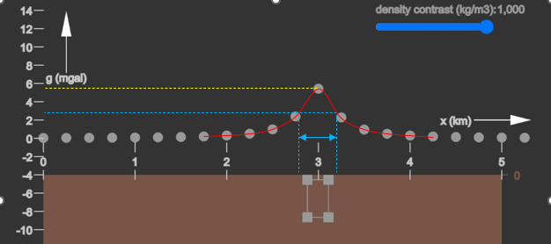

- From your results in the Depth Summary Table, how does the depth of the buried object affect the width of the gravity profile? Explain.

Summary:
As you saw in the video and the animation from Part 1 of this unit, scientists can use gravity data to locate where, beneath the surface, buried objects with extra mass or missing mass may be.
From your analysis of the equation of gravitational acceleration, you now know that the amplitude and width of signals on a gravity profile depend on the amount and depth of buried (or missing) mass. Scientists can also use these relationships between the amplitude and width of the gravity profile to make estimates of the mass and depth of the buried objects. You can do this yourself in Unit 3 of this gravity and magnetics module!

