Locating Subsurface Features Using Gravity and Magnetics Unit 1: Locating Buried Objects Using Gravity Part 2 Student Worksheet
Sarah Kruse (University of South Florida)
Watch or rewatch the Gravity Animation.
Part 2A. Meanings of each of the variables in Newton’s Law.
To find gravity conditions on Earth’s surface, let’s first examine Newton’s law of universal gravitation
$$F=G\frac{Mm}{r^{2}}$$
Where F is the force of gravitational attraction between two objects of masses M (larger mass) and m (smaller mass) spaced r distance apart.
We can combine Newton’s law of universal gravitation with Newton’s second law of motion, $F=ma$, to find an equation for gravitational acceleration experienced by the object of smaller mass ($m$).
$$ma=G\frac{Mm}{r^{2}}$$
And since $a$is acceleration due to gravity, it can be rewritten as $g$.
$$mg=G\frac{Mm}{r^{2}}$$
Now $m$ will cancel on both sides of the equation, and we are left with the following relationship:
$$g=G\frac{M}{r^{2}} (equation for acceleration due to gravity)$$

Why are the masses M and m?
You may wonder, why don’t we just call the “big M” in the equation for gravitational acceleration M_{Earth}? While it is true that for gravity surveying, “big M” is the mass of Earth, many fields of science and engineering include studying other objects throughout the universe. Sometimes Earth represents the larger mass in the equation, but an astrophysicist might be examining a problem on the scale of the Solar System, in which the Sun might be “big M”. On the other hand, an engineer testing the safety of two cars during a crash might make “big M” one of the two cars. The scale of the science will affect how you use the equation!
This equation works well for most applications, but there are some very large scales in which the equation needs to be modified according to discoveries made by Albert Einstein.
Recall from the animation that this equation describes the gravitational acceleration of one object that is created by the mass of another object.
- This exercise is to help make it clear that the equation for acceleration due to gravity above describes the effect that one object, with mass M, has on a second object. Make a sketch of one heavy object on the left (anything!) and a second, lighter object on the right.
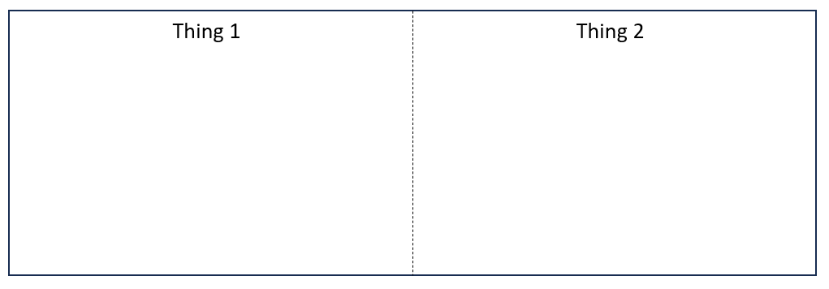
There are four variables in the equation for acceleration due to gravity; we’ll review what role each plays in your sketch above.
- Assume whatever you have drawn on the left has mass M, so add a label M to the object on the left.
- The g in the equation for acceleration due to gravity describes the gravitational acceleration experienced by the second object. This g is produced by the mass M of the first. What direction is this gravitational acceleration? (Review the gravity animation if needed.) Draw an arrow labeled g near your second object to show the direction of its acceleration caused by the first object.
- What is r in the equation for acceleration due to gravity? (a) Describe it in words below and (b) add a line showing r on your picture in question 1.

- Finally, what is G? Use the following example to calculate G and determine its units in the SI system.
$$g=9.81m/s^{2}$$
$$M_{Earth}=5.97×{10}^{24}kg$$
$$r_{Earth}=6.374344×{10}^{6}m$$

- Optional extension: When was this physical constant G first determined through laboratory measurements? Did Newton himself know the value of this constant?

- Notice your diagram in question 1 shows that Thing 1 with mass M causes the gravitational acceleration g of Thing 2. But the equation for acceleration due to gravity can also be used to ask the reverse: What is the gravitational acceleration of Thing 1 on the left due to the mass of Thing 2 on the right?
Considering this reverse scenario, complete the following statement:
The gravitational acceleration of Thing 1 due to Thing 2 will be _________ (greater than / less than) the gravitational acceleration of Thing 2 due to Thing 1 (as drawn above).
Justify your answer. Start by stating whether the mass of the second object is greater or less than the first, and then describe how you get to your answer.

Part 2B. Gravity is a Potential Field.
Scientists will often describe gravity as “the gravity field.” In math or physics, you’ll eventually hear it described as a potential field. In simple terms on the surface of the earth, this is because a mass (e.g. you [Figure 1], or the mass on the end of the spring in the gravimeter [Figure 2], or a car teetering on the edge of a cliff [Figure 3]) has the potential for downward acceleration. (That downward acceleration would occur without the forces holding it back, which in these examples are the force from the spring holding the mass and the rock supporting the van.)
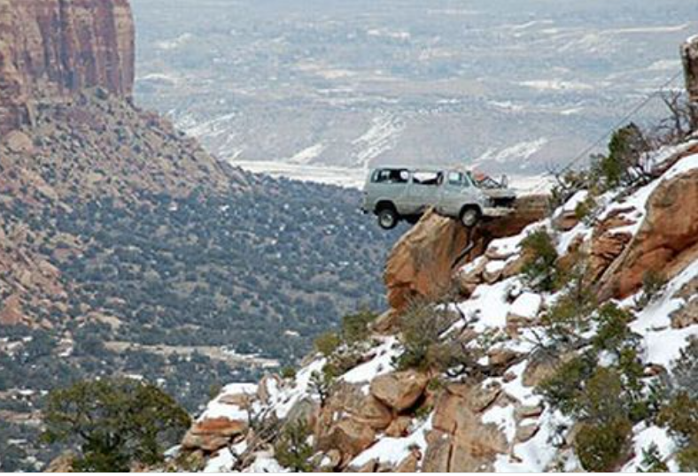
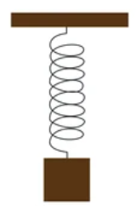

Figure 1 – Left. A person jumping has the potential for action because they are in a gravitational field
Figure 2 – Center. A block on a spring has the potential for action because it is in a gravitational field.
Figure 3 – Right. A car teetering on the edge of a cliff has the potential for action because it is in a gravitational field.

Diagrams of a field in space are drawn with lines showing the direction of the field, or in this case the direction of acceleration due to gravity. For gravity around a spherical mass, these lines all point toward the center of the sphere, as shown in Figure 4.

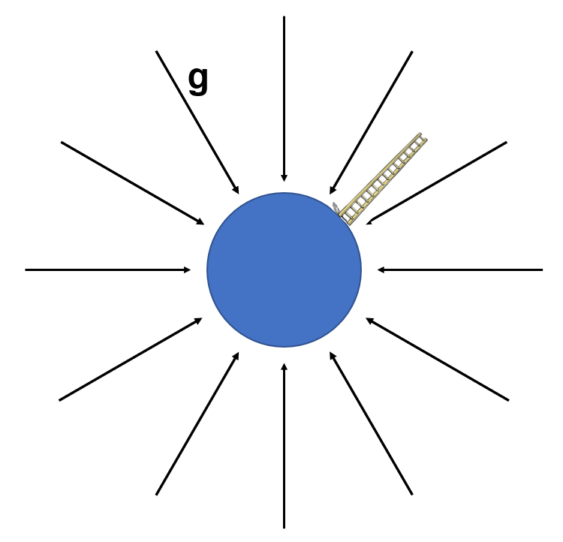
Figure 4 - The gravity field around a spherical mass, and a very tall ladder. The closer together the field lines, the stronger the field is.

In field line diagrams like Figure 4, the closer together the lines, the stronger the field.

The questions below ask you to work out some of the implications of that fact for the Earth’s gravity field.
- If you climb the very large ladder in Figure 4, at the bottom the field lines are ______________ (closer together / farther apart) than they are at the top. So this means the gravity field is ___________ (weaker / stronger) at the bottom step than at the top step of the ladder.
Here’s why it matters: When we want to use gravity to find buried objects, we need to correct for the effects of being higher or lower relative to sea level. So we have to measure the elevation, as precisely as possible.
- Here’s an example of the problem. If we measured a weaker (lower g value) at some points on a survey (negative anomaly), that could be caused by
_________________________ (missing mass like a tunnel / extra mass like an ore body)
OR it could be caused by
_________________________ (being at the top of a hill / being at a low point).
So unless you measure the elevation precisely and correct your data accordingly, you can’t tell how much of the weaker signal is caused by elevation or by buried features. You will see in Unit 3 that the elevation comes into play in the free air and Bouguer corrections.

