Locating Subsurface Features Using Gravity and Magnetics Unit 1: Locating Buried Objects Using Gravity Part 1 Student Worksheet
Sarah Kruse (University of South Florida)

Part 1: What kinds of buried features can you detect by measuring gravity?
You will need access to the internet to answer some of the questions in this worksheet.
Watch the Gravity Animation at this link: https://www.youtube.com/watch?v=SF3A0Knz-SQ
Then, check back through it to answer the following questions.
- In the Gravity Animation, did the ore body create a higher or lower gravitational attraction (g)?
- The example shown of a buried feature that has missing mass compared to surrounding rock is a ___________________. Did this create a higher or lower gravitational attraction (g)?

To focus just on the “missing” or “extra” gravitational attraction, scientists often subtract the expected regional gravity from the observed survey data. The resulting value is called the gravitational anomaly.
$$observed gravity-regional gravity=gravitational anomaly$$
- For each of the following examples, would you measure a positive or negative gravitational anomaly over the buried feature?
A cannon that fell off a barge is buried in a riverbank. | Positive | Negative
An abandoned mine shaft. | Positive | Negative
An empty underground gas storage tank. | Positive | Negative
An underground magma chamber; the chamber is completely filled with magma of density 2,800 kg/m³, the surrounding rock has a density of 3,000 kg/m³. (*See Aside on Density and Mass at the end of the worksheet.) | Positive | Negative
An underground storage tank filled with gasoline. The tank is buried in loose sands. | Positive | Negative

The schematic below shows where water resides underground. Above the water table, some open spaces in soil or rock are filled with air. Below the water table, all open spaces are filled with water. When groundwater is pumped out of the ground faster than it is replenished by rainfall, the water table drops and forms a cone of depression around the pumping well.

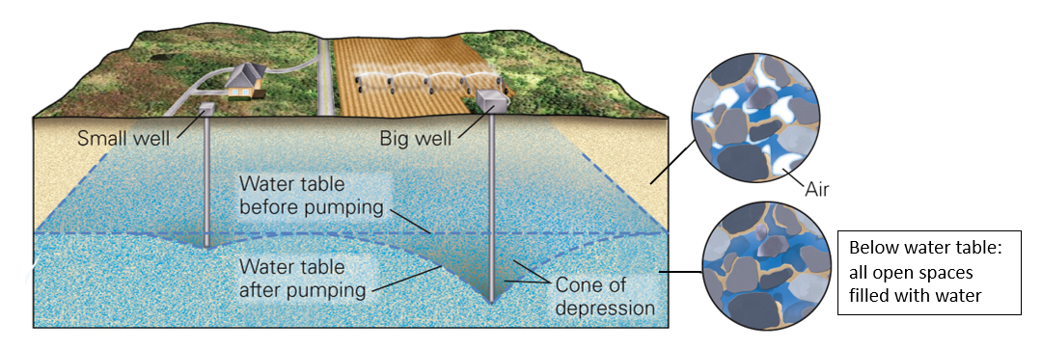
Figure 1 – Cross-section of an aquifer and cone of depression. (Modified from Earth Portrait of a Planet, Marshak, 7th edition.)
- Consider the change in mass in the subsurface that occurs when the cone of depression forms. Which of the following statements do you think is true? (Circle one)
  - Gravity measured on the surface by the well would be greater when the water table was flat and gets weaker when the cone of depression forms.
  - Gravity measured on the surface by the well would be less when the water table was flat and gets stronger when the cone of depression forms.
- Explain your answer to Question 4 in a sentence and note if this would create a positive or negative gravitational anomaly.

Aside on sinkholes
Sinkholes form as cracks and other voids in the ground grow through weathering and erosion over time. Ultimately the ground above the voids will either subside (sink) slowly (Figure 2) or collapse suddenly (Figure 3). Sinkholes usually form where bedrock is carbonate rock (e.g. limestone) because carbonates can be dissolved away slowly simply by rainwater traveling through it. But they can form in other areas too if something causes soils to be carried away (this can happen around leaking underground pipes).

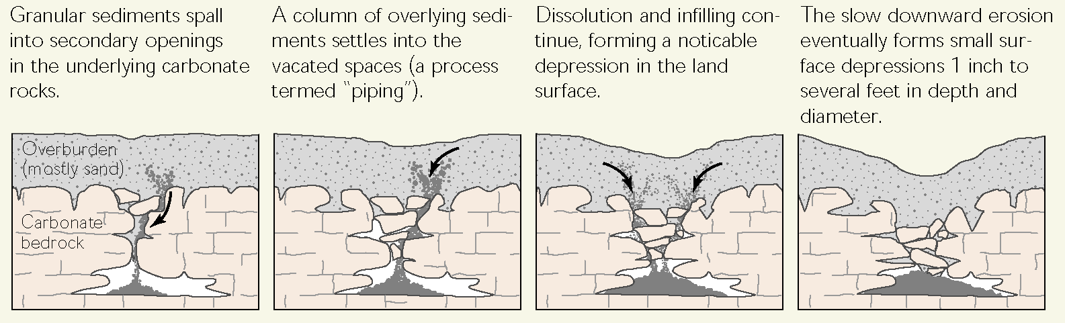
Figure 2 - Sinkholes causing subsidence. (Credit: USGS, https://fl.water.usgs.gov/Abstracts/c1182_tihansky.html)
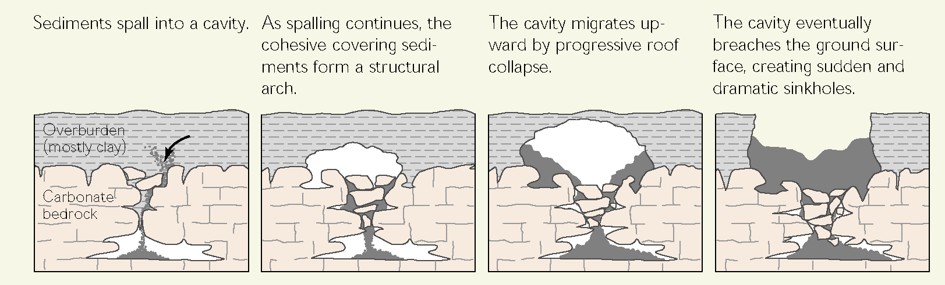
Figure 3 Sinkholes causing ground collapse. (Credit: USGS, https://fl.water.usgs.gov/Abstracts/c1182_tihansky.html)
To see a collapse over a sinkhole happening in real time, start at 1:15 in this video and watch for a minute or so: https://www.youtube.com/watch?v=SlrMw8OPGv8. If you have any doubt there is a void underground, keep an eye on the palm tree!
- Describe one aspect of the video that surprised you or one topic related to sinkholes that you would like to learn more about.
- Where you live, is the bedrock limestone? Check this map to find out: https://www.usgs.gov/media/images/karst-map-conterminous-united-states-2020.
- Why might this information be relevant to construction companies? Do you think they would approach the construction process differently if they are building on carbonates instead of other types of bedrock?
- Imagine you work for an environmental investigation firm. They send you out to take a gravity profile over a place where they suspect an underground void may exist, as shown below. You take six readings along the profile (similar to the gravity animation examples). Sketch six data points as you might expect them and draw a smooth line connecting your data points.
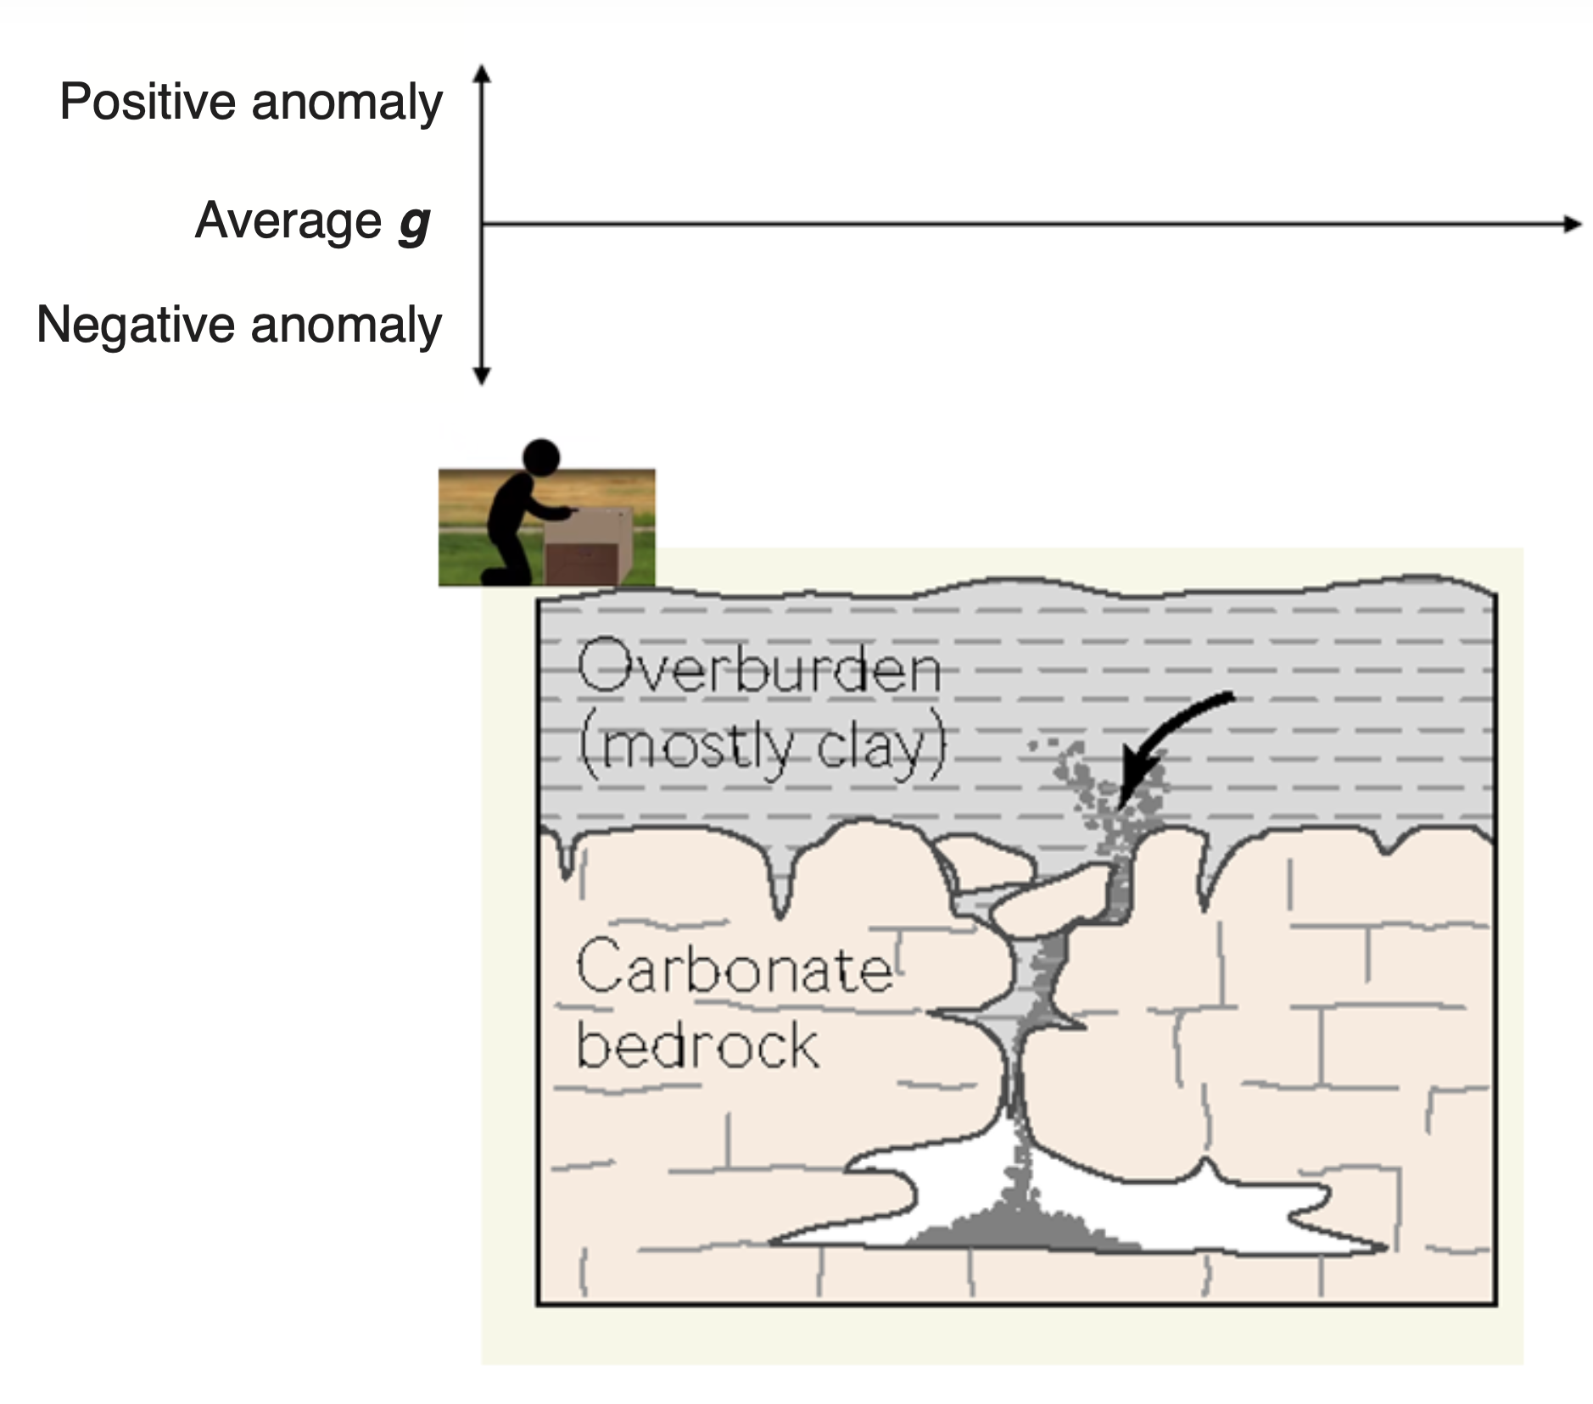
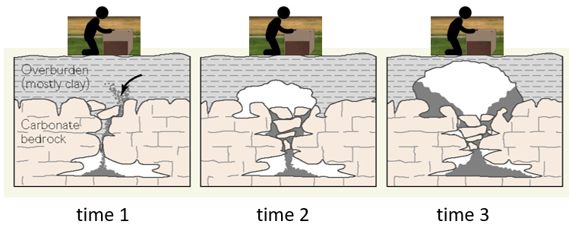
- Based on your report on your gravity data to your firm, they decide they should monitor this area, and they send you back two more times, when the cross-section looks like the sequence above. What would your data look like if the process shown were happening? On your graph on Question 9, add a second smooth line for what you expect at time 2; label that line. Add a third smooth line for what you expect at time 3; label that line.
On a much larger scale (hundreds of meters to hundreds of kilometers), earth scientists can use gravity to estimate the locations and dimensions of very large geological features. In the example shown below, there is a zone of sediments, which have a lower density* than the surrounding rock. (*See Aside on Density and Mass at the end of this worksheet.)
- Which of the following options in the figures below (Profile A or Profile B) would you expect for a gravity survey over this area?
  - Profile A
  - Profile B
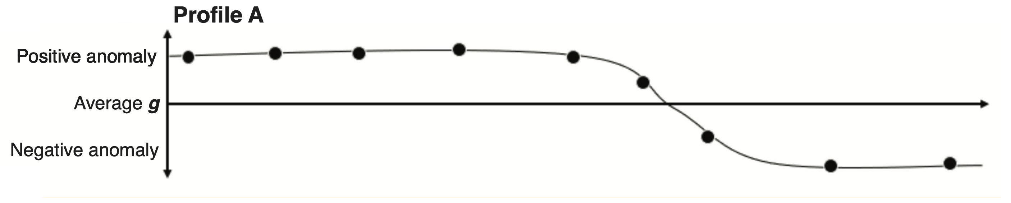
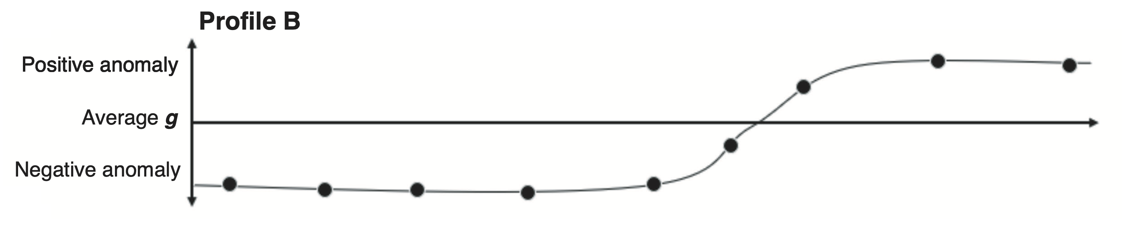
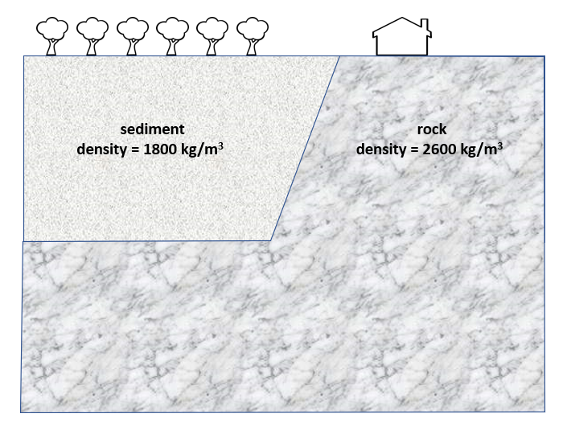
When earthquakes happen, ground made up of sediment shakes more than hard rock. (See https://www.youtube.com/watch?v=536xSZ_XkSs)
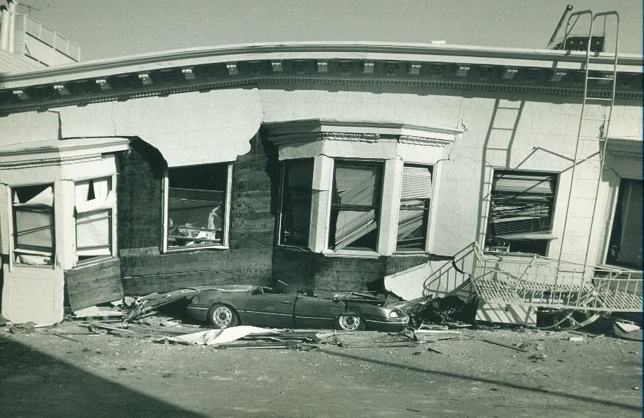
Figure 4 - Homes built on sediment, like this one in San Francisco, suffered the most damage in the large 1989 earthquake. (Credit: Wikimedia Commons, Creative Commons 3.0 https://commons.wikimedia.org/wiki/File:Damage_in_San_Francisco%27s_Marina_District_the_day_after_the_October_1989_Loma_Prieta_earthquake_struck.jpg)

- The figure below shows a gravity survey across an area where houses will be built. Earthquakes are known to occur there. Given your answer to Question 11, put an x on the tree where you think the safest place to build a house would be.
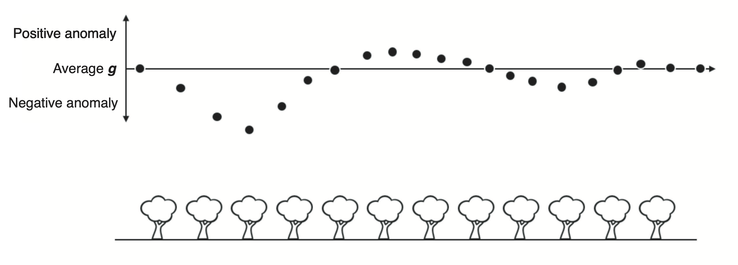

Aside on density and mass
Density is defined as:
$density=\frac{mass}{volume}$ , with typical units of kg/m³

A sponge has a low density, a gym weight made from lead has a high density. Water has a higher density than air.
Re-arranging the equation:

$$mass=density×volume$$
A water-filled balloon and an air-filled balloon blown up to the same size have the same volumes but different masses, because water and air have different densities.

$${mass}_{water balloon}={density}_{water balloon}×{volume}_{water balloon}$$
$${mass}_{air balloon}={density}_{air balloon}×{volume}_{air balloon}$$

So for a given volume, a material of greater density will have greater mass.
A good introduction to these ideas is at: https://serc.carleton.edu/mathyouneed/density
The gravity polygon animation used in Part 3 (http://www.cas.usf.edu/~cconnor/gravity_poly.html) applies this relationship: the user enters the volume (polygon size) and the density, the code computes the mass and then the gravity profile over the buried object.

