GPR Unit 3: EKKO Project Software GPR Data Processing Quick Guide
Sarah Kruse (University of South Florida)

Introduction
Have you gathered your own GPR data? Are you ready to process it and see what lies in the subsurface? This guide will outline the general steps you will need to upload, clean, and process your data with the EKKO Project Software.
Although this guide will allow you to initially process your data, there are more details that may be required to fully analyze and interpret your data. The vendor, Sensors & Software, has a more complete EKKO Project User’s Guide (as well as other Resources).
This guide was developed for EKKO Project V6 R2 and assumes that you already have GPR data that you or someone else collected. See also GPR EKKO Project Software Download Instructions.

Get Prepared
- Ensure that you have a Windows OS device available with EKKO Project V6 R2 software installed on it.
- Transfer your data from the Noggin GPR Digital Video Logger (DVL) to your computer using a USB device.
- Move the files to a location where you will be able to find them in EKKO Project. For example, you may want to create a GPR Data folder in your Documents.
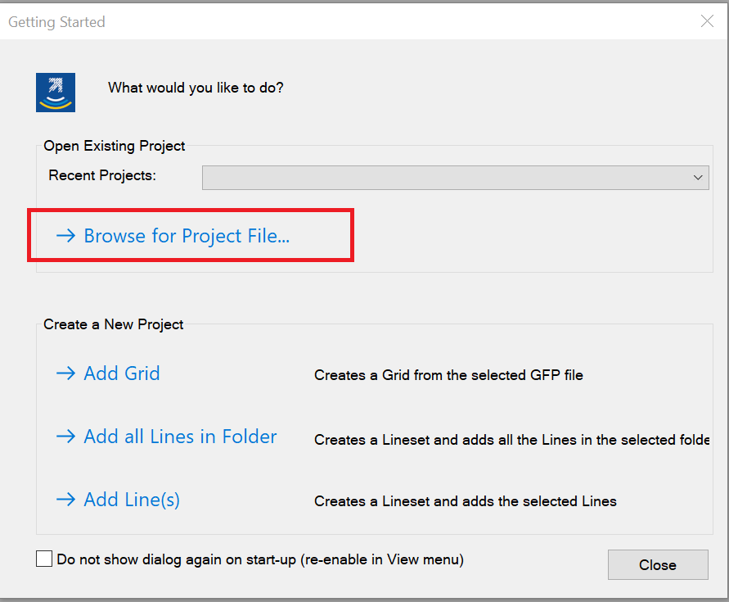
- Launch EKKO Project by double-clicking the desktop icon or searching for the program in your device’s program files.
Figure 1: EKKO Project Getting Started window.
- Upon opening, the Getting Started menu will appear. Select the Browse for Project File button and locate your GPR data (.gpz file extension). You may also open a line file ending in the .DT1 file extension.
- On opening, you should see the Project Explorer, with a preview of the GPR profile and possibly a model of the grid or path that the GPR unit took to get the data (if available).
- Pause and get a broad look at the data in this view. Do you see any patterns in the hyperbolas? What path did the surveyor take to get the data?
- Zoom or resize window to change vertical exaggeration to better see features of interest. In this example there is no signal coming from below 3 m depth, so just the top 3 m are selected by selecting the zoom button and dragging the mouse.
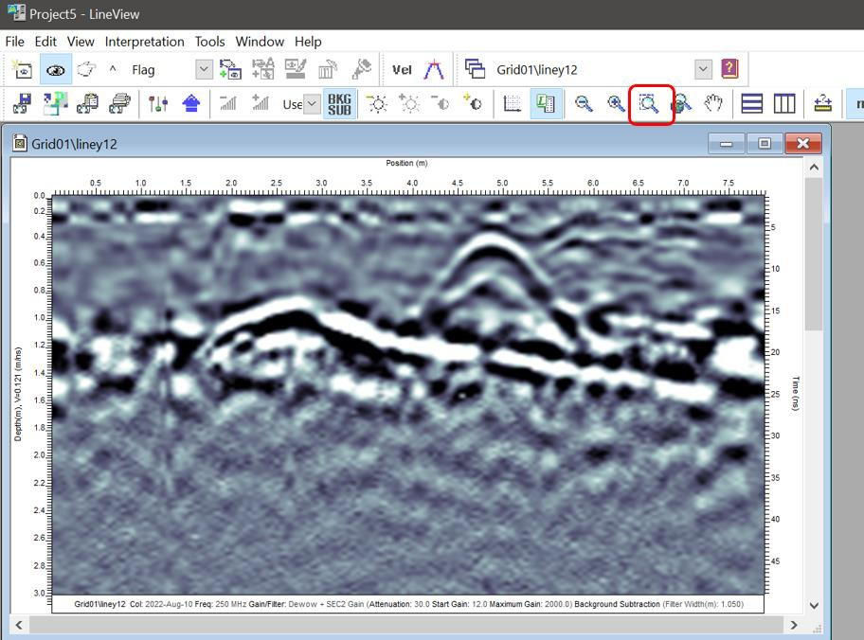
Figure 2: GPR profile with larger, more prominent features using the Zoom function.

Processing the Data

Data Cleaning
Though we can look at GPR profiles as they are recorded, we will need to clean our data to ensure we get the most out of it. Recall that we are looking for hyperbolas, the upside-down U’s, that may indicate a point-like object in the subsurface. EKKO Project has tools that help us emphasize the hyperbolas we want to see and clear away things we don’t want to see, like the direct wave.
We need to:
- Reduce the noise in our data
- Make sure we have the correct speed of the medium
- Get our data ready for export

- If you have many lines of data, select one line to view using the Layer View window on the left.
- Once your selected line has loaded, click Line View in the upper left-hand side of the Menu Bar.
- The Project Explorer window will close and load the Line View window. Don’t worry, you did not close the program, Line View just takes a few seconds to load.

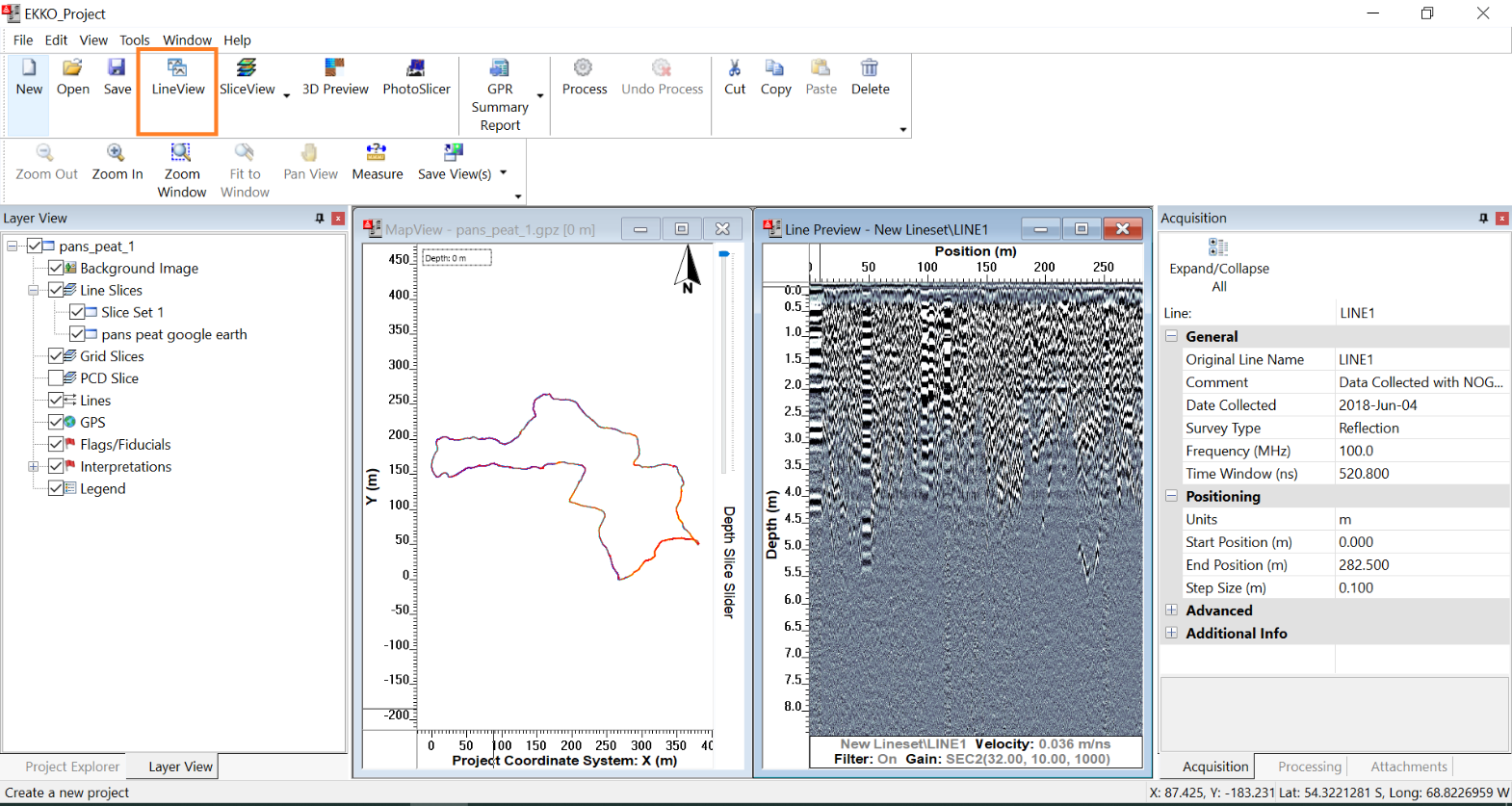
- You will see a new menu in Line View and just the GPR profile, unlike in Project Explorer that has the map view as well.
Figure 3: EKKO Project Explorer window with Line View highlighted.

Background Filter
Recall that in addition to buried features, a distinct straight-line signal will appear close to the surface. This is the direct wave that bounces between the transmitter and receiver of the GPR antenna, and it does not indicate any buried feature. EKKO Project provides a way to dim this band and make our data clearer.
- In Line View, click on the Background Filter button to toggle the filter that gets rid of any horizontal banding in the data.
  - Background Filter removes the average of all the traces. Any other signals that cause horizontal banding in your profile are removed as well. So double check the original data when deciding to leave Background Subtraction, it may make it more difficult to see any real horizontal features.

Gain
Recall that as GPR waves travel through the subsurface, they attenuate, or become weaker, the further they go. Attenuation can make buried features difficult to see with depth. Gain means amplification of the weaker energy arriving at the receiver at later times, or further down the depth axis. Adding gain to your GPR data is like adding additional contrast or brightness so signals in the data are easier to see. EKKO Project offers a few ways to adjust the gain in your data.
- In Line View next to the Background Subtraction button, click on the Modify Gain dropdown menu.
- Feel free to click on the different levels of gains in the dropdown menu and see what they do to your data. You can also adjust gain incrementally using the Increase and Decrease Signal Gain buttons to the left of the dropdown menu.
- EKKO Project also uses specific algorithms to calculate the best gain for your data. Click Auto in the Modify Gain dropdown menu to allow EKKO Project to choose your gain for you.
  - Even in geoscience, creating readable figures is both an art and a science: there is no perfect, one-size-fits-all solution. Though using Auto Gain is well-calibrated and convenient, it may not be the best way to see all the features in your data. Be sure to double check if there are any hyperbolas that are not captured when using Auto Gain
- For more customizability and to see the gained data vs the original, select View from the Menu Bar and select Settings from that dropdown menu.
- In the View Settings window that appears, navigate to the Gain/Filter tab. If you move your mouse around the GPR Data, the window will show each wiggle trace that makes up the GPR profile (black line) and how much that wiggle trace has been adjusted by the gain (red line). You can also view the gain curve by checking the Gain box

Changing the Color Palette
- Also in the View Settings window, navigate to the Color Palette tab to change the color of your line image. Feel free to play around with the color settings to find which one works for you.

Determine the Radar Wave velocity
GPR waves will travel and attenuate differently based on the material it is traveling through. Though EKKO Project may offer a default ground velocity, it is important to determine the velocity that is specific to your survey site.
- In LineView, visually scan and find a hyperbola that is distinct to you.
  - If your dataset has multiple lines (multiple GPR profiles), feel free to select a new line with more distinct hyperbolas. Right click on the line in the Project Explorer Window, and select the LineView in the pop-up menu.
- Adjust the window to a size and zoom where any hyperbolas are not too stretched out to see.
  - Our eyes are most sensitive when the hyperbola wings are at about 45 degrees.
- Choose how you will select the top of a hyperbola by clicking on the blue up arrow icon for the Time zero offset preference menu and choosing an option. Press OK when your preference is selected.
  - If you would like this preference to apply to all the lines in your dataset, check the Apply to all open lines box.

- Click on the Hyperbola Calibration button, the icon with the blue hyperbola with a red crosshair at the top. A thin red hyperbola will appear in the middle of your profile.
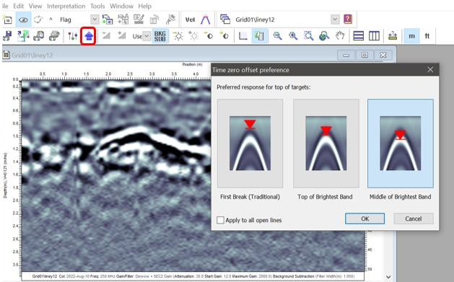
Figure 4: Time zero offset preference menu to choose where you consider the "top" of a hyperbola.
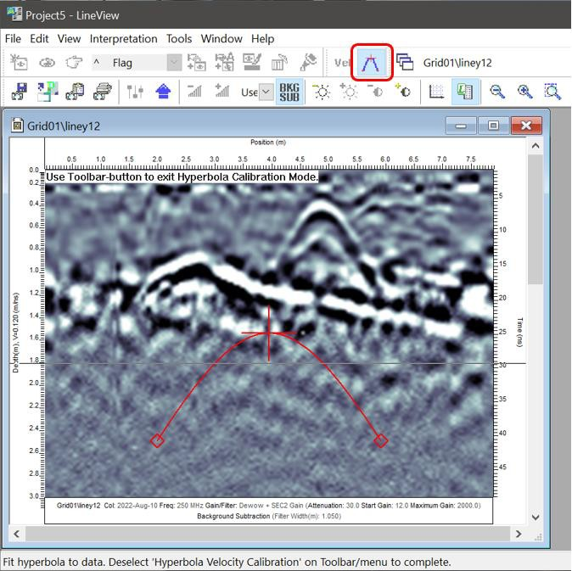
- Click and drag the red crosshair in the sample hyperbola to the hyperbola in your profile, making sure the red crosshair is at the “top” of the hyperbola that you selected earlier.
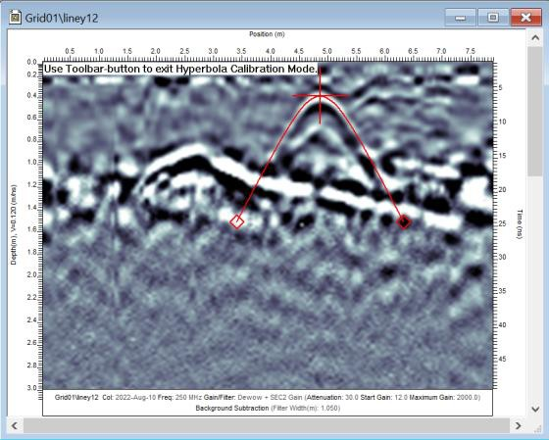
- Adjust the diamonds on the ends to adjust the length and width of your parabola so that it matches the dimensions of the hyperbola in your profile.

- Your calibrated velocity will be displayed in text at the bottom of the screen. Record this velocity or take a screenshot to use later.
  - If your dataset has multiple lines and you would like to apply the calibrated velocity to all of the lines in your dataset, save the selected velocity using the Modify Settings button and navigating to Axes and checking the box next to “Apply to all lines in the lineset.”
  - Many materials have an average GPR velocity that researchers have agreed upon. Is the velocity you calibrated close to the standard? Double check the velocity of your material using the GuidelineGEO article on GPR Velocity and recalibrate your hyperbola if you need to. Alternatively, you can search “GPR Wave velocity of [YOUR MATERIAL HERE]” in your search engine of choice.
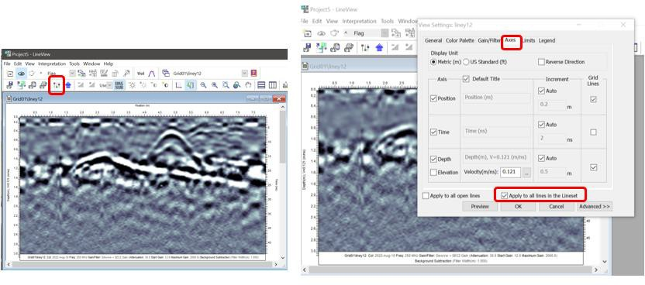
- Click the Hyperbola Velocity Calibration icon to leave Hyperbola Velocity Calibration mode. A menu will appear asking if you want to save your newly calibrated velocity.
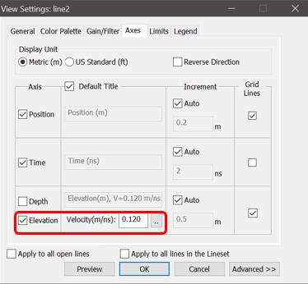
- If you have significant elevation changes over the course of a line, you may want to apply a topography correction. In the same Modify Settings window under the Axes tab, check the Elevation box.

Exporting your Data
From 3D animations to maps, EKKO Project offers many ways to visualize your data.
- Once you have calibrated a more accurate velocity for your data, save your profile as an image using any of the tools at the top left of the screen. You can:
  - Save your image as a .png, .jpg, etc. to your computer using the floppy disc icon.
  - Save the current window to your project profile in EKKO Project
  - Copy the profile image to your clipboard
  - Print the current image
- Exit LineView using the large Exit button in the top left corner. Don’t worry, you didn’t close the program! This will return you to the Project Explorer
- If your data includes a grid, select the grid, and click on the SliceView button. After some processing time, the SliceView window will appear and a new .gfp file will have been created.
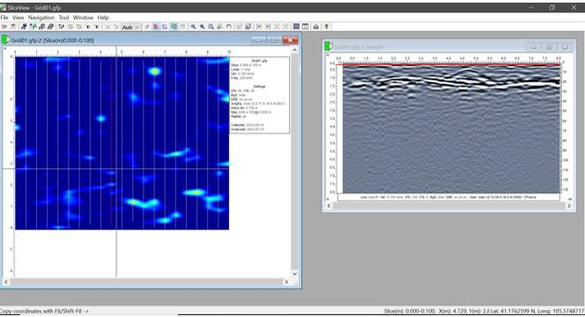
- To look at different slices and lines, move your mouse over the grid, yellow crosshairs will follow. If you click, it will pull up the nearest GPR line, which appears as a red line on the depth slide. The red line on the GPR profile shows the depth of the slice shown. Similarly, if you click on the profile it will pull up the corresponding depth slice.
- You can use the Menu Bar to move through the depth slices and adjust the contrast.
- Make a gif of the depth slices. Close up SliceView, go back to EKKO Project, select the MapView window. From the main menu at top, select View/Export Animation, select Depth, speed of choice.
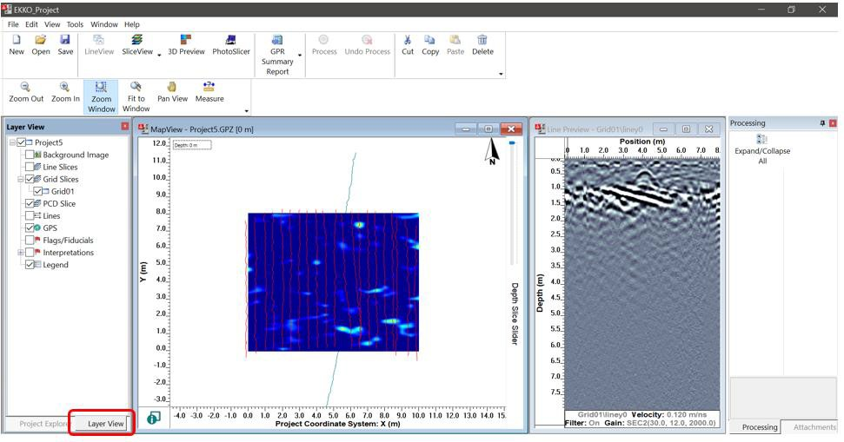
  - You can select what you want to appear in the gif by opening Layer View, which is a window that toggles with the Project Explorer window.
- To save your current slice as a .kmz file, go to the SliceView dropdown menu and select SliceView-Lines. Here, double check that your calibrated velocity will be used to process the data, make sure the level of gain is being used, and change the color palette of the slices if needed.
- Check the Export Data box and toggle the Google Earth (KMZ) radio button.
- When you are ready, select Process.
You can now open Google Earth Pro on your computer and open the .kmz file of your data from within Google Earth. The geolocated path and depth slices will appear in the location they were taken in Google Earth!

