GPR Unit 3: GPR Survey Guide
Sarah Kruse (University of South Florida), Kitri Spencer (EarthScope Consortium)
This document provides a guide to preparing for and conducting GPR surveys. It includes:
- Recommended supplies
- Selecting a survey type
- Things to do before the main data acquisition
- Doing a Line Survey
- Doing a Grid Survey
- Data Acquisition Tips

Introduction
Almost ready to begin your GPR survey with your students? This document will outline all of the supplies you need, how to select the right survey type for your needs, how to set up your desired survey, and what tips may make your survey proceed smoothly.

1. Recommended supplies
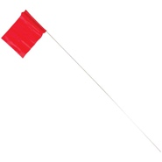
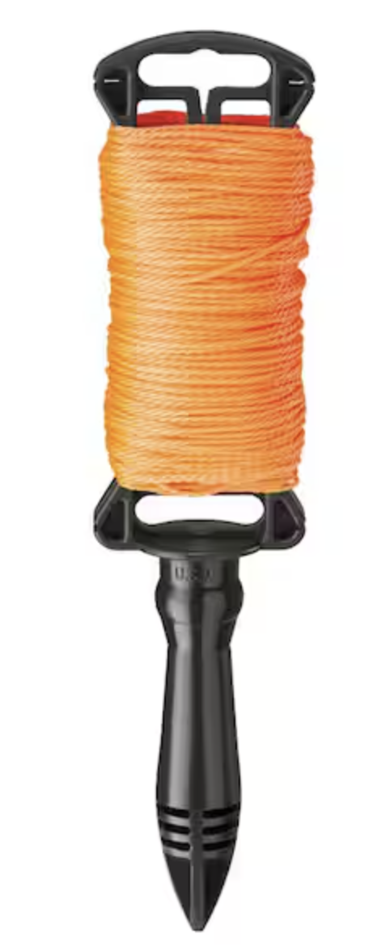
In addition to your GPR Unit and cart setup, here are other items you will need to set up your survey:
- >8 GB USB Drive
- 2 100-m survey tapes
- 8 plastic markers or flags
  - For example, Vinyl Marking Flags (https://www.amleo.com/plastic-staff-marking-flags-glo-red/p/45P-1R )
  - Alternatively, plastic tent stakes that are high visibility will also work
- Roll of string, preferably neon-colored or high visibility
  - For example, 250 ft. Nylon Orange Line (https://www.amleo.com/plastic-staff-marking-flags-glo-red/p/45P-1R)

2. Selecting a survey type
Depending on the type of subsurface feature you are looking for, the time you have with your students, and the space available, there may be a survey type best suited for your needs. The two primary survey types are:
- Line Surveys
- Grid Surveys

Line Survey
If you want to be extra careful about the location of your line survey, you may want to set up a line using high-visibility string and a measuring tape.

When to Use
- When you want to do an exploratory survey (scanning)
- When you have a large area to survey
- When you are limited on time to survey

When Not to Use
- When you want to make 2D depth slices
- When you have limited maneuverability
- When you want resolved 3D images of the subsurface
- Don’t do a line survey parallel to a linear target

Grid Survey
The grid survey is considered the traditional method of GPR surveying. You may use the Noggin GPR System to acquire your survey grid, or you may set up a grid using high-visibility string and a measuring tape.

When to Use
- When you want to do a more detailed survey
- When you want to create 2D depth slices or 3D images of the subsurface
- When you have more time to survey
- When you need to detect smaller targets

When Not to Use
- When you have a large area to survey
- When you are limited on time to survey
- When you have rough ground

3. Things to do before the main data acquisition

Charge the battery
The GPR Kit from EarthScope should include a grey battery pack shaped like a small suitcase and an adapter to charge that battery pack. The battery pack powers the GPR antenna, Display Video Logger (DVL), GPS unit, etc., so be sure to charge it indoors at least one night prior to the survey date.
- See the Noggin GPR Operation Guide from Sensors and Software for additional information.

Check the weather and your soil suitability
Soil type and moisture will affect how deep you can see with GPR. If you are in soils with very limited depth of penetration, it’s better to try in dry conditions. On a wet day you will see stronger returns from layers in the ground, but you will likely not see as deeply.
- Check your soil suitability using the USDA Ground-Penetrating Radar Soil Suitability maps. If your soils are not suitable for GPR (the GPR signal does not penetrate deeply enough), you can probably still use GPR to find buried pipes or tree roots and could definitely use it to find rebar in concrete or joists in floors, but you may not be able to do deeper soil surveys.

Consider your site
If you pick up nice but shallow hyperbolas (< 1 m) with the 250 MHz antennas during your test survey you may want to re-survey those features with 500 MHz antennas as the hyperbolas may be a bit clearer and you will see more of any other shallow features. Then you can choose the optimal frequency to run with students if you have limited class time. It takes a bit of time to change antennas.
If you want to use the GPS unit, be sure your site is relatively clear of heavy tree cover or tall buildings. These obstructions can interfere with the GPS function. While using the GPS unit is optional, combining your GPR data with GPS can be advantageous when processing your data after the survey, if precise location information would be helpful to your study. For the highest precision location information, you can also set up a GPS base station over a known point so that the rover GPS unit on the GPR can receive location corrections from the base station (see more about GPS surveys: https://serc.carleton.edu/getsi/teaching_materials/high-precision/index.html)
- Tip: Your campus facilities may have maps that outline locations of pipes and other subsurface features. You can reference these maps to select a site and give your students a clear objective with the GPR Survey.
- Tip: Before you head out to a distant field site, you may want to test the GPR instrument closer to home (ex. Line Survey steps 1-6). Also make sure that you GPS rover on the GPR is getting fix (if you have a base station as well).

Test your Site
It is worth doing a preliminary survey before you go out with students. Run some profiles across the area of interest and mark with physical flags in real time the approximate locations of features. It is not worth setting up and acquiring a grid of GPR data unless you know you will find some buried targets.
We recommend starting with the 250 MHz antenna because it will see deeper than 500 or 1000 MHz but has higher resolution than 100 MHz. Set the time window to 30 ns and depth to 2 m to start with. Or estimate a velocity, based on what you know about the substrate. Velocities in soils and bedrock are usually 0.07-0.14 m/ns. The radar wave velocity is lower when the water content is higher.
Move the gain level to a higher value if you are not seeing any returns after the direct wave. Make sure you are seeing the whole time (depth) window on the screen. Zoom out on the Noggin screen if needed.
For tree roots, try going in a rough circle around the tree. Put in a marking flag in the ground at any locations where you see distinct upside-down U’s. You can back up the cart and it will show you where you are, and you can try to match the top of the U. It will collect data again going forward. Do a circle with a larger radius to see if you can map roots as they radiate away from the tree. (Note the GPS may not work when you are under the tree canopy, but if you can track roots further out you can record good positions.)
For buried pipes, you can survey parallel to a wall on the outside of a building. Or go in a circle around a light pole.

Determining Site Suitability
If you can make sense of the pattern of the major hyperbolas in your data after you test your site, you can return to the site with students where you know they can get results.
What would your data look like if the GPR signal does not penetrate the ground even to shallow pipes? It might look like the boxed data in Figure 1. You can see that there is a horizontal banding that appears when there are no reflected waves returning to the receiver antenna. This is “system noise”. If an initial scan of your site reveals only system noise, select another site with clearer returns for your students.
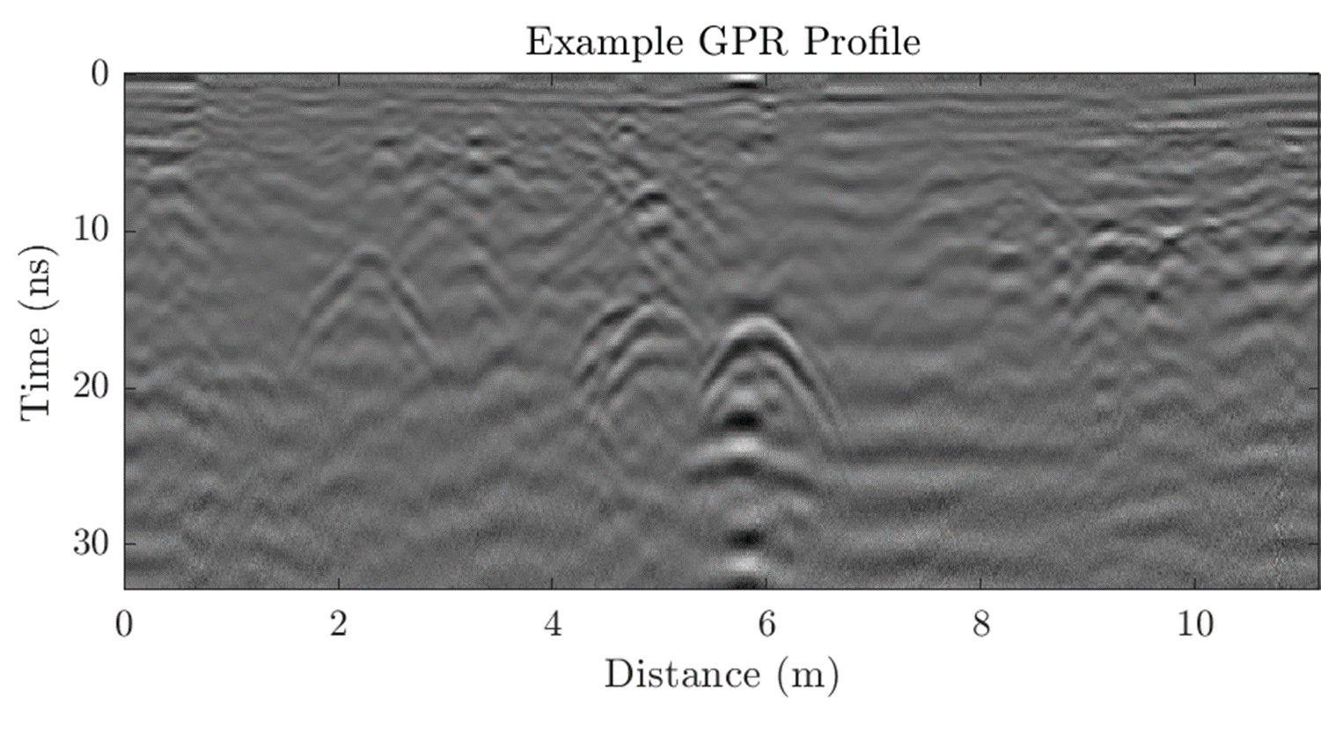
Figure 1: Example GPR Profile with clear returns and system noise.

Optional: Set up your Grid ahead of time
If you are collecting data on a grid, it can take some time to set out the square grid. If you are time-limited and want the students to focus on the data acquisition, you may want to set up the grid yourself ahead of time. Refer to the How to: Grid Survey section of this document for additional information.
- Tip: It helps to have at least two people to set up the grid.

Optional: Calibrate your Odometer Wheel
If you want to calibrate the odometer wheel, you will need to lay out a survey tape or measuring tape for 10 or 20 m and stake the tape down. Calibrating the odometer wheel is not essential – if the wheel moves slightly differently over your surface than expected for the calibration, then your distances will be slightly off, and your velocity and depth calculations will be slightly off, but probably not significantly.

4. Doing a Line Survey

Using the Noggin GPR System
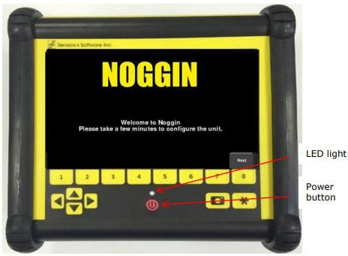  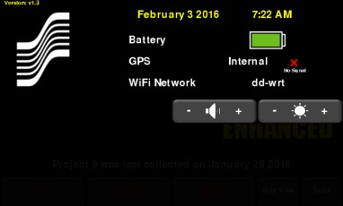 | Step 1  Turn on the Digital Video Logger (DVL) and adjust the brightness as needed.  You can swipe down from the top of the screen toward the bottom to see a menu that lets you check the battery level, change the sound level, and change the screen brightness.
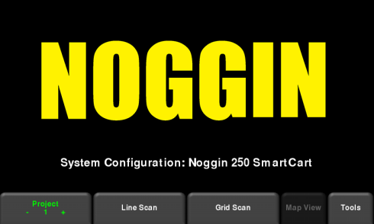  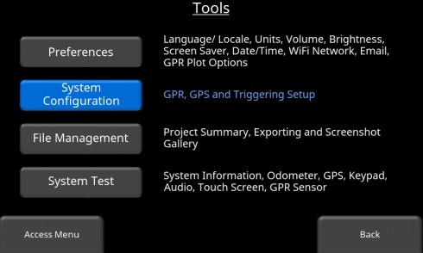 | Step 2  Set the GPS Settings. From the main menu, select  - Tools  - System Configuration  - GPS  In the GPS window, set the following:  - GPS Mode = External  - Topcon or Trimble brand GPS  - Baud Rate = 19200  - Serial Port Power = On  - Emlid brand GPS  - Baud Rate = 9600  - Serial Port Power = Off  If the system is outside, a small green LED on the GPS indicates that the system can be seen by the GPS satellites and is ready to use.  Tip: The data will be easiest to process if you choose Universal Transverse Mercator (UTM) map projection to map your data.
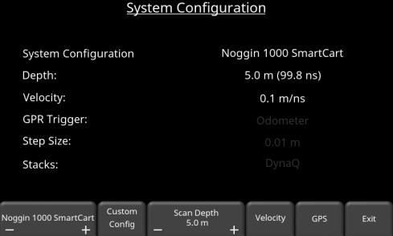 | Step 3  Return to the System Configuration menu and set the System Configuration parameters for your profile.  System Configuration= Noggin Smart Cart  Velocity – set to value expected for your environment. If not sure, choose 0.1 m/ns.  Depth - With your velocity guess, now set the depth to about twice the depth of the deepest target you hope to find. (For buried pipes or tree roots, set to ~4 m.)  Important note – if you zoom in on the depth while collecting data, it will only export data to that depth rather than the one set here.  GPR Trigger = Odometer  Step Size – use the default value recommended for your antenna frequency  Stacks – set to DynaQ
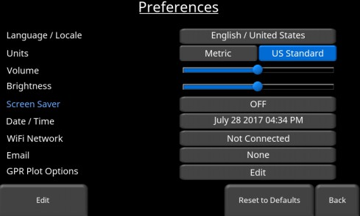 | Step 4  Return to the Main Menu, choose the Preferences Menu and change the Preferences as needed.  Tip: You do not need to enter a Wifi network or email.

Step 5
Go back up to the main menu and set a Project number for your work with the button in the lower left.
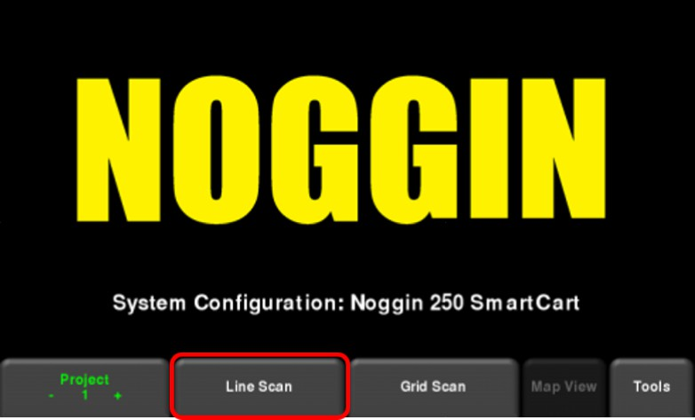 | Step 6  Select Line Scan.  This is the end of the testing process. Now you are ready to collect real data.
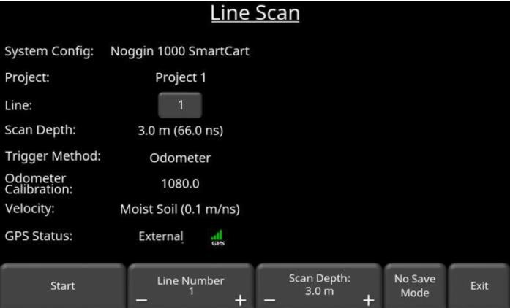 | Step 7  Set your Line Number, make sure GPS status is green.

Step 8
Press Start to start your line scan.
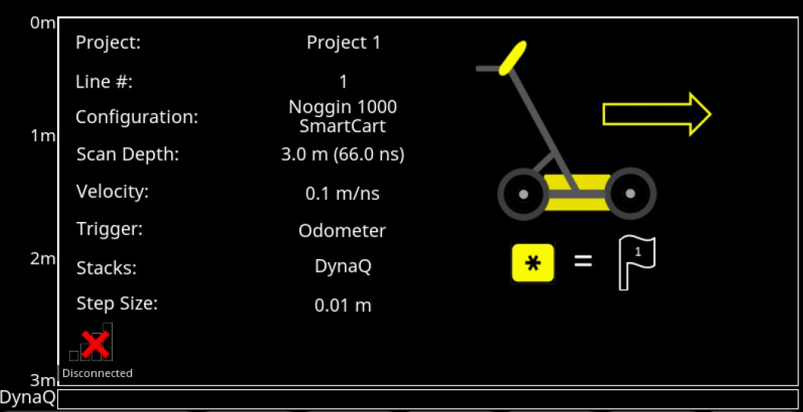  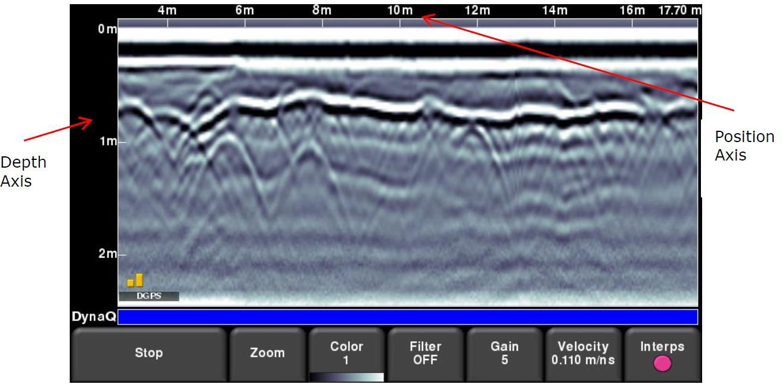 | Step 9  At the beginning of your line scan, you will see an initial screen with your System Configuration settings and a depiction of the SmartCart with a forward arrow.  Once you start walking forward with the cart, the data will scroll in from the right of the screen
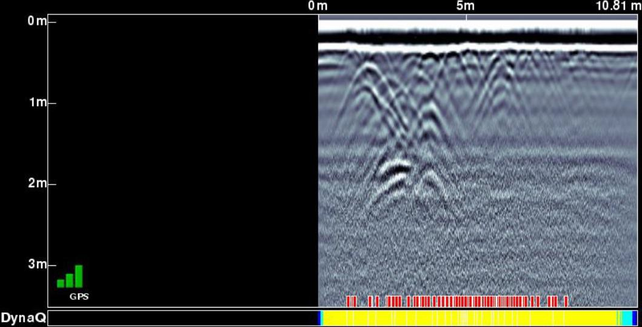 | Step 10  Check the color of the DynaQ bar below the data.  The bar will be dark blue if you are walking at the right speed.  If the bar turns light blue, you are walking too fast.  If the bar turns yellow or white, you are walking too fast for proper data collection. Slow your pace with the cart if this happens  Tip: Red bars will appear above the DynaQ menu to indicate where data could not be collected (skipped traces) due to fast pacing.
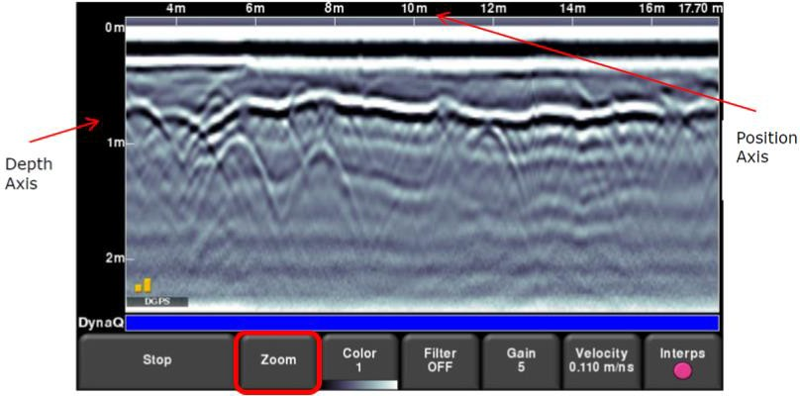  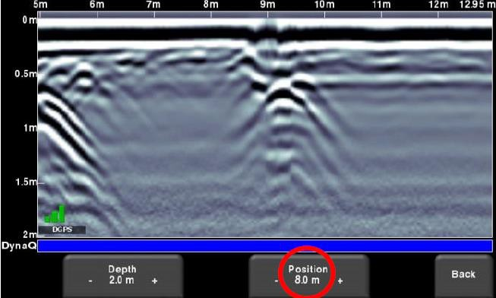 | Step 11  Adjust the Zoom on your data as needed.  Set the Position to 8 m or more to display that length across the window and make it easier to see lateral variations in your profile. The whole line will be saved and can be viewed later.  Tip: Do not hit the Stop button! That will end your line prematurely.
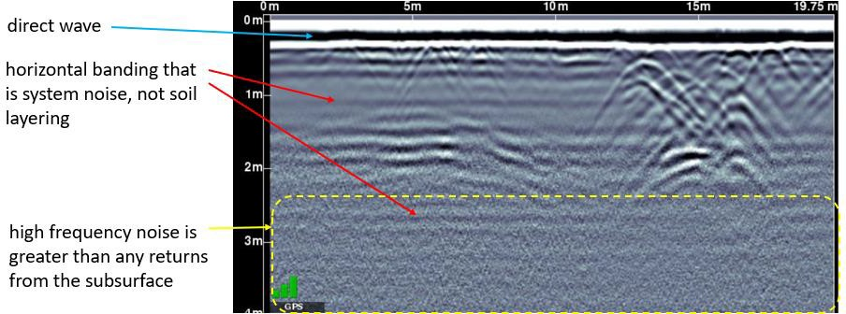 | Step 12  If you are only seeing noise at lower depths, you may want to reduce the Depth to the range in which you are acquiring meaningful returns. Reminder: whatever your zoom Depth is set to, only Data to that depth will be exported.  You may not see the system noise as shown in the example above if your Gain is set to a low value. The following figure discusses the Gain.
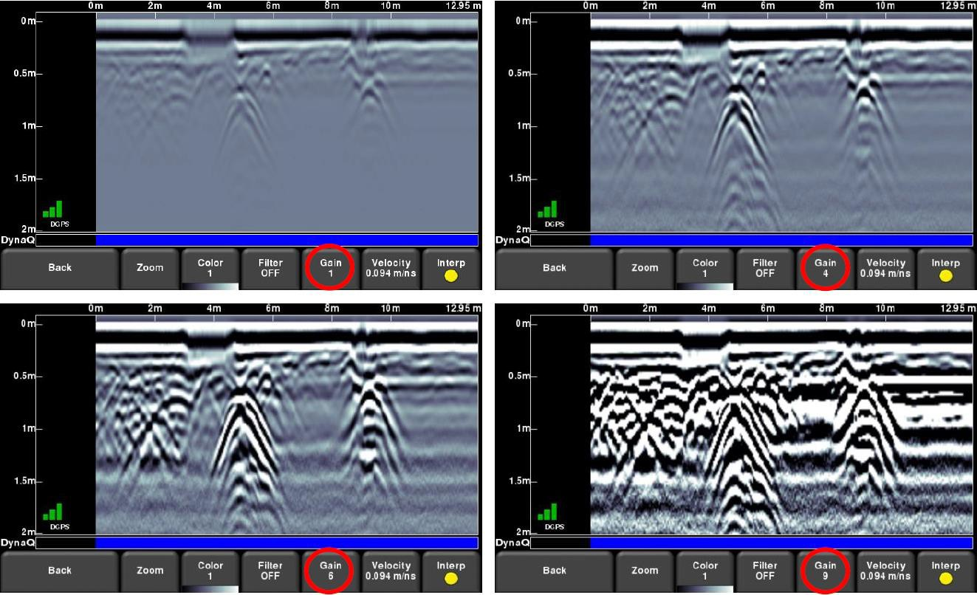 | Step 13  Change the Gain as needed to see your data more clearly. This is just an amplification factor for plotting and will not change the actual data.
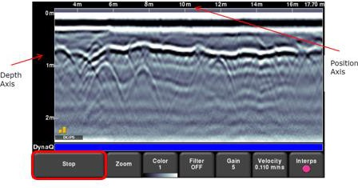 | Step 14  When you are finished with your line, press the Stop button.
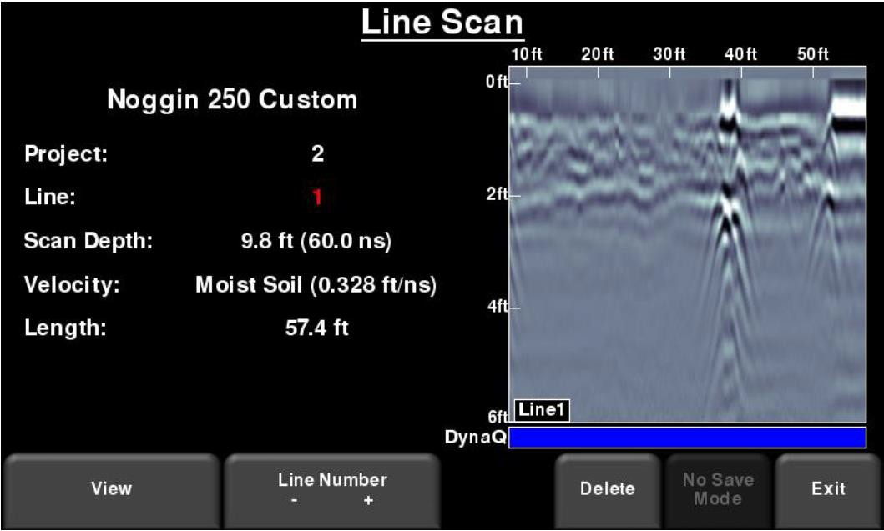 | Step 15  You can review your whole line after finishing. In the Line Scan menu, select the number of the line you have collected, and View.
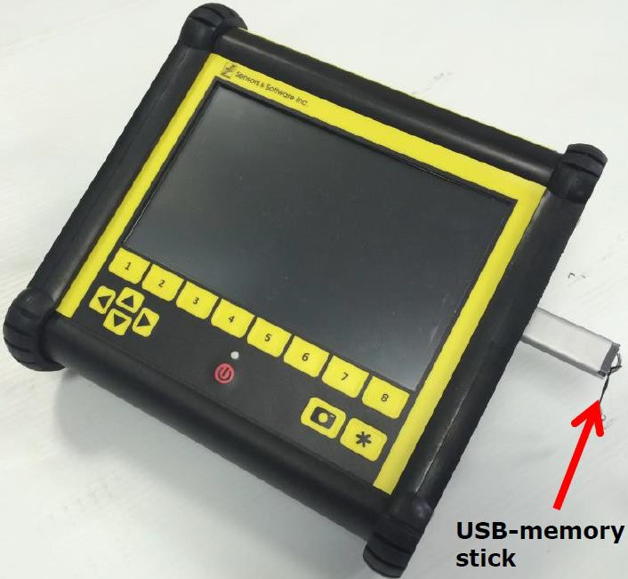  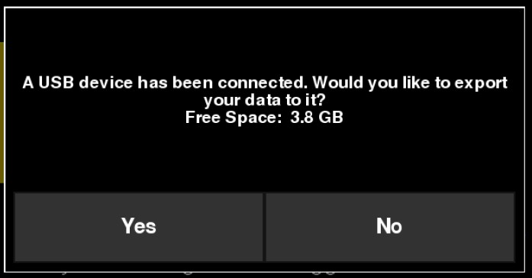 | Step 16  Export your data. With the DVL turned on, insert a USB drive into the port on the DVL.  If you do not see a window stating that “A USB device has been connected,” it means that your USB drive has an issue. Try reformatting the drive or using another drive

Using string as a guide for a Line Survey
- Cut string sections at your desired length, or you can use the measuring tape as a guide to line up your cart
- Stretch your guide string or measuring tape alongside the cart in the X-direction a few cm from the cart, but close enough that the person pushing the cart can try to maintain a uniform distance between the cart and the guide string.
- Push the cart following the guide string.

5. Doing a Grid Survey

Using the Noggin GPR System
Taken from the Noggin GPR Operation Guide from Sensors and Software who manufactures the GPR carts used by the EPIC. Please see the Guide for more details.

Step 1
From the main menu, ensure you are in the desired project then press the Grid Scan button to enter the Grid setup menu.
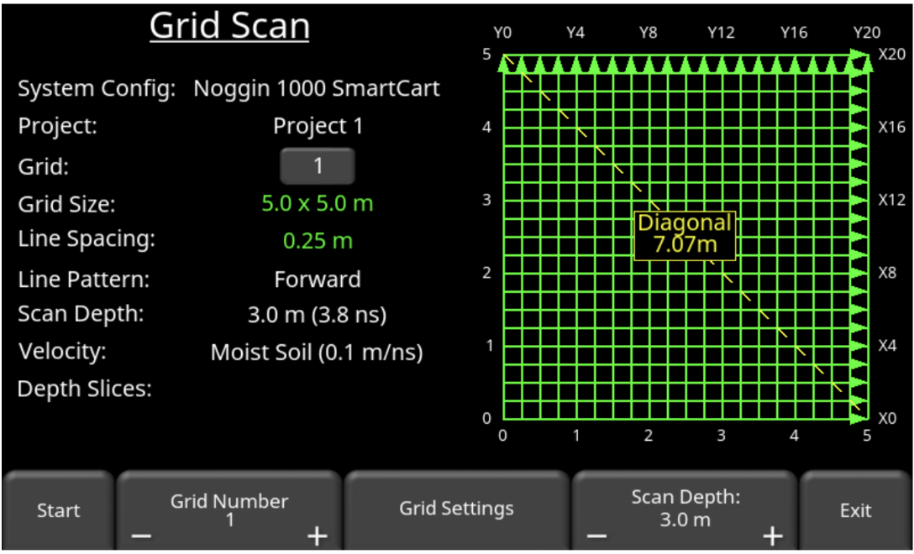 | Step 2  The grid scan setup screen will allow you to set parameters of the grid, before data acquisition begins. Information about the grid is displayed on the left side of the screen, including whether the depth slices are processed. The right side of the screen shows an image of the grid setup and lines to be collected, including direction. It also shows the diagonal or hypotenuse measurement of a right-angle triangle; this is valuable when you are measuring out your grid.
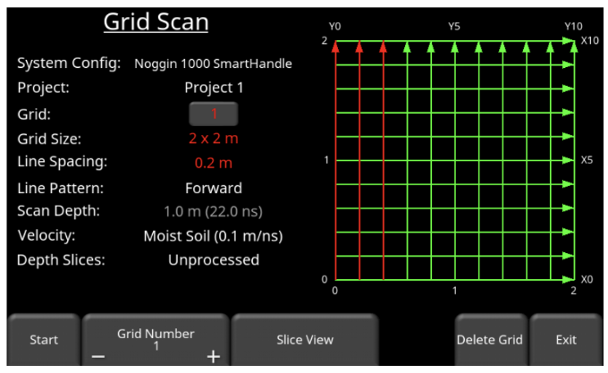 | Step 3  Select a grid number and Grid Size by pressing the + and - buttons under Grid Number at the bottom of the screen. Grids that contain no data will have some text and grid lines shown in green, whereas grids containing data will have the text and grid lines shown in red.

Step 4
Set the Scan Depth by pressing the + and – buttons to set how deep the scan should be.
Tip: the deeper you go, the more depth slices will be generated in SliceView mode. If a minimum of 3 lines are collected, the SliceView option will be enabled. You can press Slice View to create depth slices for the gridded area.
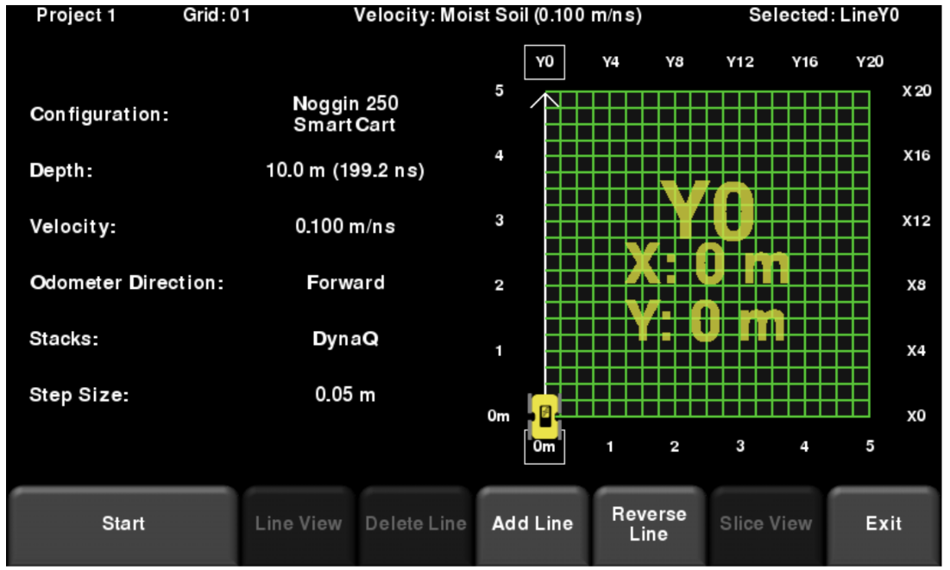 | Step 5  Press Start when all the parameters are setup and data collection is ready to begin. Push the system in a straight line towards the end of the line. Your current position (or distance travelled) is displayed in real time immediately below the DynaQ status bar.  If Grid Line Stop is set to Auto, the system will automatically stop acquisition once that distance has been covered. If it is set to Manual, you will have to manually press End Line when you are done.
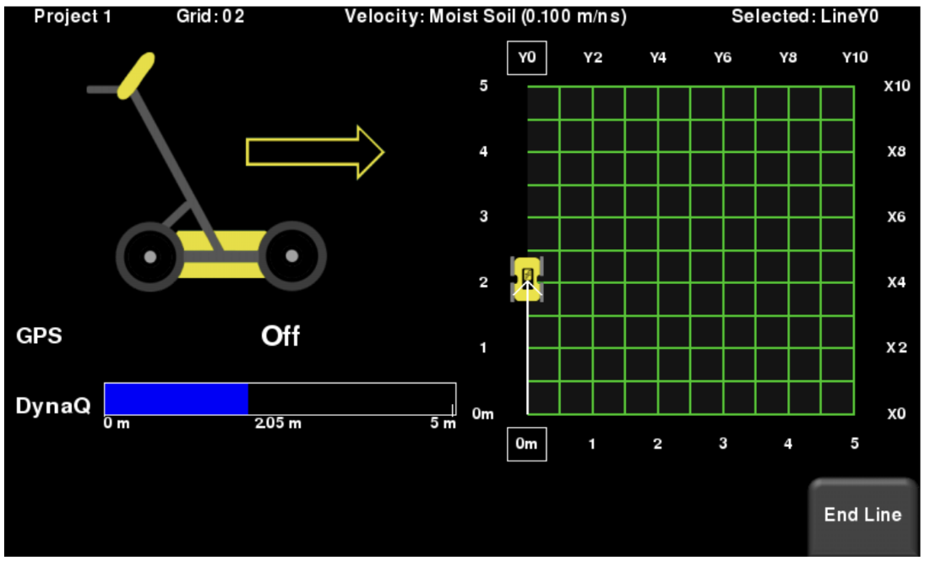 | Step 6  As you are collecting a line, you must move in a forward direction. If you back up more than two step sizes during collection, it will stop and make you re-collect that line.
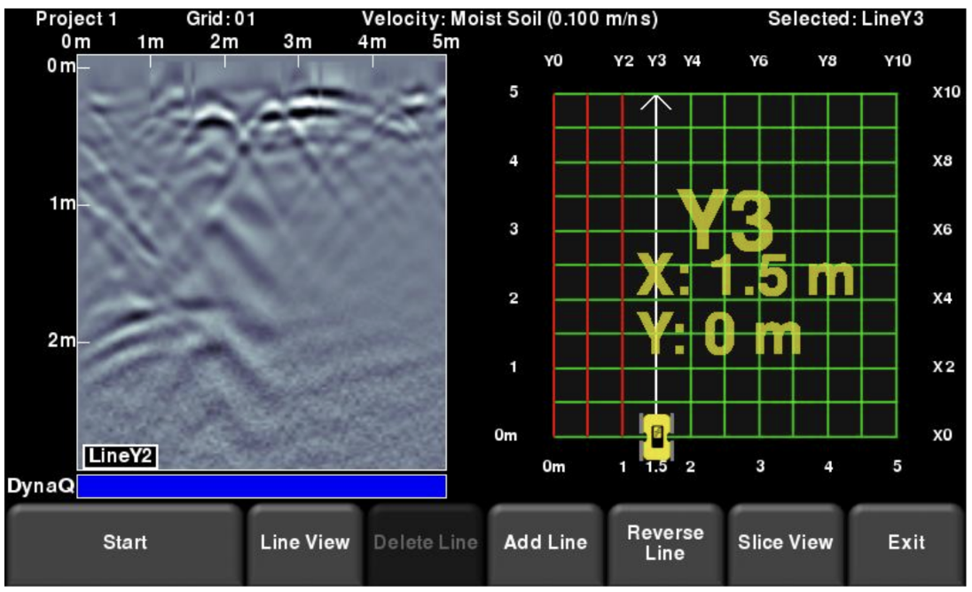 | Step 7  Once data is collected, the Grid Line will turn red and the system will beep twice. The current line will now advance to the next one and is shown in white. The remaining lines to be collected are shown in green.
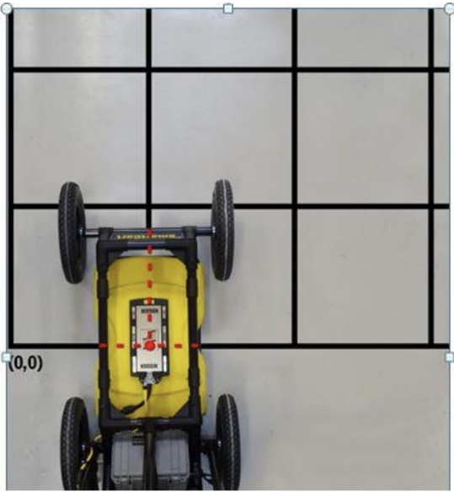 | Step 8  Move to the start of the next line and repeat the process. The grid image will always display the line number (e.g. Y3) and the position of your line, relative to your origin. Once all the lines are done in one direction, it will automatically prompt you to collect lines in the other direction.
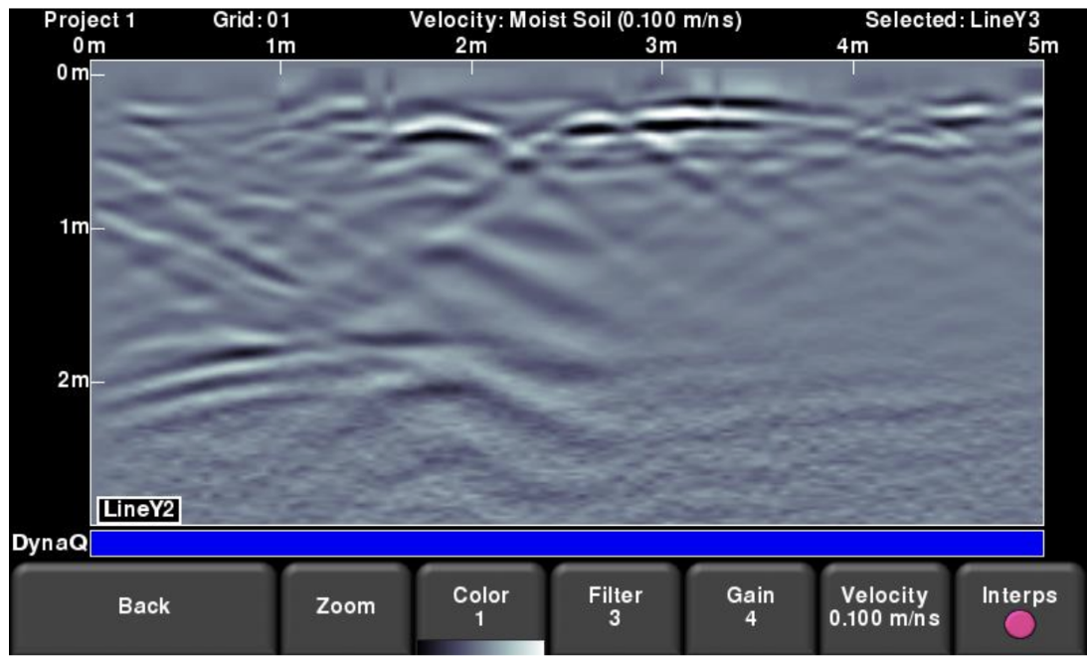  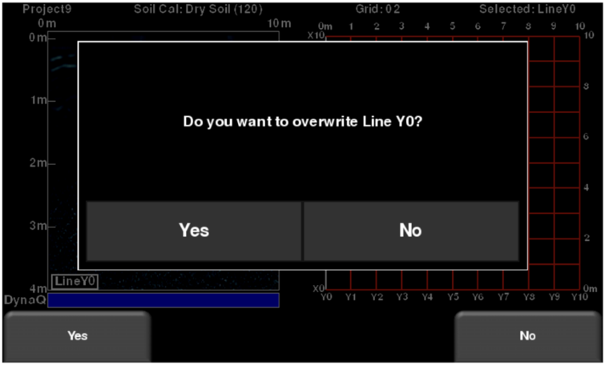 | Step 9  You may want to recollect a line if you make a mistake, or maybe just view a line. Use the 4-way directional keypad to highlight different X and Y lines. The selected line will always be in white. Collected lines will be in red and lines remaining to be collected will be in green.  To recollect a line, press Start. You will be prompted with a message asking if you want to overwrite that line. Press Yes to proceed.
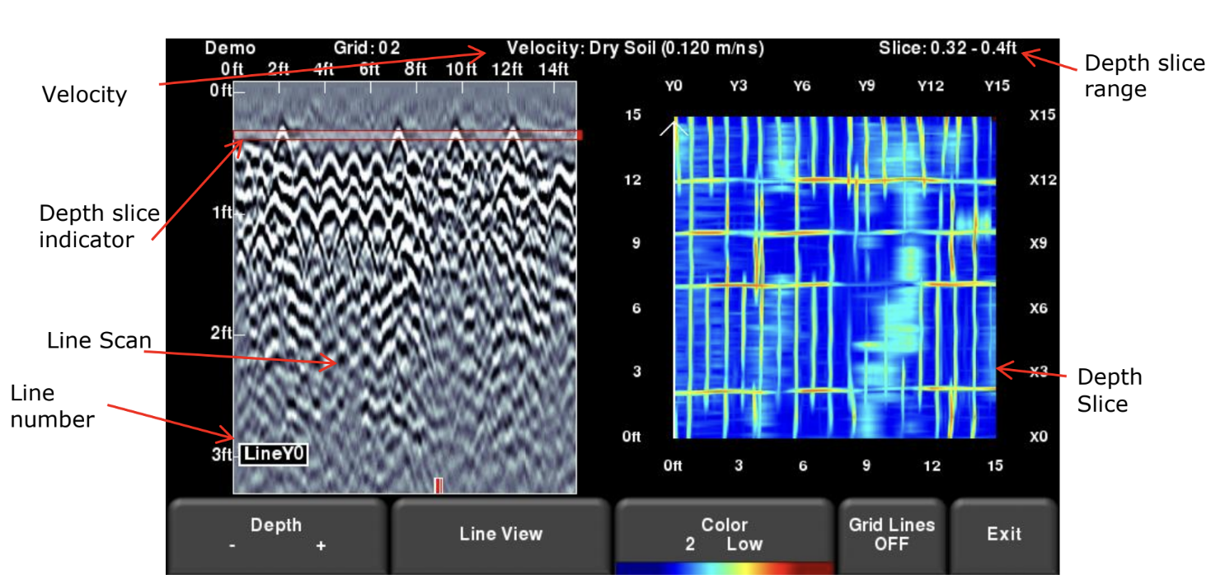 | Step 10  Once you have finished collecting all the grid lines, you may press Slice View at the bottom of the screen to view your depth slice.  Tip: Before the data is processed and depth slices created, you must ensure the velocity is accurate; this will result in the most accurate and sharpest images.

Designing a Grid Survey
Recommendations before acquiring a grid:
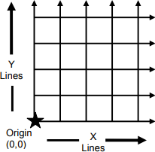
- Make sure you establish your origin as follows-

- The recommendations for maximum spacing between lines are
  - 250 MHz antennas: 0.5 m (2 ft)
  - 500 MHz antennas: 0.25 m (1 ft)
  - 1000 MHz antennas: 0.10 m (0.5 ft)
With these spacings between lines it’s better to collect smaller, more manageable grids. With 11 lines each direction, you can acquire a 5 m by 5 m grid with 250 MHz antennas.
- If you know the direction of pipes or other buried features, set up the grid so that X line
directions will cross the pipes perpendicularly, and you don’t need to collect lines in the Y direction. Adding additional length to lines in the X direction doesn’t cost much time.
- Time spent laying out the grid carefully and lining up the cart carefully at the start of lines will really pay off.
- Students can cycle in and out of pushing the cart and watching data acquisition, but it
really requires one person taking notes to keep checking that the positions on the ground match up with those shown on the screen.

Setup your Grid
See also the Grid Quick Guide at the end of the document.
- Determine the size and orientation of your grid. Measure and record the length and width of your allotted space. For best results, try to align the primary target with the grid layout so that it is parallel or perpendicular to grid lines. Make sure to leave enough space at the start and end of the lines for the cart to turn around.
- Choose a corner to be the grid origin. When choosing an origin, consider the GPR line directions within the grid and any possible collection issues, such as the angle of the sun at the survey time, slope, car or foot traffic if applicable.
- Mark the Origin. Secure the zero (0) mark on the tape measure to the origin using a spike or marker (plastic flag or plastic tent stakes can work well). You will be making a right triangle to form the basis for your grid.
- Measure and mark the base along the horizontal axis of your survey space. This will be distance A.
- Measure and mark the height of the triangle, distance B.
- Define your line spacing. Choose a spacing interval for your grid lines and mark the ground at each interval along the two axes you have currently defined. It can be helpful to make two kinds of marks for major and minor intervals.
- Flip the measuring tape over the long edge of the right triangle, leaving the origin and the distance B marker in place.
- Mark the fourth corner of the grid.
- Mark the major and minor intervals along the new axes created. Your grid will now be a full square or rectangle ready for survey.

Using string as a guide for a Grid Survey
If you cannot make marks on or drill stakes into the ground in the grid setup, you can make a guide string.
Using the neon-colored construction string:
- Cut string sections about 3 meters longer than your longest grid dimension.
- Tie the string ends around weights, these can be rocks or small barbells.
- Mark the four corners of the grid.
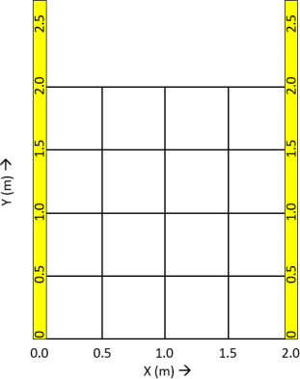
- Stake down two survey tapes along the Y-direction boundaries of the grid with their zeros where Y = 0. Use plastic non-metallic stakes. These tapes need to be firmly staked down on both ends, so they won’t move as the cart is pushed over them.

- Stake out the ends in the Y-direction at least 50 cm past the end of your grid.
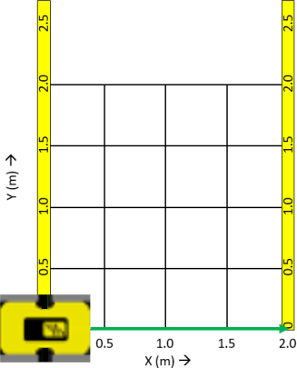
- Move the cart so the antennas are centered over the origin of the grid, ready to go in the X-direction.

- Stretch your guide string alongside the cart in the X-direction a few cm from the cart, but close enough that the person pushing the cart can try to maintain a uniform distance between the cart and the guide string. Then measure the offset distance in the Y direction between the Y = 0 line and the guide string.

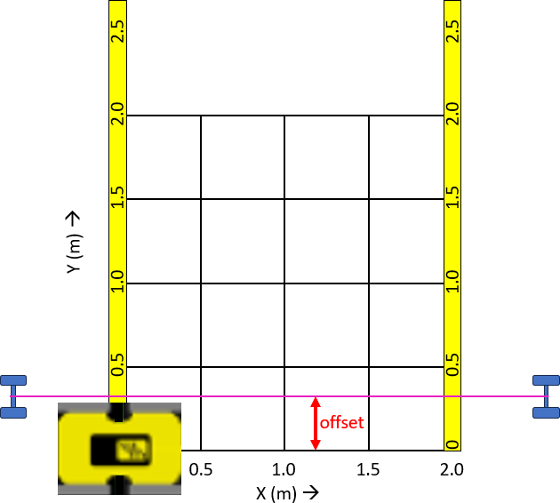
- Push the cart following the guide string, being careful to stop when the center of the antenna is aligned with the edge of the grid. (If you find that the distance along the GPR profile doesn’t match your grid size, you may need to recalibrate the odometer. See the Noggin User’s Guide.) Then move the string up to the position to guide the next line in the X direction.
- Move the cart up to start the next X-line and continue to survey lines along the X-direction until the X-axis of your grid is complete.
- Move the two measuring tapes so that they lie along the edges of the grid in the X-directions.
- Rotate the string similarly rotated to the other direction.
- Survey line-by-line in the Y-direction one at a time similar to the X-axis lines.

6. Data Acquisition Tips
- Make a sketch of the experiment in your field notebook, sketching locations and direction of each line. This may be especially important if you have to work under canopy and lose GPS positioning. It can also be useful to take screenshots during data acquisition showing maps, as you acquire. These will be included in the project export when you download the data.
- It’s really helpful to have the person taking field notes keep track of the line number used in the GPR software, the position along the tape, and the guide string location. The notetaker can call out string locations to people at each end of the line.
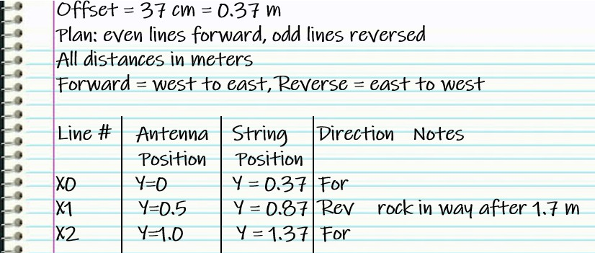
- After you are finished, if you have pounded-in stakes survey tapes and can’t get them out, hit them on the side to create a bigger hole and then pull them out.

