EarthScope Noggin GPR Packing and Assembly Guide
Sarah Kruse (University of South Florida)

Introduction
Assembly instructions are documented in the manual. The photographs here show unpacking and assembly instructions specifically for the EarthScope cart configuration. The photos can be used in reverse to repack the components. This photo shows assembly with a short version of the horizontal bar that holds the GPS, which made the GPS tilt slightly toward the rear of the cart. There is a separate longer bar that should be used with the 500 MHz antennas.

Components Overview
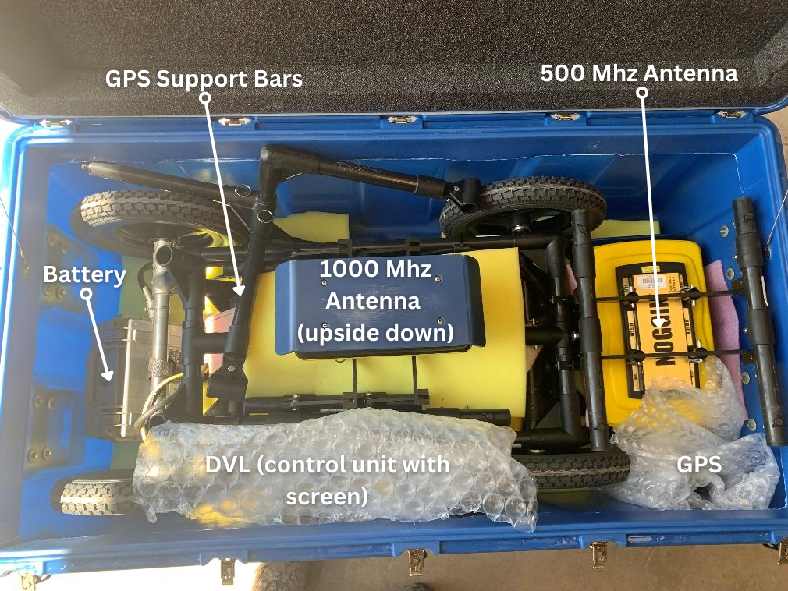 | Fully packed, all components labeled
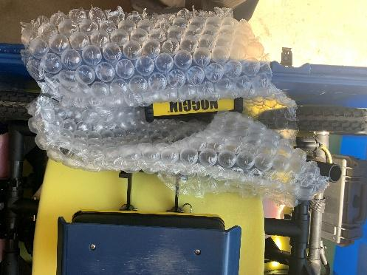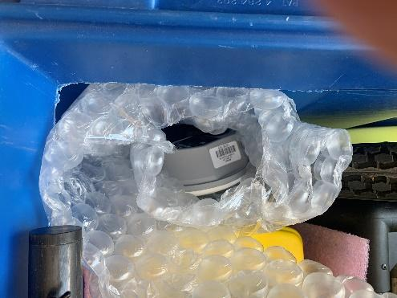 | DVL (digital video logger; i.e. “screen”) and GPS

Step 1: Unpacking
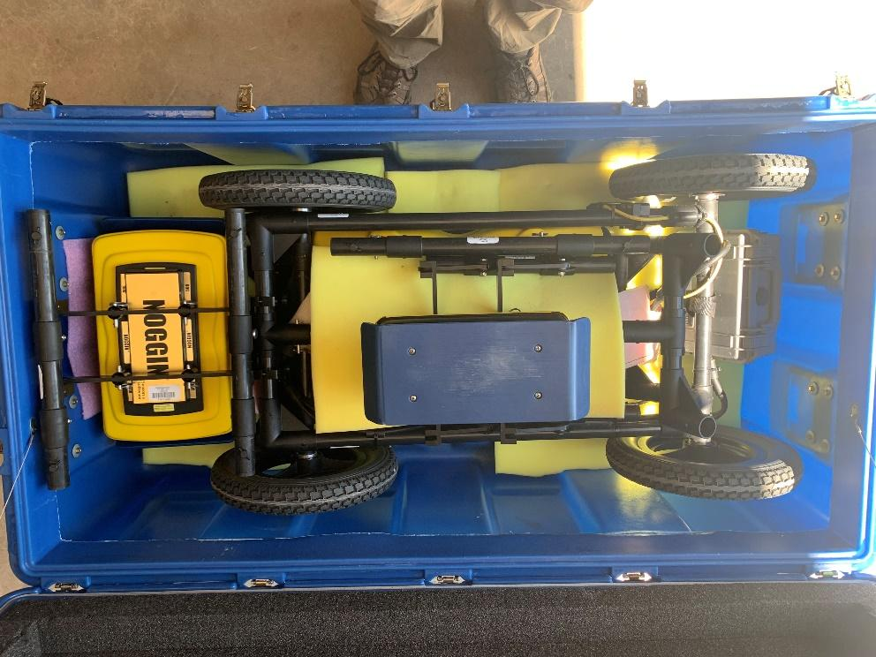 | - Remove DVL, GPS, and GPS support bars.
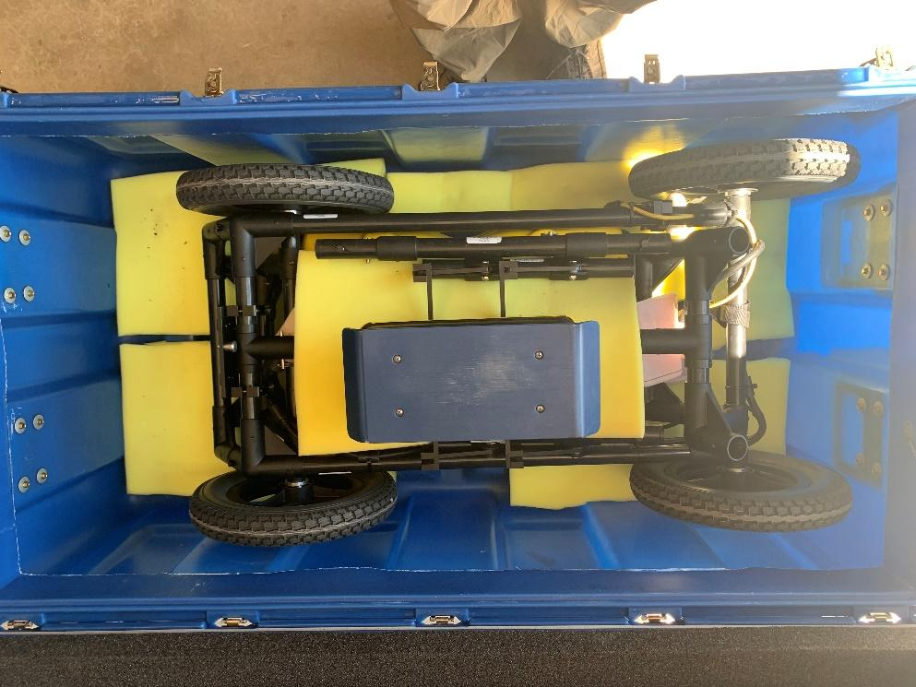 | - Remove battery and 500 MHz antenna
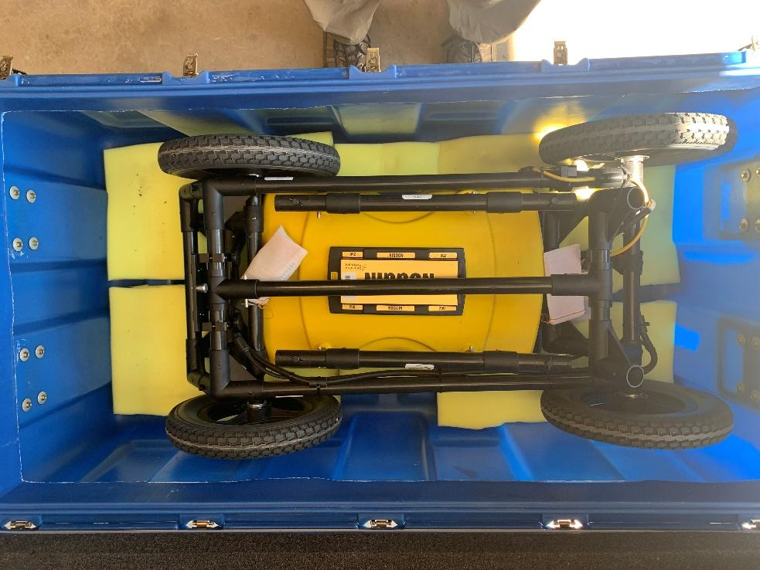 | - Remove 1000 MHz antenna. Pink bags are connector covers.
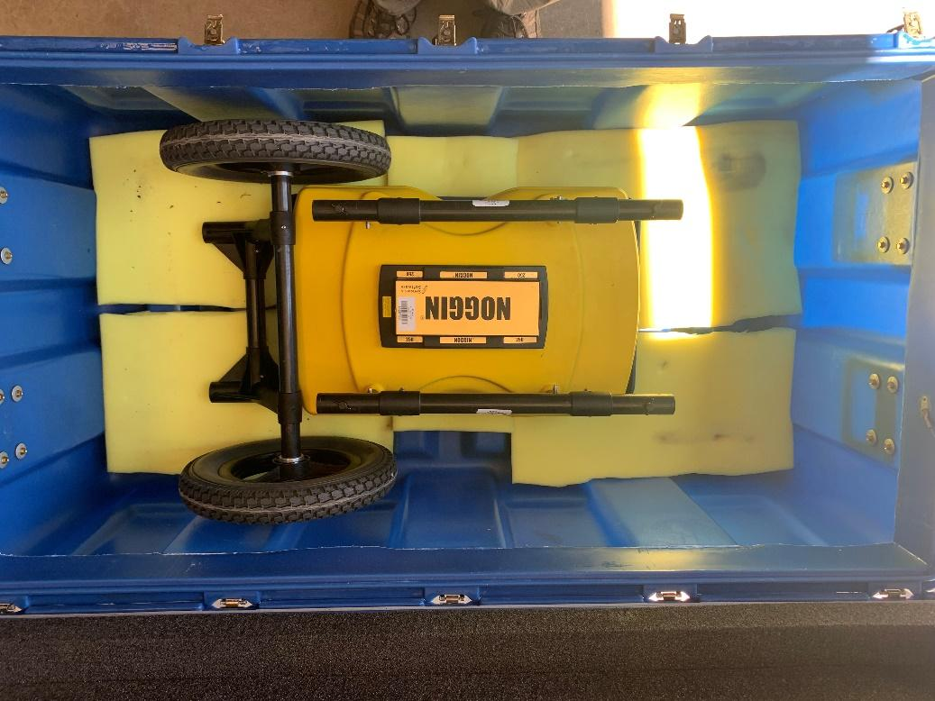 | - Remove back half of cart (which contains odometer). This leaves the cart front wheels and the 250 MHz antenna in the shipping box.
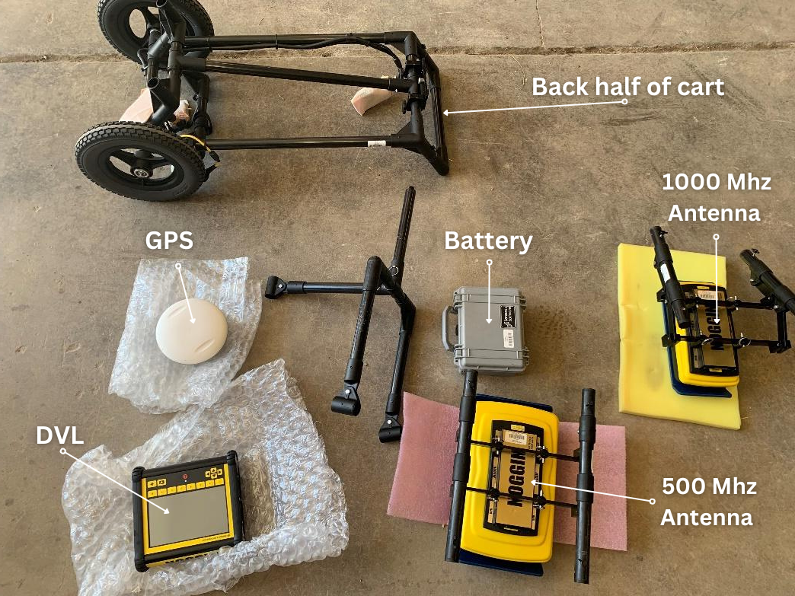 | Components that have been unpacked:  - back half of cart  - GPS  - GPS support bars  - Battery  - 1000 MHz antenna (smallest)  - DVL (control unit with screen)  - 500 MHz antenna (bigger)

Step 2: Assembling the Cart and Antenna
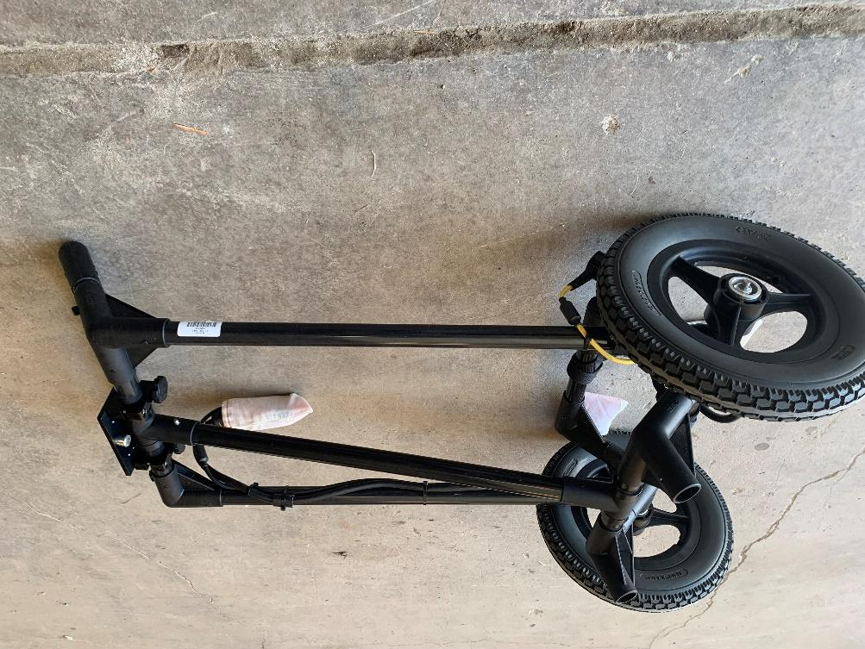 | - To assemble cart, start with the back half.
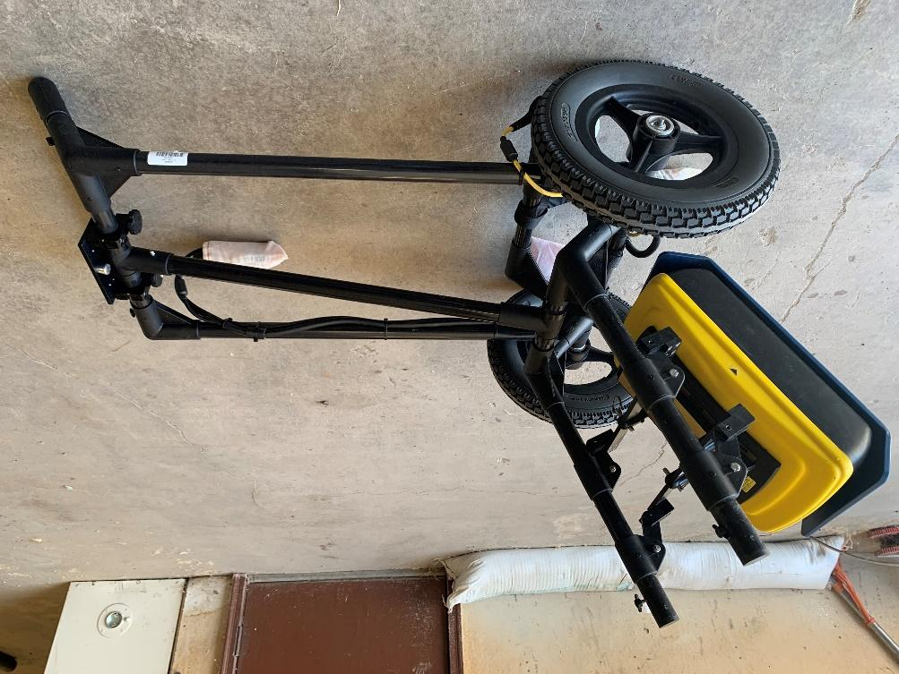  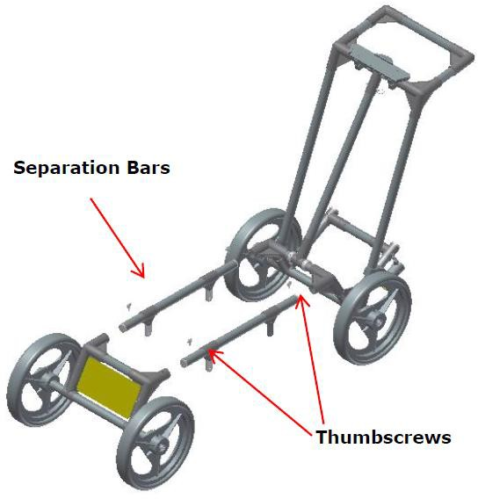 | - Attach antenna of choice (500 MHz shown here).  Note: When shipped from Earth Scope, the antennas will be attached to the separation bars. Be careful with the thumbscrews – they will stick after half a turn if they are not aligned properly. If they stick, back out and start over.
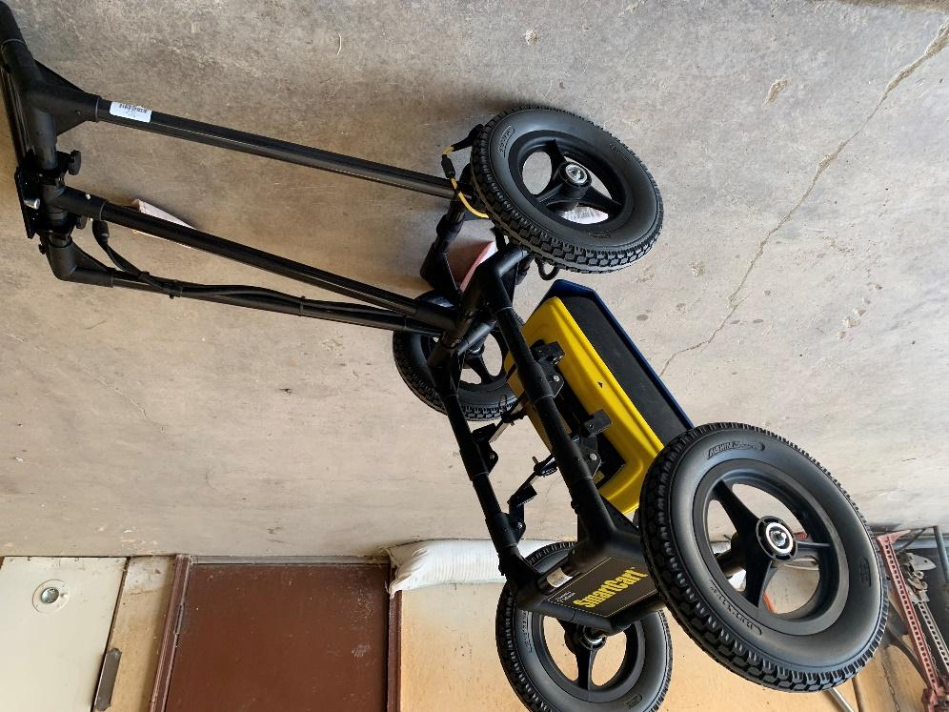 | - Attach front wheels.

Step 3: Attaching the DVL (Digital Video Logger)
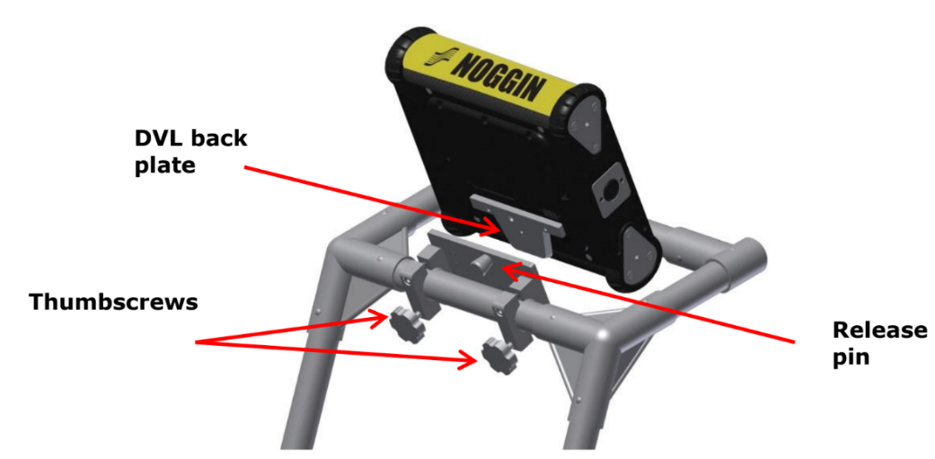 | - Align the back plate on the DVL with the mount near the cart handle.  - Slide the DVL onto the mount so that the sides of the mount catch on the DVL back plate.  - The release pin will snap into place when secure.  Tip: Wiggle the DVL to make sure it is firmly connected before letting go of the DVL unit.
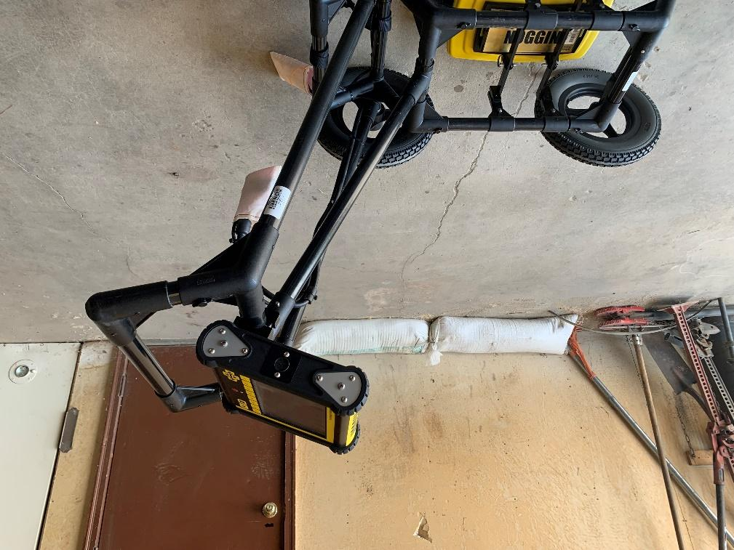 | - Pivot the DVL to adjust the view angle.  Tip: Adjust the thumbscrews on the bottom of the support shelf as needed to help with adjustment.

Step 4: Connecting the Antenna and DVL
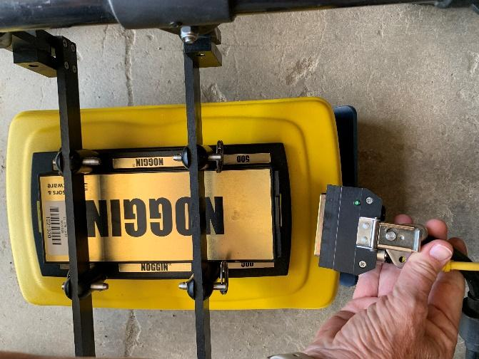 | - Gently connect the 37-pin Connector into the back of the antenna.  Tip: Be sure to connect gently and carefully!
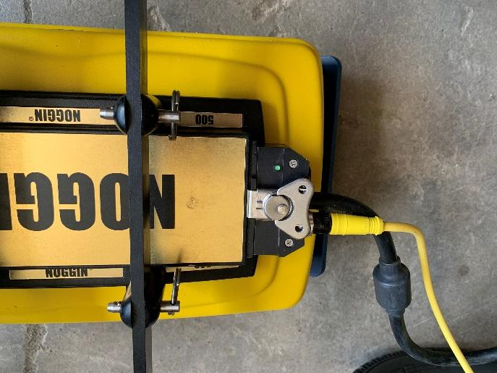 | - Once you are sure it is properly seated, then flip the latch.
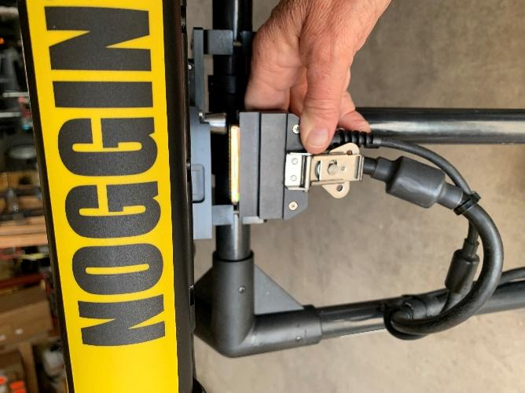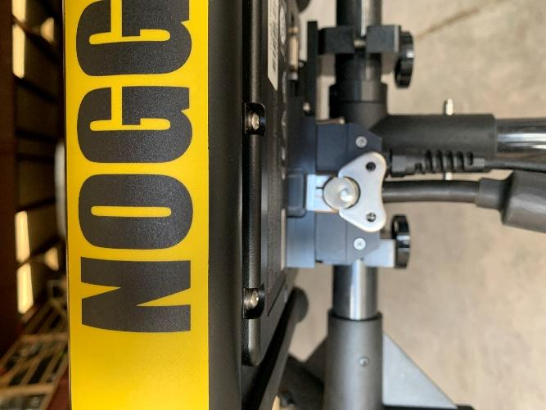 | - Squat underneath the DVL (screen) and gently connect to the cable coming off the top of the cart.  Tip: Don’t try to do this from above without looking at what you are doing.
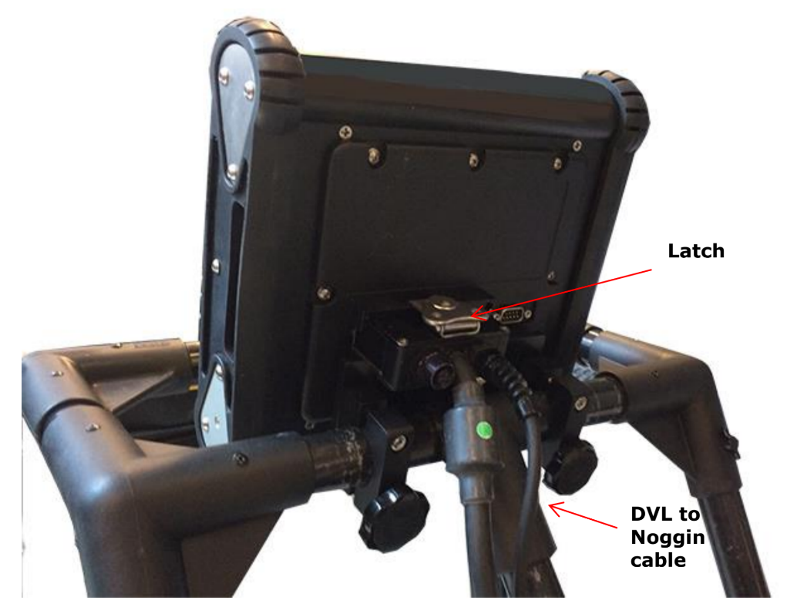 | - Secure the connector cable with the latch.  Tip: Don’t turn the latch until you are sure you have the connector seated properly.

Step 5: Attaching and Connecting the Battery
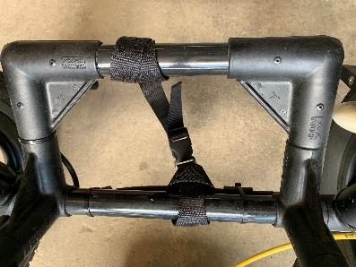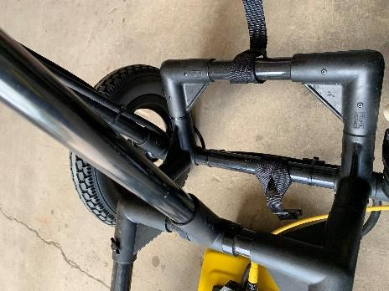 | - Unfasten the strap on the lower rear of the cart. placing battery as shown, and refastening the strap.
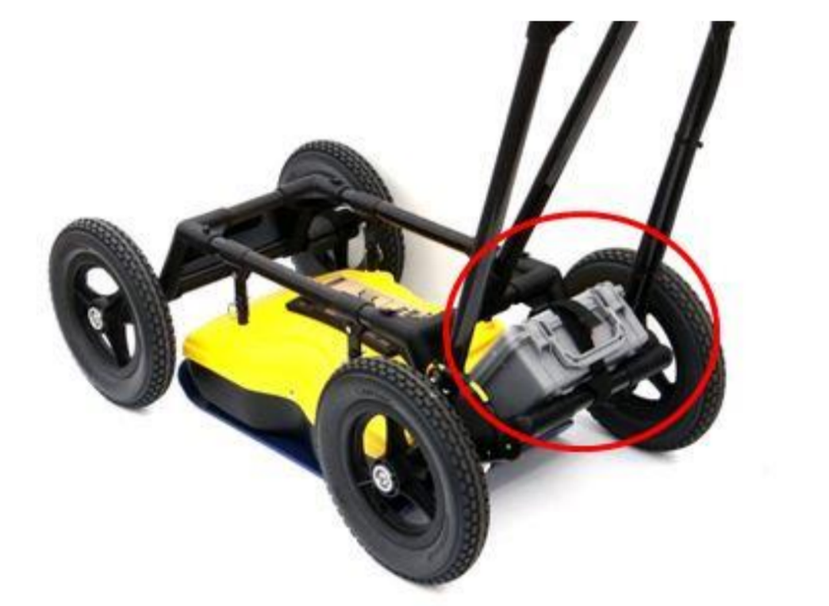 | - Place the battery onto the lower shelf on the back of the cart.  Tip: Make sure the handle on the battery pack is facing the back of the cart and that the battery is somewhat secure on its shelf.
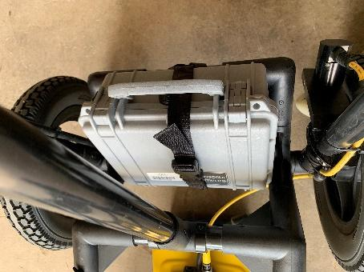 | - Refasten the strap around the battery pack
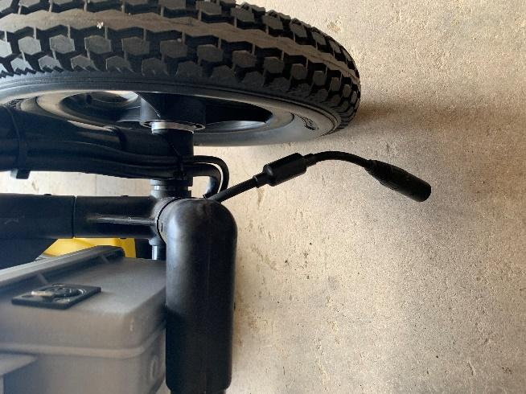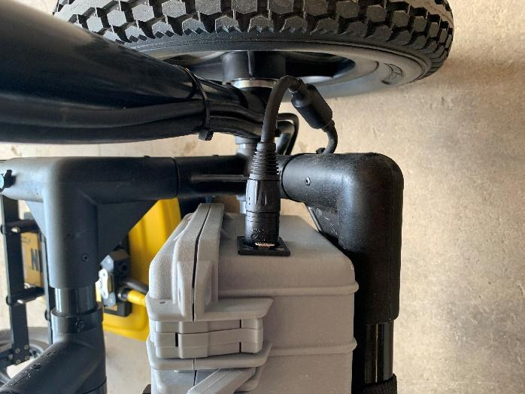 | - Connect the battery to the connector on the lower right on the cart.
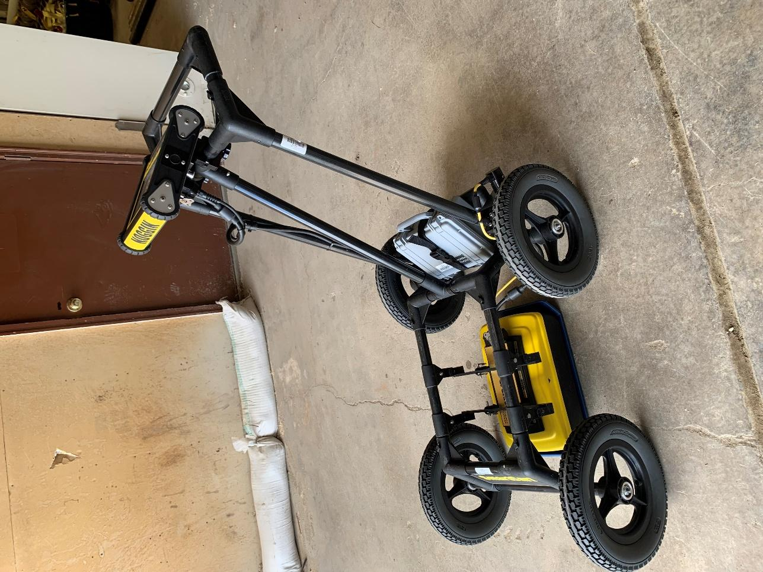 | Now everything is connected except the GPS.  Note: The GPS should be mounted above the mid-point of the antenna. The 500 and 250 MHz antennas have the same GPS post. If you are using a 100 or 1000 MHz antenna, you will be provided with a different post for those.

Step 6: Attaching and Connecting the GPS
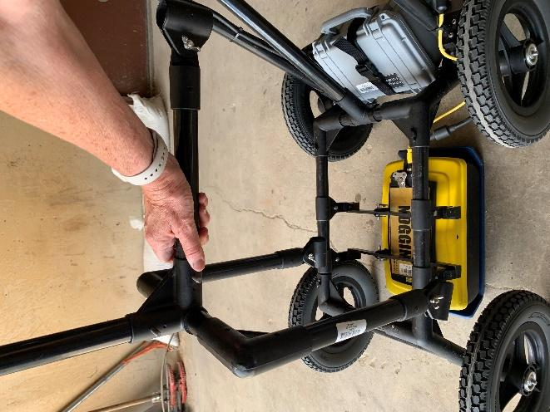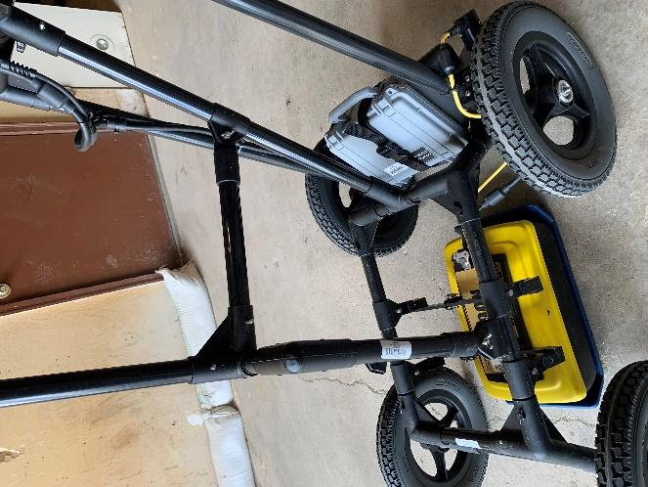 | - Open two tube clips and push them over the separation bars. Position the clips at the mid-point of the Noggin antenna.
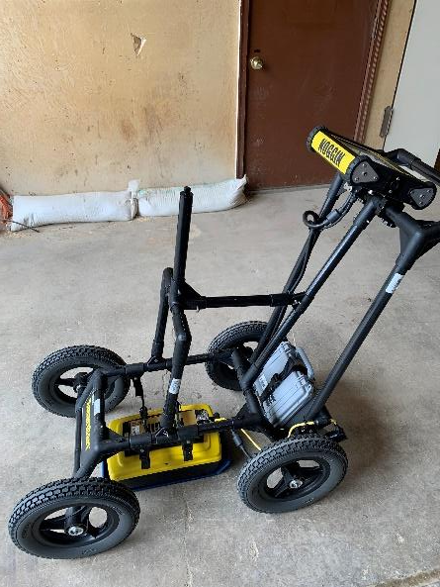 | - Use two screws with a lock washer and wing nut to fasten the U-shaped vertical support section onto the tube clips on the separation bars.  Tip: It helps to have two people for opening the wingnuts, getting all three connection points in position, and tightening the wingnuts.
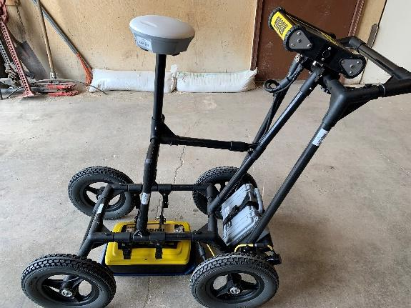 | - Carefully screw in the GPS on the vertical mounting post.  Note: some Noggins may have a GPS unit that looks a little different than the one in these pictures
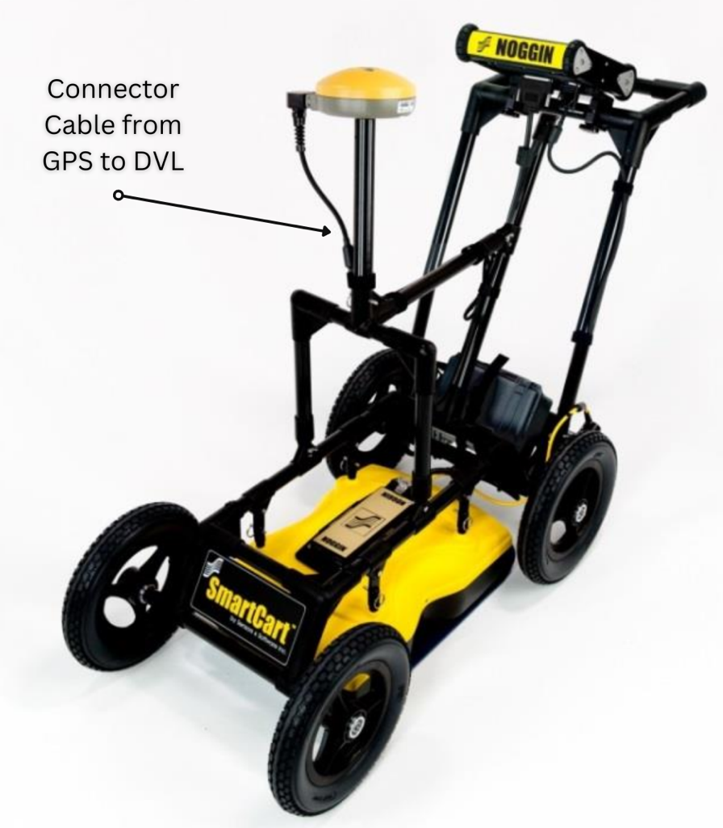 | - Connect your GPS to the DVL. The cable sends data to the DVL. If your GPS is Emlid brand, you will need to charge the GPS unit separately. With other brands, the GPS may be powered by the cable.  Tip: Make sure the DVL is powered down when connecting or disconnecting the GPS cable.
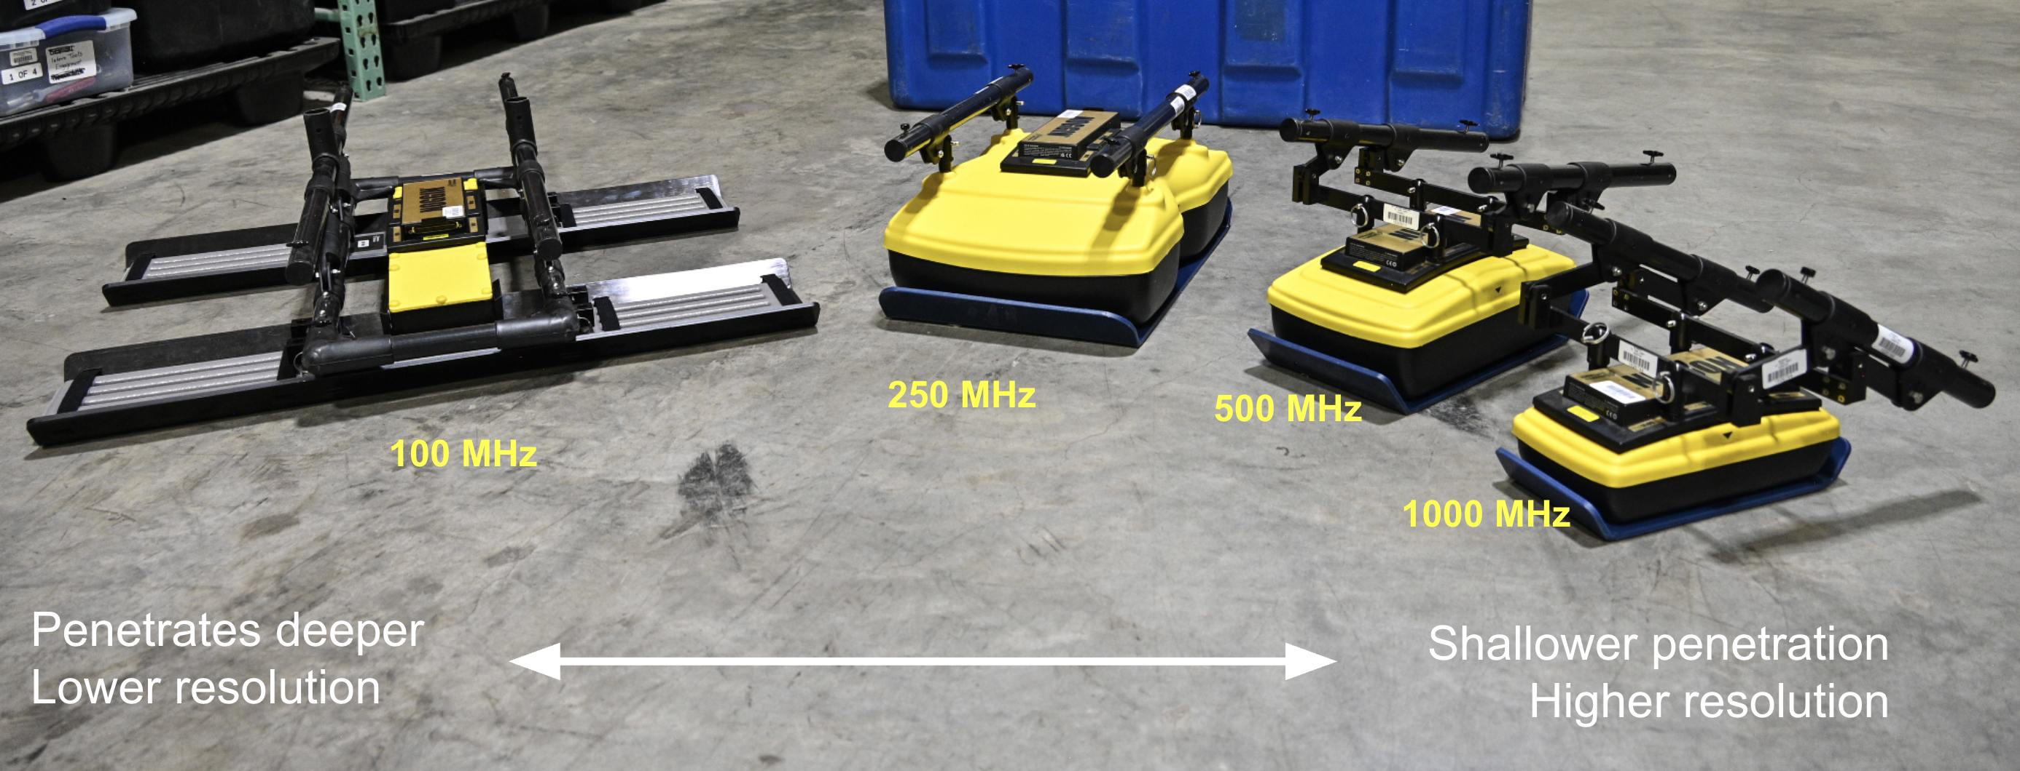 | What the four different GPR antenna look like. They can all be fit to the Noggin SmartCart.

Step 7: Disassembling
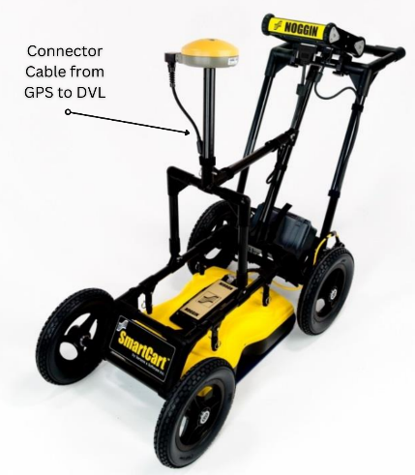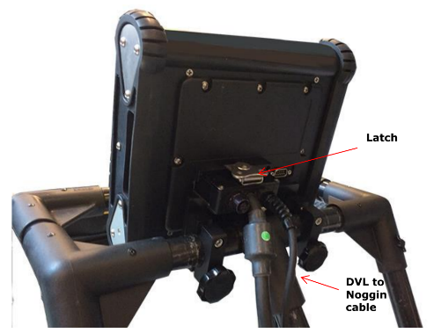 | - Power down and unplug all powered parts.  - Disconnect GPS from DVL.  - The DVL from the 37-pin connector cable.  - The battery from the battery connector.  - The antenna from the 37-pin connector cable.  Be particularly gentle with the 37-pin connectors.
- Unscrew the GPS unit from the supports.

Tip: set the GPS unit (along with the DVL, battery pack and cables) to the side in a safe place, but don’t put them back in the box just yet. There is a specific packing sequence we will outline below.
 | - Remove the DVL.
 | - Release the strap and remove the battery pack.
- Detach GPS Vertical Support system
- Release the quick release pin and remove the top mounting post.
- Unpin the horizontal support bar from the vertical support section.
- Unscrew the tube clips beneath the U-shaped vertical support section and remove it from the clips.
- Remove the tube clips from the separation bars.
- Disassemble the cart
- Remove the front wheels.
- Unscrew and detach the separation bars from the back half of the cart.

Tip: keep the antenna attached to the separation bars

Step 8: Packing Up
- Insert the 250 MHz antenna and the cart front wheels in the shipping box.
- Insert the 1000 MHz and the back half of the cart into the shipping box.
- Pack the battery pack on one edge of the shipping box. Pack the 500 MHz antenna on the other side of the box.
- Pack the GPS support bars towards the back of the shipping box, overlapping the 1000 Mhz antenna.
- Rewrap the DVL and pack it below the 1000 MHz towards the front of the box.
- Rewrap the GPS unit and pack it below the 500 MHz antenna towards the front of the box.

With that, all components should be packed in the shipping box!

