SNOTEL station:
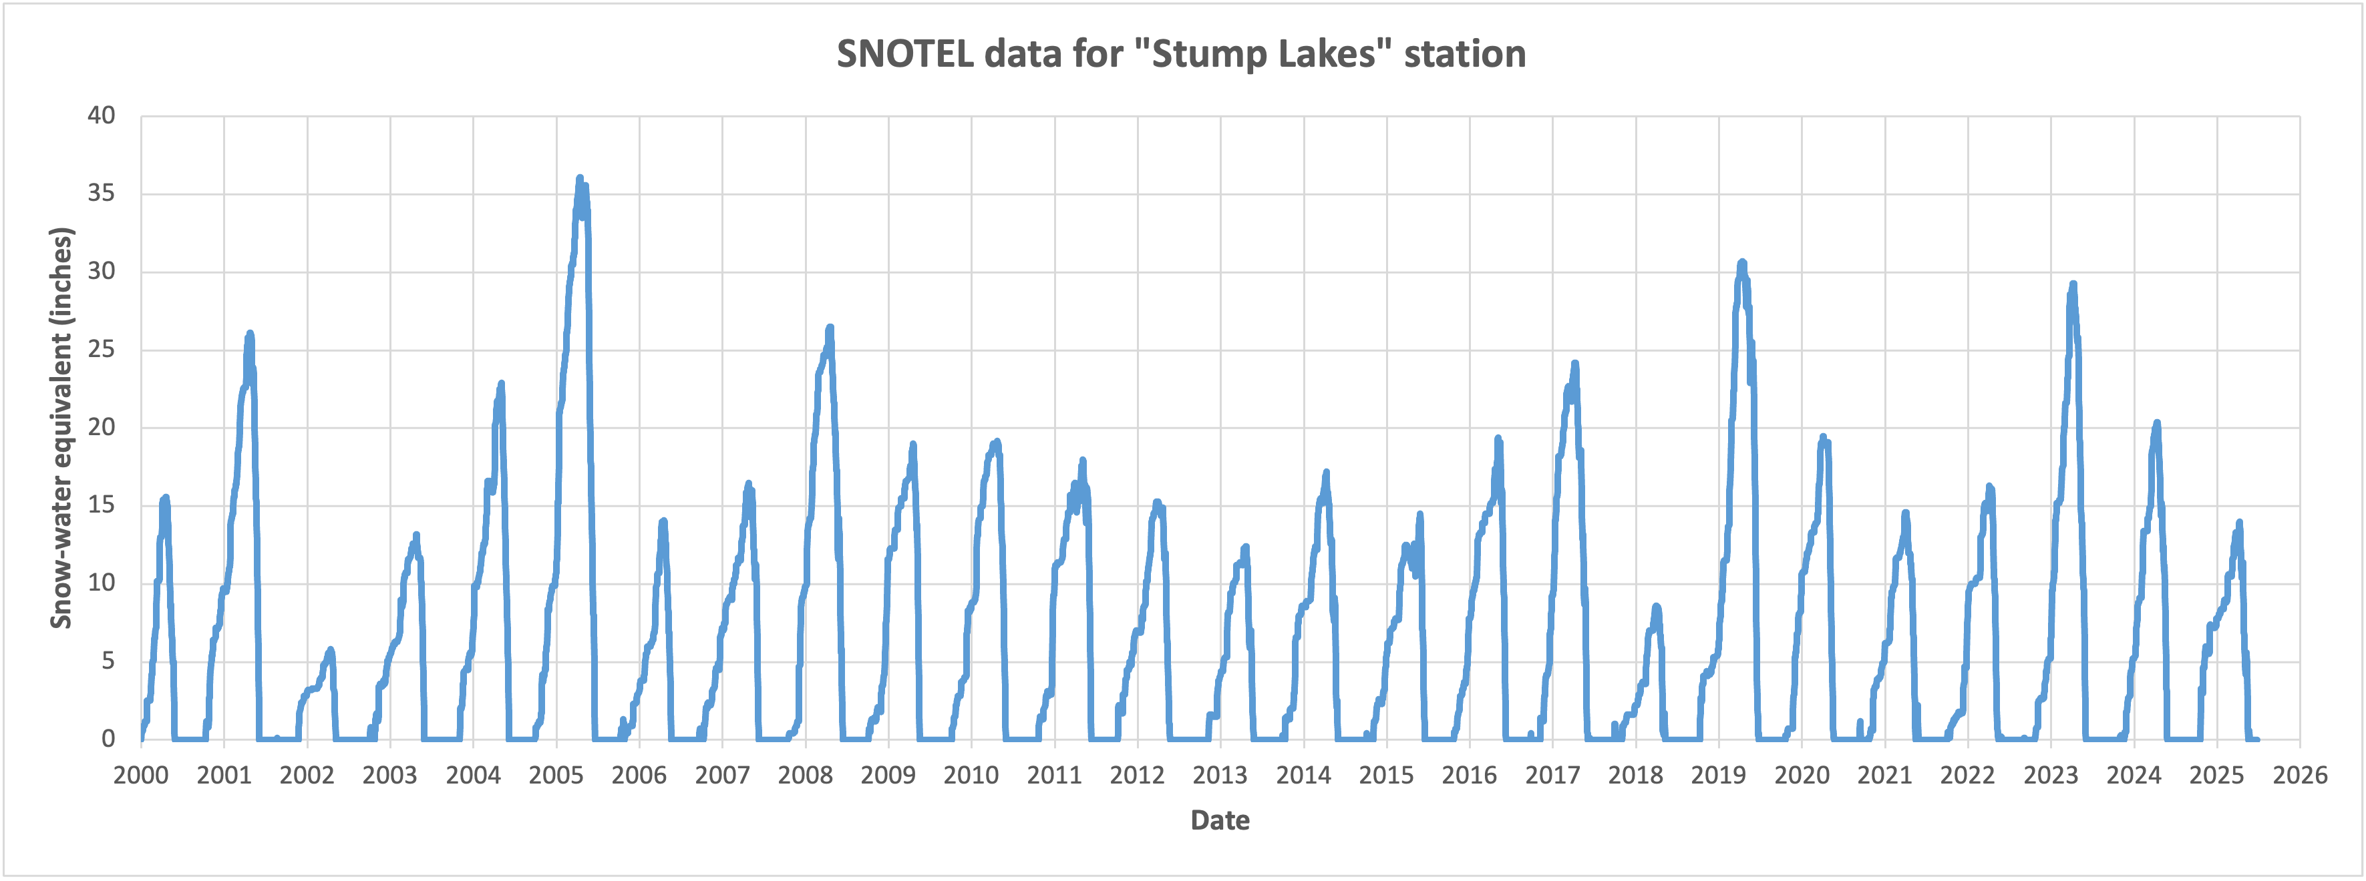
Reflection GPS data:
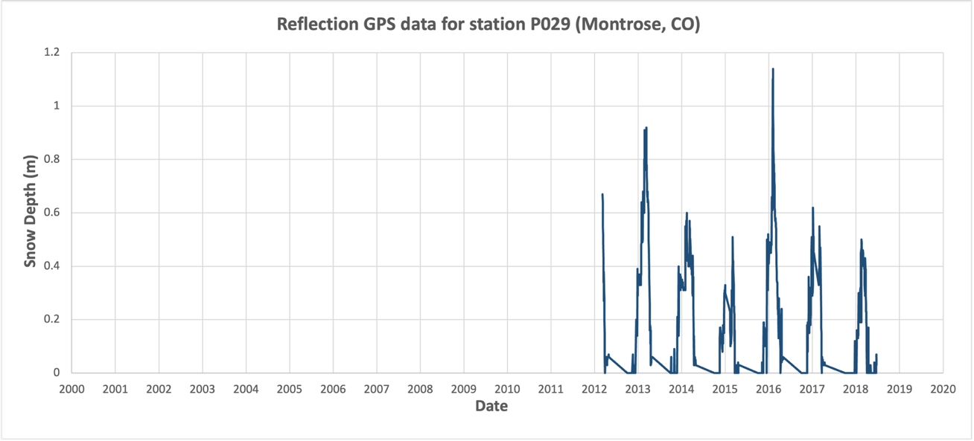
SNOTEL and reflection GPS plotted together:
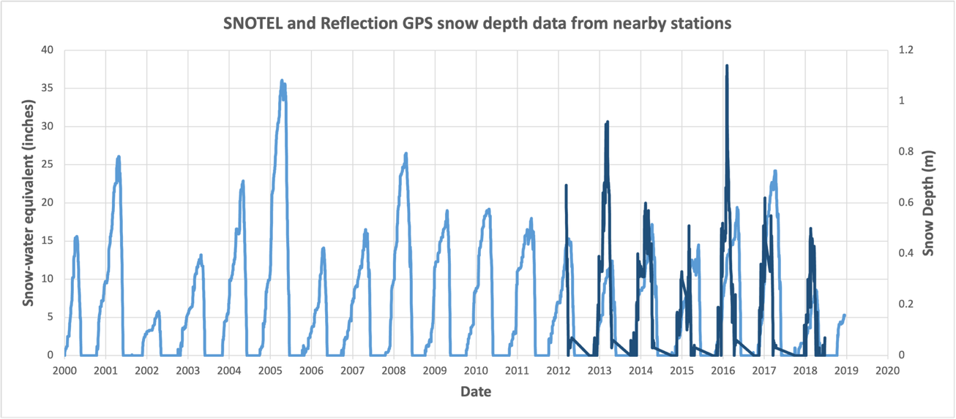

Charts for surface water stations:
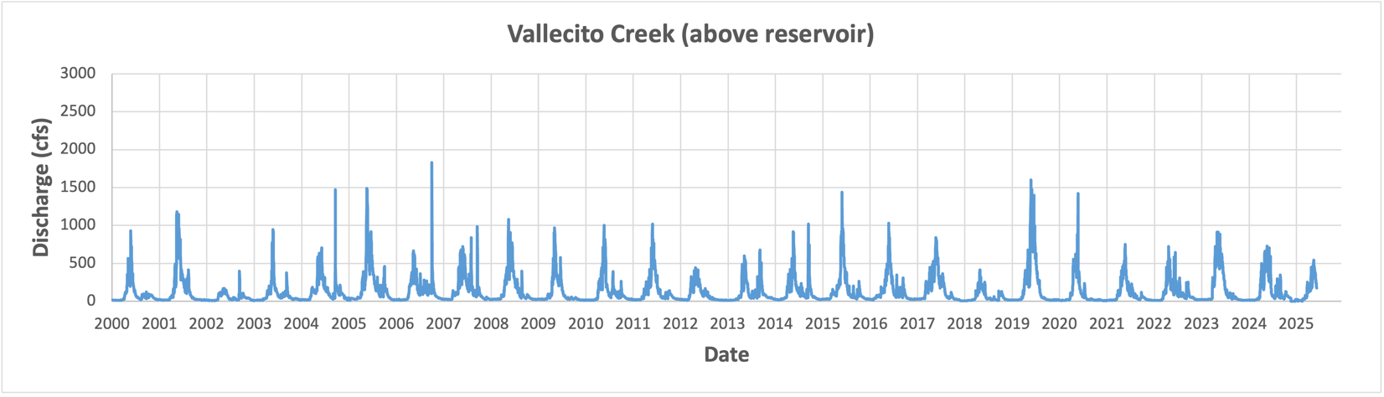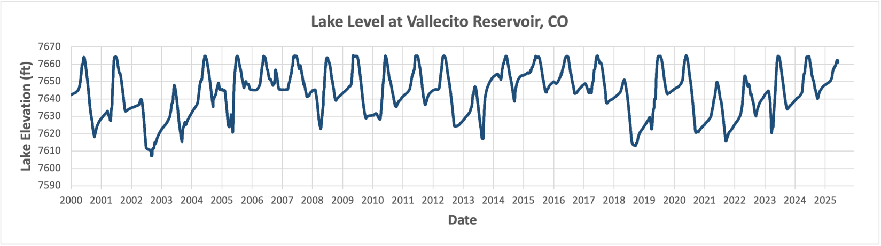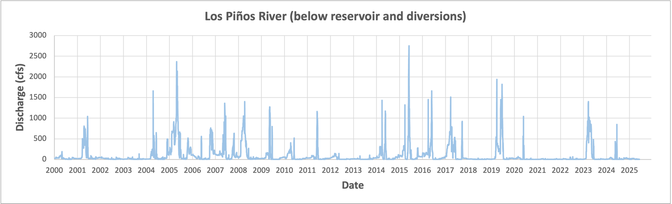
For comparison – same SNOTEL data again here:

Data sources
- SNOTEL - https://wcc.sc.egov.usda.gov/nwcc/site?sitenum=797
- Reflection GPS - https://cires1.colorado.edu/portal/ (although more recently data have moved to https://nsidc.org/data/nsidc-0722/versions/1)
- Gaging stations
  - https://nwis.waterdata.usgs.gov/co/nwis/uv/?site_no=09352900&agency_cd=USGS
  - https://www.usbr.gov/rsvrWater/HistoricalApp.html
  - https://waterdata.usgs.gov/co/nwis/nwismap/?site_no=09353800&agency_cd=USGS

