Eyes on the Hydrosphere Unit 1.2: Traditional and Geodetic Methods for Measuring Water Resources—Student Prep Exercise
Jon Harvey (Fort Lewis College) and Becca Walker (Mt. San Antonio College)

In preparation for your next class meeting, you will do some reading on a particular method that scientists use to measure different parts of the hydrologic cycle. This preparation may involve answering some questions, looking at figures, and/or watching short video clips about the method that you have been assigned. You will be responsible for teaching your colleagues about the method that you studied. Here is what you should be prepared to discuss with your colleagues before your next class meeting:
1.) What is the name of the method?
2.) What type of equipment is used in conjunction with this method?
3.) How does the method work?
4.) Over what timescale(s) is the method used?
5.) If the data for this method are plotted, what does a time-series look like? (In other words, what is measured on the X-axis, and what is measured on the Y-axis?
6.) What might different patterns in the data indicate about what is going on hydrologically in the area being studied?)
7.) For which reservoir(s) and/or transport pathway(s) of the hydrologic cycle is the method typically used?
8.) You will also receive 1–2 thought questions about your method that you should consider prior to your next class meeting.

Remember, you will be the only person in your group who has read about your particular method. You need to be well-prepared to discuss the points above with your colleagues and teach them about this method for measuring water resources.
Which method are you preparing? (Please circle one.)
stream gaging depth to groundwater vertical GPS
GRACE reflection GPS SNOTEL

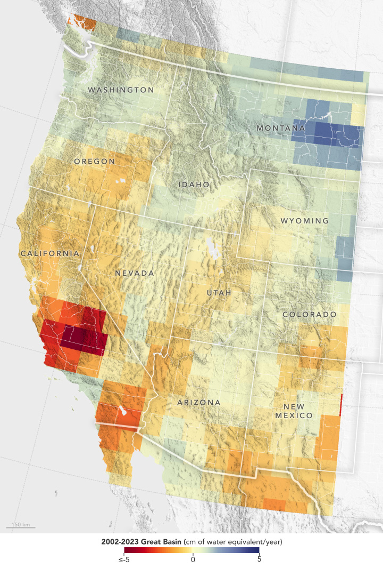
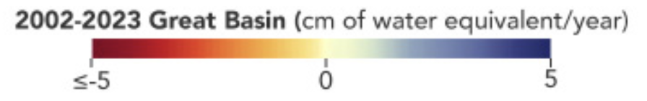
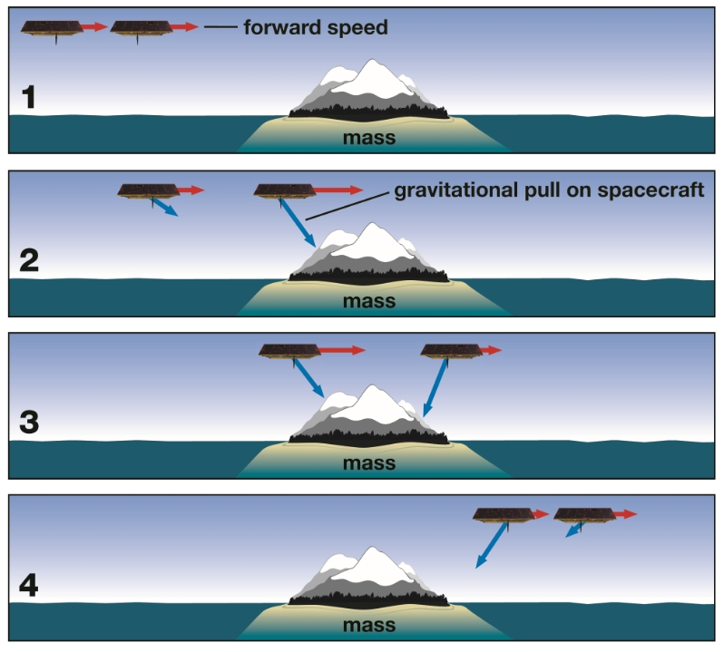
GRACE
Different objects have different gravities, depending on their mass. The more massive an object, the greater its gravity. The GRACE (Gravity Recovery and Climate Experiment) mission is a NASA project, begun in 2002 and consisting of two spacecraft flying roughly 220 km (137 miles) apart in a polar orbit 500 km (310 miles) above the Earth’s surface. When one of the satellites passes over an area of the ground with a different mass, its speed changes slightly, so the distance between the two satellites will also change. GRACE measures these position differences between satellites to measure the Earth’s gravity field and essentially “weighs” the Earth’s water. GRACE data allow scientists to study changes in various hydrosphere reservoirs over time. GRACE data are most commonly depicted using maps (Figure 1, Figure 2) but can also be represented graphically using a time-series, which illustrates time on the X-axis and the change in mass on the Y-axis (not shown here, but your colleagues will talk to you about time-series data during your next class meeting). GRACE-FO (GRACE-Follow On) mission launched in 2018 to continue the data collection after the original GRACE instruments reached end-of-life.
Figure 1. GRACE data illustrating the change in groundwater storage rates from 2002-2023 in western US. Shades of red represent a decrease in storage rate. Shades of blue represent an increase in storage rate. Data from NASA Earth Observatory.
Figure 2. Cartoon illustrating changes in separation distance of GRACE satellites depending on the mass (and therefore gravity) of parts of the Earth system over which they move. In these is the landmass. These two areas have different gravities.

Please watch a video entitled, GRACE: Tracking Water from Space, which explains how GRACE works and some examples of how GRACE can be used to measure components of the hydrosphere. https://www.amnh.org/learn-teach/curriculum-collections/grace/grace-tracking-water-from-space
Do you have some preliminary thoughts about whether GRACE data would be best used to measure short-term (hours/days/weeks) OR long-term (months/years) changes in the hydrosphere? Would GRACE be most useful for small areas OR larger regions?
Additional resources:
UT Austin “How GRACE Works”: https://www2.csr.utexas.edu/grace/GRACE_Edu_Poster/page_03.pdf
GRACE mission website: https://www.csr.utexas.edu/missions/grace/
GRACE Follow-on mission website: http://gracefo.jpl.nasa.gov/mission/

