Eyes on the Hydrosphere Unit 1.2: Traditional and geodetic methods for measuring water resources – Student Prep Exercise
Jon Harvey (Fort Lewis College) and Becca Walker (Mt. San Antonio College)

In preparation for your next class meeting, you will do some reading on a particular method that scientists use to measure different parts of the hydrologic cycle. This preparation may involve answering some questions, looking at figures, and/or watching short video clips about the method that you have been assigned. You will be responsible for teaching your colleagues about the method that you studied. Here is what you should be prepared to discuss with your colleagues before your next class meeting:
1.) What is the name of the method?
2.) What type of equipment is used in conjunction with this method?
3.) How does the method work?
4.) Over what timescale(s) is the method used?
5.) If the data for this method are plotted, what does a time-series look like? (In other words, what is measured on the X-axis, and what is measured on the Y-axis?
6.) What might different patterns in the data indicate about what is going on hydrologically in the area being studied?)
7.) For which reservoir(s) and/or transport pathway(s) of the hydrologic cycle is the method typically used?
8.) You will also receive 1–2 thought questions about your method that you should consider prior to your next class meeting.

Remember, you will be the only person in your group who has read about your particular method. You need to be well prepared to discuss the points above with your colleagues and teach them about this method for measuring water resources.
Which method are you preparing? (Please circle one.)
stream gaging depth to groundwater vertical GPS
GRACE reflection GPS SNOTEL

Vertical GPS
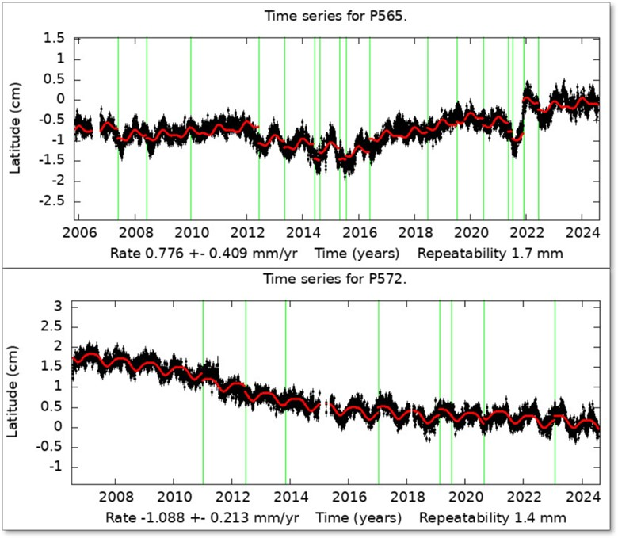
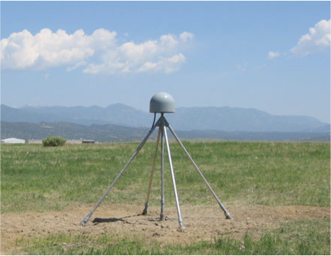
The position of a GPS station changes when the position of the surface to which it is attached changes. Simply stated, when the ground surface moves so does the GPS station. Typically, these position changes are too small to detect without the use of high-precision GPS stations, which consist of a GPS antenna inside of a dome for protection, the monument securely attached to the ground, a solar panel for power, and an enclosure for the GPS receiver, power/batteries, communications equipment to send data to offsite facilities for analysis, and data storage (Figure 1.) There are GPS networks on every continent. The largest GPS networks in the United States are the Network of the Americas (NOTA), with more than 1100 stations, and CORS (Continuously Operating Reference Stations), with approximately 2000 stations. You may be familiar with some tectonic processes that can cause ground deformation, but changes in the location and/or amount of water in a particular reservoir of the hydrosphere can also cause ground deformation, and thereby, position changes in the GPS station. For hydrosphere studies, scientists are most interested in the vertical position changes of the GPS over time. The data are represented graphically with a plot called a time-series, which illustrates time on the X-axis and the vertical displacement on the Y-axis (Figure 2.) Decreases in the elevation of the GPS station over time indicate that subsidence (i.e., sinking) of the ground has occurred. Increases in the elevation of the station indicate that the ground has experienced uplift.
Figure 2. Time-series for vertical movement of two GPS stations in the Central Valley of California. https://sideshow.jpl.nasa.gov/post/series.html
.
Figure 1: Network of the Americas GPS station PO37. (EarthScope)
Please watch an animation: Measuring Drought: A GPS Network Offers a New Perspective, to see one example of how GPS can be used to measure the hydrosphere.
https://www.youtube.com/watch?v=5Bzt374u5aU
Do you have any preliminary thoughts about the kinds of changes in the hydrosphere that could cause ground subsidence? How about uplift?
Additional resources:
GPS and Water Use: https://spotlight.unavco.org/how-gps-works/gps-and-the-water-cycle/gps-and-water-use.html
Case study of GPS station P349 used to measure Lake Shasta water levels: https://spotlight.unavco.org/station-pages/p349/p349.html
Description of GPS ground networks: https://spotlight.unavco.org/how-gps-works/gps-basics/gps-ground-networks.html

