High Resolution Topography Unit 1.1: Pre-class reading on SfM-GNSS survey design with GCPs and UAV
Sean F. Gallen, Margaret Windingstad, Nathan Weaver, and Emily Hofer (Colorado State University)
In this unit, students will learn how to design a Structure from Motion (SfM) survey with ground control points (GCPs) located using real-time kinematic (RTK) GNSS methods. This reading covers considerations when planning an SfM survey with GCPs. SfM is a photogrammetric method that constructs 3D models using overlapping photos. SfM applications are widespread and are now commonly used in numerous subdisciplines in Earth Science. RTK GNSS techniques allow rapid collection of high-accuracy and high-precision (±2 cm) position information. Combining SfM and RTK GNSS is commonly used to locate SfM models precisely, and temporal surveys are used in the same location for surface change detection.

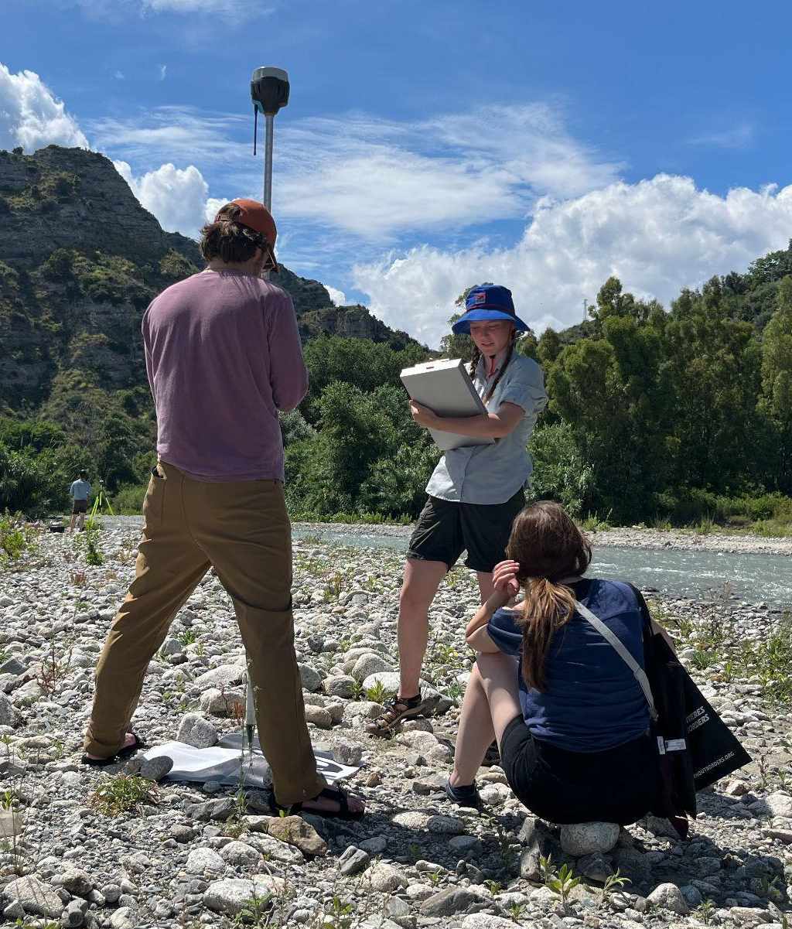
Introduction
In this unit, you will be applying knowledge of survey design from the module High Precision Positioning with Static and Kinematic GPS/GNSS Unit 2 to think about how to best design an RTK survey of ground control points (GCPs) for a structure from motion (SfM) survey. You will be challenged to consider survey design to maximize the resolution and quality of an SfM digital surface model, safety, and logistics. Once this exercise is complete, you should have a basic understanding of the concepts, be prepared to mockup and discuss a pre-field survey design in class and ultimately build confidence in designing your own survey.

Ground Control Points (GCPs)
Ground Control Points (GCPs) are precisely surveyed locations on the ground used as reference points in Structure from Motion (SfM) surveys to ensure spatial accuracy and georeferencing of the generated 3D models or maps. Typically marked with visible targets, GCPs are identified both in the physical environment and in the imagery captured during the survey. Their coordinates, typically measured with high-precision GPS/GNSS, are incorporated during the SfM processing to align the model to a real-world coordinate system. This alignment is crucial for scaling, orienting, and correcting the SfM outputs, especially in applications where accurate spatial data is essential, such as topographic mapping, environmental monitoring, and construction planning.
Figure 1: Students in the field surveying a ground control point (GCP) target (black and white flag on the ground) with RTK GNSS.

Survey design considerations

Ground Control Point (GCP) Basics
GCPs are typically identified with targets - physical markers that can be identified in the SfM photos - that are surveyed precisely with high-precision GPS/GNSS. Targets can be as simple as a clearly identifiable ground feature, like a lone boulder in a grassy field, but are more commonly temporary features, like flags, flat-lying fabric markers, or spray-painted X’s. Regardless of the target type, they should be easily and readily identifiable from the SfM photos, thus standing out from the background landscape.
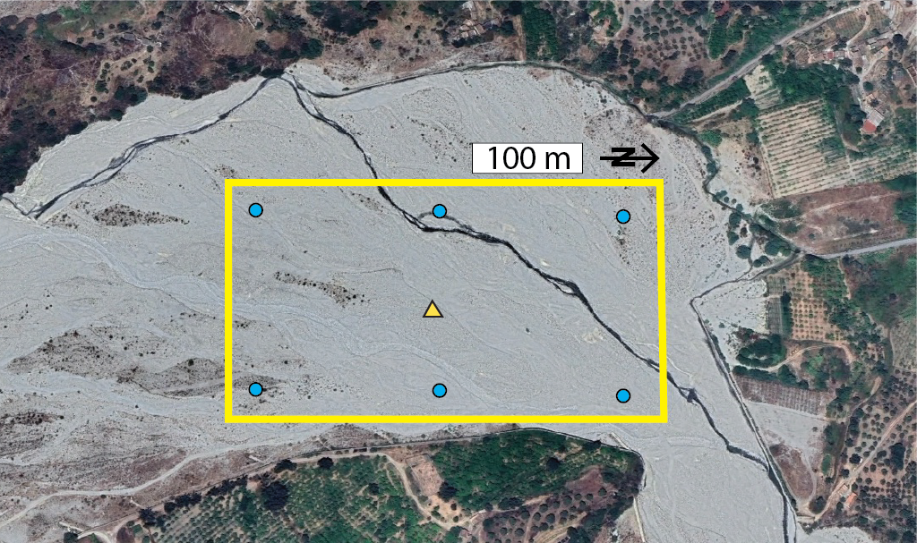
After defining an area of interest (AOI) for your survey - the region where you will produce your SfM digital surface model - you must decide on the number and positioning of your GCPs. The number of GCPs for a given SfM survey depends on the size of the area being surveyed. Most often, ~5-10 GCPs are sufficient. You will need one target for each GCP you intend to survey.

Considerations for GCP positions within the AOI depend on several factors, including:
Figure 2: Google Earth™ image of a river valley with an area of interest (AOI) outlined in yellow. The AOI is flat and easy to access. Prospective GCP locations are shown as the blue dots, and the base station location is the yellowish triangle.
(1) the optimal locations to maximize SfM model quality and precision
(2) safety
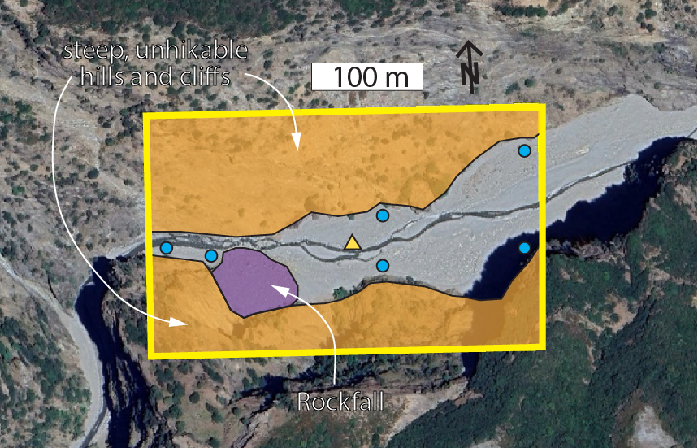
(3) logistics (e.g., access to equipment, walking distance, line of sight with base station)
When safety and logistical concerns are minimal, it is best to distribute GCPs evenly across the entire AOI in a grid-like pattern. It is good practice to set up GCPs in the corners of the AOI whenever possible. An example of an AOI and GCP placement is shown in Figure 2. In this example, the base station can be positioned anywhere there is a line of sight for all six GCP positions.
Figure 3: A Google Earth™ image with an area of interest (AOI) outlined in yellow highlighting regions of safety and logistical concern. Given these considerations, one option of ground control point (blue dots) and base station (yellow triangle) positions are shown.
In the event of locations with safety and logistical concerns, compromises must be made. An example of an AOI in complex terrain is illustrated, along with a potential example of a GCP layout, as shown in Figure 3. In this example, it is not feasible to set up the GCPs in a grid-like pattern. The goal is to spread the GCPs as far as possible to cover the study area, where it is safe to access and where all the GCPs have a line of sight to the chosen base station location.

Pre-trip planning
Before going into the field, it is good practice to know the AOI as well as possible to think through how to best set up your survey. After deciding on the resolution and scale of the survey, a good way to get a sense of the area is to inspect the prospective AOI in Google Earth™. This can give you some sense of safety and logistical aspects of the survey, and where you might plan to set out GCP targets. It can also be helpful to check if the AOI is located on public or private lands to ensure you have the appropriate permissions and avoid any issues when starting your survey. In Google Earth™, you can define the approximate AOI using the polygon tool. After you do this, define the staging area location, which is usually near where you park your car, and identify any potentially hazardous (e.g., cliffs) or logistically challenging areas (e.g., steep slopes, heavy vegetation, larger water bodies). Keeping these in mind, place pins at the locations you think are the best for GCPs, as well as the base station, similar to what is shown in Figures 2 and 3. Remember that the base station must have line-of-sight viability with all your GCP positions. As you make this rough survey plan for your GCPs, keep an eye out for alternative target sites because you might find that some locations will not work once you are out in the field. It can also be helpful to use Google Earth to calculate distances from the parking lot and staging area, as well as the distance between GCPs. Finally, printing a screenshot of the survey plan or saving it on a computer or tablet that you will have in the field can be very helpful.

Preparing for and conducting the field survey
Before departing for the field, run through the equipment checklist to make sure (1) you have all the equipment, (2) all pieces of equipment are working and can communicate with each other (e.g., base station, roving station, tablet), (3) all software and firmware is updated, and (4) all batteries are charged.

Upon arriving in the field, decide on a staging area where you will set up the equipment for the survey. This is typically located outside, but near, the AOI, and is sometimes the parking lot. Next, if it is your first time on a site, do a walk-through before taking any equipment out. Bring your notebook, camera, and your pre-trip plan. Walk around and inspect the site, taking note of any complications, safety concerns, fences, vegetation, and other factors that may influence your survey or require adjustments to your pre-trip plan. Also, take notes on observations that are important to your survey objectives. Based on your walk-through, revise your GCP target locations as needed and note these changes in both your pre-trip plan document and your notes.

Meet back at the staging area, and inventory and test the equipment as you bring it out of the vehicle. Provided everything is there and working properly, set up the base station in the pre-determined location, making sure you have line-of-sight for where the GCPs will be placed. Turn on the base station and start recording data. Next, place the GCP targets in the designated locations and verify that they have a clear line of sight to the base station. Ensure the center of the target is supported by a hard surface that is roughly level with the target's surface. This can be a small rock. Once the targets are out, begin surveying them with the roving station, taking care to record the location, precision, and time of record information in your notebook. Also, note which GCP you are surveying based on your pre-trip survey GCP locations. Do not pick up the targets!

Once the GCPs are measured using the kinematic GNSS, fly the survey with the UAV and ensure the targets are visible in the UAV images. In your notebook, take notes on time of flight, weather, lighting conditions, and other factors that might influence survey quality.

When done flying, retrieve the GCP targets and take down the base station. Bring all equipment back to the staging area. Inventory the equipment before leaving to make sure you have everything. Pack everything in the vehicle and get excited to start working with your data.

Processing the data
Processing the collected data will occur in the computer lab later.

Overview of the workflow

