High Resolution Topography Unit 1.1 Student Exercise: SfM-GNSS pre-trip planning activity
Sean F. Gallen, Margaret Windingstad, Nathan Weaver, and Emily Hofer (Colorado State University)
Uncrewed Aerial Vehicle (UAV) surveys use ground control points (GCPs) to improve survey precision and accuracy and place the survey in an exact geographic position. Critical to successful UAV with GCP surveys is pre-planning a survey before going into the field. This can help iron out logistical and safety considerations before arriving in the field and simplify the execution of the field survey. This activity is designed to give students a chance to conduct a pre-survey plan in Google Earth™, applying what they learned in the associated pre-class reading. This activity uses Google Earth Pro.

Exercise Part 1: Initial Survey Design and Considerations
- Working in groups of two to three students, open Google Earth Pro.
- Change units to decimal degrees and metric, and elevation exaggeration. To do this, click the Tools tab and select Options. In the window that opens, select 3D View. Under Show Lat/Lon, select Decimal Degrees. Under Units of Measurement, select Meters, Kilometers. Under Terrain, you will see Elevation Exaggeration. Change this value to 2. Select Apply and then click Okay to close the window. A screenshot of this window is below, which highlights where to make these changes.
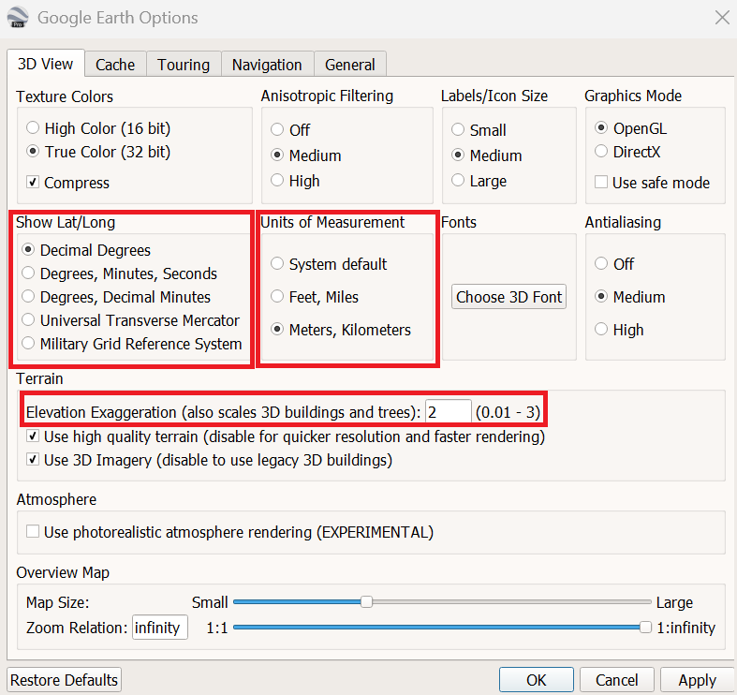

- Go to File Open and navigate in your file explorer to the kmz file provided called "Example Survey Area 1 data.kmz" and open it. Google Earth should fly to this location, and it should look like this:
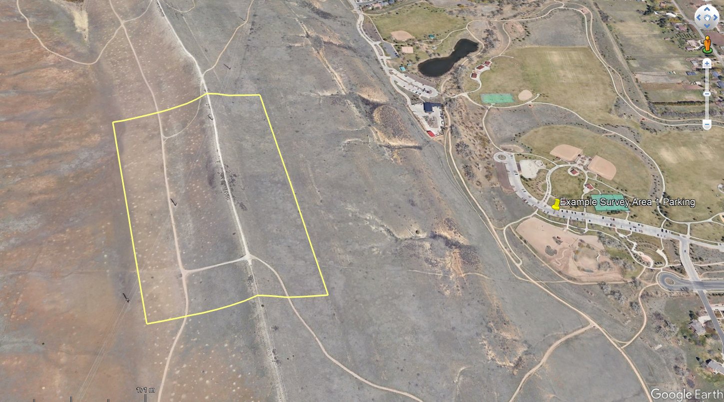
The yellow area is the area of interest (AOI), and the pin to the left is the parking lot.
- Your task is to decide where to place your staging area and position your GCPs and base station. Come to a consensus as a group on this. Place the locations of (i) your staging area, (ii) your base station location, and (iii) your GCPs as labeled pins in Google Earth. Save your locations in two ways: (1) as a kmz file and (2) as a screenshot.
  - To save your data as a kmz, right-click on My Places and select New Folder. Name the folder “My Example Survey”. Drag and drop your pins into the folder. After all your pins are in the folder, right-click the folder and select “Save As” and save the kmz file in a folder you can easily find.
- As you work through your survey design, in a Word document, address the following questions:
(i) What are the potential safety issues or considerations with conducting a UAV and GCP survey at this site?
(ii) What are your logistical considerations?
(iii) What led you to pick your staging area location and your base station location?
(iv) Why did you place your GCPs where you did? What are some other potential locations you might choose for GCPs and why?
(v) What questions do you have regarding this site?
- Once you are satisfied with your survey and have answered the questions, include a screenshot of your survey at the end of the Word document. At the top, list all group members' names and save the file. Submit this Word document, as well as the kmz file you saved, to the instructor.
- Come together as a class for a class discussion regarding designing this survey.

