Instructor Guide for Emlid Reach RS2/2+/3
Beth Pratt-Sitaula, Sam Beane, Diana Krupnik (EarthScope) and Brigid Lynch (Indiana University)
This document provides a guide on the setup of Emlid Reach RS2 (also RS2+/3) receivers and other functions that may be needed by instructors or field engineers. This manual includes:
- Updating receiver firmware
- Initial settings for both the base and rover receivers for RTK survey
- Good Base locations
- Determining a known point for Base Position with Precise Point Positioning (PPP)
- PPK – Post processing kinematic
- Base shift (moving the base during a survey)
- Using NTRIP over cellular to access a permanent GNSS station instead of a local base
- Downloading a system report
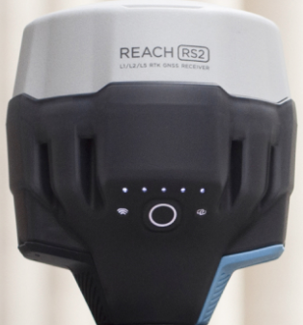
- Connecting to receiver using Windows or Mac computer browser
1
2
3
4
Figure 1. Image of the Emlid Reach RS2 receiver. (1) power button, (2) battery status, (3) WiFi status (4) RTK status. Steady white WiFi status means receiver is in Hotspot mode. Blue it is connected to a local WiFi network.

1. Updating receiver firmware
If you borrow equipment from the GETSI Field Project (EarthScope Consortium) you will most likely NOT need to do the steps in Section 1). The receivers should arrive to you with updated firmware and base/rover setting. However, these are provided for your reference or in case an update is released while the survey kit is in your possession.

Charge receivers to full power
Check battery status of the receivers. Press the power button once to display the current power level (Fig. 1). If device needs to be charged, plug it in using the included USB charger.

Update firmware using phone or tablet
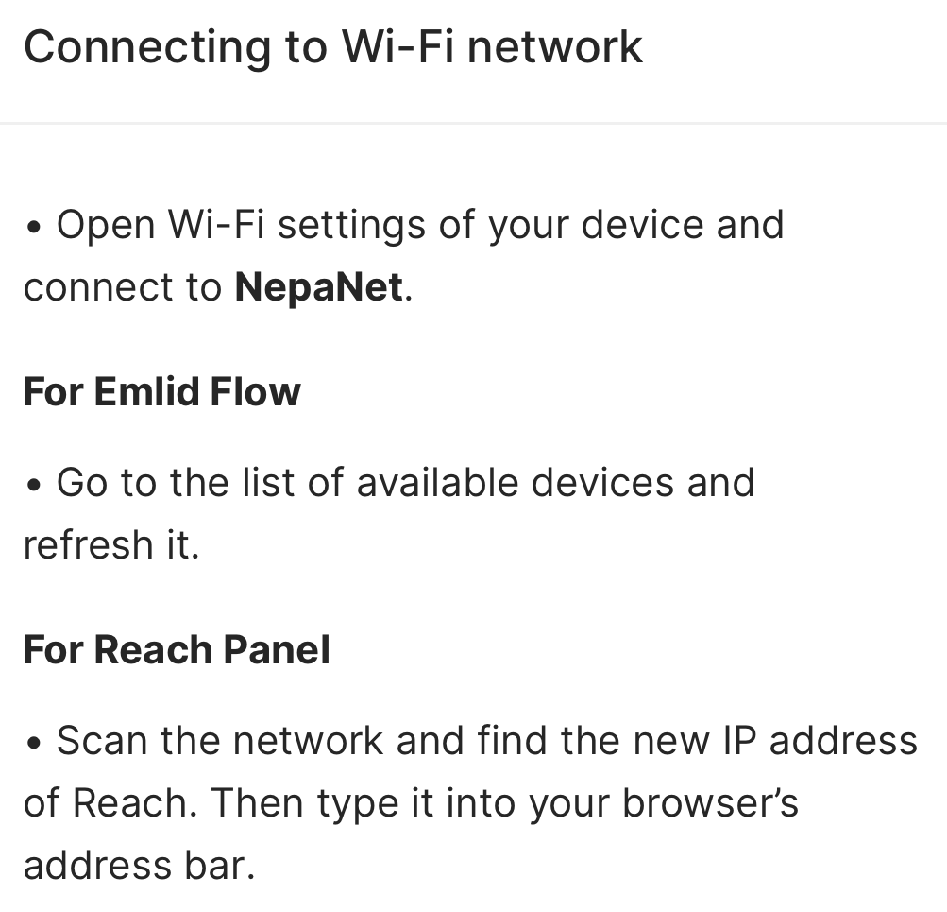
You will need the Emlid Reach receivers, a 2.4 GHz WiFi connection, and a smartphone or tablet with the Emlid Flow companion app installed (alternatively you can connect to the receiver using a computer as described in the last section below). If you have issues with the app, restarting it will typically solve the problem. For additional help with firmware updates: https://docs.emlid.com/reachrs2/reference/troubleshooting/updater/
- Connect to the receiver as described in the Emlid Quick Guide with your phone/tablet using the Emlid Flow app (the receiver in hotspot mode and you are connecting to its WiFi network).
- Next you need to change the configuration so that both the devices are on a 2.4 GHz (not 5 GHz) internet-connected WiFi network, rather than having the receiver serve as a hotspot. WiFi > Available. Select the WiFi network that you wish to use. The receiver will then switch to that WiFi network and stop being a hotspot to your phone/tablet. You will see a notice that says “Connection to Reach was lost.” When both devices are on the same WiFi network, the phone/tablet can function again as a controller.
- Settings (will have a red dot if a firmware update is available) > New Reach Firmware is available > Update Reach > Update Reach
- It will take a few minutes for the update to download. It often helps to keep the phone screen active to maintain the connection between devices.
- Backtrack through the app menus to get to the Receivers page. After a couple minutes, Refresh to find the receiver again. When the receiver is done turning on again, both the receiver and your phone/tablet will still be on the same local WiFi network. Select the receiver in the Emlid Flow app.
- If you wish to have the receiver stop reverting back to the local WiFi network whenever it reboots, you can “forget” the local network. Go to WiFi > Hotspot mode. Turn the hotspot ON. Go to your phone/tablet’s Settings and choose the receiver as your WiFi network again. Refresh or restart Emlid Flow app > choose the receiver. Go to WiFi page again and forget the local network that you had the receiver connected to.

2. Initial settings on base and rover for RTK survey

Base settings for RTK survey
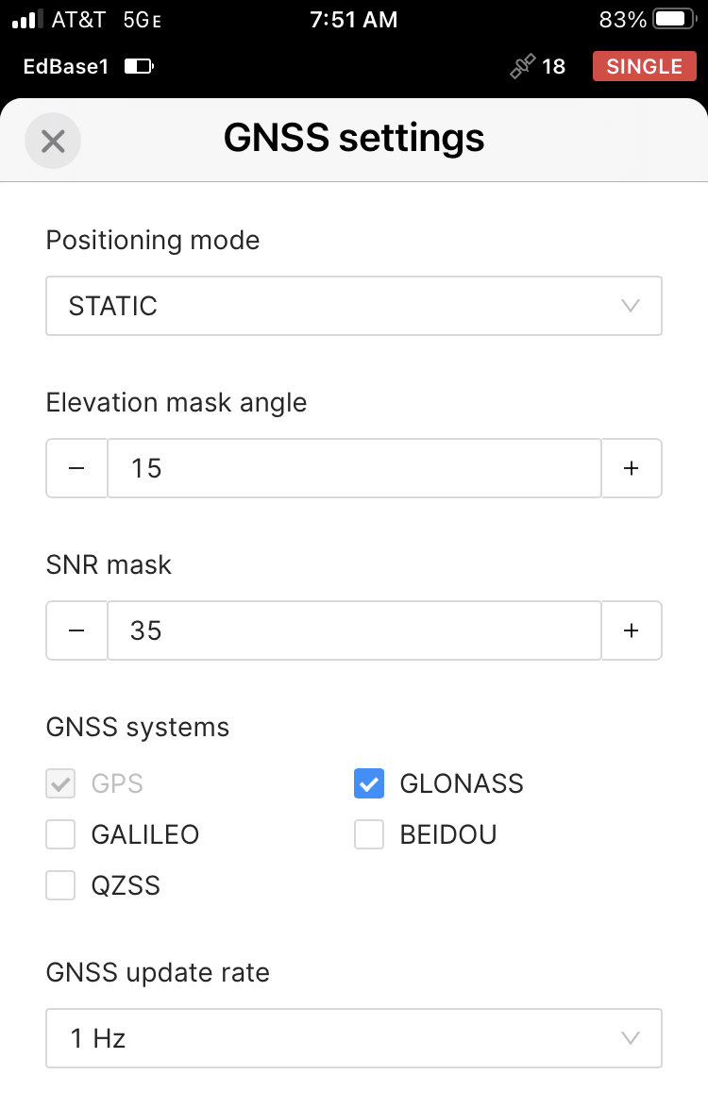
This section provides a list of the initial settings that this receiver should arrive with from EarthScope if it is designated as the base. Starting from the initial Receiver page once you are connected to the receiver (see Quick Guide for getting the app started).
- Correction input: Off
- Base output:
  - Select LoRa
  - Frequency: 902.0 MHz
  - Output Power: 20 dBm
  - Air data rate: 9.11 kb/s
- Base settings
  - Configure > Coordinate entry method > Average Single
    - Note: the user may change this to Manual depending on their needs, but it will typically arrive set to Average Single (see more info below)
    - Average Single (to collect a quick location)
      - Coordinate Accumulation Time: options for up to 30 min but 5 minutes can work fine. It is fine to set it to “Average Single” if you are just collecting a longer occupation for PPP processing (see below PPP section).
    - Manual (If you are using a known benchmark location)
      - Antenna Height: Measure from the ground to the base of the Reach device to determine the Measured height. The actual phase center of the antenna is 0.134 m higher but the receiver will include that automatically. If you are using a 2-meter pole and quick tripod, this will be 2 m.
      - Enter in the Latitude, Longitude, and Ellipsoid height of the benchmark
  - RTCM3 messages:
    - ARP station coordinates: 0.1 Hz
    - GPS MSM4: 1 Hz
    - GLONASS MSM4: 1 Hz
    - Uncheck Galileo MSM4, BeiDou MSM4, and GLONASS code-phase biases
- Settings
  - Base output 2: Off
  - Mobile data: Off
  - GNSS Settings
    - Elevation Mask Angle: 15°
    - SNR (Signal Noise Radio) Mask: 35°
    - If you are going to process a PPP survey in CSRS only select GPS and GLONASS. If you have other processing plans or if the base location is already known, then it may be fine to select GALILEO, QZSS, BEIDOU as well.
    - Update Rate: 1 Hz (How often the receiver recalculates its location; Emlid’s recommended base setting is 1 Hz; 5 Hz also fine)
  - Position streaming 1: Off
  - Position streaming 2: Off
    - Unless you are connected to a real time permanent station for corrections.
- Logging – If the receiver was turned off with logging still going, it will automatically restart when you turn the receiver on. It is recommended to stop logging at the end of a survey and re-start manually for the next survey. This ensures that data files are ended and restart properly. So, it should be shipped with logging off.
In general, the base will log Raw data and Position. The Base correction file is not relevant when a receiver is being used as the Base.
Recorded logs and settings > Gear Icon > Show Configuration (if you want to see all the options):
  - Raw data:
    - Format: RINEX3.03
    - Either “CSRS” or “Custom” to start with (unless you specifically know a user wants to use OPUS)
    - Show configurations
      - Logging interval: 1 s
      - Satellite systems: GPS and GLONASS
    - Info for RINEX header: antenna height should be the same as in Base settings above.
    - “Automatically start recording” should be unchecked
  - Additional logs:
    - Position track: LLH (lat-lon-height); also fine to do X-Y-Z (coordinates from Earth’s center), but that is less intuitive for most educational users
    - “Automatically start recording” should be unchecked
- Status – there are no settings on this page but it can be helpful to think about some of the info displayed
  - Satellites in view: just what is sounds like; 6 is really a minimum that you would want to use and more than 10 is better and these days more than 15 is very normal, although technically 4 is enough for a basic solution
  - PDOP (position dilution of precision): describes the error caused by the relative position of the GPS satellites. Basically, you want the satellites as spread out across the sky as possible and not only in one area – say overhead. Low PDOP values, in the range of 4.0 or less, indicate good satellite geometry, whereas a PDOP greater than 7.0 indicates that satellite geometry is weak. Aim for <2.0 if you can.
  - Solution: Single

Rover settings for RTK survey
This section provides a list of the initial settings that this receiver should arrive with from EarthScope if it is designated as a rover. Starting from the initial Receiver page once you are connected to the receiver (see Quick Guide for getting the app started).
- Correction input: should match the Base Output
  - Select LoRa
  - Frequency: 902.0 MHz
  - Air data rate: 9.11 kb/s
- Base output 1: Off
- Base settings: not relevant to a receiver set up as a rover
- Settings (scroll down to the ones lowest on the page)
  - Base output 2: Off
  - Mobile data: Off
  - GNSS Settings
    - Elevation Mask Angle: 15°
    - SNR (Signal Noise Radio) Mask: 35°
    - Generally, the base is only set to collect GPS and GLONASS because those are the systems that can be used with the CSRS PPP portal. The rover is also usually set to just be GPS and GLONASS but it is fine to select GALILEO, QZSS, BEIDOU as well if you wish.
    - Update Rate: 5 Hz (Emlid’s recommended rover setting)
  - Position streaming 1: Off
  - Position streaming 2: Off
- Logging - If the receiver was turned off with logging still going, it will automatically restart when you turn the receiver on. It is recommended to stop logging at the end of a survey and re-start manually for the next survey. This ensures that data files are ended properly. So, it should be shipped with logging off.
In general, the rover should be logging Raw data and Position and Base correction.
Recorded logs and settings > Gear Icon > Show Configuration (if you want to see all the options):
    - Format: RINEX3.03
  - Raw data:
    - Either “CSRS” or “Custom”
    - Show configurations
      - Logging interval: 1 s
      - Satellite systems: GPS and GLONASS
    - Info for RINEX header: antenna height should be the same as in Survey
    - “Automatically start recording” should be unchecked
  - Additional logs:
    - Position track: LLH (lat-lon-height); also fine to do X-Y-Z (coordinates from Earth’s center), but that is less intuitive for most educational users
    - Base corrections: RTCM3
  - Common settings:
    - “Autostart” recording should be unchecked
- Status – same as above for the base except
  - Solution: Fixed (or Float) but fixed is needed for the full RTK solution

3. Good Base locations
When you choose a base location, you need to think about both the sky view for good satellite coverage, but also the base-rover communication. RTK surveys depend on a radio link between the base and rover. The goal is to have the base location and rover survey plan such that the rover is always able to achieve Fix between the devices. Some things to keep in mind:
- Open sky view, free from large nearby objects as much as possible (trees, buildings, etc.), and on stable ground. (see also the Kinematic GPS/GNSS Survey Methods Manual - https://serc.carleton.edu/details/files/108023.html; https://serc.carleton.edu/getsi/teaching_materials/high-precision/unit1.html - manuals)
- Line-of-sight between the base and rover is best for being able to do longer distances but over shorter distances may not be essential.
  - We have been able to get up to 8 km with full line-of-sight when base was on a building, the rover was used in various places that had a view of that building, and the air data rate was slowed from 9.11kb/s to 4.56 kb/s (this also meant only the GPS constellation was being used due to slower data transfer rate). Rover and base must have the same rate, so change them both if you are trying this adjustment. It is also recommended to turn off GLONAS. See Section 2 for making receiver settings changes.
- High ground for the base seems to particularly help.
  - We have been able to get ~5 km distance between the Emlid base and rover when the base was on a hill and the rover was out in the plains below. Line-of-sight largely available but not completely perfect.
  - Even without line-of-sight, having the base up on a hill allowed 1-1.5 km distance through trees and bamboo.
- Base placement can be a bit of an art. As an instructor, if you have time, you may choose to scope and test an ideal base location well before going out with students. That would also allow you to get the best solution using PPP (see next section). However, if you are not able to test the base location before going out with students, you can include the students in that part of the survey design and decision making, which is also a super valuable learning outcome, even if it reduces the time spent on addressing a geoscience research question.
- Troubleshooting suggestions for getting good Fix with the rover are given in the Quick Guide.
- If you still have troubles establishing Fix and would like to discuss it with a technician, please take multiple pictures of the site and contact education@earthscope.org.

4. Determining a known point for Base Position with Precise Point Positioning (PPP)
If you will be working at a location that does not have a known benchmark, you will typically want to get a known point for your base station. This section will describe setting up the base receiver for PPP and uploading the results to the Natural Resources Canada (NRCAN) Canadian Spatial Reference System website (CSRS-PPP) https://webapp.geod.nrcan.gc.ca/geod/tools-outils/ppp.php?locale=en. It is ideal to do this workflow the day before, several days, or even two weeks before you want the known point for an RTK survey. If you prefer to use the NOAA’s OPUS (Online Positioning User Service), Emlid describes that workflow https://docs.emlid.com/reachrs3/base-setup/determining-base-position/online-post-processing-services/opus-workflow/.
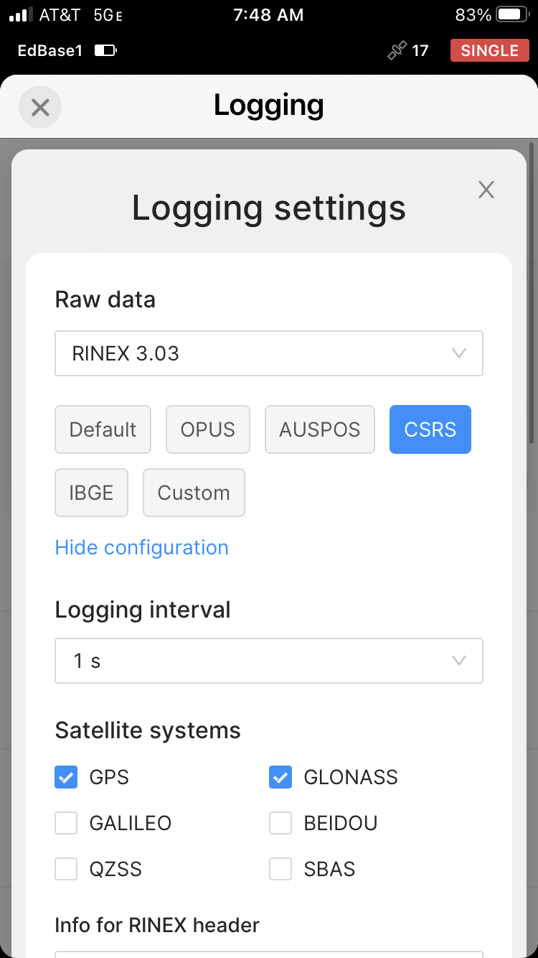
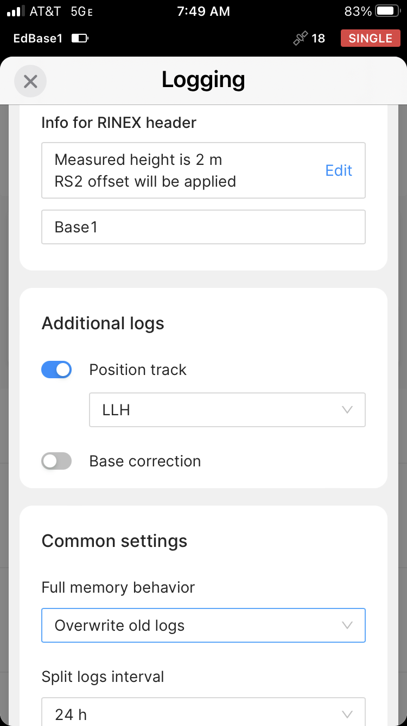
The longer you collect the base location data ahead of time, the better the PPP solution because the satellite locations and correction are better known. There are three options:
- Ultra Rapid solution is available 1.5 hours after the GPS data are collected
- Rapid solution is available the next day
- Final solution is available ~2 weeks later when final satellite location data is included
Read more about it (https://docs.emlid.com/reachrs/tutorials/post-processing-workflow/nrcan-workflow/). The Emlid Community Forum also has a nice example from someone who compared Ultra Rapid and Rapid deviations (https://community.emlid.com/t/study-of-deviation-of-ppp-with-rs2-with-different-observation-times/19185). The published accuracies suggest the Ultra Rapid will have decimeter-scale accuracy, Rapid will have ~½-decimeter accuracy, and Final will be ~2-cm accuracy. In practice we have often found only cm-scale differences between the three solutions. In some cases, Rapid and Final are essentially identical.
- Set up the base tripod and receiver over the point for which you want to get a known position and turn the base receiver on.
- Make sure the base is set up to collect data for the PPP service you plan to use (unless the base location is already a known point). Go to the Receiver page > Logging > Recorded logs and settings > Gear Icon > Show Configuration (if you want to see all the options). Select the PPP service you plan to use. This will probably be CSRS or OPUS. This will ensure that only the satellite systems that work with a particular service will be included.
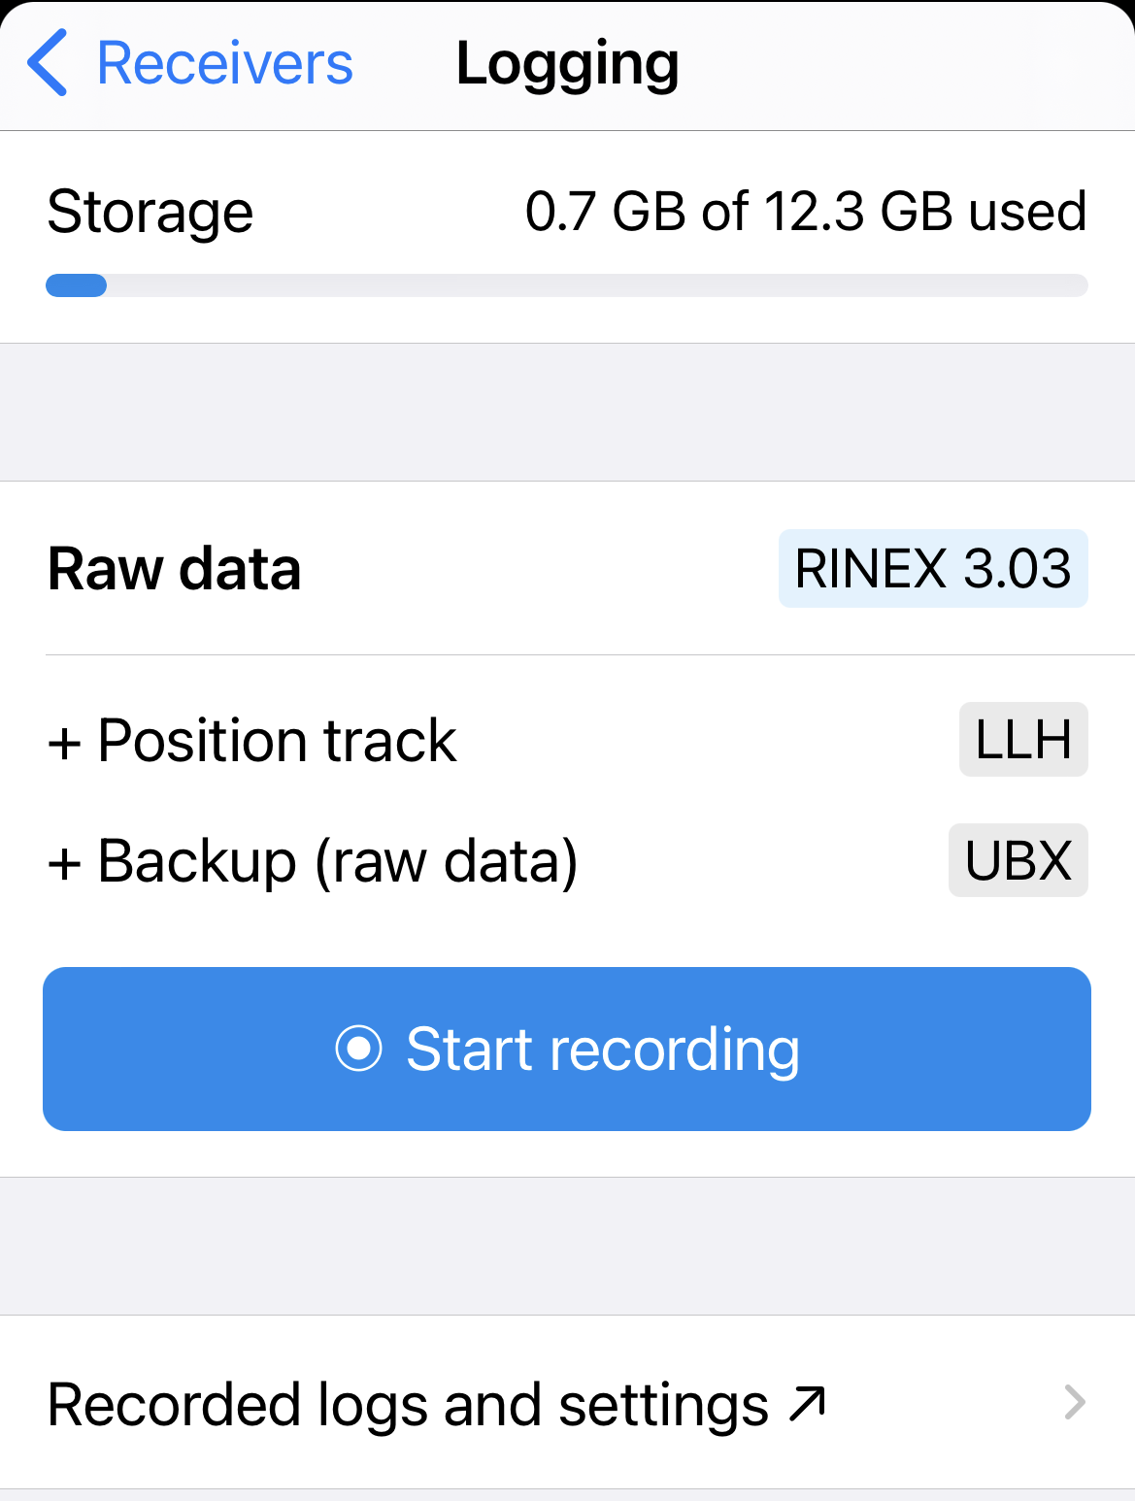
- Format > RINEX 3.03 (unless you have a particular reason to use another format)
- Logging interval > 30 s is fine if you are only collecting base data at this time. If you are also collecting rover points for post-processing kinematic (see Section 6 PPK), then use 1 s (as in GNSS settings).
- It is fine to have “Backup source data for RINEX (UBX)” checked. Most people don’t use it though.
- Measured height is from the benchmark to the bottom of the receiver (in meters). This is 2-meters for a quick tripod and your measured value for a traditional tripod. You can also enter a Marker name. Click Apply. The measured height should be the same as in Base settings.
- Back on the main Logging page, Start recording the Raw Data and Position. For more on logging within the Emlid Flow app: https://docs.emlid.com/emlid-flow/#logging
- Allow the base receiver to collect data for at least 2 hours, preferably 4 hours.
- Retrieve the raw data that was recorded:
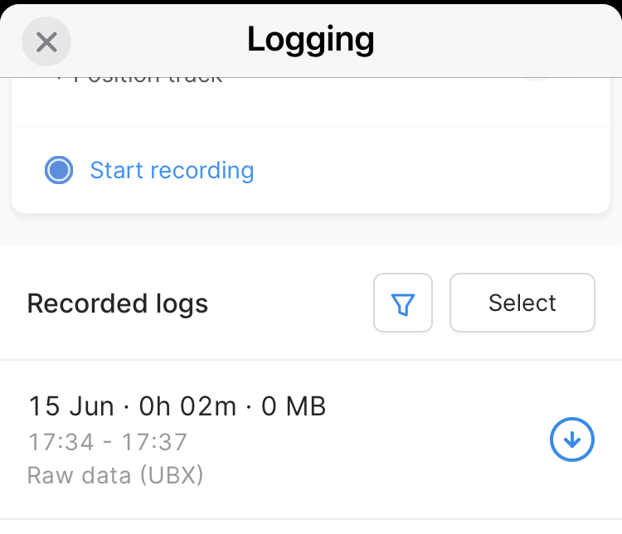
  - In the Logging tab,
    - Click the red “stop” button/s to end the logging
    - Scroll down lower on the screen; click on the download icon next to the data you want to download. (The data is organized by date, time and type.)
  - The data will download as a zip file onto your phone and provide methods to send it to your computer.
    - Use any method (Airdrop, text message, email) to move the data from your phone to a computer.
    - You can either use the receiver’s hotspot WiFi to do this or reconnect the receiver and your smartphone to your home WiFi.
  - You can also connect a laptop to the Emlid’s WiFi hotspot or have both devices on the same local WiFi network. Then go to http://192.168.42.1/#logging in a browser window and downloading the files that way.
  - For more on downloading files from the Emlid Flow app: https://docs.emlid.com/reachrs2/tutorials/post-processing-workflow/nrcan-workflow#downloading-logs
  - Unzip the Raw data file and identify the observation file which will end .xxO (xx denotes the year as in .22O for 2022). It will also be the largest file by size.
- Now you are ready to submit to CSRS: https://webapp.geod.nrcan.gc.ca/geod/tools-outils/ppp.php?locale=en
  - Create an account with them if you do not have one already.
  - Sign in to your CSRS account, enter the email that you would like the results sent to, then select Static and ITRF.
    - For more information on NAD83 vs ITRF and WGS84 see: https://www.e-education.psu.edu/geog862/node/1804#:~:text=It%20is%20important%20to%20note,plate%2C%20and%20moves%20with%20it
  - Upload the .xxO file to CSRS.
- Record the Latitude, Longitude, and height coordinate, found in the summary link of the CSRS email or in the pdf within the full_output_zip file. Note: CSRS-PPP only retains saved files for 36 hours, so download them right away.
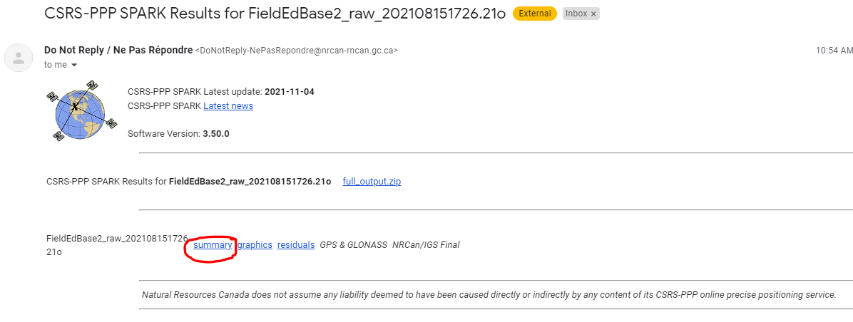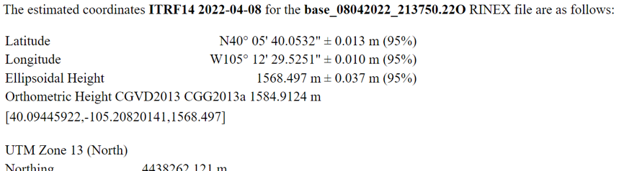

5. PPK – Post processing kinematic
Post processing kinematic (PPK) allows one to determine corrected rover positions after the survey is completed. The base and rover do not need to have a LoRa radio connection during the survey. This can be a good option if you are having trouble getting Fix between the base and rover, if you know ahead of time that line-of-sight will not be possible, or if you will not be able to acquire a known point for your base station prior to the kinematic survey day. Download Emlid Studio software.

Preparing to collect data
- Follow the procedures in the PPP section above (Section 4) for details on base station set-up and data recording settings.
- For both the base and the rover, go into the Receiver page > Logging.
Make sure that raw data is being logged, if it is not, click on the blue circle to start recording. The data should be logged in RINEX 3.03 format.
- Once the data logging is enabled, collect the survey data as you normally would, except make sure that you collect for at least 30 seconds at each rover point.
- A base occupation of at least 2 but preferably 4 hours is best.

Post-processing
- Download the RINEX files from both the base and the rover (see instructions in Section 4 PPP).
- As usual, also download the .csv project file of rover points from the Survey page.
- Submit the base station data to your PPP service of choice to an online processing service (see Section 4 PPP).
- Open Emlid Studio. In the dropdown menu in the upper left corner, select Stop & Go with Emlid Flow.
- Drag the RINEX .xxO file from the Rover into the Rover box.
Note: the “xx” in the RINEX file’s extension indicates the collection year. “.22O” means it was collected in 2022.
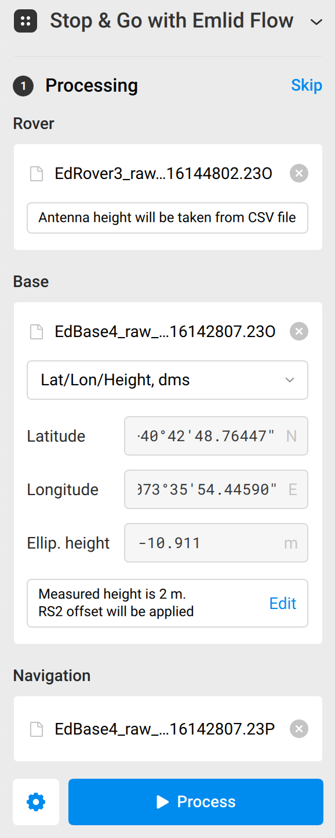
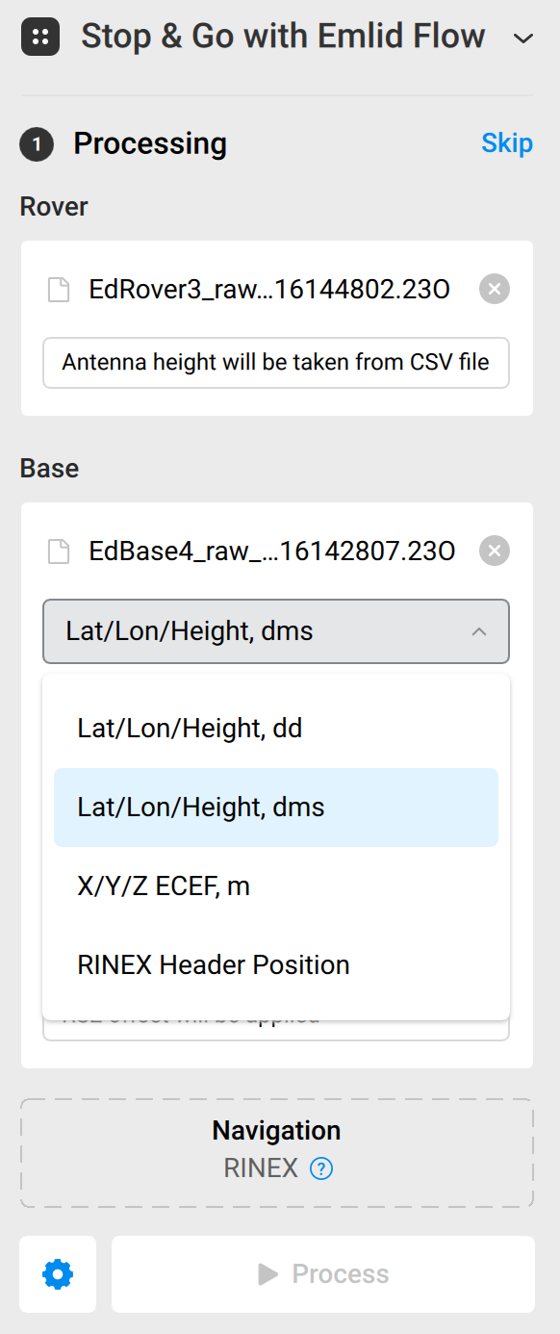
- Drag the RINEX .xxO files from the Base into the Base box. Select Lat/Lon/Height, dms from the drop-down. Enter the base coordinates from the PPP service you used.
Note: Emlid Studio will read the base height from the RINEX file but you can edit if needed in the Base section of Emlid Studio:

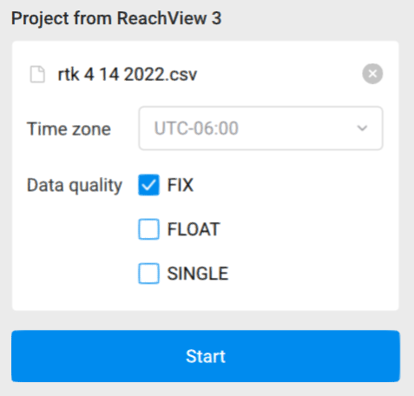
- For the Navigation file, drag in the .xxP file from the base.
- Click Process.
- For the next step, Generating Corrected CSV, drag in the survey project you exported from the Emlid Flow app (.csv file). Select the data quality you would like to keep (Fix, Float, Single). If you are doing PPK because you did not have line-of-sight between base and rover during your survey, you will probably want to select Fix, Float, and Single.
- Click Start.
- The output files should be saved in the same folder on your computer as the input files came from but sometimes it ends up in another recent folder. The resulting csv file will have the same name as the original but with ‘_corrected’ added to the end of the file name.

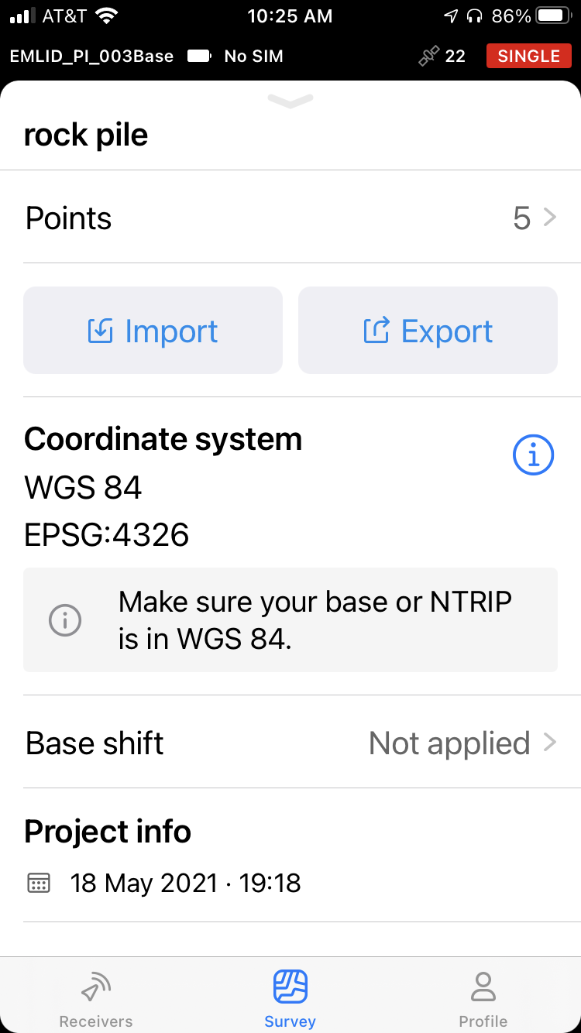
6. Base shift (moving the base during a survey)
There is a feature in the Emlids Flow app (Survey tab) called Base shift that will allow you to adjust the base position to a new location and carry on with the survey.
This can be helpful if you want to move the base to a new location and keep going on the survey (ex. leapfrogging along a survey line that is too long to do from a single base position; you might move the base to the position of a point surveyed by the rover). It does not shift the location of the previously collected rover points.
- Go to Survey and then select the Project for which you want to shift the base. Scroll down below the map to Base shift.
- Measured point > +Add point > Select the existing survey point that you want to use for the new base position > Apply
OR
- Known point > +Add point > Fill in the longitude, latitude, and height. (For instance, this could be a PPP solution from CSRS [see above]).

7. Using NTRIP over cellular to access corrections from a permanent GNSS station instead of a local base
This section will describe how to set up a rover receiver to NTRIP (Networked Transport of RTCM via Internet Protocol). NTRIP allows the rover to receive corrections over the internet and does not require a base receiver. You will need one Reach RS2+ or RS3 receiver that will be the rover station, two smartphones or tablets with the Emlid Flow companion app installed on one, the other will provide a cellular hot spot to the receiver. You can also use a SIM card (not provided) inserted into the receiver if you cannot use your smartphone as a cellular hotspot or do not have two smartphones.
You will also need access to an NTRIP provider in your region. One free option is the Network of the Americas (NOTA) real-time data service. This network has much higher density in the western US. Look for stations near you on the NOTA Real-time Network Monitoring Map. https://www.unavco.org/instrumentation/networks/status/nota/realtime. Request access by emailing rtgps@unavco.org.
Note: The longer the baseline between base (NTRIP station) and rover, the lower the resulting accuracy. Uncertainty increases by ~1 mm per km distance on top of the ~1 cm initial uncertainty. This means that an NTRIP station 30 km away will allow at best 4-cm accuracy. Baselines should be 50 km at most. Less than 20 km is better.
For more information on NTRIP see: https://www.unavco.org/data/gps-gnss/real-time/real-time.html and https://igs.bkg.bund.de/ntrip/ For Emlid notes on using NTRIP see: https://docs.emlid.com/reachrs2/quickstart/ntrip-workflow
The rover receiver needs an internet connection to work with NTRIP. There are two ways to connect the Reach to the internet:
- Turn on mobile data on your smartphone and share it with the receiver over a WiFi hotspot, the reach will connect to your network and get internet access.
  - The smartphone used as a WiFi hotspot cannot be used to connect to the receiver through the Emlid Flow app. You will need a second smartphone or a SIM card to control the receiver.
- An active SIM card in the receiver avoids the use of a smartphone hotspot.
  - You will need a Nano SIM card for the Reach,
  - Insert the SIM card into black sealing at the bottom of the receiver.
    - Slide the metallic cover to the right, lift it up, insert the SIM card into the cover, close the cover and slide it to the left to lock it in place.

If you will be using two smartphones follow these steps:
- Prepare your smartphone to provide a mobile hotspot.
  - Typically, you will find this under Settings/Cellular
- Turn on your receiver and make sure it is in hotspot mode, WiFi symbol (Fig. 1) is white.
  - To turn hotspot mode on, select the menu in the upper right corner (Fig.1), select WiFi and switch Hotspot to On
- On the smartphone you will use to control the rover, connect to the Rover via its WiFi hotspot.
- Return to the rover's WiFi settings, and connect the rover to the phone's hotspot which should be listed under Available Networks.
- In the Correction Input settings, select the NTRIP tab, and enter:
- Address (the IP address of your provider)
- Port (specified by your provider)
- Username for your NTRIP provider
- Password for your NTRIP provider
- Select your Mount Point from the dropdown list.
  - This is your closest GPS station in the network. Scroll through the pull-down list to find the correct station. Be sure to select the closest location with the RTCM3 option.
- Format: RTCM3
- Once these changes are applied and you are connected, the bottom of this page should show that you are connected in green text.
- On the Status page:
  - Grey bars next to orange and green bars confirm that you are receiving a correction.
  - Solution Status should be Fix and the accuracy should be around 0.01m. If not, restart the controller/receiver.
- At this point, you can leave the smartphone that is acting as the hotspot in your pocket and control the rover with the other smartphone to collect data. No need for a base!

If you are using a SIM card instead of a second smartphone follow these steps:
- Turn on your receiver.
- Open the Emlid Flow app on your smartphone, click on the rover device and wait for the SIM card to load (it will say Loading… at the top of the app).
- If the SIM card is locked, you will be prompted to enter the PIN for the SIM card. Once connected you should see green bars under Status.
- Go to the menu and select Mobile Data and switch to On. You should now see network bars at the top of the Emlid Flow app next to the battery icon.
- In the Correction Input settings, select the NTRIP tab, and enter:
- Address (the IP address of your provider)
- Port (specified by your provider)
- Username for your NTRIP provider
- Password for your NTRIP provider
- Select your Mount Point from the dropdown list.
  - This is your closest GPS station in the network. Scroll through the pull-down list to find the correct station. Be sure to select the closest location with the RTCM3 option.
- Format: RTCM3
- Once these changes are applied and you are connected, the bottom of this page should show that you are 'connected' in green text.
- On the Status page:
    - Grey bars next to orange and green bars confirm that you are receiving a correction.
- Solution Status should be Fix and the accuracy should be around 0.01m. If not, restart the controller/receiver.
- You are now ready to conduct your survey without a base.

8. Downloading a system report
This could be useful in order to retain record of the settings you used. It could also help if a field engineer is trying to diagnose any issue remotely.

- Connect to the receiver WiFi and open the Emlid Flow app. Select the receiver, then select Emlid Flow.
- Settings > Troubleshooting > System report.
- Select the simple or full report.
- Simple report > Copy. This will copy the report to the clipboard. Now this can be pasted and emailed as text.
- Full report will generate a zipped file, this can be downloaded as well and then emailed or otherwise transferred but cannot be copied as text to the clipboard. The simple report does have most settings that we would need to troubleshoot the issue.

9. Connecting to receiver using Windows or Mac computer browser
One can also connect to the Emlid Reach receivers using a computer instead of a mobile device as described in the first section. Instead of using Emlid Flow, you can find all the same information and controls via a browser for both Mac and Windows machines.

Connecting computer to receiver over WiFi
Note: Emlid Reach devices require 2.4 GHz (not 5GHz) WiFi network. If you intend to connect your receiver to a local network, determine that the network is at least dual frequency. Typically, Emlids will successfully connect to the 2.4 GHz component of a network with both 2.4 and 5 GHz.

To see the Emlid controls on your computer browser (or a browser on your phone), the main thing you need to know is the correct IP address to enter into the browser address bar.

Make sure you are on the same WiFi network as the receiver.
- Hotspot mode – if the receiver WiFi indicator light is steady white, the receiver is sending its own hotspot signal.
  - Join the receiver’s hotspot with your computer. On a Windows machine, you may need to select “Connect using a security key instead” (of a pin number). Then use the typical password: emlidreach.
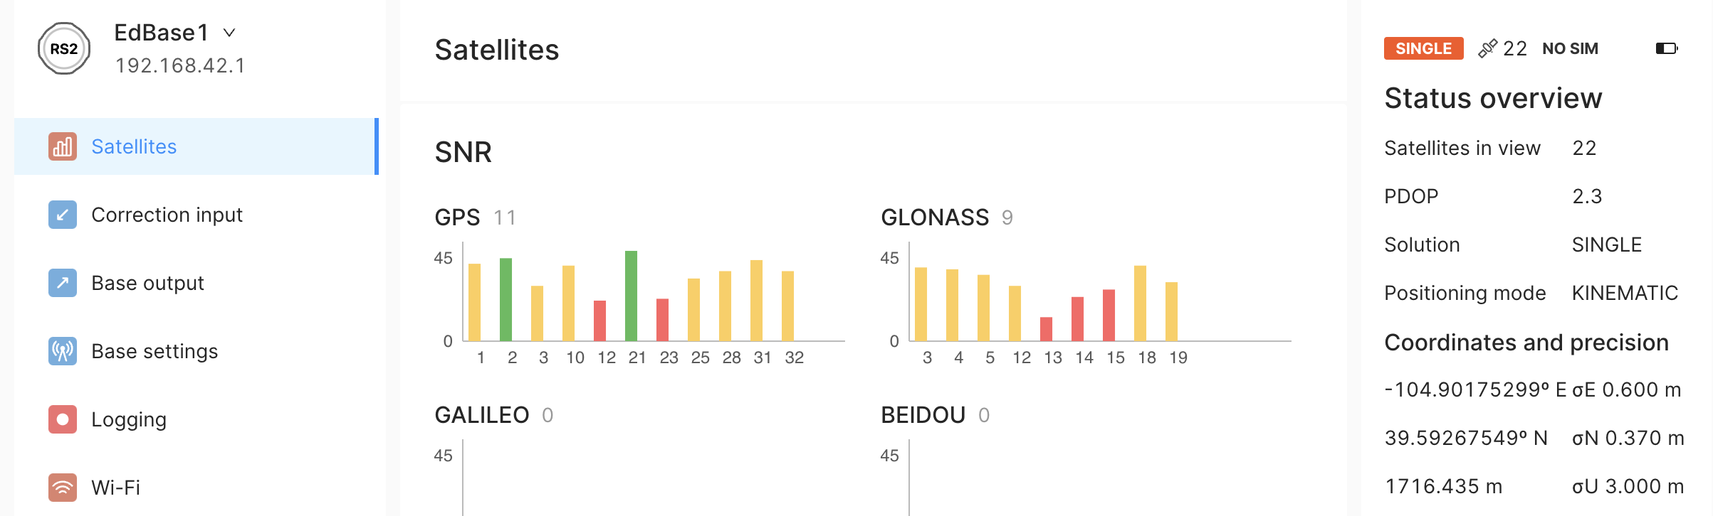
  - Open a browser window and enter IP address 192.168.42.1 into the browser address bar. You should see a page that looks similar to Emlid Flow but more spread out.
- WiFi network – if the receiver WiFi indictor light is steady blue, the receiver is on a local WiFi network.
  - Join the same WiFi network with your computer. Now you need to find out what IP address the receiver has on the local network.
  - Option 1: Download a program called “Fing” (fing.com) to easily find the IP address of your receiver under “devices” and enter the specified IP address into your browser address bar.
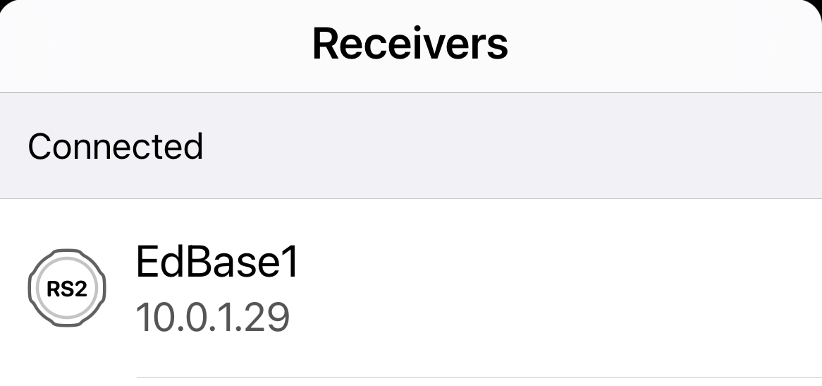
  - Option 2: If you also have a mobile device with Emlid Flow, you can find the IP address listed under the receiver’s name in the app. Ex. 10.0.1.29. Then enter the specified IP address into your browser address bar.
  - Option 3 Windows: Find the IP address of your receiver via command prompt.
    - In the command prompt, enter “ipconfig”.
    - The IP address of your computer is listed under WiFi next to “IPv4 Address”.
    - Then, enter “arp -a” to provide a full list of devices on your network. The receiver will likely have an IP address very similar to that of your computer. It will also have a “dynamic” IP address and will be listed as so. (see screenshots below)
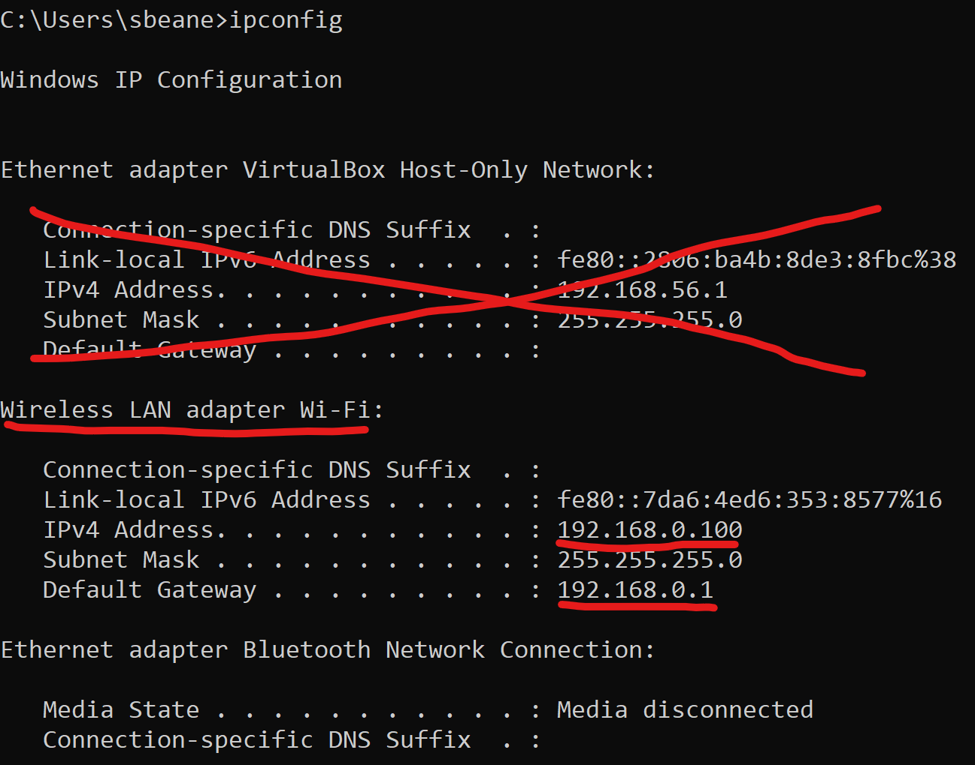
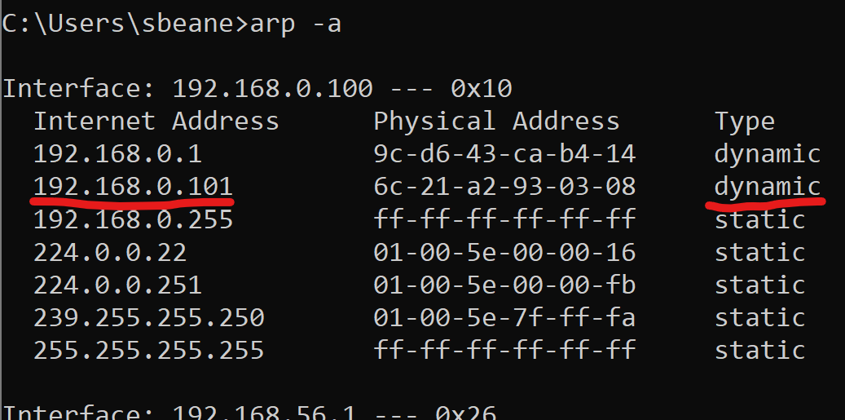
    - Enter this IP address into a web browser address bar.
“ipconfig” showing the router’s IP address as 192.168.0.1 and this computer’s IP address as 192.168.0.100
“arp -a” showing the router and receiver IP addresses. If you have a lot of devices on the network, it may take a few tries to figure out exactly which one the receiver of interest.

  - Option 3 Mac: Find the IP address of your receiver via the Terminal by entering “arp -a” and entering that IP address into a web browser. Again, it may take a little trial and error to find which device on the network is the receiver of interest.

Connecting Mac computer to receiver using USB cable
- Turn on the receiver and connect via USB cable (same one used for battery charging).
- In System Settings > Network, you should see “ReachRS” pop-up with a green light and an IP address 192.168.2.XX. This is the IP address of your computer on this network.
- Emlid sets an IP address for when the Emlid Reach is connected with a cable to be 192.168.2.15. Enter this in a web browser.

Note: at the time of writing, the method to connect Windows machine using Ethernet over USB was complicated and not reliable.

