QuickStart Guide for the Emlid Reach RS2/2+/3
Beth Pratt-Sitaula (EarthScope) and John Galetzka (UNAVCO)

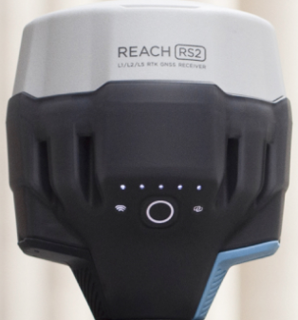
Quick Start
1
2
3
4
Emlid provides many good resources for getting started with Reach GPS/GNSS receivers https://docs.emlid.com/reachrs2/. This guide is designed to augment the online resources for easy access in the field.

This QuickStart Guide assumes:
- Students have learned the basic overview of how Real-time Kinematic (RTK) GPS/GNSS surveys work with both base station and rover/s.
- The supplied Emlid Reach base and rover are preconfigured and fully charged so that you may rapidly carryout an RTK survey.
Figure 1. Image of the Emlid Reach receiver. (1) power button, (2) battery status LEDs, (3) WiFi status, (4) RTK status
- You are provided a benchmark for the base station with accurate known coordinates.
- You are provided a tripod for the Reach base and survey poles for the Reach rovers.
- Minimal solar activity—check NOAA website (https://www.swpc.noaa.gov/)
- You already downloaded the Emlid Flow app from your phone/tablet’s app store. Apple and Android are both supported. Do this before you leave cellular or WiFi range if you are headed to a remote field site. Also, while you are on cellular or WiFi, open a Survey project and zoom in on your field location so the maps download.

Turning on and connecting with a Emlid Reach receiver
- Turn on the receiver by pushing the round button for 3 seconds until all LEDs light up. Wait until WiFi status light turns steady white (about 60 seconds). White shows that the receiver is in hotspot mode and broadcasting WiFi.
(If the WiFi status light stays blue it means the receiver has joined a local WiFi network instead. You can join the same WiFi network and continue with Step 3 below. If you want the receiver to switch to Hotspot mode instead, see troubleshooting section below.)
- Go to your phone/tablet’s Settings and select the WiFi network broadcasting from the receiver you want to connect to (it will take a little while to show up after the receiver turns on).
Password for all Emlid Reach is “emlidreach”
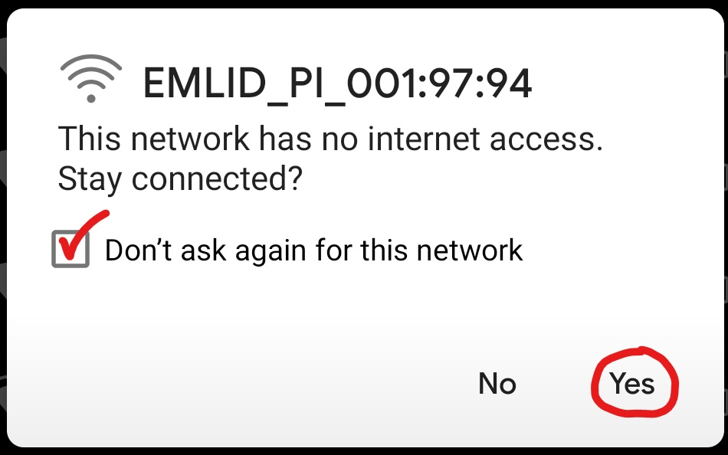
NOTE: After selecting the receiver’s network on your list of available WiFi connections, make sure you are truly connected. On some Android and Apple phones, a pop-up notification may say that the newly selected network “has no internet connection” and will default to immediately disconnect unless you specify otherwise. See images below. The name of your receiver’s connection may not be the same as shown below.
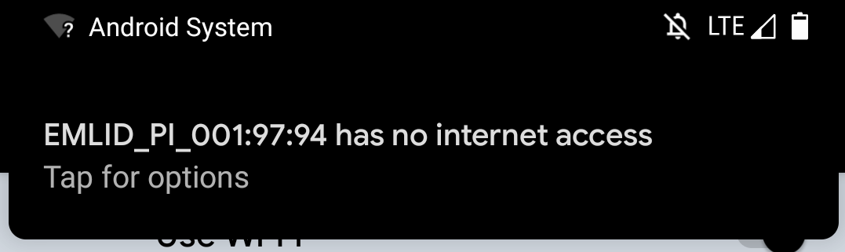
- Open Emlid Flow app. If it is already open, it might work best to close and reopen. (Generally, if you have any issues with the Emlid Flow app, restarting usually helps.) Once the dot-lights on the receiver become solidly on, the receiver will show up in the Emlid Flow app and you can select it. This will take you to the Receivers page and show you the one you are connected to.

Starting the base
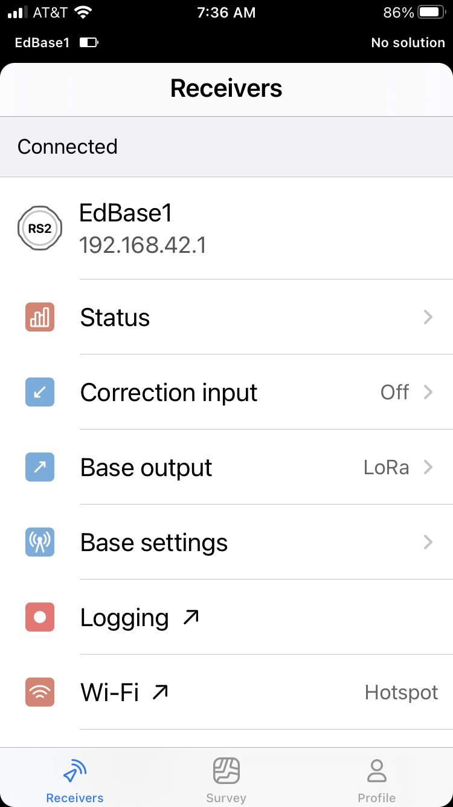
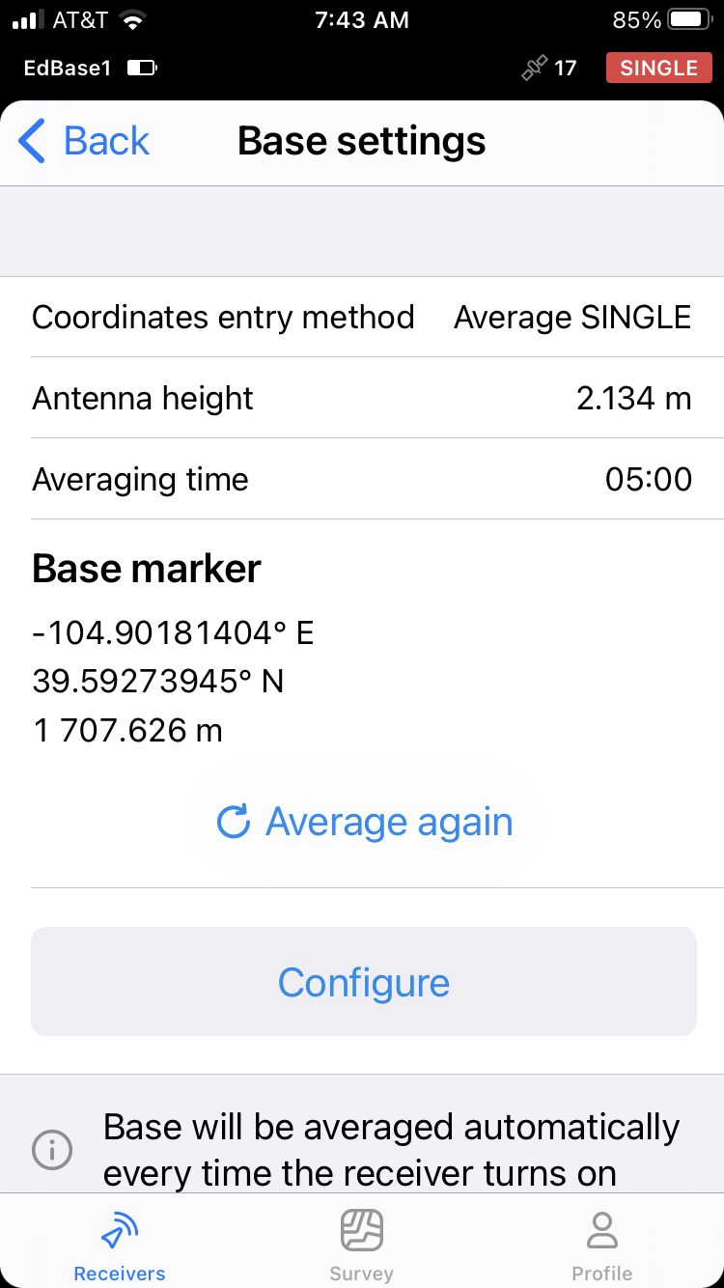
- Attach the LoRa antenna and mount the Emlid Reach base on the tripod and accurately level over the benchmark.
- Turn on and connect with the receiver as described above.
- Select Base settings.
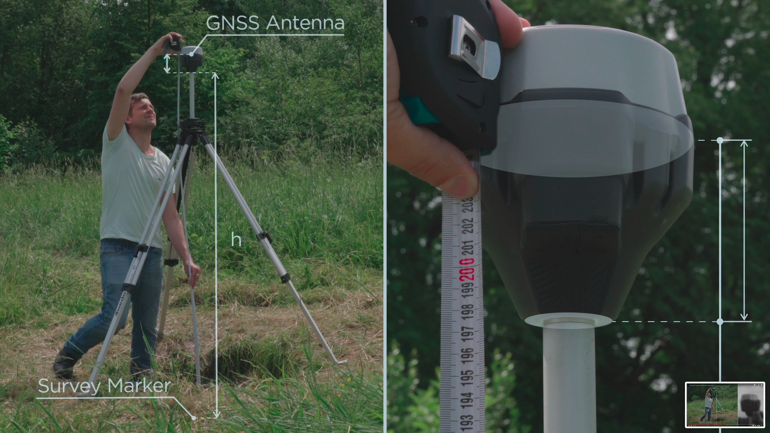
- Configure > Coordinate entry method > Manual and enter in the coordinates for the base station that you have been given. Antenna Height: Measure from the ground to the base of the Reach device to determine the Measured height. For example, if you are using a 2-meter pole and quick-tripod setup, your Measured height will be 2 meters. The actual phase center of the antenna is 0.134 m higher but the receiver will include that automatically.
0.134m
- OR if the survey you are doing does not require a highly accurate base location and there is no known benchmark, your instructor might tell you to just collect a quick location. To do this, select Average single instead of Manual. Then select a duration of time to average the position over. Five minutes can work if your instructor does not tell you otherwise.
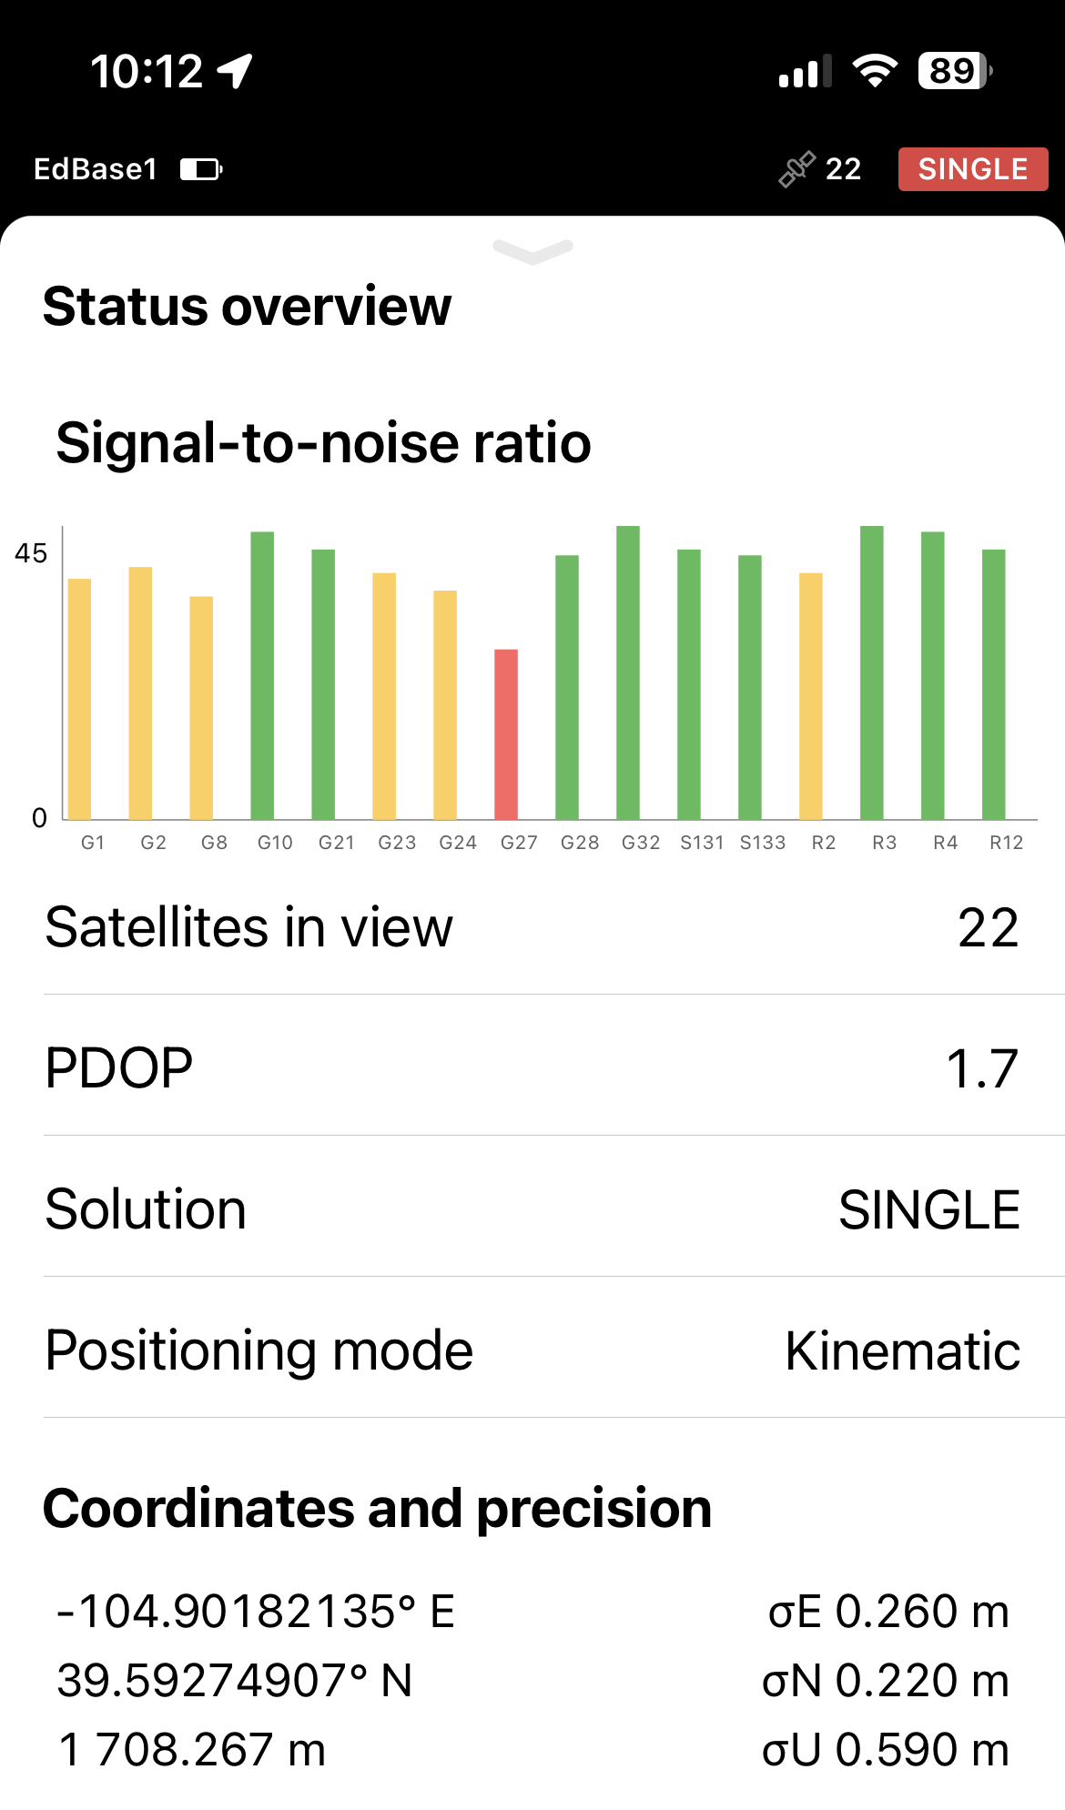
- Select Status on the main receiver page and check that there are plenty of Satellites in view. Technically 4 is enough but these receivers are set to require 7 or more; more than 10 is best, and these days >15 is common. PDOP (position dilution of precision) describes the error caused by the relative position of the GPS/GNSS satellites. Basically, you want the satellites as spread-out across the sky as possible and not only in one area, say overhead. Low PDOP values, in the range of 4.0 or less, indicate good satellite geometry, whereas a PDOP greater than 7.0 indicates that satellite geometry is weak. Solution will be Single because the base is not receiving any corrections from another receiver. Estimated accuracy will likely be in the meter-range for the base.
- Check Logging tab. Start recording Raw data (RINEX 3.03) and Position (LLH or XYZ). If the data are already recording, it means the previous user did not stop the logging before turning off the receiver, so the logging automatically restarted when the receiver was turned back on. This is ok, but less recommended. If you turned on the base station after the receiver was in place on the tripod, you can just let the logging continue. If the base station receiver was moving around while on, then you should stop the logging and then restart it. This will ensure that all the data in the file was collected after the receiver was in place. (Base correction should be off for the base station because it is not receiving corrections.)
- When the survey time is complete, stop the Logging and export the Raw and Position files before turning off the receiver (see final step in Rover section below on how to export).

Starting the Rover
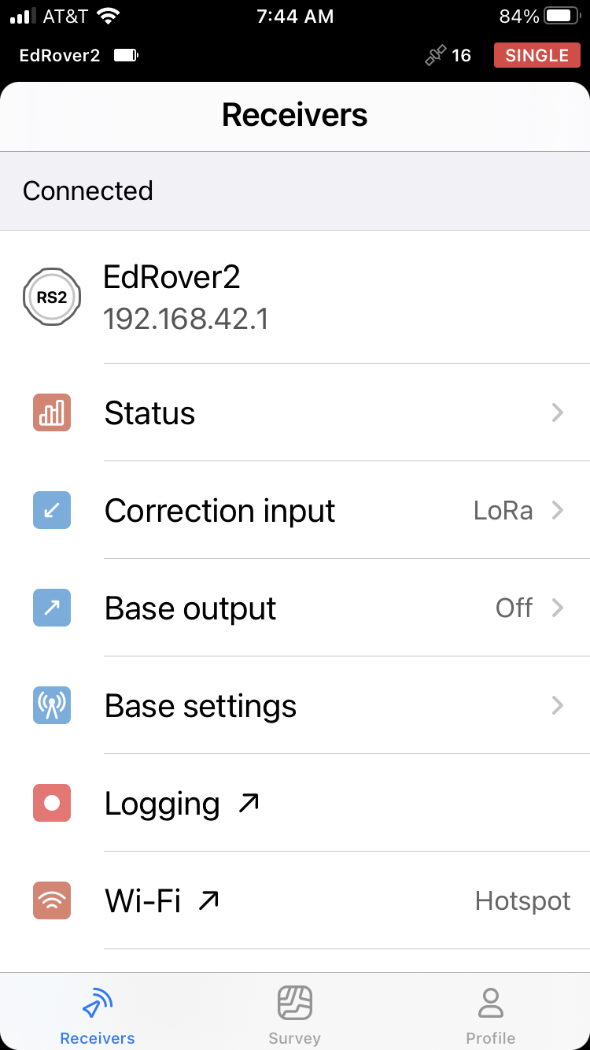
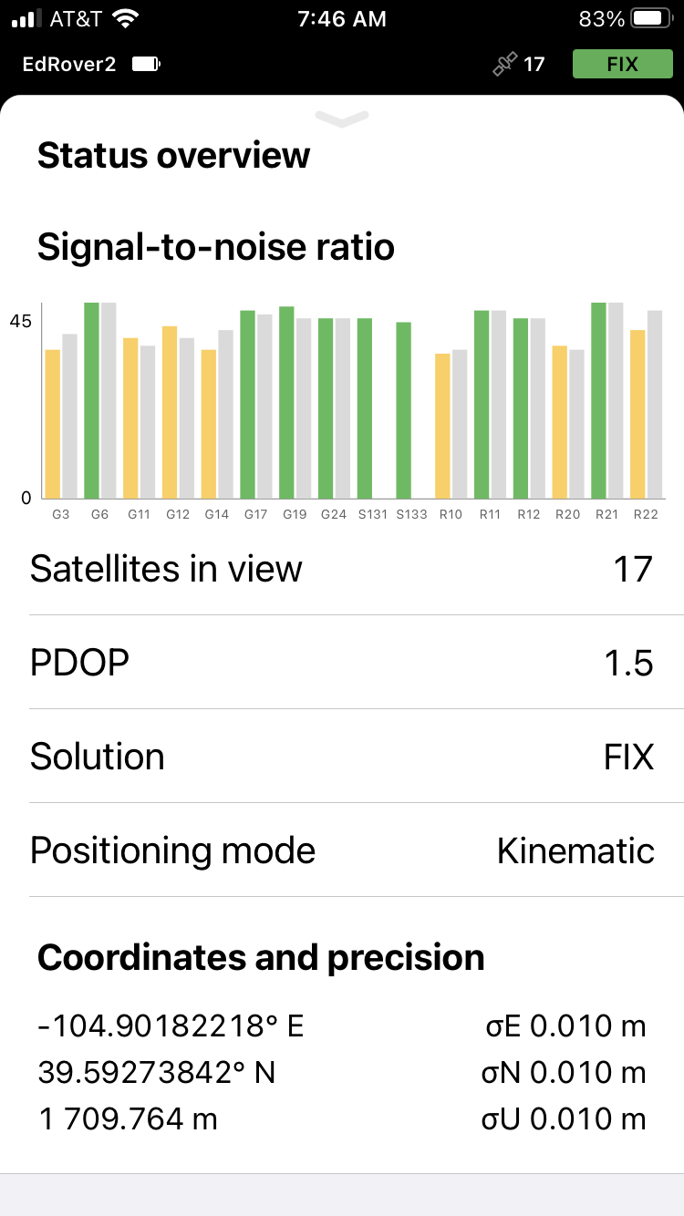
- Attach the LoRa antenna and mount the Reach a survey pole. Turn on and connect with the receiver as described above in the base section. Select Status on the main receiver page and check that there are plenty of Satellites in view. Technically 4 is enough but these receivers are set to require 7 or more; more than 10 is best, and these days >15 is common. PDOP (position dilution of precision) describes the error caused by the relative position of the GPS/GNSS satellites. Basically, you want the satellites as spread out across the sky as possible and not only in one area, say overhead. Low PDOP values, in the range of 4.0 or less, indicate good satellite geometry, whereas a PDOP greater than 7.0 indicates that satellite geometry is weak. After a few minutes, the Solution should change from Single (no base correction) or Float (base connection but not full correction) to Fix, meaning all ambiguities are resolved and RTK solution is showing centimeter-level Estimated accuracy. Establishment of Fix is accompanied by a beep from the receiver. You are now ready to start your surveying. You can close the Status page.
- Check Logging tab. Start recording Raw data (RINEX 3.03), Position (LLH or XYZ), and Base correction (RTCM3). If the data are already recording, it means the previous user did not stop the logging before turning off the receiver, so the logging automatically restarted when the receiver was turned back on. This is okay, but less recommended.
- Go to the Survey icon on the bottom of them main receiver page. This feature allows you to make project-based point collection with auto-save rules or manually and then export the data into different formats. It is perfect for surveying and ground control point collection.
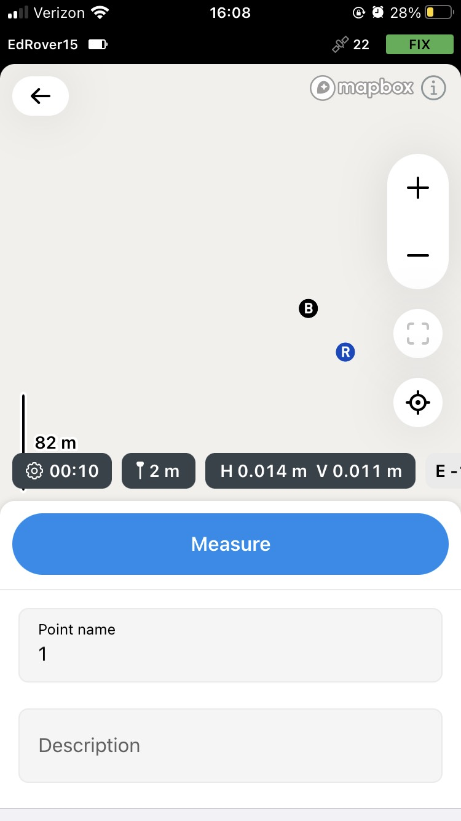
- Click the + in the upper right corner to start a new project (or click on a project name to open an existing one). Give the new project a name, put down the people involved in the survey as Authors, and add a description if it will be helpful.
  - Coordinate system
    - Default is geographic coordinates which will appear as Global CS (which is the Emlid term for WGS 84, EPSG:4326) with vertical datum of “ellipsoidal height.”
    - If projected coordinates are preferable, use WGS84 / UTM zone xxx (select correct zone for your region),
  - Then click Save.
- Press to go to the point collection window. Open the pole height menu. 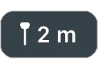 In most cases you will be using a 2-meter pole so no changes will be needed, but if your pole is a different height, enter that value instead. Click Save.
- If you want the data collection to average over a certain time period, select 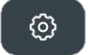 to choose the duration you want. Ten seconds can work fine if your instructor does not give you another protocol. To ensure highest quality results, it is a good idea to activate FIX only option. You will not be able to collect a point unless the rover has a Fix solution.
- If you wish to change the point’s name or add a description you can edit those in this menu. If you do not change it, the default point name will increment through “1,” “2,” etc. If you choose a name such as ‘Point 1’ the name will similarly increment automatically as you collect more points.
- When you are ready to collect a point and the pole is being carefully held over the survey point with the level bubble leveled, select the blue “measure” button to start collecting.

- If you are having trouble maintaining Fix, there are suggestions in the Troubleshooting section below. If that still does not solve the issue, your instructor may decide to switch to a PPK workflow. In that case, turn off FIX only and each collection point should be done for 30 seconds.
- Point options: To open the list of all points, press . You can open point details, edit the point info, find it on the map, or stake out the point. You can work with each point separately by choosing it on the map. Read more about Point Stake Out function (finding a point of known coordinates) in the Emlid guide (https://docs.emlid.com/emlid-flow/survey-with-ef/points/stakeout/). When you are done, press <Projects to close and save. The project will be available in the Survey menu.
- Exporting Data: When you finish collecting points, you can export your project. Press ••• and Export. Generally, the default format is CSV. You will be prompted to decide how you wish to send the file. Then go to the Logging tab and turn off logging for Raw, Position, and Base correction data and export those as well. If you choose to email files to yourself and you are currently connected to the receiver hotspot, after you “send” the email, disconnect from the receiver hotspot so that the email can actually can go out via cellular or another WiFi network.

Troubleshooting and some good things to know
This is not a comprehensive troubleshooting guide but addresses some of the more common issues.
- If the Emlid Flow app does not seem to be finding the receiver or is taking a really long time to move from the selection pane to showing you the status of the receiver, try restarting the app. Restarting the app seems to help with many things.
- If the WiFi LED light to the left of the power button is showing blue, then the receiver is joined to a local WiFi network rather than serving as hotspot itself. Join the same local WiFi network so you can connect to the receiver through it. Go to WiFi, then Activate the Hotspot. If you wish to prevent this in the future, you can “forget” the known WiFi network.
- Some phones are set to not connect to hotspots/WiFi networks that are not connected to the internet. If you appear to be joined to the receiver’s hotspot but are then not actually able to connect in the app, open your phone’s settings. Select the receiver’s WiFi network and require it to “join anyway” (even though it is not connected to the internet)
- If the Emlid Flow app is saying “sorry Emlid Flow is not responding” try forgetting the receiver’s WiFi network and then rejoining it again. Rebooting your phone/tablet can also work.
- Survey maps not showing up – The maps need to be downloaded while you are on cellular or WiFi. If they are not showing up and you are already in the field, hopefully you still have some cell service. Disconnect from the Emlid and allow the app a chance to download the maps over cellular by zoom in on the field area while in your Survey project. Restarting the app can also help before you try to reconnect with the Emlid. If you are already out of cell range, the data points you collect will still be fine, the survey map view will just be less helpful.
- The reference frame used by Emlids is WGS84 and vertical datum “ellipsoidal height”.
- Getting Fix status with the rover: Usually the rover shows Fix after a few minutes (accompanied by a beep). However, sometimes, it can take longer—even more than 10 minutes—for reasons that can be hard to determine. Here are some things to check:
  - Make sure the LoRa antenna on both the base and rover are screwed all the way on. You often need to gently hold the little rubber flap back with one hand in order to get a completely perpendicular angle to screw in the antenna with the other hand.
  - If your rover is still not getting a Fix status, trying waiting longer. If it still does not work, try restarting the rover. Moving to a slightly different distance from the base can help sometimes (perhaps there is interference at a particular distance OR you are too close to trees or buildings).
  - Make sure that your base has a fairly accurate known location. If the base location is off by >10 meters from its actual location, it can take longer to get and keep Fix with the rover. If the base location is off by 100 meters, it is unlikely Fix for the rover will be achieved. If you used a Manual location in Base coordinates, check that you entered it correctly. If you used an Average single, try collecting again for a longer period of time.
  - If the rover is receiving corrections (you can check this by going back to the main menu and choosing Correction Input where it will either say “Waiting for corrections” or “Receiving corrections”) and is in the Float status but not Fix, try moving to an area with better sky view.
  - If you have an Emlid Reach RS3 try turning off the tilt compensation if it is on. This is a useful feature in certain tight situations, but not needed for most geoscience use cases. It seems to make the rover more fussy about achieving Fix.
  - Check solar activity (NOAA Space Weather https://www.swpc.noaa.gov/). It can affect the signal from the satellites as they pass through the ionosphere. If either the base or the rover is not getting consistent “lock” on at least seven satellites, the rover will not get Fix.
  - Consider whether there could be radio interference in your area from other sources or a significant multipath reflector (nearby buildings, vehicles, or trees reflecting the GPS/GNSS signal along a path longer than the direct signal).
  - If you lose Fix after having it, try coming back closer to the base. You may have lost line-of-sight between the two receivers and need to reestablish Fix from a closer point. You may need to experiment for a particular location on conditions for how far away you are able to get away from the base or what LoRa settings (above) are optimum.
  - Make sure you have the same LoRa settings in the Correction output tab on the base unit and in Correction Input on the rover. The base should be at full Output power of 20 dBm. You could also try adjusting the LoRa settings, such as lowering the air data rate (this typically allows the LoRa signal to have a longer baseline, although fewer corrections will be sent per unit time, so you would likely need to select just the GPS constellation to limit the amount of data). You could also try adjusting the frequency. Although generally higher frequency will penetrate further, you may have local interference at certain frequencies. Try stepping down 1–2 MHz at a time (of course you need to make the same changes on both base and rover/s).
  - If you still have trouble establishing Fix and would like to discuss it with a technician, please take multiple pictures of the site and contact education@earthscope.org.
  - In the meantime, if a survey needs to be completed that day, it may make sense to switch to a PPK (post-processing kinematic) survey. That workflow is described in the Instructor Guide for Emlid Reach RS2/2+/3 (https://serc.carleton.edu/getsi/teaching_materials/high-precision/equipment.html#emlid). Be sure to increase survey point collection time to at least 30 seconds and hold that pole as still as possible even for this longer time.

