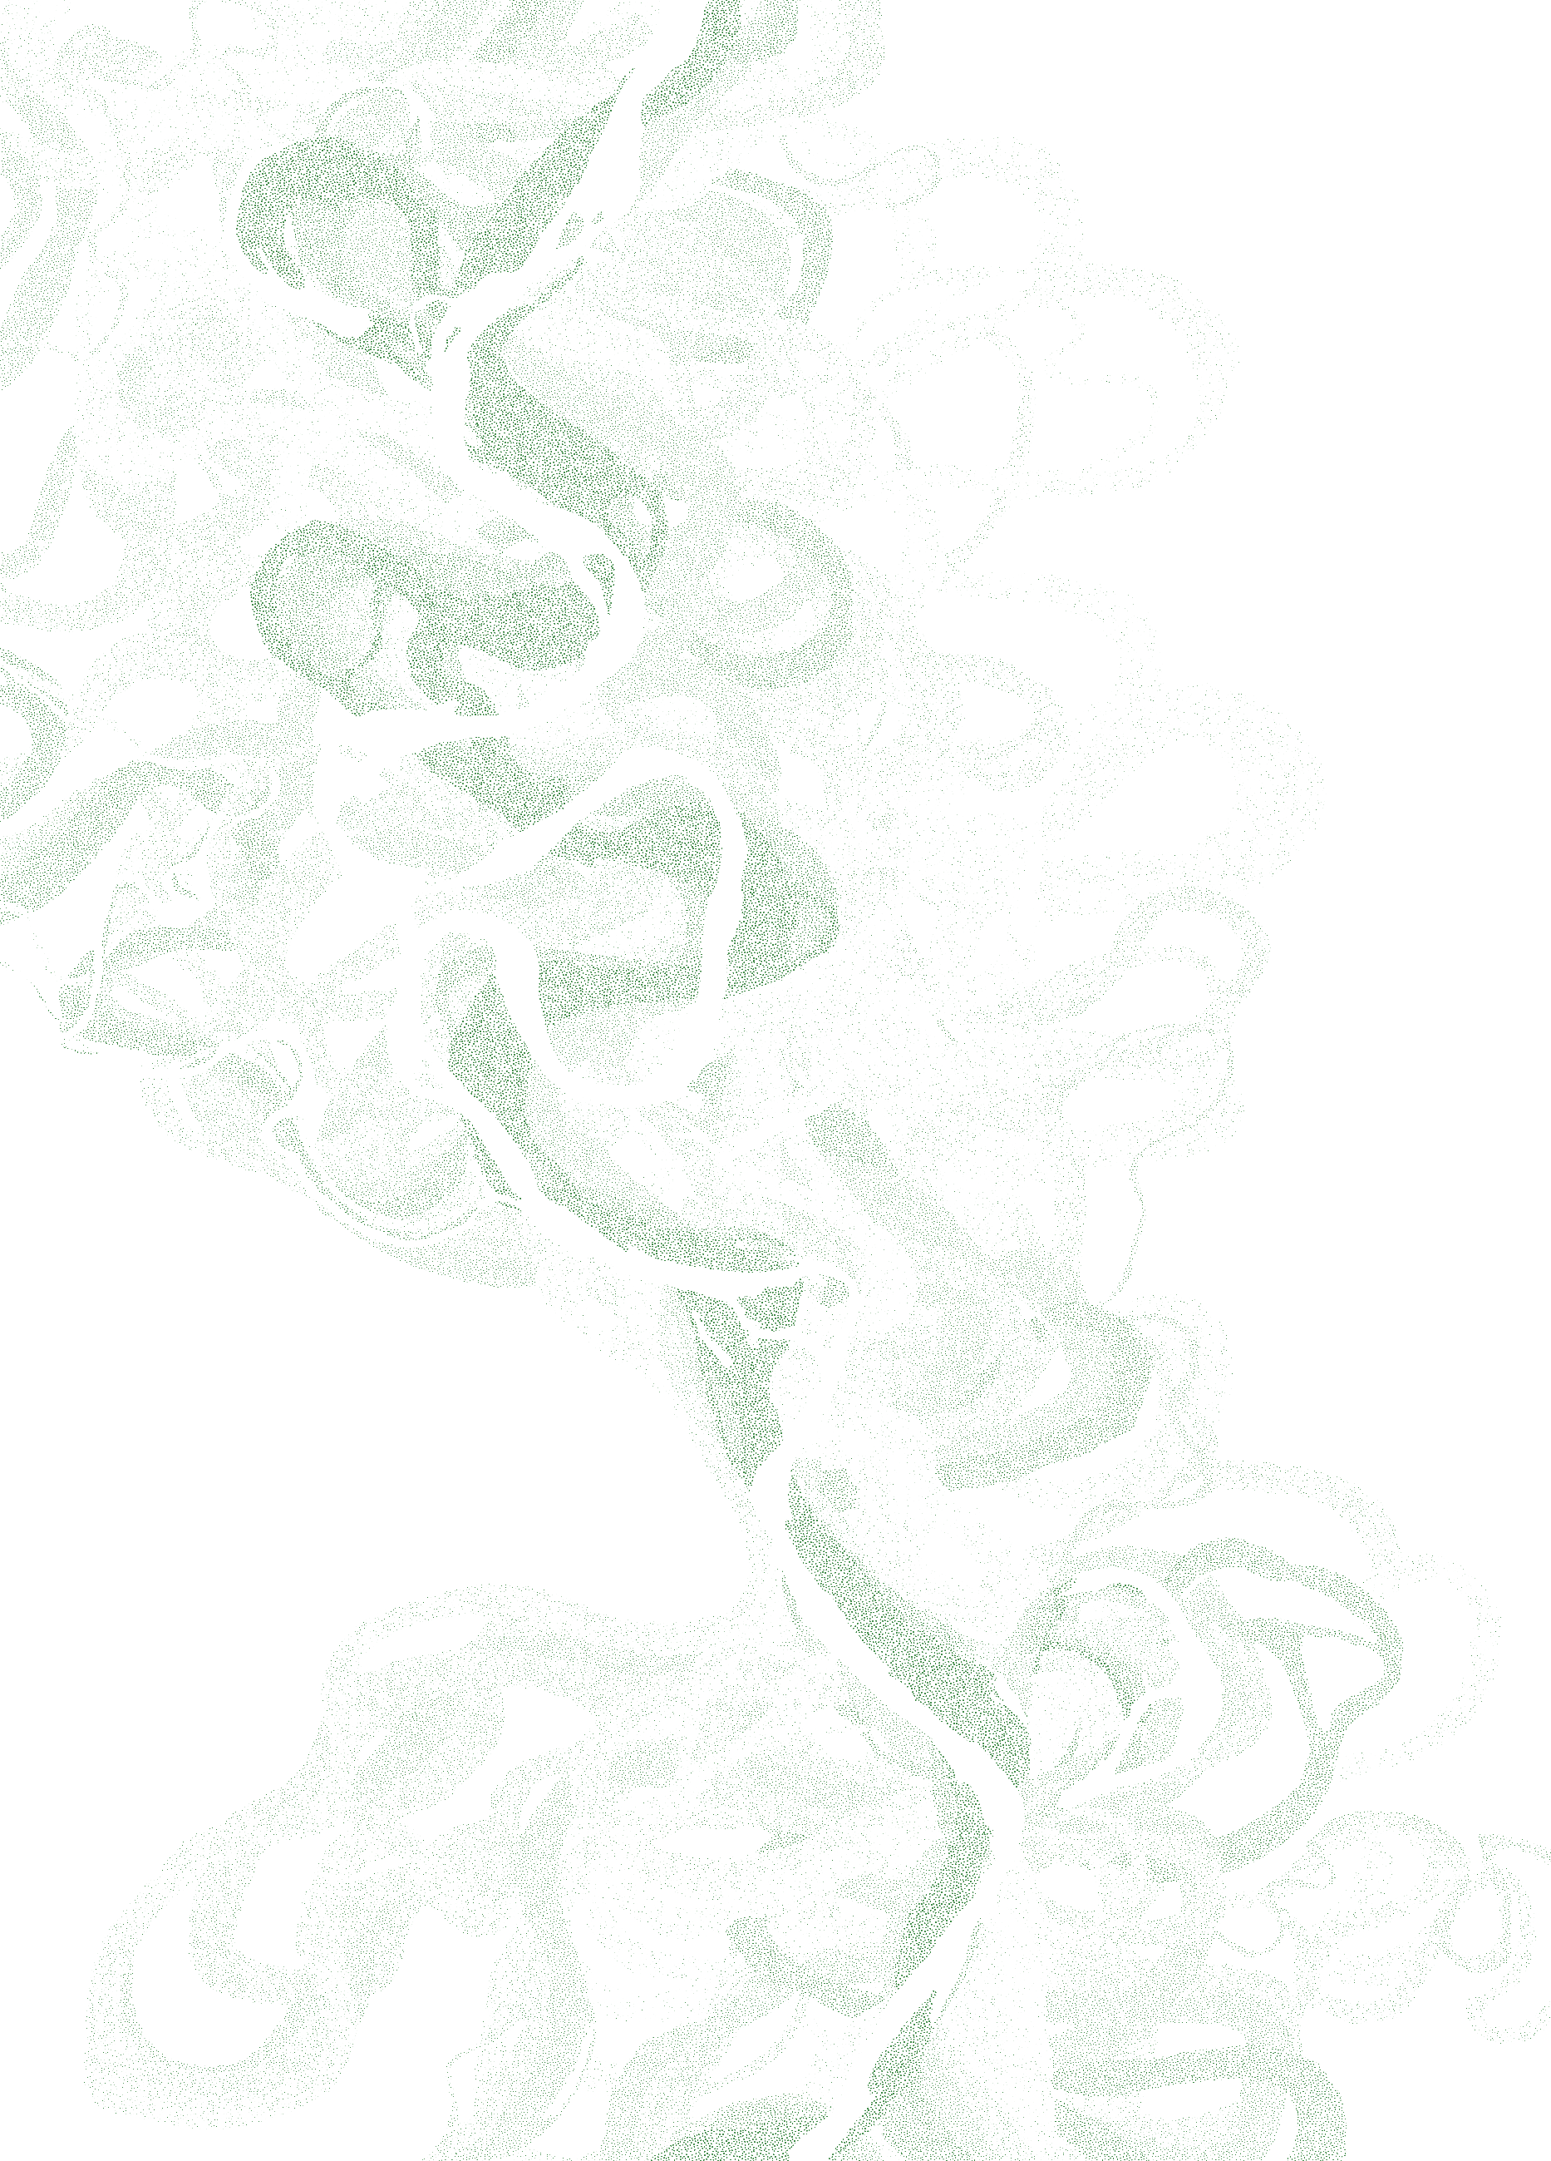
Emriver Stream Table Lab
Figure 0.2. Parts of the Emriver WHATEVER.

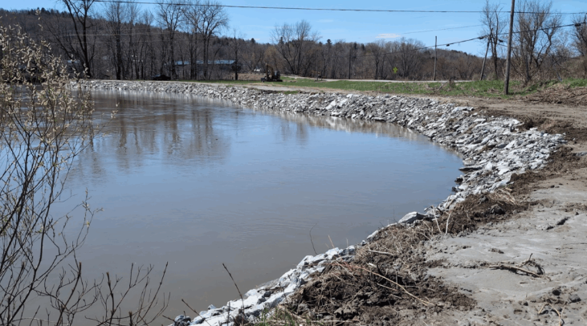
  - Bank Stabilization and Armoring
Emriver, Inc.
Carbondale, Illinois, USA
+1.618.529.7423
info@emriver.com
www.emriver.com
Rip rap armoring on stream bank. Vermont River Conservancy

Introduction

Stream Bank Stabilization and Armoring
Bank armoring is likely as old as civilization. Where people settle or build structures near rivers, they encounter channel movement across the floodplain that threatens those structures. Channel migration is, of course, part of the process that built fertile, flat floodplains, but people are in constant conflict with it.
Armoring schemes are limited only by the imagination, economics, and materials at hand, ranging from old automobiles, junk, and tires dumped on banks by a landowner to multibillion-dollar engineered projects along big rivers like the Mississippi.
When considering the various approaches to bank armoring, engineers work to quantify variables such as maximum flow, sediment load, slope over a long reach, etc. The techniques applied for stabilizing banks and controlling erosion involve changing the bank roughness (quantified using the Manning’s coefficient), channel and bank substrate, and channel geometry. For the purposes of this lab, it is helpful to think of the stream as an energy system, and consider how the armoring approach may absorb, dissipate or redirect that energy.
This lab invites students to experiment with various techniques in the small, controlled environment of a small stream table. It focuses on qualitative observation and comparison. Field observations, as a class or a homework assignment, are a great addition.

Armoring Techniques
Soft Armor
Soft armoring involves the use of living plants, either alone or in combination with natural material structures, to protect a riverbank against erosion. Planted vegetation protects a riverbank in numerous ways including holding soil together through root structures, absorbing rainwater, dissipating the impact of rainfall through leaves, and helping to slow water flows and encourage sediment deposits that can help build up the shoreline rather than wear it away. Bioengineering is generally less expensive and less disruptive than hard armoring, and supports natural habitat for both terrestrial and aquatic wildlife. However, soft armoring is not appropriate for every site. The riverbank must be stable enough to support vegetation, and even strong trees are sometimes no match for freezing, thawing, and ice scouring, or large-scale seasonal floods.
Hard Armor
Hard armoring is a riverbank stabilization technique in which the bank is graded to a low angle, then covered with materials such as stones, called rip-rap, stacked with rock-filled wire baskets called gabions. Poured concrete is sometimes used, typically in dense, urban areas. Hard armoring can be expensive, add little in terms of environmental value, and may not be aesthetically pleasing. Hard armoring can also redirect flow and erosion to the streambed, downstream banks, or adjacent unprotected areas. If poorly designed, hard armoring may fail or even contribute to additional erosion and the ability of a channel to adjust over time. Hard armoring may be appropriate in severe situations where more environmentally friendly solutions like seeding or planting are unlikely to hold or where urban constraints require.
An alternative to installing gabions parallel to the shore is to build groynes or spur dykes. These consist of a series of walls running perpendicular to the shore, anchored in the riverbank and extending into the river to slow and redirect the water flow.
A helpful summary of techniques, with photos, created by the Tennessee Valley Authority is available here: https://www.govinfo.gov/content/pkg/GOVPUB-Y3_T25-PURL-LPS106852/pdf/GOVPUB-Y3_T25-PURL-LPS106852.pdf

Objective
Compare the effects of various methods of bank stabilization using a stream table and experiment with novel approaches. Students should pay particular attention to the location and rates of change after any applied armoring technique. Where do erosion and deposition occur before and after the intervention?
Equipment and Materials
- Emriver Em2, Em3 or Em4 stream table
- Plastic vegetation
- Limestone riprap
- Plastic riprap
- Rigid plastic, such as the triangular scrapers
- Synthetic fabric or mesh

Procedures
This lab can be conducted in a single session, but results are more informative if each experiment can run at least a half hour. Breaking the different techniques into separate sessions will allow for longer runs.

Setup for Bank Armoring Demonstrations
Start with a meandering channel with at least one significant bend. Multiple bends can be carved in larger stream tables. If the sediment is completely dry, wet and mix it before forming the initial channel.
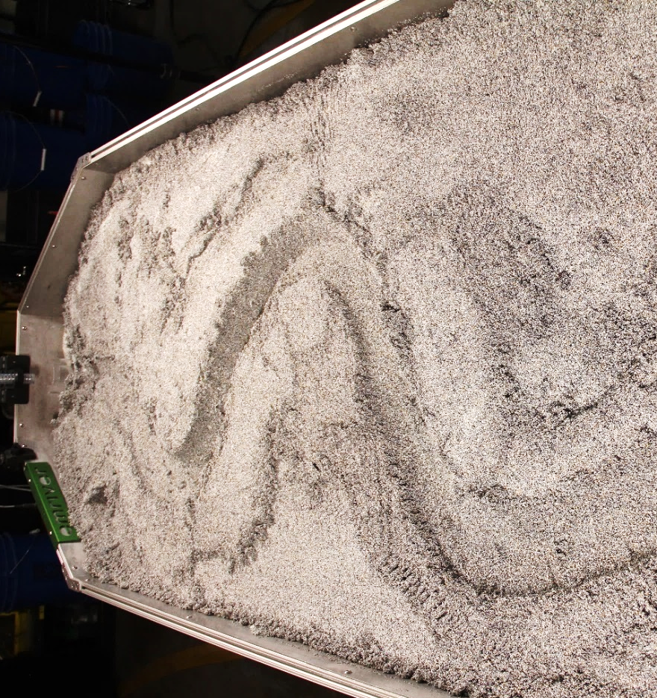
Figure 1. Initial meander in stream table

Begin with a steady flow (approximately 35-55ml/s) and allow the flow to run long enough to establish dynamic equilibrium in the sediment transport; i.e. you see sediment moving at approximately the same rate throughout the stream. (Figure 2)
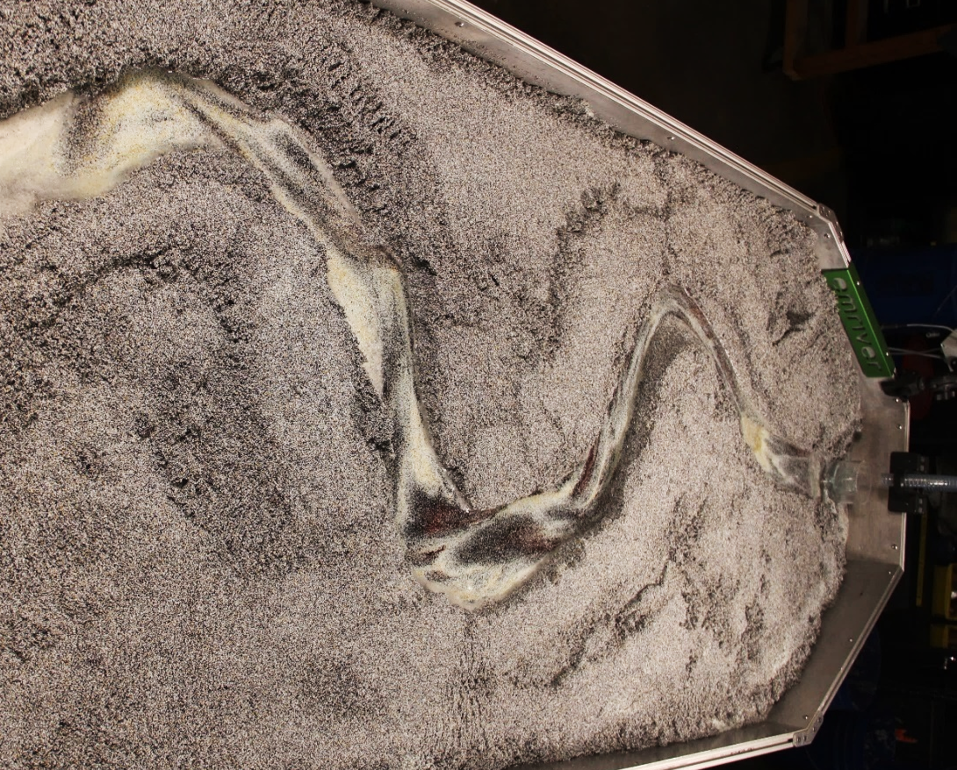
Figure 2. Dynamic equilibrium in meandering stream

If you have multiple meander bends in the stream, you may be able to contrast the response of different armoring techniques simultaneously. However, be sure to allow enough space between armoring to observe up- and downstream effects.

On the outer bend of the meander, imbed the simulated armoring material into the sediment. The photos below are for reference, but your materials and placement may vary.
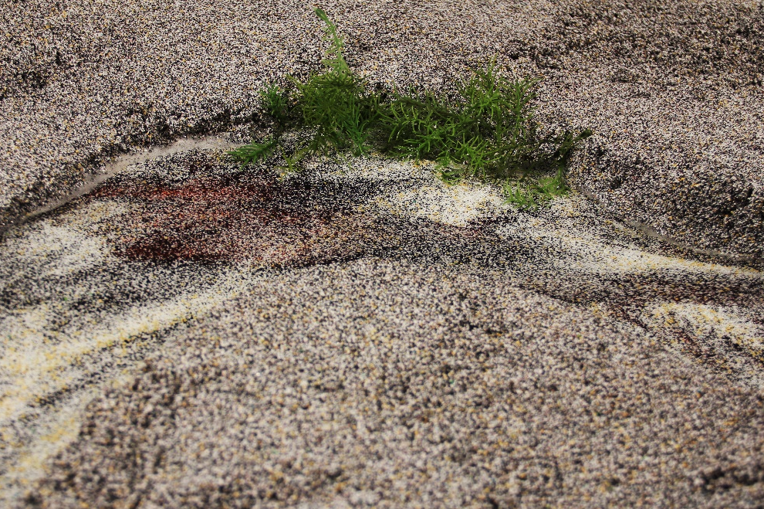
Figure 3. Plastic vegetation

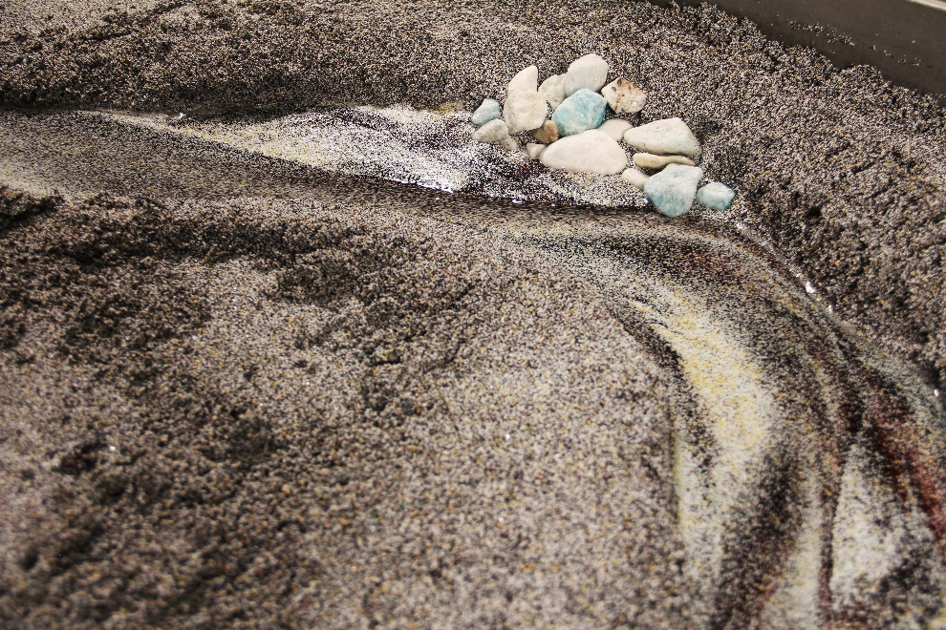
Figure 4. Limestone rip rap
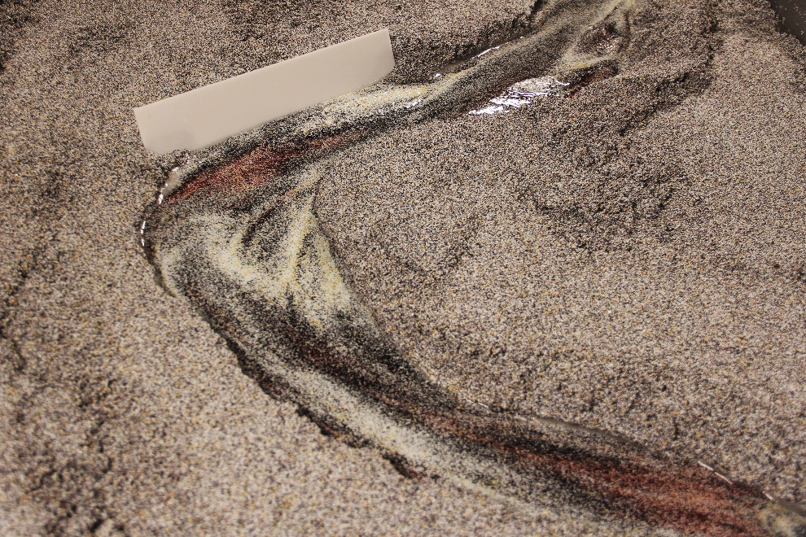
Figure 5. Rigid armoring with plastic

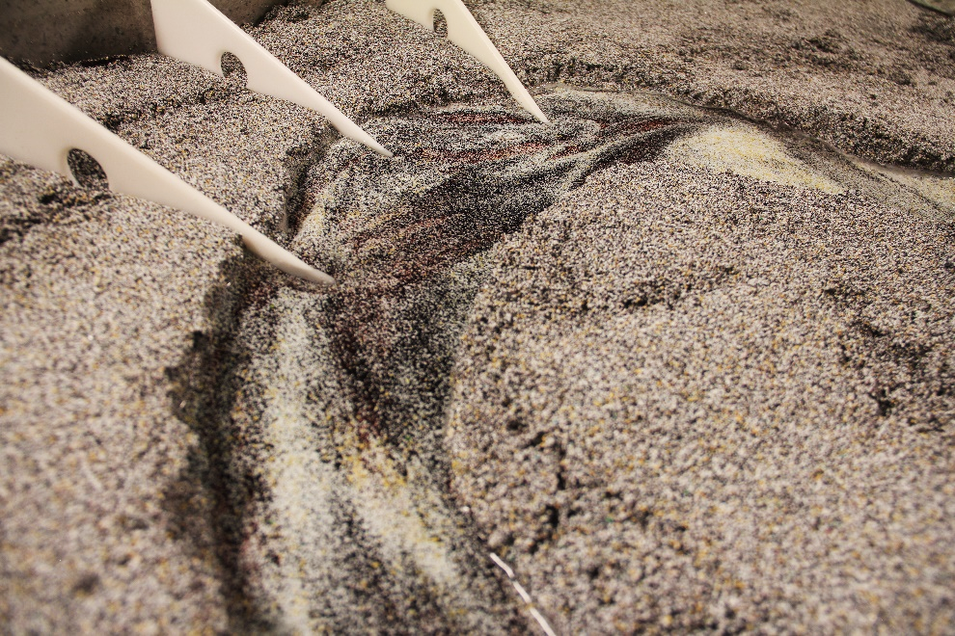
Figure 6. Groynes on outer bend

Record your observations for each configuration at normal and high flow conditions. Begin with a planform drawing (bird’s eye view) of the meander and the position of the armoring.

Armoring Technique: Vegetation
Drawing
Describe (or draw) observed changes in flow and sediment movement. Make note of where you observe erosion, scour and deposition.
Normal Steady Flow | Upstream
Normal Steady Flow | At Site
Normal Steady Flow | Downstream
High Flow Flood | Upstream
High Flow Flood | At Site
High Flow Flood | Downstream

Armoring Technique: Stone rip rap
Drawing
Describe (or draw) observed changes in flow and sediment movement. Make note of where you observe erosion, scour and deposition.
Normal Steady Flow | Upstream
Normal Steady Flow | At Site
Normal Steady Flow | Downstream
High Flow Flood | Upstream
High Flow Flood | At Site
High Flow Flood | Downstream

Armoring Technique: Rigid plastic
Drawing
Describe (or draw) observed changes in flow and sediment movement. Make note of where you observe erosion, scour and deposition.
Normal Steady Flow | Upstream
Normal Steady Flow | At Site
Normal Steady Flow | Downstream
High Flow Flood | Upstream
High Flow Flood | At Site
High Flow Flood | Downstream
Armoring Technique: Groynes/Spur dykes
Drawing
Describe (or draw) observed changes in flow and sediment movement. Make note of where you observe erosion, scour and deposition.
Normal Steady Flow | Upstream
Normal Steady Flow | At Site
Normal Steady Flow | Downstream
High Flow Flood | Upstream
High Flow Flood | At Site
High Flow Flood | Downstream

Suggestions for more experiments
Place a model home or structure near a bend in the river and try to protect it with one or more of the techniques you have tested.
Can you make a change up- or downstream of the bend that will minimize the erosion without making a direct change to the bend?
Try various other methods for stopping erosion. Use synthetic fabrics, rocks in mesh bags, 3D-printed structures, etc.

Closing Procedures
- Stop the flow at the controller.
- Remove all structure, rocks, vegetation, tools, etc. from the stream table.
- Use the perforated scoop to pile the media in the center of the stream table box to allow the excess water to drain.
- Lower the standpipe to about 1cm above box floor to drain the water.
- Remove the power from the controller and all components.

Results/Discussion
- Based on your experiments, describe possible advantages and disadvantages of each of the following:
  - Soft armoring with vegetation
  - Rigid armoring with rip rap
  - Rigid armoring with solid wall
  - Redirecting flow with the use of groynes
- In your experiments, which method was the most effective in protecting the stream bank during normal, steady flow? Why do you think that is?
- In your experiments, which method was the most effective in protecting the stream bank during flood conditions? Why do you think that is?

