GEOG201: Environmental Processes: Principles and Applications 2026
Name ………………………………………………………
Lab 3: Deltas and Coastal Sediment Transport

DUE DATE: At the end of your lab.
SUBMISSION: Submit this sheet with all your answers as a hard copy at the end of your lab.
This lab will be marked out of 24 marks and is worth 10 % of your final course grade. Make sure to include your name at the top when you submit.

1.0 Introduction
Coastal deltas form at the mouths of big rivers with constant high fluvial discharge and sediment supply. They prograde (i.e. build out) into ocean basins. Deltas respond to changes in sea level, fluvial flow, and sediment supply. These changes can occur naturally or be brought on by human activity (e.g. dam building can hold back water and sediment like we talked about in class for the Nile Delta). Understanding how deltas have responded to changing boundary conditions in the past is useful to predict how they will evolve in the future. Today’s lab will use a series of videos showing coastal showing sediment transport in a flume/stream table. We will look at how changes in sediment supply, river flow, and sea level impact on sediment transport in deltas. The exercise is framed largely around changes in environmental conditions that would have occurred during the Holocene. We will also have a go at recreating these conditions on a stream table and think about future threats to deltas.

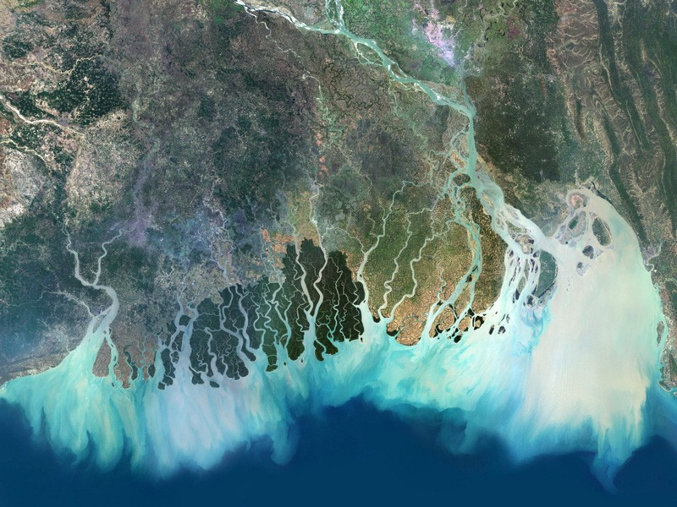

All questions you must answer on this handout are in red text. Hand this in at the end of the lab.
2.0 Objectives
- To understand how changes in boundary conditions impact on sediment transport in deltas.
- To become familiar with sediment transport processes (e.g. progradation) in coastal river deltas.
- To understand how people can modify the natural processes of delta evolution.

3.0 Tasks and procedure
There are three parts to today’s lab:
- Part 1: Delta processes in the stream table (approx. 30 mins).
We will first observe delta sediment transport processes using a stream table. We will see what impact changing river flow, sediment supply, and sea level have on sediment transport. There will be some time at the end to test different processes/scenarios on the stream table just for fun.

- Part 2: Delta response to sea level change (45 mins) (18 pts).
We will use several videos showing delta evolution in a flume under different sea level conditions. In the videos, you can see the sediment structure very well. As base level (i.e. sea level) changes, the delta adjusts its processes of deposition and erosion. Over multiple sea level cycles, periods of erosion/deposition result in sequence stratigraphy. There are TWO written questions to answer.

- Part 3: The Yellow River Delta: A World of Change (20 mins) (6 pts).
The last part of the lab will use aerial imagery to think about modern threats to deltas, using the Yellow River Delta (China) as a case study. There are THREE written questions to answer.

Part 1: Delta processes in the stream table (approx. 30 mins).

We use the stream table in the lab to observe delta processes and sediment transport. This part of the lab is really for you to look and observe how deltas form and prograde. A few things we will look at and try to recreate are:

- Delta progradation: Can we build a delta which progrades (i.e. builds out) into the basin? What is the recipe for this in the real world? What conditions might this require in the stream table and how can we get these right to form a delta here? How is sediment moving?
- Can we see avulsions and lobe switching? What would cause these processes? Can we force an avulsion to occur? Give it a go :)
- Delta classification: What type of delta are we likely to form using the stream table? What types of marine (or other) processes are we not capturing using the stream table? How might the delta look different in the real world? What if we added waves to the stream table?
- What would we expect to happen if we raised sea level? Can we do this on the stream table? What is happening to the “accommodation space” in the basin? How does this impact sediment transport and the progradation of the delta?
- What would happen to the delta if we increased the flow rate to represent more river discharge? What if we decreased it? Let’s try both of these things and see what happens.
- What would we expect to see if we starved the delta/river of sediment? When or where might this be happening in the real world? What impact can we see downstream?

You are also welcome to try any other experiments, so have a think and give it a go!
Part 2: Delta response to changing sea level (45 mins) (18 pts).

We will now use four videos to look at delta response to changing sea level. Ccredit for videos is given to a University of Nevada Las Vegas (UNLV); Hanson (2011). Videos are publicly available at:
- Desktop Delta Part 1 - https://www.youtube.com/watch?v=KIFQjlrDiZA
- Desktop Delta Part 2 - https://www.youtube.com/watch?v=Z3lK09n9_EE
- Desktop Delta Part 3 - https://www.youtube.com/watch?v=hHmF_c443ik
- Desktop Delta Part 4 - https://www.youtube.com/watch?v=IvAlZguGg8c&t=480s

The videos allow us to see the actual stratigraphy of a delta as it progrades in a flume. The stratigraphy refers to the stacking and architecture of the topset, foreset, and bottomset beds (e.g. Figure 1). Our stream table showed us the delta prograding into a basin from a bird’s eye view, but we were somewhat limited in viewing the internal stratigraphy.

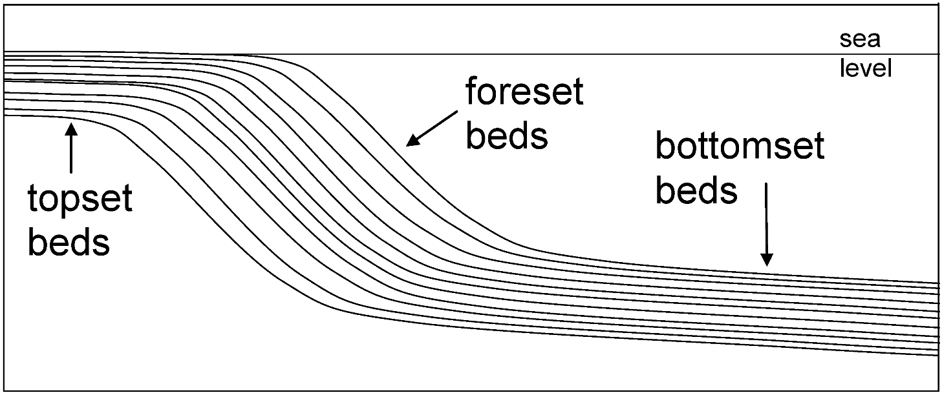
Figure 1. Example cross-section through a delta front showing its sediment stratigraphy (i.e. layers).

Using the videos, we will look at four scenarios where the desktop delta responds to changes in sea level. These scenarios are shown in Figure 2 and Table 1 on the next page and broadly represent the changes in boundary conditions occurring since the last ice age (24,000 years ago). Using each corresponding video (at the times outlined below), you will fill out Table 2 on page 4. We will go through the videos as a class and discuss ideas as we go.

Some things to think about include:
- What is base level doing? | - Can you see topsets, foresets, and bottomsets?
- Where is erosion/deposition occurring? Why? | - Can you see knickpoints or erosional surfaces?
- Is accommodation space being created or lost? | - Is the delta receiving enough flow + sediment?

Here is what part of the video to watch for each scenario:
- Scenario 1: LGM (24 ka to 20 ka)
Desktop Delta Part I: 4.40 - 6 min into the video (while the delta is doing its normal thing).
- Scenario 2: PGMT (20 ka to 6 ka)
Desktop Delta Part I: 6.40 min to end, then Part II: 0 - 1.30 min (where they raise base level).
- Scenario 3: Late Holocene regression (2 - 3 kya)
Desktop Delta Part III: 4.20 - 7 min (where they are lowering base level by draining the flume).
- Scenario 4: Modern transgression (1950 - present)
Desktop Delta Part IV: rest of video (where they are raising base level again).
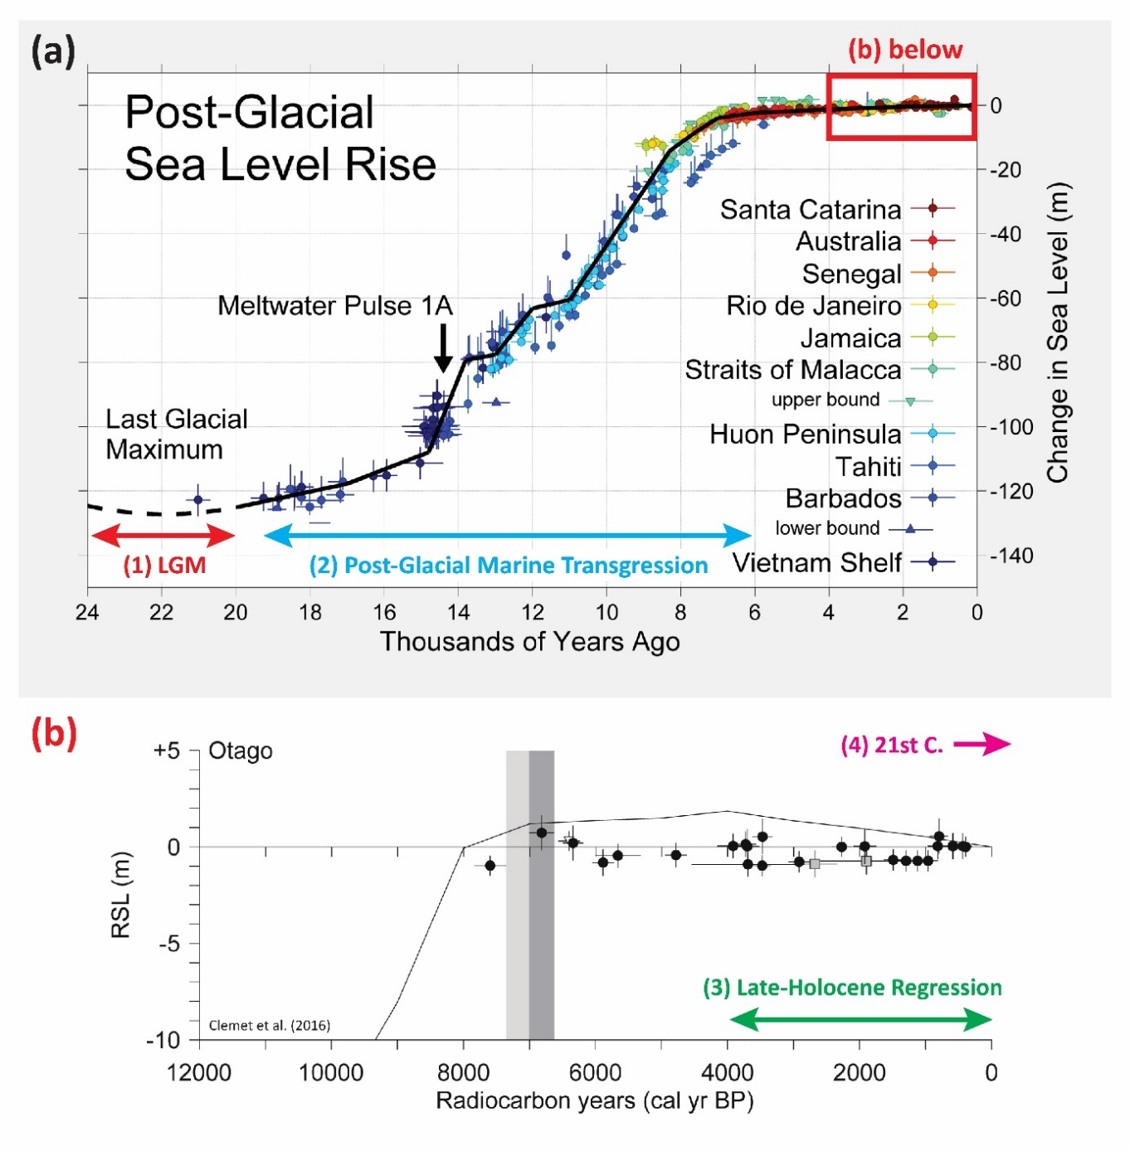

Figure 2. Sea level curve corresponding with the four hypothetical scenarios of changing boundary conditions in Table 1 below. Image recreated from: WIkiCommons, (2025); Clement et al., (2016).

Table 1. Description of scenarios. Assume fluvial discharge and sediment supply stay the same for all.
Scenario | Description | Timing (see Fig 1) | Boundary conditions at the time
1 | Last Glacial Maximum (LGM) (i.e. last ice age) | 24 - 20 kya | Sea level: Stable  Discharge and fluvial sed. supply: Sufficient discharge and sediment supply to build and maintain a delta
2 | Post-Glacial Marine Transgression (PGMT) | 20 - 6 kya | Sea level: Rising  Discharge and fluvial sed. supply: Same as above
3 | Late Holocene regression | 4 - 0 kya | Sea level: Falling  Discharge and fluvial sed. supply: Same as above
4 | 21st century sea level rise | 21st C. - onwards | Sea level: Rising  Discharge and fluvial sed. supply: Reduced (human impacts e.g. dams holding back flow and sediment).

Q1. In Table 2 (below), describe what changes you see for each scenario and how the structure of the delta is changing. Describe why the change is occurring with respect to changing boundary conditions and sediment transport (e.g. sea level, fluvial discharge, and sediment supply). Take notes during the videos in the left column and then explain why you see these changes in the right column. Only the right column will be marked! (12 pts)

Table 2. Observed change in coastal delta morphology in response to changing boundary conditions (as per Table 1). (12 pts)

Scenario | Boundary conditions | Changes observed (what you see) (max 3 bullet pts).  This column is not marked, just space to take notes. | Reasons why (geomorphic explanation) (max 3 bullet pts).  This column is marked. Worth 12 pts overall, 3 pts per row.
1 | Description: LGM  Timing: 24 ka to 20 ka  Sea level: Stable  Sediment flux: Assume high/constant  Discharge: Assume high and constant.
2 | Description: PGMT  Timing: 20 ka to 6 ka  Sea level: Rising  Sediment flux: Assume high/constant  Discharge: Assume high/constant.
3 | Description: Late-Holocene regression  Timing: 4 ka to 0 ka  Sea level: Falling  Sediment flux: Assume high/constant  Discharge: Assume high/constant.
4 | Description: Modern transgression  Timing: 21st century onwards  Sea level: Rising  Sediment flux: Reduced  Discharge: Reduced.

Q2. Based on your observations from the videos, draw a conceptual model of the likely change in delta morphology over the last 24 ka in response to changing sea level and/or other boundary conditions. Draw in the boxes. The stages correspond with scenarios 1-4 as described in Table 1 and shown in Figure 2. Pictures to be legible but not fancy. The first one is done as an example but more detail can be included. (6 pts)

- A conceptual model in physical geography is a diagram generalising key processes and changes in landforms and landscapes. Conceptual models show how different geomorphic processes interact over time to shape landforms.
- You only need to include features mentioned in the videos and that you can see represented in the video for each stage (i.e. don’t need to get into too much detail about the systems tracts but if you see a clear example of such a surface or layer, feel free to include it in the figure);
- You will need to draw a cross section of the stratigraphy (clearly show the topsets, foresets, and bottomsets);
- Include arrows to show the direction of sediment movement (i.e. erosion and deposition) and water flow;
- Consider labelling if there is an increase or decrease in accommodation space;
- You can label key features or processes on the images (e.g. sea level rise or fall, knickpoints).

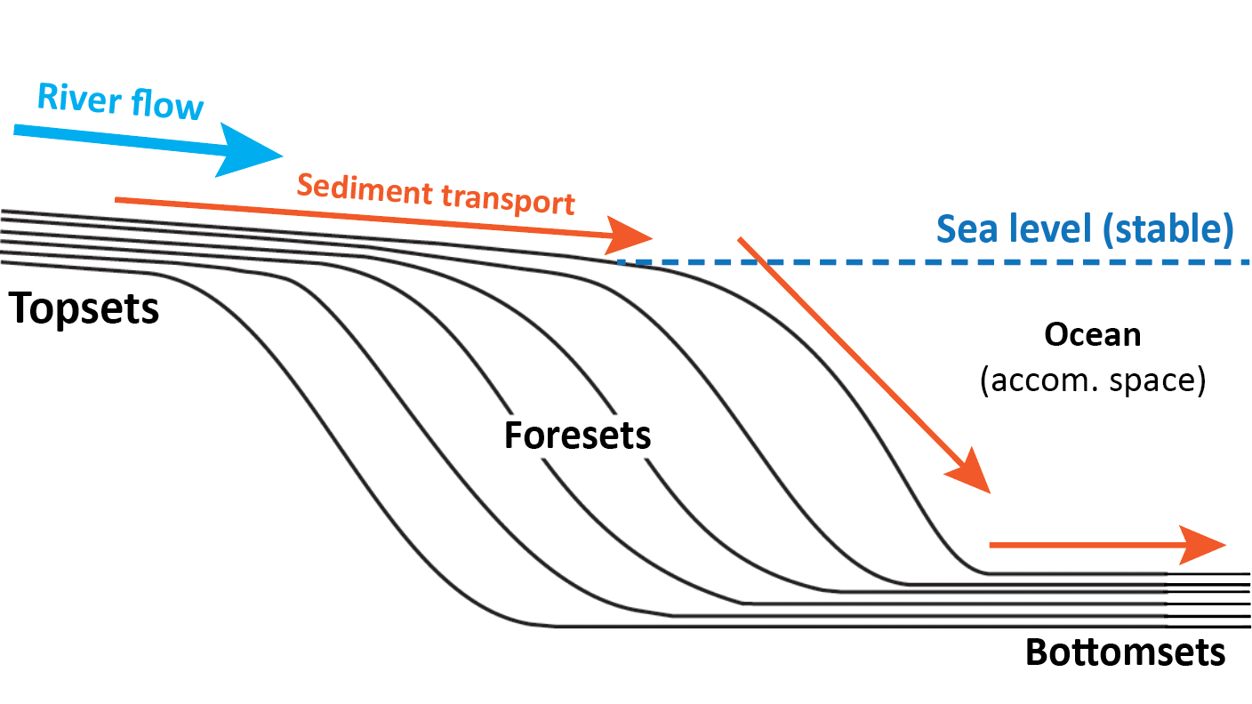
Stage 1: LGM (24 ka - 20 ka) |  | Stage 2: PGMT (20 ka - 6 kya)
Stage 4: 21st century onwards |  | Stage 3: Late Holocene regression (4 ka - 0 ka)
Part 3: The Yellow River Delta: A World of Change (20 mins) (6 pts).

The Yellow River Delta (in China) is a very dynamic system which has been heavily impacted by people over the last 50 years. For this part of the lab, use the sequence of Landsat satellite imagery from the website listed below from NASA (2026). The imagery shows change at the Yellow River delta (China) at five-year intervals 1989-2020. You can view it here: https://earthobservatory.nasa.gov/world-of-change/YellowRiver

Q3. In 1996, engineers forced the channel to enter the sea at a different location (to the northeast). What is the name of this process and under what conditions would it naturally occur? Name the process and answer this question in 1-2 short sentences. (2 pts)

Q4. Since the exit location of the river changed (from 1999 onwards), what has happened to the old lobe to the southwest where the main channel used to enter the ocean? Give one reason why this may have happened. Answer in 1-2 short sentences. (2 pts)

Q5. The change in channel exit location was forced by people to try to build land to the northwest to protect an oil and gas field. We will discuss this in the lab. What may be some factors that could limit the success of this strategy? HINT: Subsidence, river flow, sediment, and base level. Answer in 1-2 short sentences. (2 pts)

References cited:

Clement, A.J., Whitehouse, P.L. and Sloss, C.R., 2016. An examination of spatial variability in the timing and magnitude of Holocene relative sea-level changes in the New Zealand archipelago. Quaternary Science Reviews, 131, pp.73-101.

Hanson, A; UNLV, 2011. Desktop Delta videos 1-4. University of Nevada Las Vegas and A. Hanson. Videos sourced from Youtube.com from the following links:
https://www.youtube.com/watch?v=KIFQjlrDiZA (Part 1); https://www.youtube.com/watch?v=Z3lK09n9_EE (Part 2); https://www.youtube.com/watch?v=hHmF_c443ik (Part 3); https://www.youtube.com/watch?v=IvAlZguGg8c&t=389s (Part 4).

NASA, 2026. World of Change: Yellow River Delta. Online article and images sourced from: https://science.nasa.gov/earth/earth-observatory/world-of-change/yellow-river-delta/

WikiCommons, 2025. R. A. Post-Glacial Sea Level.png. Created by Rhode via Wikimedia Commons. Image sourced from: https://commons.wikimedia.org/wiki/File:Post-Glacial_Sea_Level.png

Wright, K., 2013, Seismic Stratigraphy and Geomorphology of Palaeocene Volcanic Rocks, Faroe-Shetland Basin [PhD Thesis]. Durham University.

