Students looked for images that tracked a particular storm
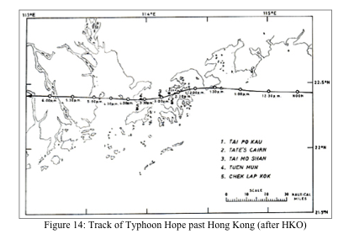

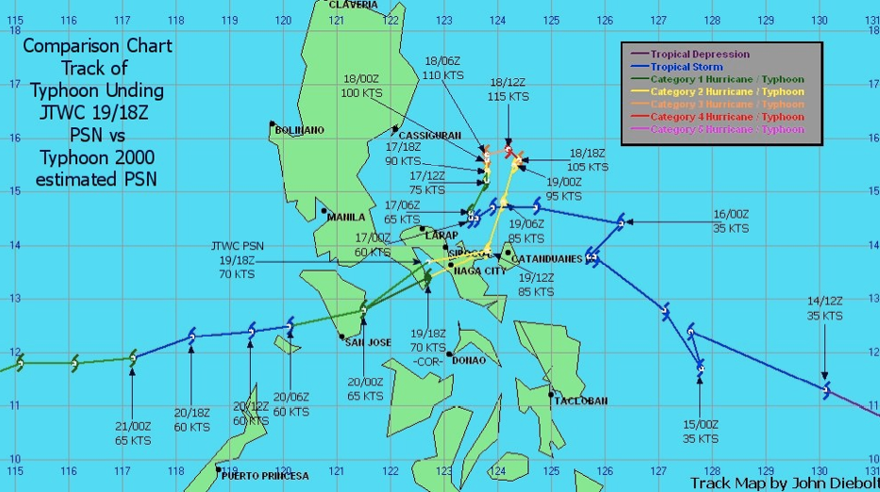

I requested that students find authentic resources and good quality information from a reliable, pertinent source.

STUDENT WORK EXAMPLE #1

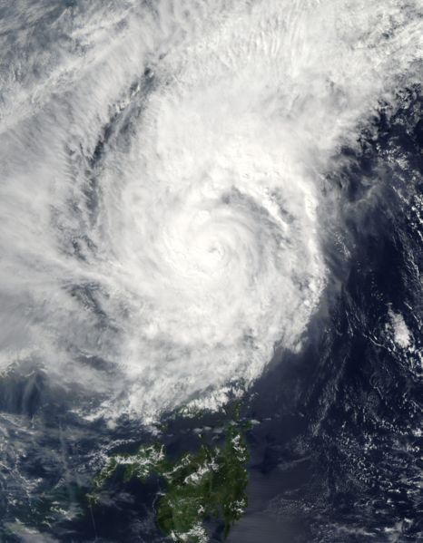
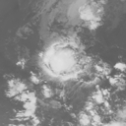
Typhoon Muifa

A tropical thunderstorm turns into a venomous

Typhoon!!
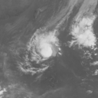
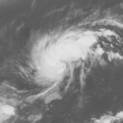
Typhoon Muifa started out as a harmless tropical storm and turned into a destructive Typhoon. It turned it to a weak typhoon on November 15 off the east coast of Leyte Island, Philippines. Typhoon Muifa was wandering around the Philippines for a couple of days and veered to move toward the South China Sea on November 20. A few people were killed and more were missing in Philippines. Typhoon Muifa is now moving across South China Sea. It is still a weak typhoon, but it would have a long life. Typhoon Muifa passed near Vietnam and is moving across Gulf of Thailand toward the Malay Peninsula. Typhoon Muifa created destruction at Vietnam, it created floods, landslides, killed about 40 people, about 40 were missing, and more than 80 houses are in danger of collapsing. The typhoon weakened back into a storm and the storm died.
This is what the people that I interviewed said about this terrible typhoon.
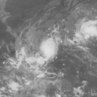
"As I woke up around past 6 in the morning of November 20, everything was a mess. Almost all of our trees outside were broken or uprooted. The aftermath video of our lawn will let you agree that Muifa was one heck of a storm. From my experience, Muifa was the fastest and strongest typhoon ever to hit out city since 1970. The damages a crossed our street were enormous: power lines down, 100 year old Narra tree just across the street- uprooted and many trees were either uprooted or broken. The winds didn't reach more than 200 kph as evidence by the coconut trees shown on the video. However, along the coastal areas of Camarines Sur, the area where the "eye" made landfall first, wind speed may have reached 200 kph. In the afternoon of November 20, my friend and I drove around his motorbike and captured some images of Muifa's wrath over Naga. The scene was the same all over: partially damaged homes and severe damages to crops and infrastructures. As of this writing death toll stood at 60. - Michael Padua " The typhoon destroyed 200 houses in the southern region where one sailor was reported missing after the boat he was on capsized in the storm. - State Media
An official said, "A 31-year-old man died when he was swept away on Tuesday in the province."
"The province has issued a high flood alert as upstream waters are pouring in. We are now on 24-hour guard.
- A disaster management official
Like these people said, the typhoon raised heck for everyone living in the Philippines. The typhoon was born on November 14, 2004 and died on November 25. Typhoon Muifa's life was about 258 hours long. Its winds reached the maximum of 80 knots. It traveled about 3653 kilometers moving about 14.2 kilometers per hour. The length of the entire storm is 288 hours, which is about 12 days. Typhoon Muifa killed a total of 61 people in the Philippines before weakening back into a tropical storm.

http://agora.ex.nii.ac.jp/digital-typhoon/news/2004/TC0425/index.html.en

http://earthobservatory.nasa.gov/NaturalHazards/natural_hazards_v2.php3?img_id=12583
STUDENT WORK #2

Typhoon Hope
1979
C

an you believe what has happened in Hong Kong? Typhoon Hope has disrupted the cities of Hong Kong. It started as a weak disturbance on July 25 about 180 marine miles below of Guam. For a day it started moving westwards. While it was moving, the typhoon slowly turned into a storm. The spiral cloud bands became more disturbed around the center. The eye of Typhoon Hope was well established at this point. After that it began to move northwest. After a while the typhoon passed within 15 marine miles of Batan. Later on that afternoon Hope was very close to Taiwan. In eastern Taiwan 38 houses has collapsed and 132 were seriously damaged. Southern Taiwan was flooded.
Hope started passing through the Bashi Channel and entered South China Sea. Hope rushed westwards, reaching the eastern parts of Hong Kong. While still moving westwards, Hope started slowing down and at midnight hope turned into a storm. On August 3, hope passed over the northern coast Gulf of Tonkin. During the whole storm, Hope affected 37 countries.
The city I went to was Hong Kong, China. The most interesting thing about this event was when I found out that this typhoon affected 37 countries. The people of this city cope with their weather conditions by staying in there homes in their basements or some of them went to their friends house and stayed in the middle of the house. The reaction of the people of the city to this event was frightening to the children and most grownups, not too scary to some people because they are used to this.

http://www.weather.gov.hk/informtc/no10/hope/hope.htm

