Dan Petritz
Cosmic Ray Pre-Activity
Copyright, 2008

Purpose: The purpose of this activity is to prepare students for participation in the Cosmic Ray Outreach Project by Georgia State University. In this activity students will:
Objective | Pages
Learn background knowledge about Cosmic Rays | 2-8
Analyze weather data from the GLOBE project | 9-11
Identify correlations between weather data and muon frequency counts. | 12

GPS Standards Supported:
- Characteristics of Science
S8CS1a: Understand the importance of –and keep – honest, clear, and accurate records in science.
S8CS2a: Follow correct procedures for use of scientific apparatus.
S8CS3b: Find the mean, median, and mode and use them to analyze a set of scientific data.
S8CS4a: Use appropriate technology to store and retrieve scientific information in topical, alphabetical, numerical, and keyword files, and create simple files.
S6CS5a” Observe and explain how parts are related to other parts in systems such as weather systems, solar systems, and ocean systems including how the output from one part of a system (in the form of material, energy, or information) can become the input to other parts.
S8CS6a: Write clear, step-by-step instructions for conducting scientific investigations, operating a piece of equipment, or following a procedure.
S8CS9a: Scientific investigations are conducted for different reasons, which include exploring new phenomena, confirming previous results, testing how well a theory predicts, and comparing different theories. Scientific investigations usually include collecting evidence, reasoning, devising hypotheses, and formulating explanations to make sense of collected evidence.
S8CS9d: Scientists often collaborate to design research. To prevent bias, scientists, conduct independent studies of the same question.
S8CS9e: Accurate record keeping, data sharing, and replication of results are essential for maintaining an investigator’s credibility with other scientist and society.
- Content
S6E1: Students will explore current scientific views of the universe and how those views evolved.
S8P1g: Identify and demonstrate the Law of Conservation of Matter
S8P2a: Explain energy transformations in terms of the Law of Conservation of Energy

Part One:
Cosmic Ray Background Information:
A reading article is available via NASA’s Imagine the Universe! web site hosted by Goddard Space Flight Center at the following link: http://imagine.gsfc.nasa.gov/docs/science/know_l2/cosmic_rays.html
See attached reading assignment
Determining Average Count Rate:
Source: CHICOS Classroom Activities: Using the Berkeley Detector
A cosmic ray detector is oriented with its paddles parallel to the ground and counts the number of cosmic rays in a 65 second interval. The experiment is performed 10 times with the following results summarized in chart 1. What is the average count rate and error?

Number of seconds per trial: __________
Trial | # of Counts
1 | 110
2 | 141
3 | 97
4 | 106
5 | 115
6 | 118
7 | 121
8 | 121
9 | 110
10 | 125
Total | 1160
Number of Trials: __________
Total time of trials in seconds: __________
Total time of trial in minutes: __________
Total number of counts: __________
Average number of counts per minute: __________
To calculate error, take the square root of the total count and divide by the total time in minutes: _________
Complete the following data from the above chart
Mean: ____________ Median: __________ Mode: ______________
Calculating the Angle of the Capture of Cosmic Ray Detector:
In order for a hit to count on the detector the muon must pass through both paddles. The distance between the paddles can be adjusted to control the angle of the sky that is being measured. Paddles close together capture muons from a larger portion of the sky. Paddles far apart capture muons from a smaller portion of the sky. The width of each paddle is 2 cm. Calculate the angle of the sky that each set up measures.
What is the maximum area of sky the paddles will collect if they are this far apart?
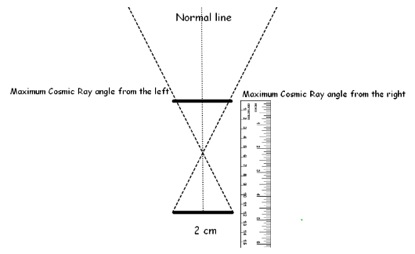
How much of the sky will be captured if they are moved further apart?
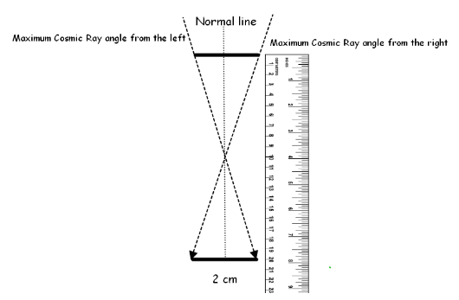
Reconstructing Cosmic Ray Showers from Directional Measurement:
Source: http://www.chicos.caltech.edu/classroom/shower/reconstruct1.html

Reconstructing Cosmic Ray Showers from Directional Information
When a cosmic ray interacts with the Earth's atmosphere it creates secondary particles. These particles then interact in the atmosphere and create even more particles, which then create more particles and on and on. This process, called a cosmic ray shower, propagates through the atmosphere until eventually, some of the particles reach the ground.
Some cosmic ray detectors measure the direction of the incoming particles, and from that information are able to reconstruct the direction of the original cosmic ray. This activity will explore that type of reconstruction in two dimensions.
Other cosmic ray detectors record the time the incoming particles arrive, and are able to reconstruct the direction of the original cosmic ray from the timing information. The CHICOS detectors work in this way. A second activity available on the CHICOS classroom webpage will explore that type of reconstruction.
In this activity students will work backwards from ground particle directions to reconstruct a two dimensional cosmic ray shower using the method of angle bisection.

Materials
To complete this activity each student will need the following materials:
- Cosmic Ray Shower Activity Sheet
- Drawing Compass
- Pencil
- Ruler
- Eraser

Cosmic Ray Shower Reconstruction
- Notice the short black lines at the bottom edge of the Cosmic Ray Shower Activity Sheet. Using a ruler, extend the two right-most lines until they intersect.
- Use a compass to bisect the angle that is formed when the two lines meet following the steps below.
- To bisect the angel, place the point of the compass at the intersection of the two lines so that it opens into the angle. Sweep an arc across the two lines.
- Reposition the point of the compass at the intersection of the arc and one of the lines. Sweep an arc through the center of the angle you are trying to bisect.
- Reposition the point of the compass at the intersection of the arc and the other line. Again sweep an arc through the center of the angle you are trying to bisect, this second arc should cross the one you just drew.
- Use a ruler to draw a line from the intersection of these two recent arcs and the intersection of the two lines which form the angle. This line bisects the angle.
- You will no longer work with the original two lines, you will only work with the bisection line. Extend the bisection line a few centimeters up the page from where the original lines intersected.
- Move on to the third and fourth right-most black lines at the bottom edge of the page. Using a ruler, extend these lines until they intersect.
- Use a compass to bisect the angle that is formed when these two lines meet, using the method described above.
- Extend the bisection line a few centimeters up the page from where the original lines intersected.
- Move on to the fifth and sixth right-most black lines at the bottom edge of the page. Using a ruler, extend these lines until they intersect.
- Just as before, bisect the angle that is formed when these two lines meet and extend the bisection line a few centimeters up the page.
- Next, extend the bisection lines until they cross and repeat the angle bisection process to find the direction of the resulting line. Whenever two lines cross, bisect their angle to find the direction of the resulting line. Extend only the bisection line once you have found it. In this manner, work your way up the page.
- Repeat this process with the lines on the left hand side of the page. However, use caution. The left hand side is more complicated. Some of the lines will not cross another line right away. Extend all six black lines on the left hand side in small increments, a few centimeters at a time, until two lines cross. Whenever two lines cross, bisect their angle and extend the bisection line up the page also a few centimeters at a time, as you increase the length of all lines.
- Every time two lines cross, bisect the angle and extend the bisection line up the page.
- In the end, you should have only one line which goes off the top of the page. This line represents the single incoming cosmic ray.
- To clean up the shower, you may want to erase all the angle bisection arcs and the portions of the lines which extend past the intersection point.
You have reconstructed a cosmic ray shower from the ground up. Looking at the completed shower, you'll see that a single cosmic ray comes in from the top of the page. It interacts with the atmosphere and produces two particles. The particle on the left quickly interacts again and produces two more particles, while the particle on the right travels further before interacting again. In this manner the cosmic ray generated a particle shower which eventually reaches the ground and is measurable in a detector.
Cosmic Ray Activity Sheet
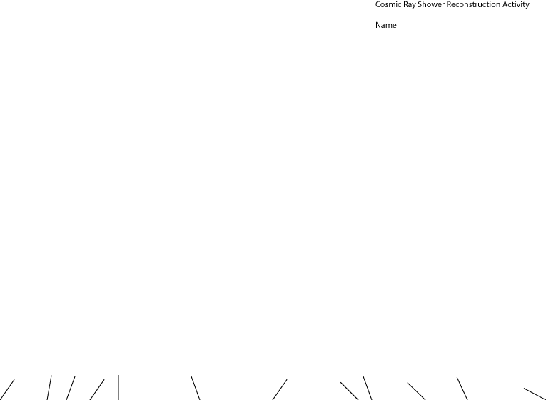

What are cosmic rays?
Galactic cosmic rays (GCRs) are the high-energy particles that flow into our solar system from far away in the Galaxy. GCRs are mostly pieces of atoms: protons, electrons, and atomic nuclei which have had all of the surrounding electrons stripped during their high-speed (almost the speed of light) passage through the Galaxy. Cosmic rays provide one of our few direct samples of matter from outside the solar system. The magnetic fields of the Galaxy, the solar system, and the Earth have scrambled the flight paths of these particles so much that we can no longer point back to their sources in the Galaxy. If you made a map of the sky with cosmic ray intensities, it would be completely uniform. So we have to determine where cosmic rays come from by indirect means.
One of the indirect observations we can make is the "composition" of GCRs. This can tell us a lot about the GCR sources and the cosmic rays' trip through the Galaxy. The "composition" of cosmic rays describes what fraction of cosmic rays are protons, what fraction are helium nuclei, etc. All of the natural elements in the periodic table are present in cosmic rays, in roughly the same proportion as they occur in the solar system. But detailed differences provide a "fingerprint" of the cosmic ray's source. Measuring the quantity of each different element is relatively easy, since the different charges of each nucleus give very different signatures. Harder to measure, but a better fingerprint, is the isotopic composition (nuclei of the same element but with different numbers of neutrons). To tell the isotopes apart involves, in effect, weighing each atomic nucleus that enters the cosmic ray detector.
About 90% of the cosmic ray nuclei are hydrogen (protons), about 9% are helium (alpha particles), and all of the rest of the elements make up only 1%. Even in this one percent there are very rare elements and isotopes. These require large detectors to collect enough particles to say something meaningful about the "fingerprint" of their source. The HEAO Heavy Nuclei Experiment, launched in 1979, collected only about 100 cosmic rays between element 75 and element 87 (the group of elements that includes platinum, mercury, and lead), in almost a year and a half of flight, and it was much bigger than most scientific instruments flown by NASA today. To make better measurements requires an even larger instrument, and the bigger the instrument, the greater the cost.

Where do they come from?
Most galactic cosmic rays are probably accelerated in the blast waves of supernova remnants. This doesn't mean that the supernova explosion itself gets the particles up to these speeds. The remnants of the explosions, expanding clouds of gas and magnetic field, can last for thousands of years, and this is where cosmic rays are accelerated. Bouncing back and forth in the magnetic field of the remnant randomly lets some of the particles gain energy, and become cosmic rays. Eventually they build up enough speed that the remnant can no longer contain them, and they escape into the Galaxy.
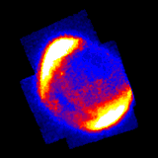 | 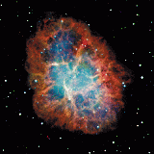
Supernova 1006 | Crab Nebula
Because the cosmic rays eventually escape the supernova remnant, they can only be accelerated up to a certain maximum energy, which depends upon the size of the acceleration region and the magnetic field strength.
However, cosmic rays have been observed at much higher energies than supernova remnants can generate, and where these ultra-high-energies come from is a big question. Perhaps they come from outside the Galaxy, from active galactic nuclei, quasars or gamma ray bursts. Or perhaps they're the signature of some exotic new physics: superstrings, exotic dark matter, strongly-interacting neutrinos, or topological defects in the very structure of the universe. Questions like these tie cosmic-ray astrophysics to basic particle physics and the fundamental nature of the universe.
- Cosmic Rays are made up of:
  - Electrons
  - Protons
  - Atomic Nuclei
  - All of the above
- Most galactic cosmic rays have been accelerated in:
  - Stars
  - Supernovae
  - Supernovae remnants
  - The Big Bang
- Cosmic rays are accelerated by:
  - Magnetic fields
  - Electric Fields
  - Pressure
  - Gravity
- The percentage of cosmic rays that are either hydrogen or helium is:
  - 80%
  - 90%
  - 95%
  - 99%
Part Two:

Analyzing Weather Data from the GLOBE System

- Use the GLOBE Program to create a map of schools participating in the GLOBE Program
  - Go to Globe Program: http://www.globe.gov
  - Select For Students: Maps and Graphs: Maps
  - Select Date and Type of data desired
  - Select and zoom into local region
    - Example 1: Find school in the Conyers, GA that are participating in the GLOBE program
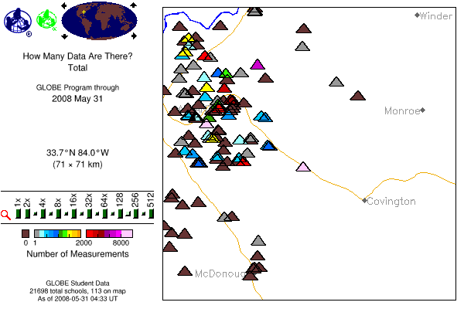
    - Example 2: Find schools that have data for 2008-05-02 in our geographic area

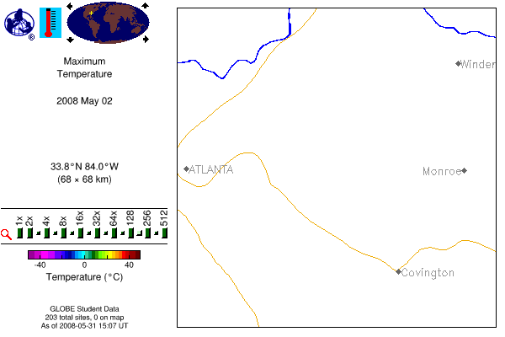
(Note: No temperature data was available for the date and location selected in this example)

- Use the GLOBE Program to access data
  - Example 1
    - Location: Georgia
    - Date Window: 2008-05-01 to 2008-05-06

Data Access -- Atmosphere

SEARCH PARAMETER SUMMARY
Location | : | Georgia, United States of America
Investigation | : | Atmosphere
Protocols | : | Air Temperature
Dates | : | 2008-05-01 - 2008-05-06

NO RECORDS EXIST FOR THE REQUESTED DATA IN THE SPECIFIED TIME PERIOD

  - Example 2
    - Location: Conyers, GA
    - Data Window: Any

School and Site Information
Top of Form

Legend:
Number of reports: TOT = Total (all measurement types), AT = Atmosphere, SW = Hydrology (Surface Water), LC = Land Cover, SO = Soil, PH = Phenology, MD = Metadata.

Margaret G. Barksdale Elementary School, Conyers, GA, US
Latitude: 33.6675 N, Longitude: 84.0178 W, Elevation: 224 m
TOT=22527, AT=22527
Information | Data | Graph | Map | GLOBEMail | Site Info
Bottom of Form

- Draw a graph of data for a selected time period
  - Example 1
    - Location: Barksdale Elementary School
    - Date Window: 2004-05-02 to 2004-05-06
    - Plot Maximum Air Temperature.

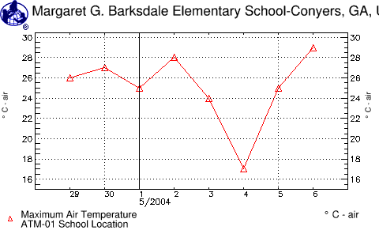

  - Example 2
    - Location: Barksdale Elementary School
    - Date Window: 2004-05-02 to 2004-05-06
    - Plot: Maximum Air Temperature and cloud Cover

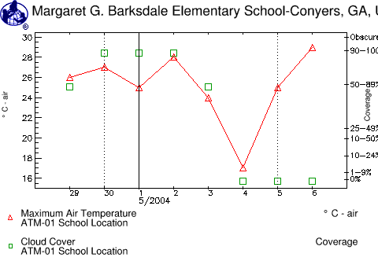
Part 3:
Identify correlations between weather data and muon frequency counts.

This part of the Cosmic Ray Preactivity requires further development. We have captured muon count rates and plotted them. However, we do not have plots of temperature or cloud cover data at the same location and time for comparisons to be made. This is an area for future development.

Cosmic Ray Plot #1
Date Range: 2008-05-02 to 2008-05-06
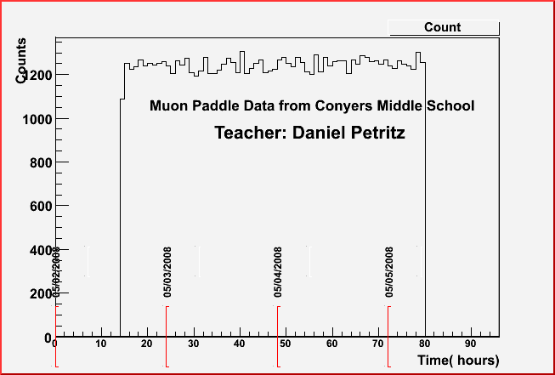

Cosmic Ray Plot #2
Date Range : 2008-04-30 to 2008-05-01
