Creating a graph using FRED

Go to http://research.stlouisfed.org/fred2/

The page that opens will look like this. In the middle of the page, find the tab labeled Popular Series.
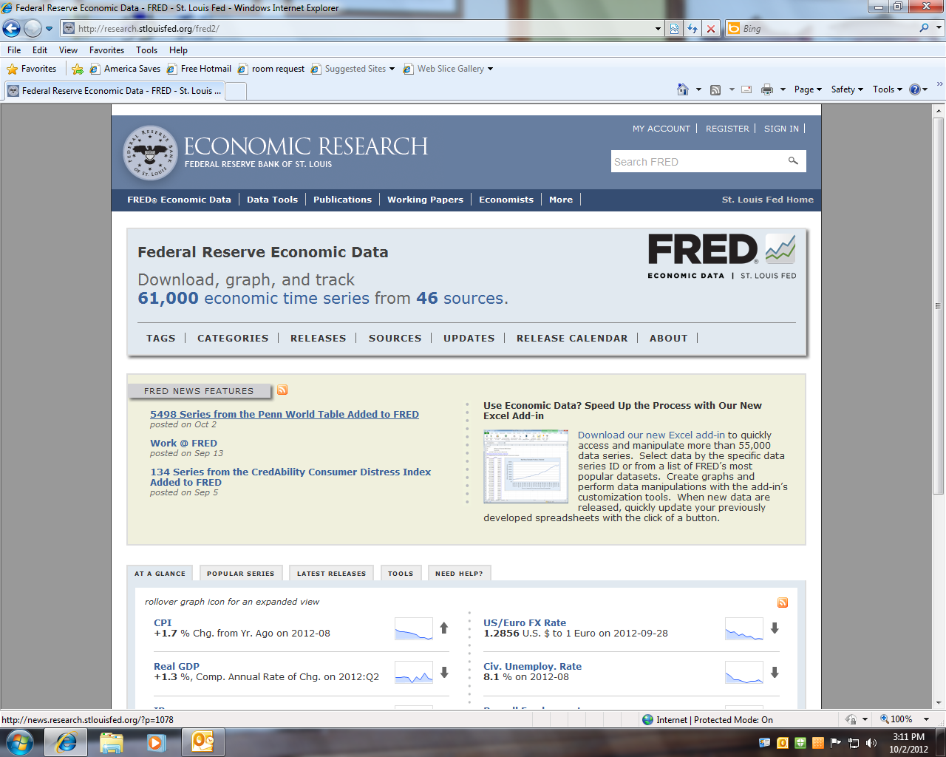

Click on the Popular Series tab, and you will get a page that includes this information in the center. I downloaded this page on October 1st. The items may appear in a different order on the day that you open the page. The most recent unemployment rate will not be September 7.
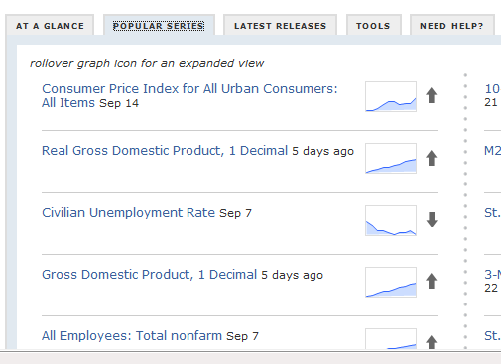

Click on Civilian Unemployment Rate. You will get a graph like the one below. It is not exactly the one that you want, but it is close. Begin by noticing all those gray bars. One of those bars is your recession.

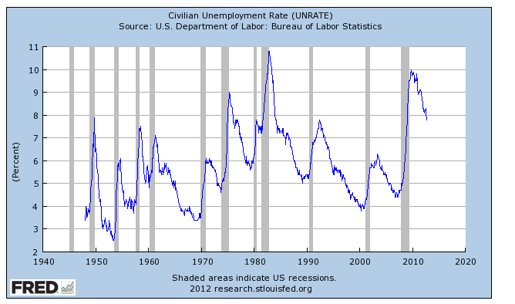
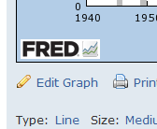
In the lower left corner of the graph, find the pencil icon, Edit Graph, which permits you to edit the graph. The first thing that you want to change is the dates covered by the graph. Find the line for Observation Date Range.

The assignment includes the specific dates for your data series. You will continue to use the same dates assigned for the RGDP graph.

Find the line for the Observation Date Range and click in the box for the start date. A calendar should appear.

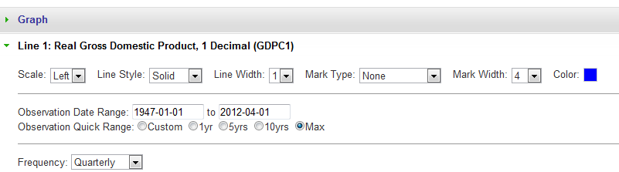

Use the calendar to select the appropriate start date for your data set. (This information is included in your group assignment.) For example, my data set begins in November 1970. After you change the date, click Close. To change the end date, follow the same steps that you used to enter the start date. For example, my end date is January 1980.

My start date: My end date:

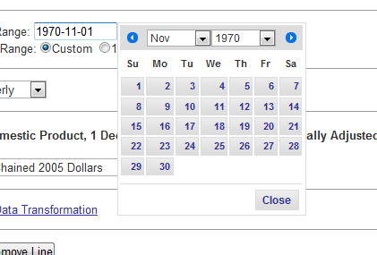
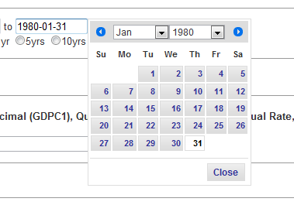

To complete the activity, click Redraw Graph in the lower left corner of the page.

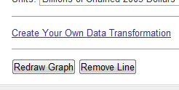

For my dates, the following graph appears.

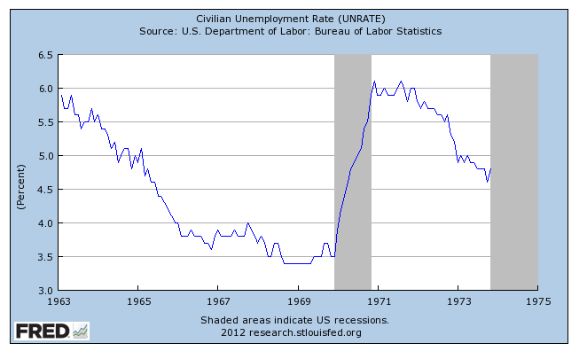

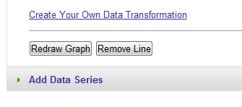
I also need to show the Labor Force Participation Rate. On the bottom left side of the page, find the button that says Add Data Series.

Click on the text.

In the search box, type CIVPART. From the drop down list, select the labor force participation rate.
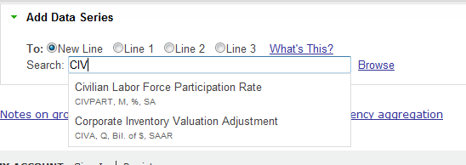

Back to the date line, ask that the calendar dates apply to both lines. Redraw the graph. (Click that button.)

It’s ugly! Never fear, we can fix this. Click on the title of the Civilian Labor Force Participation Rate or click on the appropriate line. In my graph, the CIVPART is line 1. It may be line 2 in your graph. Find the Scale.

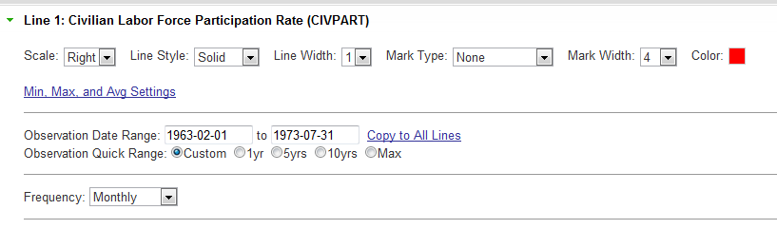
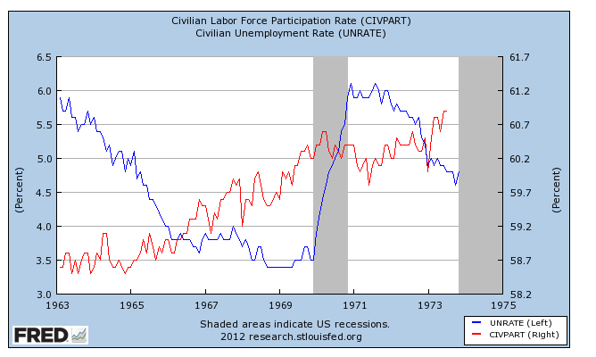
In the drop down box, move the scale for the CIVPART to the right side. (Notice that it is on the left in the default format.) Now you should get a graph that looks messy but informative.

You also need to retrieve the data associated with your graph. Above the upper left corner of the graph, find Download Data in Graph. Click here, and the data will appear in an Excel spreadsheet.
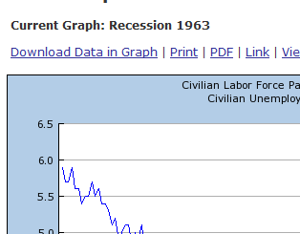

To print the graph, click the PRINT tab above the graph and follow the directions for your printer. Save your graph. You may need it later.

