Investigating Paleoclimate: Understanding Global Climate Change by Investigating the End Triassic Mass Extinction?

Objective: Determine the atmospheric concentration of CO₂ (pCO₂) during the end Triassic using stable C-isotope data.
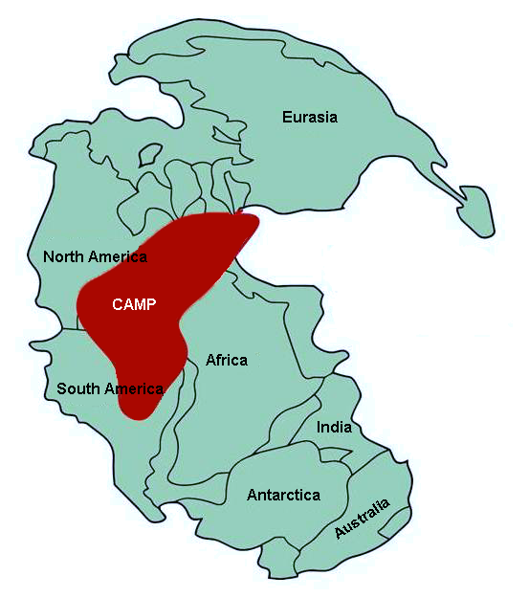
Figure 1: distribution of the Central Atlantic Magmatic Province

202 million years ago, the supercontinent Pangea began to break apart due to plate tectonics. Lava covered vast stretches of northern Africa, eastern North America, northern South America, and portions of Europe (Figure 1). Super massive volcanic events in Earth's past are referred to as large igneous provinces (LIPs), and this one is known as the Central Atlantic Magmatic Province (CAMP). CAMP released large amount of CO₂ gases that altered the global carbon cycle, which is responsible for regulating global temperature because CO₂ is a greenhouse gas.

The Central Atlantic Magmatic Province and the end Triassic extinction event:

Extinction is a part of life; animals and plants disappear all the time. An extinction occurs when the number of species vanish faster than they are replaced. Earth’s normal background rate of timing and frequency of extinctions are 10% of species lost every 1 million years, 30% every 10 million years, and 65% every 100 million years. Extinctions occur due to additional environmental or ecological pressures (e.g., drought, species competition, etc.) that prevent species from being able to survive in their current environment and unable to adapt to these changes. A mass extinction is an extinction event where ~75% of the species on Earth vanish in a geologically short period of time, typically less than 2.8 million years. In the 3.5 billion years that living organisms have thrived on Earth, there have been 5 mass extinctions (Figure 2).

The extinction event of interest to us is the end Triassic mass extinction. The end Triassic mass extinction occurred 202-200 million years ago, which resulted in 76% of all marine and terrestrial species going extinct. The leading hypothesis for the end Triassic mass extinction was volcanic eruptions, specifically the flood basalts of the CAMP, releasing massive amounts of CO₂ into the atmosphere causing rapid global climate change. In the ocean, the high amount of CO₂ in the atmosphere resulted in an increase in primary productivity. This increase in primary productivity caused much of the O₂ in the atmosphere to be used up, resulting in ocean anoxia. The CO₂ also reacted with water resulting in ocean acidification. On land, the earliest evidence for the end Triassic mass extinction was a major loss of amphibian, reptile, and non-mammalian therapsid species. All archosauromorphs (i.e., aetosaurs, phytosaurs, and rauisuchids) except crocodylomorphs, pterosaurs, and dinosaurs went extinct. Post end-Triassic extinction, the dominant faunas ware pterosaurs, dinosaurs, and marine reptiles. The increase in CO₂ resulted in a rapid increase in temperature which greatly affected plant life, the organisms that fed on plant life (herbivores), and the organisms that preyed upon the plant eaters (carnivores).
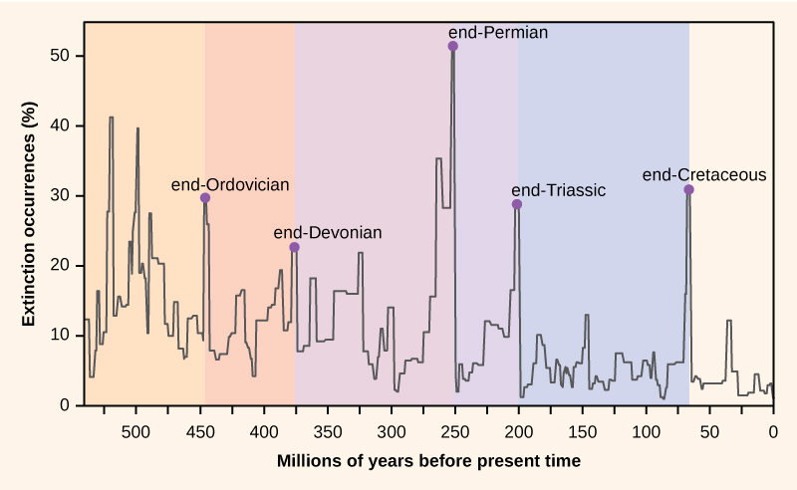
Figure 2: The Big 5 mass extinctions. Figure from http://wikipedia.org

How does volcanism affect C isotopes?

To measure changes in CO₂ levels through geologic time, we look at ancient fossil soils also known as paleosols. Soils are natural carbon sinks that store carbon in the form of organic material (dead leaves, roots, bacteria, and fungus) and minerals such as calcite (CaCO₃). Because soils are excellent carbon sinks that reflect local and global climatic conditions, we can use them as a proxy to determine the atmospheric CO₂ concentration (pCO₂) at a specific point in time using stable isotopes of carbon (C).

We measure carbon isotopes in the rock record by measuring residual organic material preserved within them as well as within the calcite that forms in soils. We can do this by using a mass balance mixing model in which we have an amount (concentration of C in the form of CO₂) and an isotopic value to that amount (Figure 3).

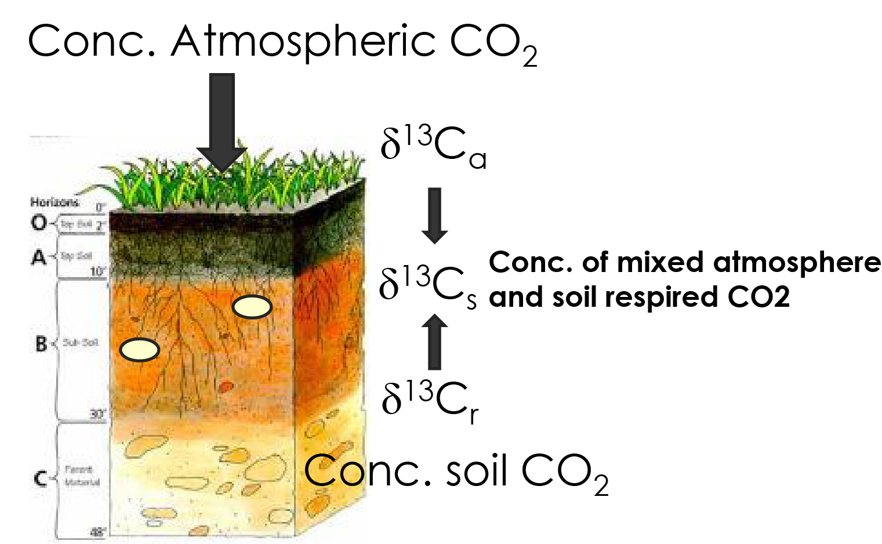
Figure 3: Mixing model for the soil paleo pCO₂ proxy. The model is based on a known isotopic composition of atmosphere (δ¹³C_{a}), the isotopic composition of root respired CO₂ (δ¹³C_{r}) and their mixture (δ¹³C_{s}).

There are two sources of carbon, CO₂ from the atmosphere and CO₂ that diffuses from roots of plants. Each of those have a known isotopic composition. If we can estimate how much of the CO₂ from the roots are being released, we can solve for CO₂ in the atmosphere. The equation that we use to calculate pCO₂ is from an equation developed by Cerling (1999) called the pCO₂ paleobarometer equation.
$$C_{a}=S_{(z)}\frac{\left({δ^{13}C}_{s}-1.0044{δ^{13}C}_{r}-4.4\right)}{\left({δ^{13}C}_{a}-δ^{13}C_{r}\right)}$$
Where:
C_{a} = atmospheric CO₂ concentration (pCO₂)
S_{(z)} = concentration of CO₂ due to soil respiration of organic matter
δ¹³C_{s} = δ¹³C of soil CO₂
δ¹³C_{r} = δ¹³C of soil-respired CO₂
δ¹³C_{a} = δ¹³C of atmospheric CO₂

We can solve for other variables using the following:
Variable | Value or Equation
S_{(z)} | 3000 ppm
T | 23.5°C
δ¹³C_{a} | -6.3‰
Epsilon (ε) | $$ε=11.98- \left(0.12*T\right)$$
δ¹³C_{s} | $\left(\frac{δ^{13}C_{CaCO3}+1000}{\frac{ε}{1000}+1}\right)-1000$
δ¹³C_{r} | δ¹³C_{Organic}

Data:
The data that will be used is an Excel (or Google Sheets) document. The data comes from the Newark Basin, USA (Schaller et al., 2015). Be sure to look at all the data provided even though you may not use all of it.

Solve for pCO₂:
- Set up a new Excel spreadsheet by adding table labels (C_{a}, S_{(z)}, δ¹³C_{s}, δ¹³C_{r}, δ¹³C_{a}). Make sure to keep track of which paper the data are coming from.
- Establish equations in empty cells. Remember, to start an equation in excel, you must enter an “=” followed by the equation.
- Solve for each of the variables using the equations in Table 1.
- Solve for C_{a} in original equation. Answer will be given in ppm (parts per million).

Make Plots:
- Plot pCO₂ against time (age)
- Plot δ¹³C against time (age)
- Set y-axis range to 200 – 205 million years for both plots
- Set x-axis pCO₂ range from 0 – 6000 ppm
- Set x-axis δ¹³C range from -20 to -30‰

Questions:
- Describe the plots. Are there any notable trends? Explain.

- What is the magnitude of pCO₂ change (i.e., min and max values)?

- There is a very noticeable excursion in the plot. For how many years does the pCO₂ change occur?

- There is evidence for CAMP volcanism. Where on the plots? (Highlight this section in the excel plots)

Concentration in CO₂ (ppm) corresponds to climate stability.
- What does stable CO₂ concentration indicate about climate stability? What do high fluctuations in CO₂ concentration suggest?

A negative C-isotope excursion (NCIE) at 201.564 million years in the δ¹³C record is a global indicator for the onset of the end Triassic mass extinction caused by CAMP volcanism.
- Look at your δ¹³C vs time plot and draw a line through 201.5 Ma. Based on what you have learned about CAMP and its relationship with the end Triassic Mass extinction, what phenomenon was recorded in this dataset?

- The NCIE is a marker for the increase in pCO₂. CO₂ gas is a unique gas. What type of gas is it?

- Since CO₂ is this type of gas, what might we expect to occur to temperature during the time period encompassed by the NCIE?

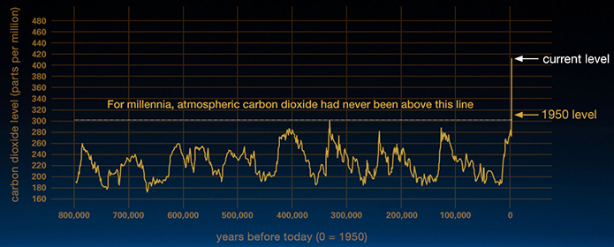
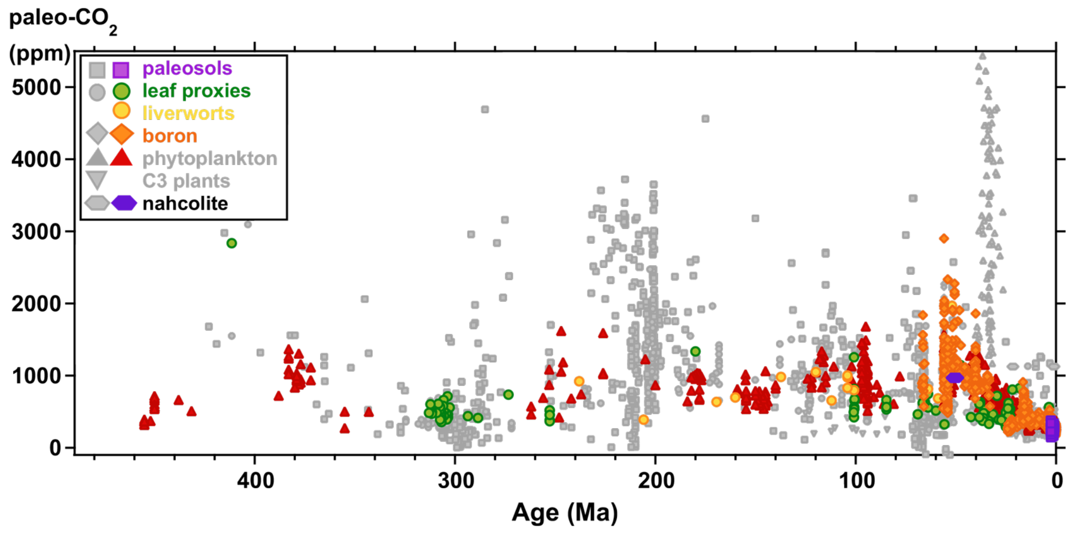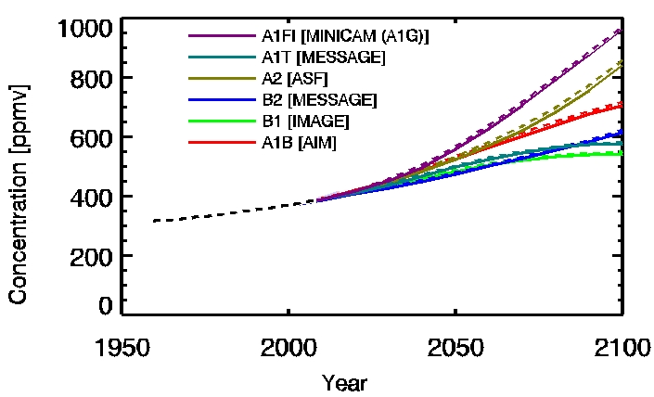
TOP: Historical (pre-1950) data from Vostok ice core and post-1950 data from NOAA Mauna Loa. Figure from https://climate.nasa.gov/.
BOTTOM LEFT: Deep time data showing all known published pCO₂ data. Colored symbols indicate the most accurate data to date. Figure from https://paleo-co2.org/.
BOTTOM RIGHT: Modern atmospheric CO₂ concentrations observed at Mauna Loa Observatory, Hawai’i from 1958 to 2008 (Black line). Colored lines are mathematical models used to estimate future pCO₂ levels based on current measurements. Figure from http://icpp.org/.

Questions:
- Compare and contrast the three pCO₂ vs time plots?

- What climate parameter is expected to increase in concert with increasing pCO₂?

- What do the different models predict will happen to pCO₂ in the future? What does this mean for future climate?

Wrap-up Questions:

- What climatological changing event did the Schaller paper data record? How is that information recorded/preserved in the rock record?

- Name 2 animals that dominated the earth post-end Triassic mass extinction.

- What is pCO₂? Provide a definition and an explanation of how it relates to climate change.

- What is causing moderns change in pCO₂?

Critters impacted by the end Triassic Mass Extinction
Extinct | Survived
Ammonites  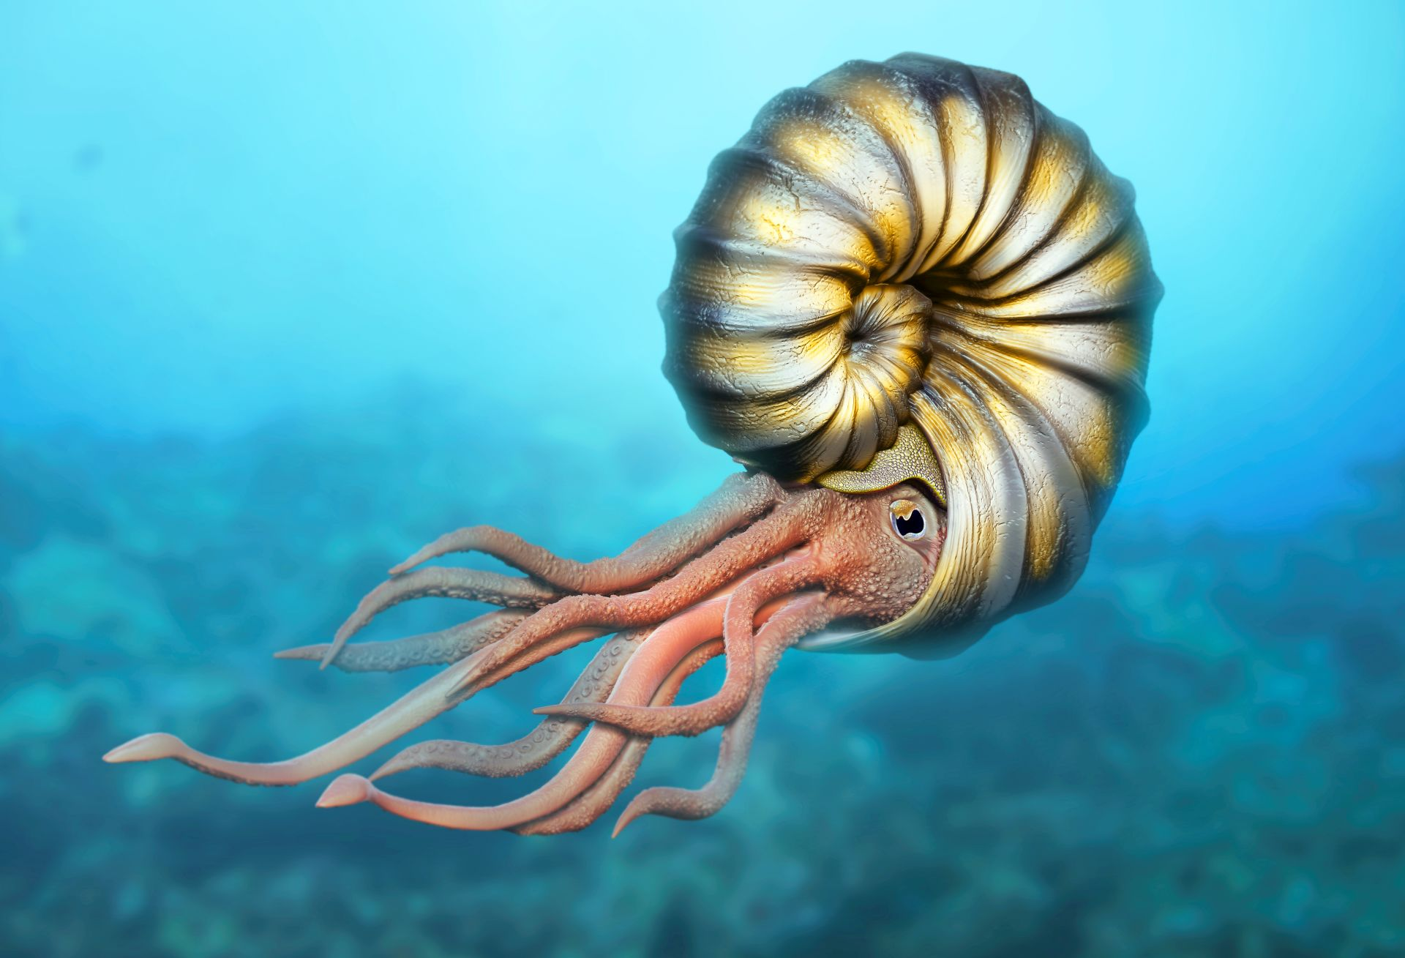  Conodonts  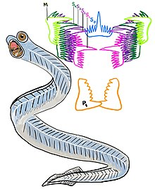  Non-mammalian therapsids (Mammal-like reptiles)  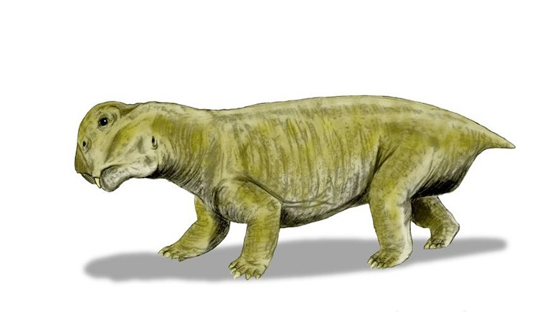  Ancient archosaurs, reptiles, amphibians, and insects  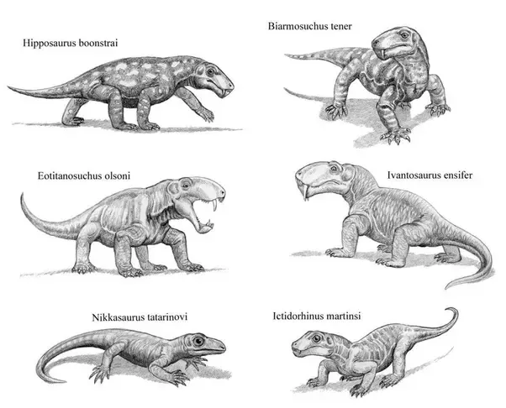 | Modern Lissamphibians (frogs/toads, salamanders, caecilians) 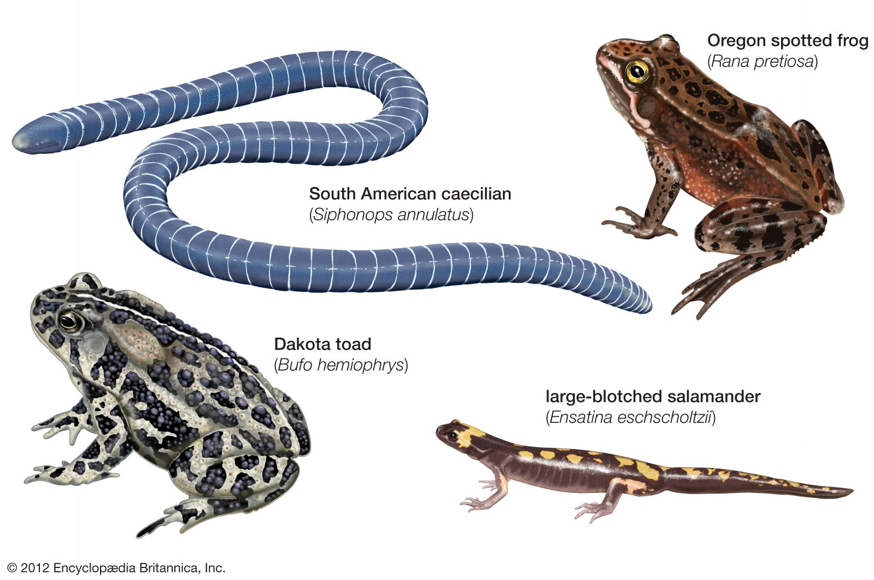  Modern Lepidosaurs (lizards, snakes, amphisbaenians)  &  Modern Archosaurs (crocodiles, turtles/tortoises, birds)  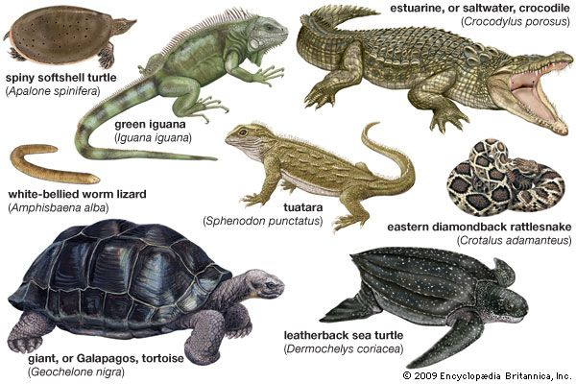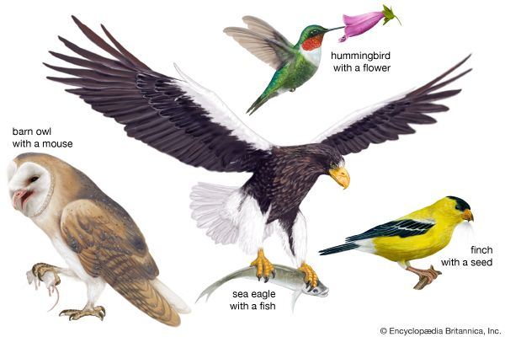  Avian and Non-avian Dinosaurs  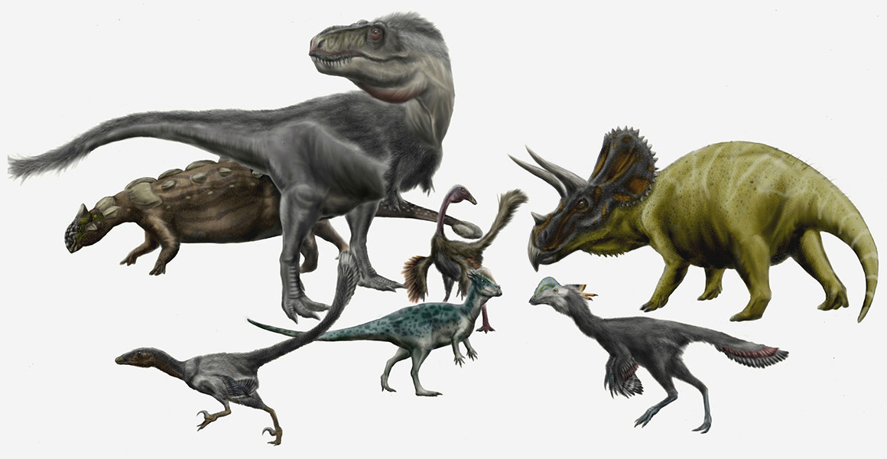  Mammalian therapsids (true mammals)  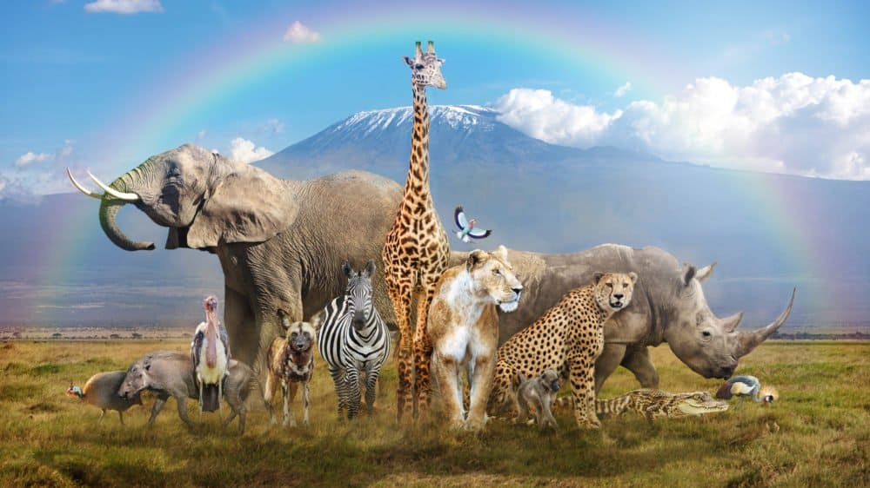

Glossary

Acidification – decrease in the pH of water or soil.
Anoxia – an absence of oxygen.
Archosauromorphs – greek for “ruling lizard forms.” Animals that are related to birds, crocodiles/alligators, dinosaurs, and turtles.
Atmosphere – a layer or layers of gases surrounding the Earth and other planets/material bodies, that is held in place by gravity.
Atmospheric CO₂ Concentration (pCO₂) – the amount of carbon dioxide gas dissolved in the atmosphere measured in ppm (parts-per-million) or percent concentration.
Atomic Mass Unit (AMU) – unit of measurement at the atomic scale.
Biogeochemical Pathways – any natural pathways by which essential elements of living matter are circulated. Biogeochemical refers to the consideration of the biological, geological, and chemical aspects of each cycle. Biogeochemical cycles can be gaseous (nitrogen, oxygen, carbon, and water) and sedimentary (iron, calcium, phosphorus, sulfur, and other earthbound elements).
Biogeochemistry – the study of the chemical, physical, geological, and biological processes and reactions that govern the composition of the natural environment (including the biosphere, cryosphere, hydrosphere, pedosphere, atmosphere, and geosphere).
Biosphere – regions of the surface, atmosphere, and hydrosphere of the earth (or other analogous parts of other planets) occupied by living organisms.
Calcium Carbonate (CaCO₃) – a chemical compound found in rocks as the minerals calcite and aragonite and is the main component of shells of marine organisms, snails, and eggs.
Carbon Cycle – biogeochemical cycle by which carbon is exchanged among the biosphere, pedosphere, geosphere, hydrosphere, and atmosphere of the Earth.
Carbon Sink – a natural reservoir that stores carbon-containing chemical compounds accumulated over an infinite period. Examples include forests, bogs, and the ocean.
Decomposition – the process by which dead organic substances are broken down into simpler organic or inorganic matter such as carbon dioxide, water, simple sugars, and mineral salts. The process is a part of the nutrient cycle and is essential for recycling the finite matter that occupies physical space in the biosphere.
Geosphere – the solid parts of the planet, specifically the deep earth through the mantle.
Greenhouse Effect – trapping of the sun’s warmth in a plant’s lower atmosphere, due to the greater transparency of the atmosphere to visible radiation from the sun than to infrared radiation emitted from the plant’s surface.
Greenhouse Gases – a gas that contributes to the greenhouse effect by absorbing infrared radiation.
Hydrosphere – all the waters on the earth’s surface, such as lakes and seas, and can sometimes include clouds and water vapor.
Inorganic – not consisting of or deriving from living matter.
Isotope – chemical element which differs in the number of neutrons.
Large Igneous Provinces (LIP) – an extremely large accumulation of igneous rocks that have an aerial extent greater than 0.1 Mkm² (mega kilometers squared), igneous volume greater than 0.1 Mkm³ (mega kilometers cubed) and a maximum lifespan of ~50 Myr (million years) that have intraplate tectonic settings or geochemical affinities, and are characterized by igneous pulse(s) of short duration (~1-5 Myr) during which a large proportion (>75%) of the total igneous volume has been emplaced.
Mass extinction – An extinction event where ~75% of the species vanish in a geologically short period of time, typically less than 2.8 million years.
Non-mammalian therapsid – Reptiles that were related to modern mammals but are now extinct.
Organic – referring to or derived from living matter.
Paleosol – a stratum or soil horizon that was formed as a soil in a past geological period.
Pangea – a supercontinent that existed during the late Paleozoic and early Mesozoic eras.
Pedosphere – the outermost layer of the Earth that is composed of soil and subject to soil formation processes.
Percent Concentration – used to describe ppm as a percent (%). For example, 1 ppm = 0.0001% gas.
Photosynthesis – a process used by plants and other organisms to convert light energy into chemical energy that can later be released to fuel the organisms’ activities.
Plate Tectonics – a theory describing the large-scale motion of tectonic plates around the Earth. This process has been happening for 3.5 billion years.
PPM – Parts-per-million is the ratio of one gas to another. For example, 1000 ppm of CO₂ means that if there are 1,000,000 gas molecules, 1,000 of them would be CO₂ while the remaining 999,000 molecules would be other gases. In climate science, it is simply a ratio of the amount of CO₂ in a million units of atmosphere. It is sort of like a percentage, but rather than being out of 100 we are looking at units out of 1 million.
Primary Production – the synthesis of organic compounds from atmospheric or aqueous carbon dioxide.
Proxy (Climate proxy) – preserved physical characteristics of the past that stand in for direct meteorological measurements and enable scientists to reconstruct the climatic conditions over a longer fraction of the Earth’s history.
Respiration – a process of living organisms involving the production of energy, typically with the intake of oxygen and the release of carbon dioxide from the oxidation of complex organic substances.
Soil Horizon – a layer parallel to the soil surface whose physical, chemical, and biological characteristics differ from the layers above and beneath.
Stable Isotope – isotope that does not decay into other elements (i.e., not radioactive).
Subduction – the sideways and downward movement of the edge of a tectonic plate of the earth’s crust into the mantle.
Therapsid – a group of animals described as mammal-like reptiles. This group includes reptiles that have mammalian-like physiology and the ancestors of modern mammals.

