NAME_____________________________ (course name…)
Due Date: XXXXXXX Cuticle lab

USING LEAF STOMATA TO RECONSTRUCT PALEO-CO₂ CONCENTRATION

Background
CO₂ is key for understanding Earth’s climate system. Knowledge of CO₂ in Earth’s past is important not only for understanding the functioning of the Earth at that time, but—for times in Earth’s past that were warmer than today—where we may be headed in our near future.

As we learned in class, proxies are an important way for reconstructing paleo-CO₂. Today we focus on one of these proxies—the inverse relationship between CO₂ and stomatal frequency. You will be observing under the microscope leaves from dawn redwood (Metasequoia) collected from campus. Do they accurately predict CO₂? How much variability do you see? Perhaps you can impress your friends by your ability to sense atmospheric CO₂ concentration just by looking at leaves on campus!

Second, you will observe images of fossil Metasequoia that were growing during a time of marked global warmth (early Eocene, ~48 million years ago). Are you estimating a concentration of CO₂ that is different than today?

Throughout this lab, you will likely be confronted with the reality of noisy data. This is very common in the natural sciences! With this in mind, I would like for you to be able to describe, at least qualitatively, a strategy for testing if one group of measurements (e.g., Eocene) is truly different than another group of measurements (e.g., present-day).

Objectives
(1) Characterize the stomatal frequency of modern and fossil Metasequoia in order to estimate the concentration of atmospheric CO₂ in which the plants grew.

(2) Think about how best to manage noisy data sets.

Hypotheses to test
(1) Do stomata faithfully record the level of atmospheric CO₂?

(2) Do other environmental factors impact stomatal distribution?

1. [15 pts] Place a wet cuticle fragment on a glass slide. Lay a cover slip over top the cuticle, making sure you do not trap any air bubbles. Using the 10× lens, bring the cuticle fragment into focus. Spend a moment to study the various aspects of the cuticle by moving the stand both front to back and side to side. Once you have done this, switch over to the 60/63× lens (or 40× if you have it), and fine-tune the focus. Again, spend a moment to study the various aspects of the cuticle by moving the stand both front to back and side to side. Switch back to the 10× lens and draw and label what you see, including stomatal pores, guard cells, and epidermal cells (both the epidermal cells that are part of the vascular bundles, and the epidermal cells in between these bundles). You do not need to draw every cell, and only label one example of each feature. Once you are finished drawing, switch back to the 40/60/63× lens and center your field of view on an area with stomata. Be sure to choose an area that is easy to focus.

a. Metasequoia label: [xxxxx] [yyyyy]

b. How many stomata do you see in your field of view?

c. How many epidermal cells (you may need to make several counts and take an average)?

d. What is the stomatal index (%)?

2. [15 pts] Calculate the number of stomata, number of epidermal cells, and stomatal index, for four other fields of view on your cuticle fragment.
________________________#2_____ ___#3___________#4_____ ____#5
# of stomata

# of epidermal cells

stomatal index (%)

a. Based on your data, what is more variable, # of stomata or stomatal index? Explain how you came to this conclusion.

b. What is the average stomatal index for your five fields of view?

c. Using the following relationship, calculate the predicted CO₂ concentration (ppm) under which your leaf grew (let me know if you get a crazy answer; it happens sometimes…).
CO₂ = 237,693 × SI ^{-2.772}

3. [10 pts] Make a similar set of measurements for the other group of Metasequoias.

____________________#1 ___ _ #2_____ ___#3_________#4____ ____#5
# of stomata

# of epidermal cells

stomatal index (%)

a. Metasequoia label: [CFA] [Long Lane]

b. Calculate the predicted CO₂ concentration under which your leaf grew.
4. [10 pts] Are there large differences in SI between your two measured leaves? How may you go about quantifying what a ‘large difference’ means?

5. [10 pts] Calculate the stomatal index for the two images below. Both come from the same leaf of a fossil Metasequoia occidentalis dating to the middle Eocene (~48 Ma).
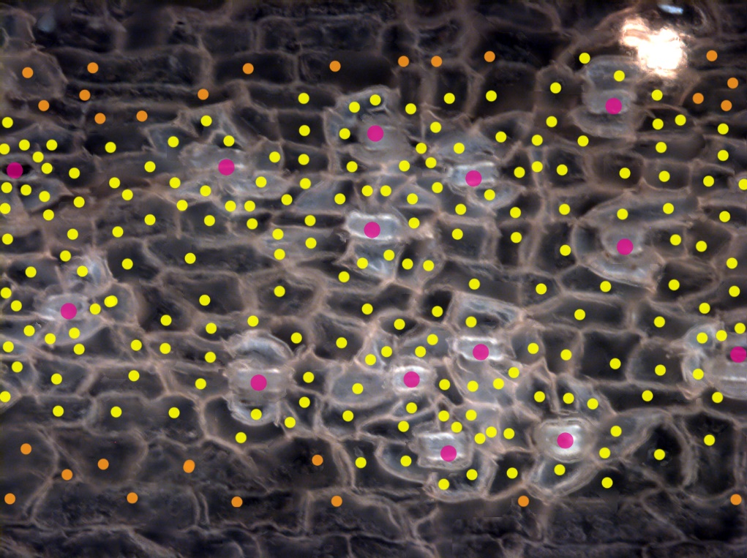
# of stomata:

# of epidermal cells:

stomatal index:

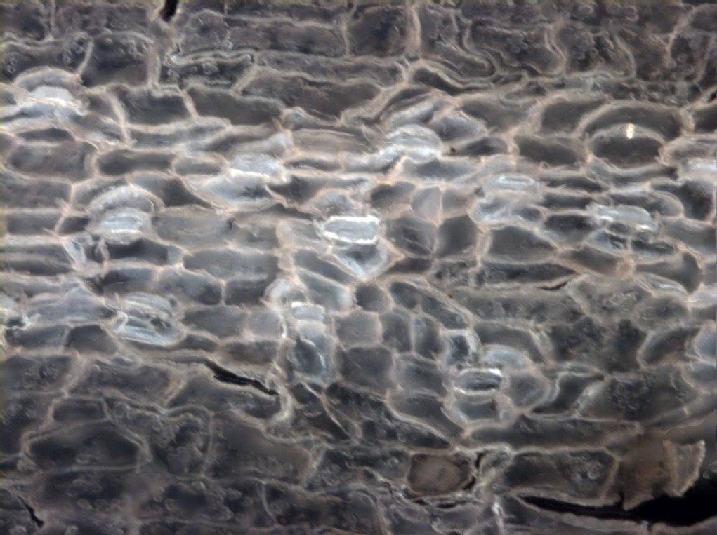
# of stomata:

# of epidermal cells:

stomatal index:

Images courtesy of Dana Royer (unpublished)
6. [10 pts] Based on your measurements, would you estimate the CO₂ concentration of the atmosphere for these two times to be higher or lower than the present-day concentration of ~420 ppm? Explain. You can assume that the fossil Metasequoia responded to CO₂ in a similar manner as modern Metasequoia.

7. [10 pts] Ginkgos growing at 3000 m elevation have stomatal indices of 25% while at sea level they are closer to 10%. Why are the stomatal indices at high elevation so high?

8. [10 pts] Metasequoia, as with many plants, only have stomata on their lower leaf surfaces. There are no pores on the upper surface. Why do you think this is so? (hint: the thickness of the cuticle on the upper surface is also thicker than on the lower surface.)

9. [10 pts] The stomatal responses to CO₂ are often species-specific. Why does this behavior limit the usefulness of using the fossil stomata to reconstruct CO₂? How can you determine if a fossil species belongs to the same species of a living (extant) species? Explain two measurement-based criteria that you could use. What could be one way to determine if the stomata in your fossil taxa responded to CO₂ in the same manner that your present-day calibration species does? Explain.

