Paleo-CO2 and Mean Annual Precipitation Homework
GOALS:
- Learn how calculations of CO₂ concentration can be made from real data.
- Learn how calculations of mean annual precipitation can be made from real data
- Learn possible limitations and potential sources of error to such calculations
Introduction:
A record of ancient atmospheric CO₂ concentration has long been the goal of many paleoclimatologists. Having such a record would allow scientists to understand the variation and response of climate to changes in greenhouse gas concentration. This assignment brings together numerous proxies to allow you to attempt to calculate CO₂ concentrations. This is not always straightforward and there are many pitfalls. Before starting this assignment, you should read the paper by Cotton and Sheldon, published in 2012. It provides a nice review and background on this particular CO₂ proxy which utilizes isotope values of paleosol calcium carbonate nodules.
The Data:
The data that you will use comes from two additional papers. Suarez at al. 2020 and Harper at al. 2021. Those citations are below. These data are the result of an NSF grant (EAR 1941017) funded from 2015 to 2020.
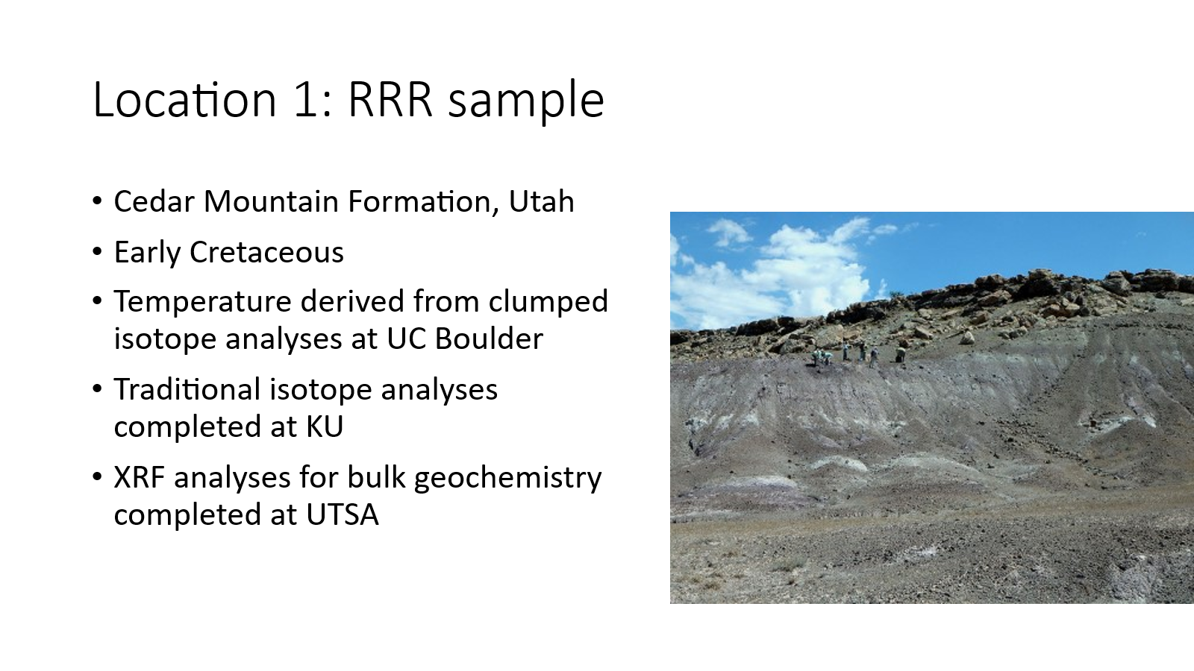

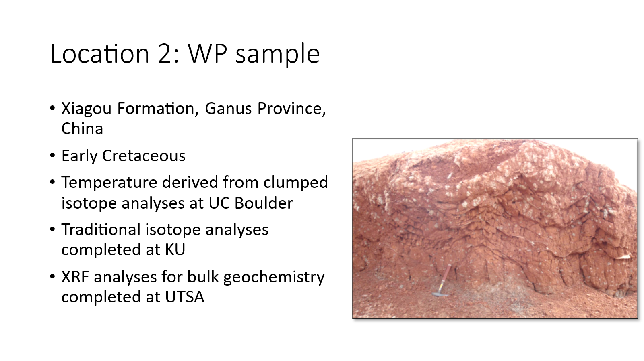

Instructions:
Utilize the provided Excel file to help you calculate CO₂ concentrations. Each tab takes you through the calculation of CO₂ concentration. You should go in order from left most tab to right most tab.

We will use this equation presented by Ekart et al., 1999.

$$C^{*}a=S\left(z\right)* \frac{δ_{s}-1.0044*δ_{ϕ}-4.4}{δ_{a}-δ_{s}}$$

Where C*a = concentration of CO₂ in ppm
S(z) = concentration of CO₂ in the soil at depth Z (presumably where the paleosol carbonates are forming)
δ_{s} = carbon isotope value of soil CO₂ in equilibrium with the water that precipitated the soil carbonate. It is also shown as δ¹³C_{s} in some papers.
δ_{φ} = carbon isotope value of soil respired CO₂. It is also shown as δ¹³C_{r} in some papers.
δ_{a} = carbon isotope value of atmospheric CO₂
Tab 1:
The goal of part 1 is to calculate the δ¹³C of soil CO₂ (δ_{s} or δ¹³C_{s}) and δ_{a} (or δ¹³C_{a}). To do this you will use the carbon isotope value of the paleosol carbonate nodule and temperature (derived from clumped isotope paleothermometry) and the equation provided which comes from Romanek, 1992). The Epsilon value is the temperature-dependent offset between the C-isotope value of CO₂ and calcite. This is used with the measured δ¹³C of soil carbonate to determine the δ¹³C of soil CO₂ (δ_{s} or δ¹³C_{s}).
$$ε_{cl-CO2}=11.98-0.12*T℃$$

$$δ^{13}C_{s}=δ^{13}C_{CO3}-ε_{cl-CO2}$$

For the δ_{a}, you will subtract 8 permil from marine carbonate δ¹³C values averaged from a number of different references. This is what is shown in the graph from Ekart et al. 1999. Enter in equations in the gray boxes.
In this figure, δ¹³C_{occ} is the same variable δ¹³C_{marine_CO3} (column H). δ¹³C_{a*} is δ¹³C_{atm} (the same variable you want to calculate in column I. The offset between δ¹³C_{marine_CO3} and δ¹³C_{atm} is 8 permil. From Ekart et al., 1999.

This calculation is a simplification of the calculation you made to determine δ¹³C_{s}. An alternative to this blanket 8 permil offset is to use the same epsilon equation (or another similar to this) and a specific sea surface temperature along with specific marine carbonate values.

Tab 2:
The goal of part 2 is to calculate S(z). First you will need to calculate CALMAG:
$$CALMAG= \frac{Al_oxide}{Al_oxide+Ca_oxide+Mg_oxide}*100$$

Then calculate MAP from CALMAG:
The relationship between Mean Annual Precipitation (MAP) and different weathering indices. In this homework we are using CALMAG: MAP = 22.69(CALMAG) -435.8
From Nordt and Driese, 2010

Lastly you will calculate the S(z) from the linear equation show from Cotton and Sheldon, 2012.
The relationship between soil-respired CO₂ and MAP. The linear regression through these data results in the equation: S(z) = 5.67 (MAP) – 269.9
From Cotton and Sheldon (2012).

Tab 3:
At this point you will calculate CO₂ concentration from the equation presented by Ekart et al., 1999 introduced at the beginning of this document. Use the δ¹³C_{r} (given in tab 1), the δ_{s}, and δ_{φ} from the previous tabs as well as the S(z) from tab 2. Note that the δ¹³C_{r} value is from the measured bulk sedimentary organic matter of paleosol matrix. There are other means of estimating this value. If you were to do this for your own samples, you would want to determine this value
Grading and Questions Tab:
After completing your calculations, consider the three questions provided in this tab and answer to the best of your ability. It may help to review the Cotton and Sheldon, 2012 paper again. There is a suggested grading rubric for this activity in this tab.
Optional Part 4:
Now that you’ve made some calculations and set up all of your equations in Excel, let’s play around with the equations.
Save a copy of your Excel file as the same name but add “_sensitivity.” Try changing some of the variables. Here are two examples, but you can do these and others if you wish.
Tab1: When we think of paleoclimate we often think of temperature. Try changing the temperature in this tab. What variables in this tab does it affect? By how much? How does that affect the CO₂ concentration that gets calculated in Tab 3?
Tab 2: The other major climate variable that we think of is precipitation. We used bulk geochemical data to calculate mean annual temperature (MAP). Instead of calculated MAP, directly enter a MAP value to change it to either higher or lower rates. What variable does it change in this Tab? By how much? How does this affect the CO₂ concentration that gets calculated in Tab 3?
Associate references:
Cotton, J.M., and Sheldon, N.D. 2012. New constraints on using paleosols to reconstruct atmospheric pCO_{2.} GSA Bulletin, 124, 1411-1423.

Romanek, C. R., Grossman, E. L., and Morse, J. W. 1992. Carbon isotope fractionation in synthetic aragonite and calcite: Effects of temperature and precipitation rate. Geochimica et Cosmochimica Acta, 56, 419-430.

Nordt, L. C., and Driese, S. D. 2010. New weathering index improves paleorainfall estimates from Vertisols. Geology, 38, no. 5, 407-410.

Ekart, D. D., Cerling, T. E., Montanez, I. P., and Tabor, N. J. 1999. A 400 million year carbon isotope record of pedogenic carbonate: Implications for paleoatmospheric carbon dioxide. American Journal of Science, 299, no. 10, 805-827.

Cerling, T. E., and Quade, J. 1993. Stable Carbon and Oxygen Isotopes in Soil Carbonates, Climate Change in Continental Records, Volume Geophysical Monograph 78, American Geophysical Union.

Sheldon, N. D., Retallack, G. J., and Tanaka, S. 2002. Geochemical climofunctions from North American soils and application to paleosols across the Eocene-Oligocene boundary in Oregon. Journal of Geology, 110, no. 6, 687-696.

Harper, D.T., Suarez, M.B., Uglesich, J., You, H.-L., Li, D.-Q., Dodson, P. 2021, Aptian-Albian clumped isotopes from northwest China: Cool temperatures, variable atmospheric pCO2, and regional shifts in hydrologic cycle. Climate of the Past. v. 17, p. 1607-1625. https://doi.org/10.5194/cp-17-1607-2021.
Suarez, M.B., Knight, J., Snell, K.E., Ludvigson, G.A., Kirkland, J.I., Murphy, L. 2020, Multiproxy paleoclimate estimates of the continental Cretaceous Ruby Ranch Member of the Cedar Mountain Formation. In: Bojar, A.-V., Pelc., A., and Lecuyer, C. (eds.) Stable Isotopes Studies of Water Cycle and Terrestrial Environments. Geological Society, London, Special Publications, v. 507. https://doi.org/10.1144/SP507-2020-85

