Climate and CO₂

Earth’s climate is changing. Whereas there have been natural changes to climate in the past, modern climate change is caused mostly by humans. Because climate change will impact us (see section below) and because we have the ability to moderate, through policy, the amount of climate change that occurs and therefore the extent of its impact, we are interested in projecting climate change under various societal/economic/political scenarios. One of the most basic variables of importance for climate change is the sensitivity of Earth’s surface temperature to changes in the level of greenhouse gases, especially carbon dioxide.

A. Climate Sensitivity
Climate sensitivity, in its most basic sense, the sensitivity of surface temperature to changes in radiation. If the sun got brighter, and the Earth received more sunlight, the surface would heat up. The amount of warming in response to the change in radiation is the sensitivity. Given the importance of carbon dioxide (CO₂) in the global warming that is happening on Earth right now, climate sensitivity has become known as the sensitivity to atmospheric CO₂ increase.
Atmospheric CO₂ affects radiation because it is a greenhouse gas. More CO₂ in the atmosphere results in more back radiation (energy that was emitted upwards from Earth’s surface, was absorbed by greenhouse gases in the atmosphere and is then re-radiated back toward Earth’s surface). The theory of atmospheric physics suggests that global mean annual temperature (the Earth’s surface temperature averaged across the entire planet for an entire year) responds to greenhouse gas levels logarithmically such that a doubling of CO₂ causes a fixed amount of warming. According to this theory, the amount of warming is the same whether the doubling of CO₂ is from 200 to 400 parts per million (ppm), 300 to 600 ppm, 500 to 1000 ppm or any other doubling. Therefore, climate sensitivity is usually expressed as the amount of warming (ºC) divided by the number of CO₂ doublings:

$$CS= \frac{warming (^{o}C)}{number of CO_{2} doublings}$$

where CS is climate sensitivity. The “number of CO₂ doublings” may be a new concept to you, so let’s look at some examples. If CO₂ starts at 200 ppm and increases to 400 ppm, that is one doubling (200 x 2 = 400). If CO₂ starts at 200 and increases to 800, that is two doublings (200 x 2 x 2 = 800). Although it may be confusing to think about, there is no (mathematical) need to have a whole number of doublings. And, of course, CO₂ in the atmosphere will not necessarily level out at some whole number of doublings. Fortunately, there is a way to calculate the number of doublings from the low CO₂ level and the high CO₂ level you are comparing:

$$number of CO_{2} doublings=log_{2}\left(\frac{high CO_{2}}{low CO_{2}}\right)$$

The function log₂ is the logarithm base 2 (if you are familiar with logarithms, you have probably seen log base 10 or log base e, but since we are considering doublings, we need log base 2). There are calculators online which you can use to evaluate log₂ of a number.

1) The importance of timescale

The magnitude of climate sensitivity depends on the timescale of interest. The temperature response that occurs solely due to the effects of CO₂ on back radiation is well known from theory. This climate sensitivity is approximately 1°C/CO₂ doubling. However, as Earth’s surface temperature warms, OTHER THINGS HAPPEN WHICH THEN AFFECT THE AMOUNT OF WARMING. These ‘other things’ are feedbacks in the climate system and are more difficult to precisely quantify. It is important to recognize that some feedbacks occur quickly (years) whereas others occur very slowly (thousands to tens of thousands of years). Therefore, we would expect the magnitude of climate sensitivity to differ depending on the amount of time being considered. Listed below are some subcategories of climate sensitivity. In actuality, there are not clear divisions between these subcategories but rather a continuum among them.

Transient Climate Response (TCR)
The Transient Climate Response is a decade-scale climate sensitivity. This type of sensitivity does include some feedbacks, such as the increase in water vapor content of the atmosphere with warming. Because water vapor is a greenhouse gas, this feedback increases the magnitude of climate sensitivity compared with the sensitivity to CO₂ alone with no feedbacks. However, the magnitude of TCR is smaller than Equilibrium Climate Sensitivity (see below) largely because, on the relatively short timescale of decades, the deep ocean absorbs some of the heat that would otherwise cause warming of Earth’s surface.

Equilibrium Climate Sensitivity (ECS)
The Equilibrium Climate Sensitivity is a 100s – 1000s of years scale climate sensitivity. Mixing of the deep ocean takes about 1000 years. Therefore, over timescales much shorter than 1000 years, the deep ocean is out of equilibrium with the surface ocean - if we are considering warming, then on short timescales, the deep ocean is colder than it would be at equilibrium. This means that part of the surface energy balance involves loss of heat from the surface to the deep ocean. This effectively cools the surface of the Earth. “Equilibrium” Climate Sensitivity refers to the climate sensitivity in the absence of this ocean buffering of surface temperature. Here the word ‘equilibrium’ is shown in quotes because although ECS does consider equilibrium between surface and deep ocean, it does not consider equilibrium in other parts of the Earth system, such as the cryosphere (most importantly, polar ice sheets). The Intergovernmental Panel on Climate Change has estimated a range of 2.5 to 4°C (best value of 3°C) for ECS: https://www.ipcc.ch/report/ar6/wg1/downloads/report/IPCC_AR6_WGI_SPM_final.pdf

Earth Systems Sensitivity (ESS)
Earth System Sensitivity is the longest timescale view of climate sensitivity, considering tens of thousands to millions of years. Earth system sensitivity includes all feedbacks in the Earth system, hence its name. Most importantly, ESS considers feedbacks associated with ice sheets. Large ice sheets are very reflective and therefore help cool the planet. These ice sheets can be enormous and therefore can take more than 10,000 years to reach a new equilibrium state.

2) Methods for estimation
There are a number of ways in which the magnitude of climate sensitivity has been estimated.

Climate models
Climate models simulate the transfer of heat, mass and momentum around the Earth through the oceans and atmosphere. The physics of radiation (i.e., absorption of longwave radiation by CO₂) is well understood and agreed upon and forms a basis for these models. The largest uncertainties in climate models – and thus in climate sensitivity determined from them - relate to the feedbacks. Climate models are commonly used to estimate TCR (climate models run for decades) and ECS (run for centuries) but climate model simulations run for tens of thousands of years that also incorporate ice sheet dynamics (in other words, models that would allow estimates of ESS) have not been reported.

Instrumental records
We have direct measurements of atmospheric CO₂ and Earth surface temperature since the mid 1900s. These measurements are only suitable to estimate TCR.

Paleoclimate data
There are also indirect measurements of temperature and CO₂ that extend far back in time (much further back in time than the instrumental records of CO₂ and temperature). These data are suitable for determination of ESS. In this lab, you will use paleoclimate data to calculate ESS and will be asked to think about the meaning of your results.

B. Climate Impacts
Impacts of climate change are many and far-reaching. Some that are likely to be the most consequential for society are listed here. There are many other impacts, some of which might be viewed as helpful to society or perhaps to certain groups. Unfortunately, these beneficial impacts are likely to be far outshadowed by the impacts listed below and others that present challenges rather than benefit. Are there other impacts you know about or can think of?

1) Sea level rise
Melting of ice on land causes sea level to increase. Sea level rise directly affects people and property near the coasts and on island nations. Depending on the magnitude of sea level change, these people may become displaced, which could lead to a refugee crisis. You can explore locations sensitive to sea level rise here: https://en-roads.climateinteractive.org/scenario.html?v=21.11.0 by selecting from the menu at the top Graphs >> Impacts >> Sea Level Rise – Flood Risk Map OR >> Population Exposed to Sea Level Rise.

2) Extreme weather events: floods and droughts

In many locations around the world, climate change is expected to result in less frequent, but more intense rainstorms (including more intense hurricanes). Higher temperatures will result in more evaporation from the land surface and therefore less availability of water. Therefore, the incidence of droughts and episodic flooding during large rainfall events is projected to increase. The combination of sea level rise and the increased intensity of hurricanes could be especially impactful to coastal regions.

3) Food Production

Due to droughts and flooding (see above) and also to higher temperatures, some crops may not grow as well or may grow better in different regions, requiring a reallocation of land use and changes to international imports and exports. Changes to food production are especially concerning given that population increase is closely related to greenhouse gas emissions. Consider the consequences of global population growth resulting in more people emitting more CO₂ into the atmosphere, resulting in more difficulty producing food. You can explore simulations of impacts to crop yields at the en-roads website shown under sea level rise above. Navigate to Graphs >> Impacts >> Decrease in Crop Yield from Temperature.

Notes for instructors

- This version of the lab exercise is meant for instructors. It includes a key and some details that may be helpful to instructors.
- This lab exercise is designed for introductory college level students.
- The websites linked is this lab are operational as of September 2025
- At UT Austin, this lab exercise is completed by students in Physical Geology after two lectures on the Earth’s climate system

Climate and CO₂ Exercise
40 pts total

What you will need to complete this laboratory exercise:
A computer or tablet connected to the internet

The goal of this laboratory assignment is to familiarize you with atmospheric CO2 changes over multiple timescales and to motivate you to consider the impacts of these changes on natural and human systems.

Objectives- after completing this lab assignment, you will be able to:
Recognize changes in atmospheric CO2 over multiple timescales
Calculate climate sensitivity from temperature and CO2 data
Make some basic calculations with scientific data
Articulate some of the challenges and opportunities associated with mitigating future rise in CO2

- Atmospheric CO2 in the past

Go to https://paleo-co2.org/
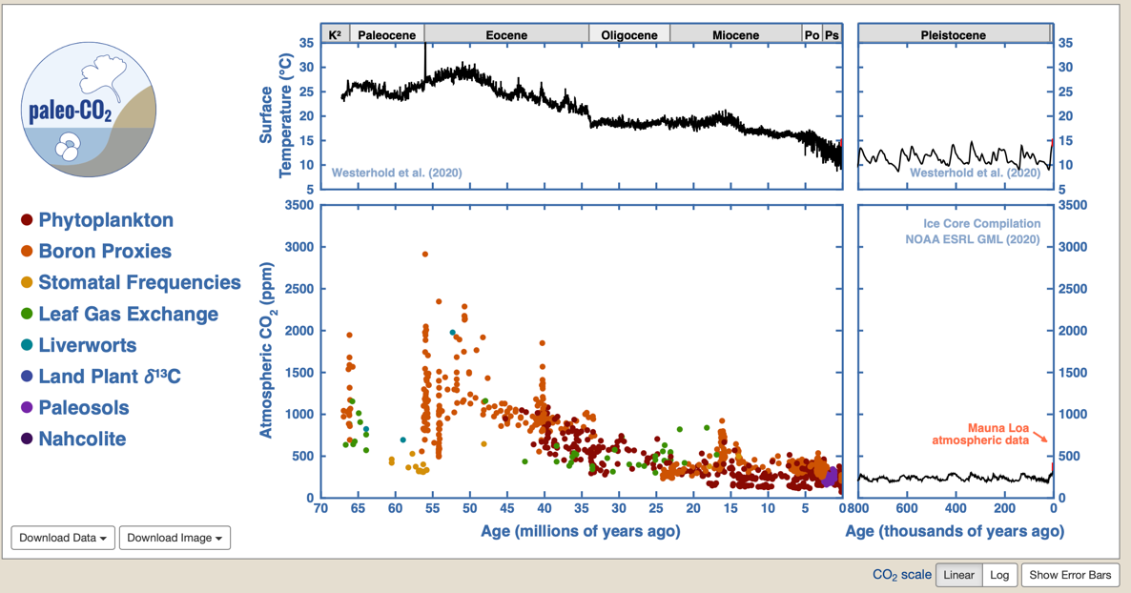

The panels on the homepage show plots of CO₂ and temperature change through time. Read the axes carefully- there is a lot of information shown here! The plot in the lower right shows atmospheric CO₂ levels as determined from ice cores (in black) and recent, directly observed, CO₂ change (in red- these are hard to see, they plot on the far right side). The glacial-interglacial cycles can be seen. There is a zoom function on the bottom left panel that may help you (you can only zoom in using the bottom left panel). If you zoom in to low CO₂ (on bottom left panel) glacial-interglacial cycles on the plot in the lower right will be easier to see.

Instructors: you may want to practice zooming so you can demonstrate for your students. Because you can only control the zoom using the bottom left panel, it takes a little practice to see what you want to see on the other panels. You cannot zoom on the top right panel.

1. Describe, qualitatively, how CO₂ and temperature are related on both glacial-interglacial timescale during the Pleistocene (plots on right) and over the entire Cenozoic Era (plots on left).
2pts
CO2 and temperature were closely at both of these timescales. In general, CO2 was lower during colder time periods

2. Based on the data shown, when was the last time that atmospheric CO₂ levels were persistently higher than they are today?
1pt

Although there are some high CO2 values during the Pliocene around 3 Ma, the last time values persistently average above modern is during the Miocene Climatic Optimum at about 15 Ma.

3. Now we will use data on these plots to make estimates of climate sensitivity. Fill in the table below using the plots on the right showing the Pleistocene Epoch.

4 pts
 | CO₂ (ppm) | Temperature (°C)
Glacial maxima | 190 | 9
Interglacials | 280 | 14

Use the data in this table to calculate climate sensitivity on a glacial-interglacial timescale. First calculate the number of CO₂ doublings. You can do this with a log base 2 function. For instance, log₂(2) =1, log₂(4) = 2, log₂(8)=3, etc. There are various calculators on the internet that can calculate the logarithm base 2 of a number (for instance, https://www.omnicalculator.com/math/log-2).

- How many CO₂ doublings occurred between glacial maxima and interglacial periods?
2 pts
log₂(280/190) = 0.56 doublings

Instructors: the concept of a partial doubling will likely be new to many students.

- How much did Earth’s surface temperature change between glacial maxima and interglacial periods?
1 pt.
5 degrees C

- What was the climate sensitivity for glacial-interglacial change (report you answer in °C/CO₂ doublings).
1 pt
5/0.56 = 8.9 °C/CO₂ doubling

- Is this value larger or smaller than the IPCC value for Equilibrium Climate Sensitivity? Why might this be the case?
2 pts

Larger, perhaps due to feedbacks associated with changes in ice volume.

Now let’s do a similar calculation comparing the warmest climate of the Eocene (the Early Eocene Climatic Optimum, or EECO, as it is sometimes called) with the recent interglacial climates. To do this, first zoom in (on the lower left panel) on all data between 52 and 50 Ma – the warmest part of the Eocene. Make sure to include data at 52 and 50 Ma in your zoomed-in view. Then click download data (bottom left of screen) and choose CSV (this will download a comma separated variable file). Now use google sheets to open this file you just downloaded. Open a new google sheet and click file >> import. On the window that appears, choose upload. You can drag and drop your csv file into the window. Then click ‘import data’ and once the data are imported, click ‘open now.’ You should now be able to see the downloaded data in your google sheet.

Use these data and the paleo-co2.org website to answer the following questions.

- What is the mean (average) CO₂ to the nearest 1 ppm?
1 pt
1612 ppm

- Now estimate the mean surface temperature (and write it below) during EECO (taken here as 52-50 Ma) from the plot on the upper left at paleo-co2.org.
1 pt
28 degrees C

- And finally, calculate climate sensitivity considering change between recent interglacial periods and EECO.
2 pts
log₂ (1612/280) = 2.53 doublings
14/2.53 = 5.5 °C/CO₂ doubling

- Compare this value to the IPCC value for Equilibrium Climate Sensitivity and to the glacial-interglacial climate sensitivity you calculated above. What might explain your result? Hint: look up when ice sheets began to form on Antarctica.
2 pts
The ECO – recent interglacial climate sensitivity is larger than IPCC estimated ECS and smaller than the glacial-interglacial sensitivity calculated above.

There is more than one possible response to the second question. One possibility that is hinted at is that because large ice sheets did not develop until the Eocene-Oligocene boundary and so the ECO- recent sensitivity integrates sensitivity associated with various climates with and without ice.

- Is the climate sensitivity you calculated a good estimation for projection of future warming? Why and/or why not? You can provide reasons why and reasons why not if you want. Provide at least two reasons.
4 pts (2pts per reason)

As above, there are many potential responses here. And in part, it depends on how far into the future we are considering. When grading, the suggestion is to look for thoughtful insight rather than accuracy.

- Convert the IPCC ECS and the EECO-recent interglacial climate sensitivities from ºC/CO₂ doubling to ºF/CO₂ doubling and write the result below:
3pts (1 pt for correct conversion factor, 1 pt each for each calculation)

3 ºC/CO₂ doubling for IPCC ECS
9 ºF/5 ºC
So, 3 ºC/CO₂ doubling * 9 ºF/5 ºC = 5.4 ºF/CO₂ doubling

5.5 ºC/CO₂ doubling for EECO-recent interglacial climate sensitivity
9 ºF/5 ºC
So, 5.5 ºC/CO₂ doubling * 9 ºF/5 ºC = 9.9 ºF/CO₂ doubling

- Space for time substitution

Let’s assume for the sake of simplicity that humanity is able to limit CO₂ increase to 1 doubling from preindustrial values. Let’s also consider warming tends to be modest in the tropics and much larger near the poles (at high latitude) and therefore make the simplifying assumption that warming at mid latitudes, where we live, is reasonably represented by global mean warming (the climate sensitivities you have calculated are for global mean warming).

4. Find two cities (or locations) in the United States (or whatever region you are most familiar with) that differ in their mean annual temperature by that expected for one CO₂ doubling based on both of the sensitivities (in ºF/CO₂ doubling or in ºC/CO₂ doubling if those units are more familiar to you) that you calculated above in question j. To answer this question fill out the table below. Maps of annual mean temperature are useful here.
8 pts

A useful global map (in ºC): https://climatedataguide.ucar.edu/climate-data/global-surface-temperatures-best-berkeley-earth-surface-temperatures).
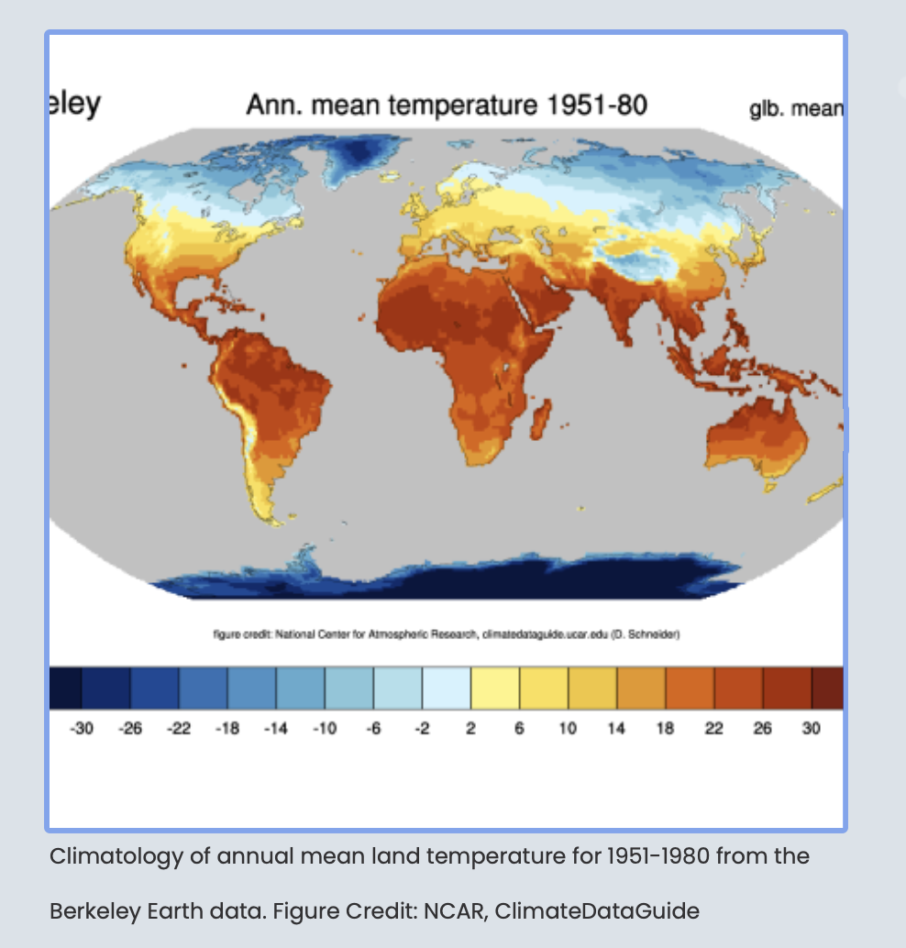

A useful US map (in ºF, The 1991-2020 average temperatures are listed at the bottom right of the map as “mean”- hover over a city to see its mean temperature):
https://www.ncei.noaa.gov/access/monitoring/climate-at-a-glance/city/mapping/110/tavg/202407/12/mean

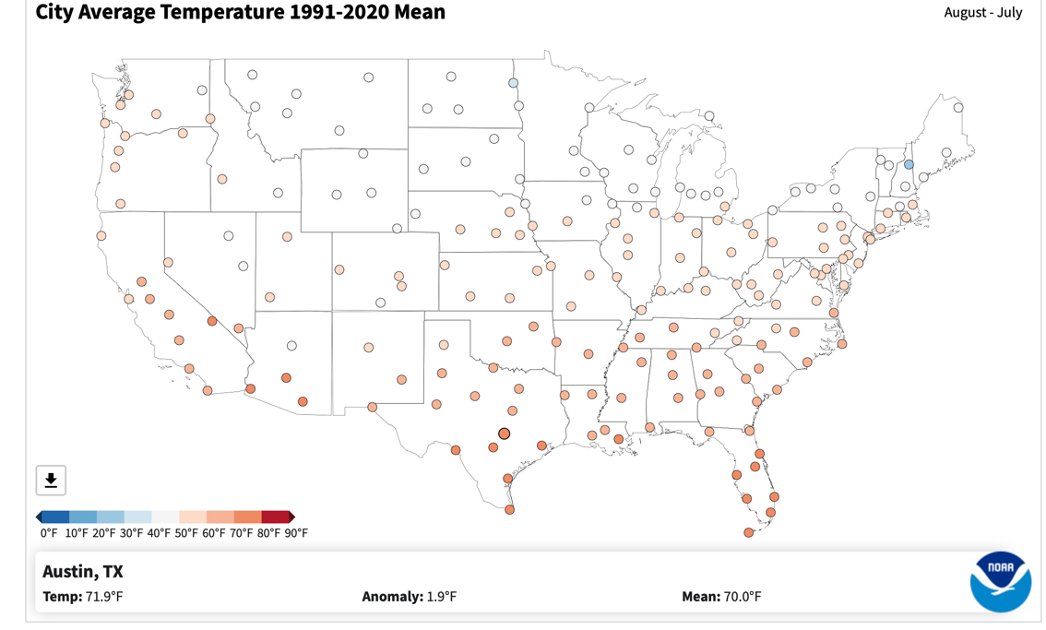

 | Temperature change | City 1 | City 2
IPCC ECS, 1 CO2 doubling | 1pt | 0.5pts | 0.5pts
IPCC ECS, 2 CO2 doublings | 1pt | 0.5pts | 0.5pts
ECO-recent interglacial, 1 CO2 doubling | 1pt | 0.5pts | 0.5pts
ECO-recent interglacial, 2 CO2 doublings | 1pt | 0.5pts | 0.5pts

Instructors: Once students complete this table, it might be a good time to have a conversation with them about what they take away from this comparison. Or that could be added as a question.
- Considering economy, policy and climate

Now go to:
https://en-roads.climateinteractive.org/scenario.html?v=21.11.0

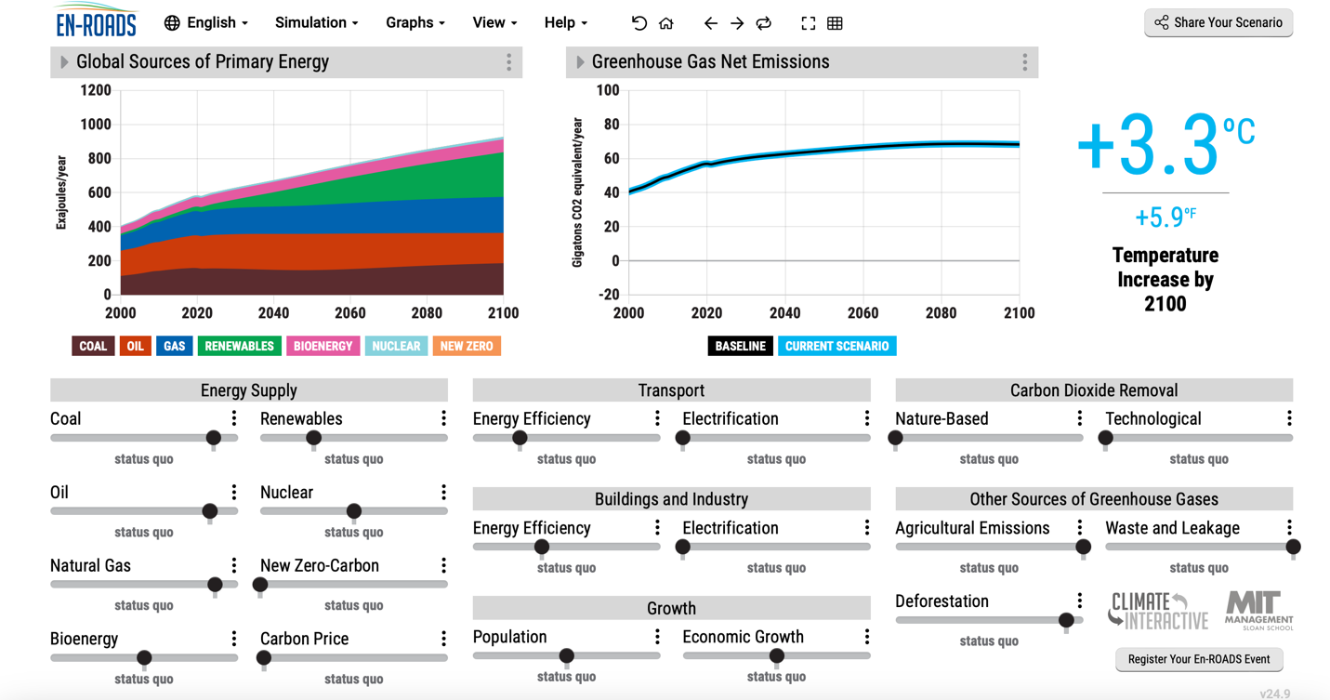

5. Spend a little bit of time familiarizing yourself with the simulation and the various options (see menus at the top- simulations, graphs, view, etc). How can we, based on this simulation, keep warming by the year 2100 below 2ºC (3.6 ºF) without causing energy prices to increase more than 20% of current price? Assume an effective future climate sensitivity of 3ºC. Then try again for a climate sensitivity of 4.5ºC (you can adjust climate sensitivity under simulation >> assumptions). It will be helpful here to make the left plot “cost of energy” and the right plot “temperature change” (the ‘graphs’ menu allows you to change what is plotted). Take a screenshot of your scenario and these plots and include it with your submission. Describe why you chose the policies and what implications they might have.
6 pts

Many potential responses here

