Climate Stripes

Description
It can be difficult or confusing to interpret Earth's average temperature over the past 150 years. Climate Stripes is an art project designed to help us visualize Earth's temperature anomaly.
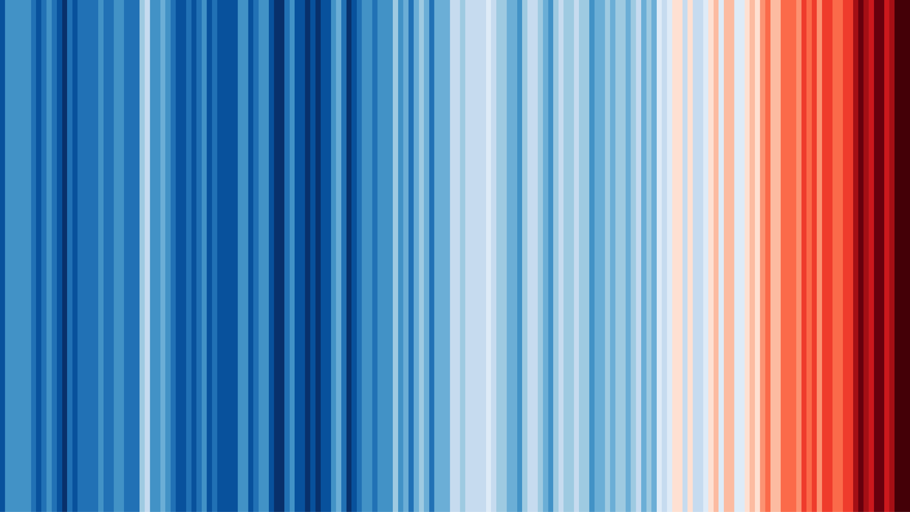

No words. No numbers. No graphs. Just a series of vertical coloured bars, showing the progressive heating of our planet in a single, striking image.
The climate stripes were created by Professor Ed Hawkins at the University of Reading in 2018.
They show clearly and vividly how global average temperatures have risen over nearly two centuries.
Each stripe represents the average temperature for a single year, relative to the average temperature over the period from 1961 to 2010. Shades of blue indicate cooler-than-average years, while red shows years that were hotter than average. The stark band of deep red stripes on the right-hand side of the graphic shows the rapid heating of our planet in recent decades.

Make your own Climate Stripe
I hope this representation of Earth's average temperature is helpful. In fact, we can also make our own local climate stripes that helps us visualize how temperature has changed in Southern California. Head over to NASA's Climate Legacies page to create your own climate stripe using the interface to compare how different people and generations have experienced climate change.

Directions
- Navigate to NASA's Climate Legacies page.
- Use the Timeline to enter at least four different entries (see the example below).
  - One entry should be Fullerton College 1913 (this is when the college, known as Fullerton Junior College, was founded)
  - One entry should be your birth year.
  - Include birth years of family members or people close to you. Try to spread them across the 20th century, i.e. try not to enter years in the same 10-year period.
- Click View Timeline then submit your Timeline on this page. (See bottom image)
- In the upper right corner, click the 'Share' button to download the image you generated.
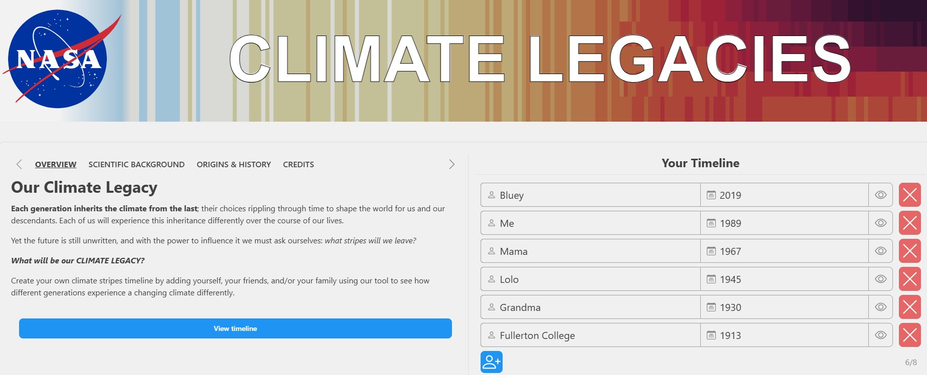
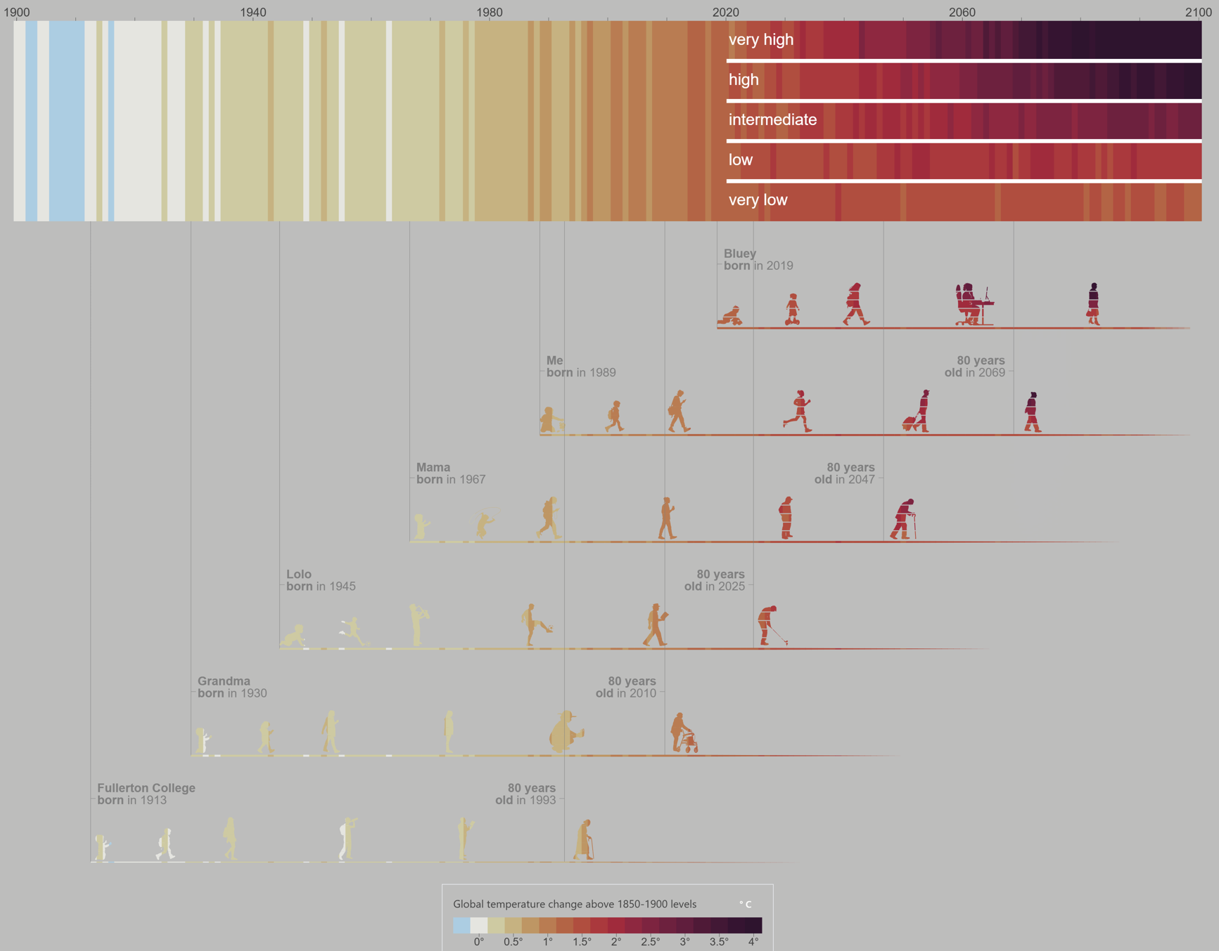

Interpreting your Climate Legacy
There are several components to the figure we generated. Let's start at the top:
The top climate stripes has a timeline going back to 1900 all the way up to 2020. Beyond 2020, the graph is further divided into five sections, very high, high, intermediate, very low, and low. These represent the projected temperatures based on different CO2 scenarios through 2100, with very high being the highest CO2 levels and very low being lower than today's CO2 levels. You can see how the scenarios differ based on the stripe trend.
Below the main stripes, you can see how Earth's average temperature in 2020 compares to when Fullerton College was founded in 1913 based on the colors. In addition, each person you entered also has a climate stripe profile based on when they were born and when they turn 80 years old. Although it is a little more difficulty to see, the different scenarios are also on each personal climate stripe.

Submission
- Submit the Climate Legacy figure that you downloaded.
- Include responses the questions below.
  - Compare the 2020 annual average temperature to 1913. Which year was warmer and by how much?
  - Choose one person on your figure who was born before you. Compare their climate stripes to yours and describe which person has experience a more stable temperature -- which person's climate stripe colors do not change as much (up to 2020)?

