Agisoft MetaShape Quick Guide for River Characteristics Activity

Originally by Yonathan Admassu (James Madison University) with modifications by Beth Pratt-Sitaula (EarthScope) – updated 6/24/2020 by Sharon Bywater-Reyes (University of Northern Colorado)

1) Open Agisoft Metashape and change the preferences. Go to Tools >> Preferences

Change Default View to “Point Cloud” and make sure measurement units is “Metre”

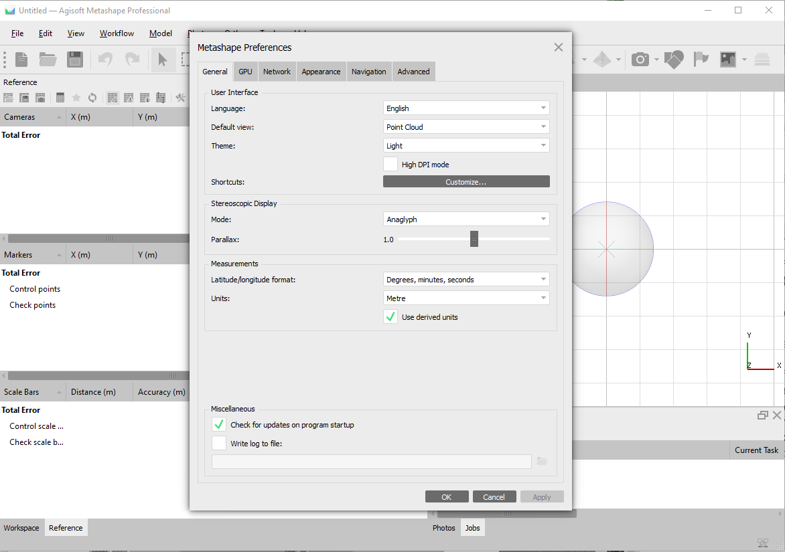

2) Add photos  
 Workflow >> Add Photos  
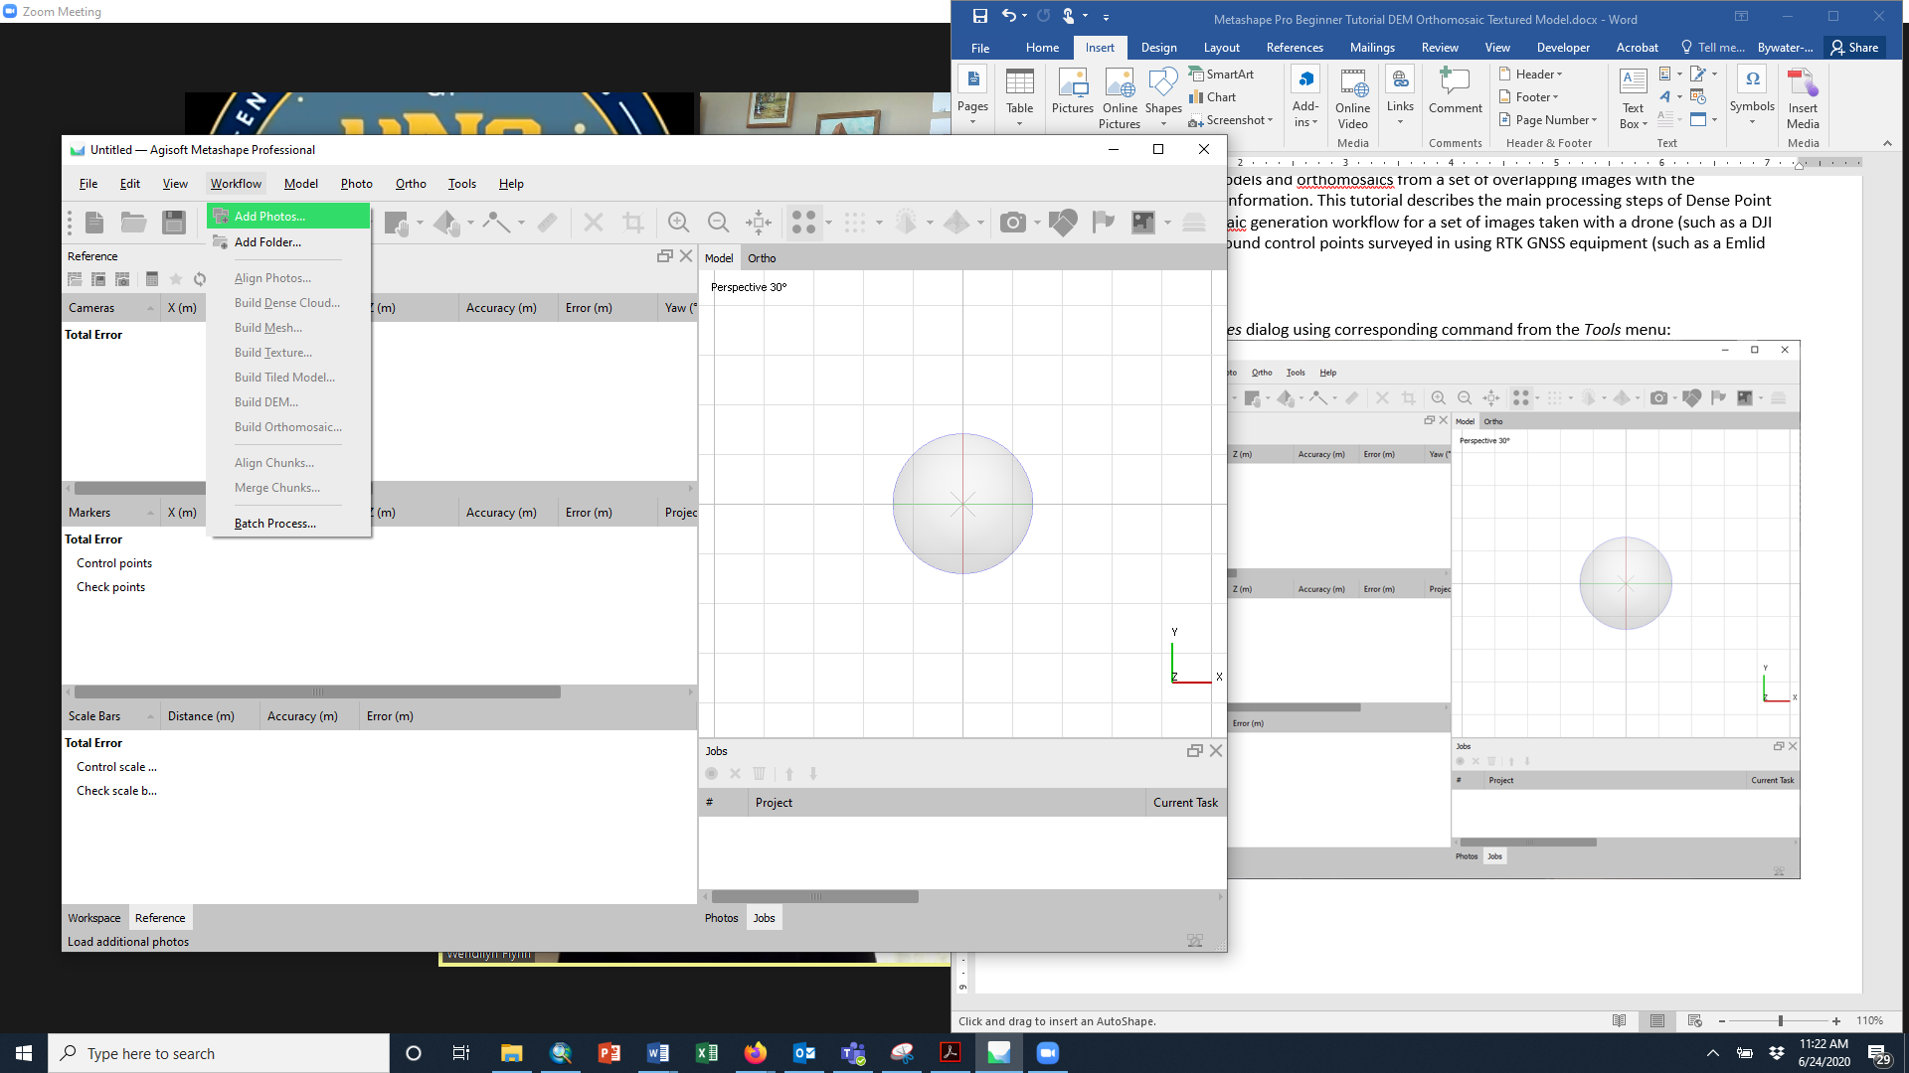

Note: For photos taken with your phone or camera that have inaccurate GPS coordinates, you will want to uncheck the Cameras (photos are referred to as cameras). For the drone images, keep them checked – these will be good enough locations to help with alignment. To uncheck or check them all at once, click on the reference pane, select all the photos, right click >> Uncheck (or Check)

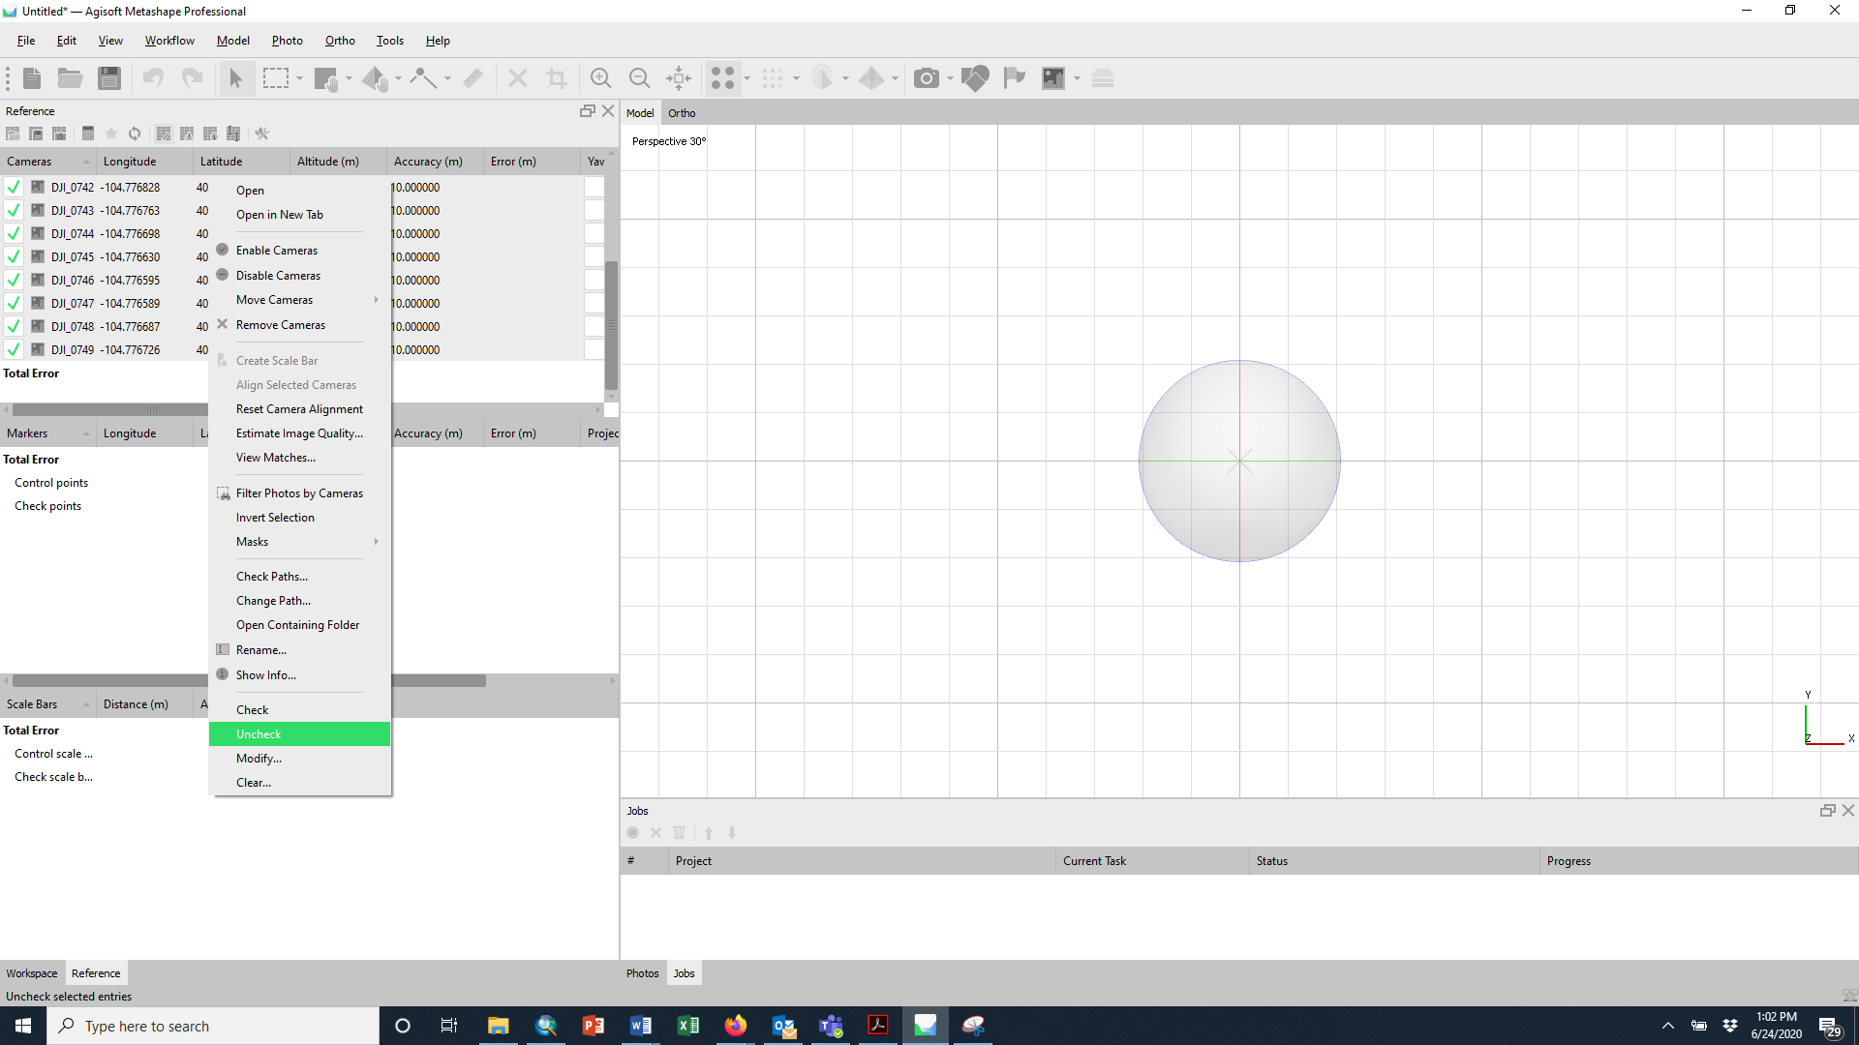

Image quality may be a problem. In the Photos Pane, select all images, right click >> Estimate Image Quality and choose all images. You may want to remove photos below a quality of 0.7. (switch Photo pane to List view to see Quality)

3) Make sure to save your project. File >> Save As

4) In the reference pane, go to Settings

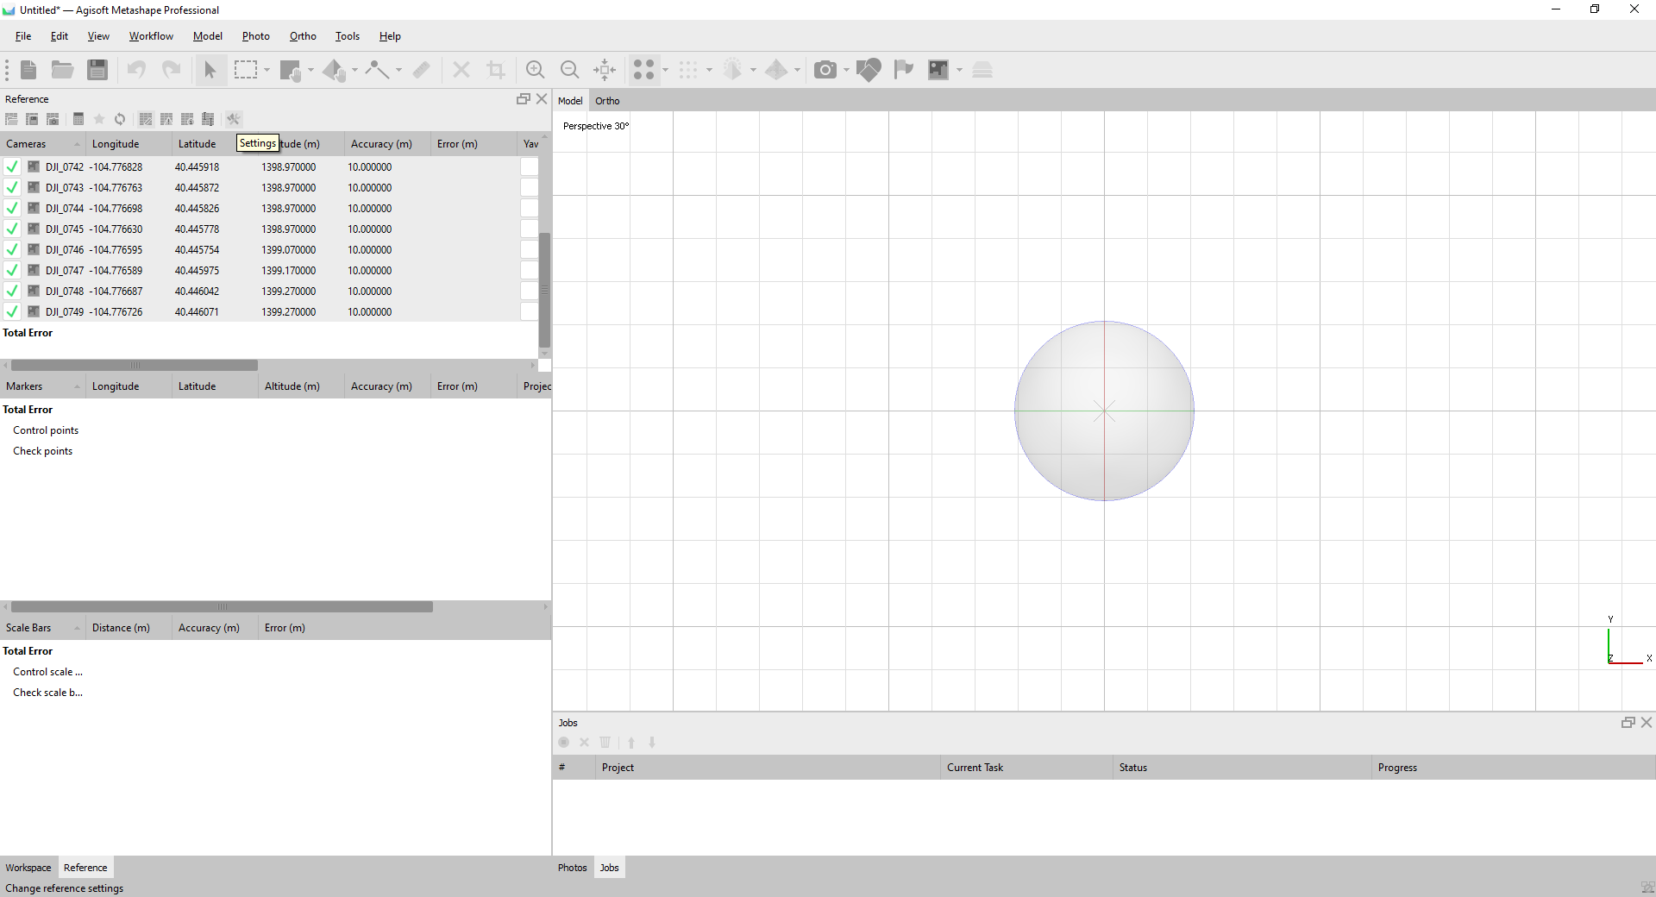

If needed, change the coordinate system you would like to use for your project and specify those of the camera and/or ground control points (Marker Reference).

In our case both DJI Mavic 2 Pro and Emlid GPS use WGS 84. If conducting in a local coordinate system, simply change all to “Local Coordinates (m)”. Or select whatever other coordinate system(s) you may be using.

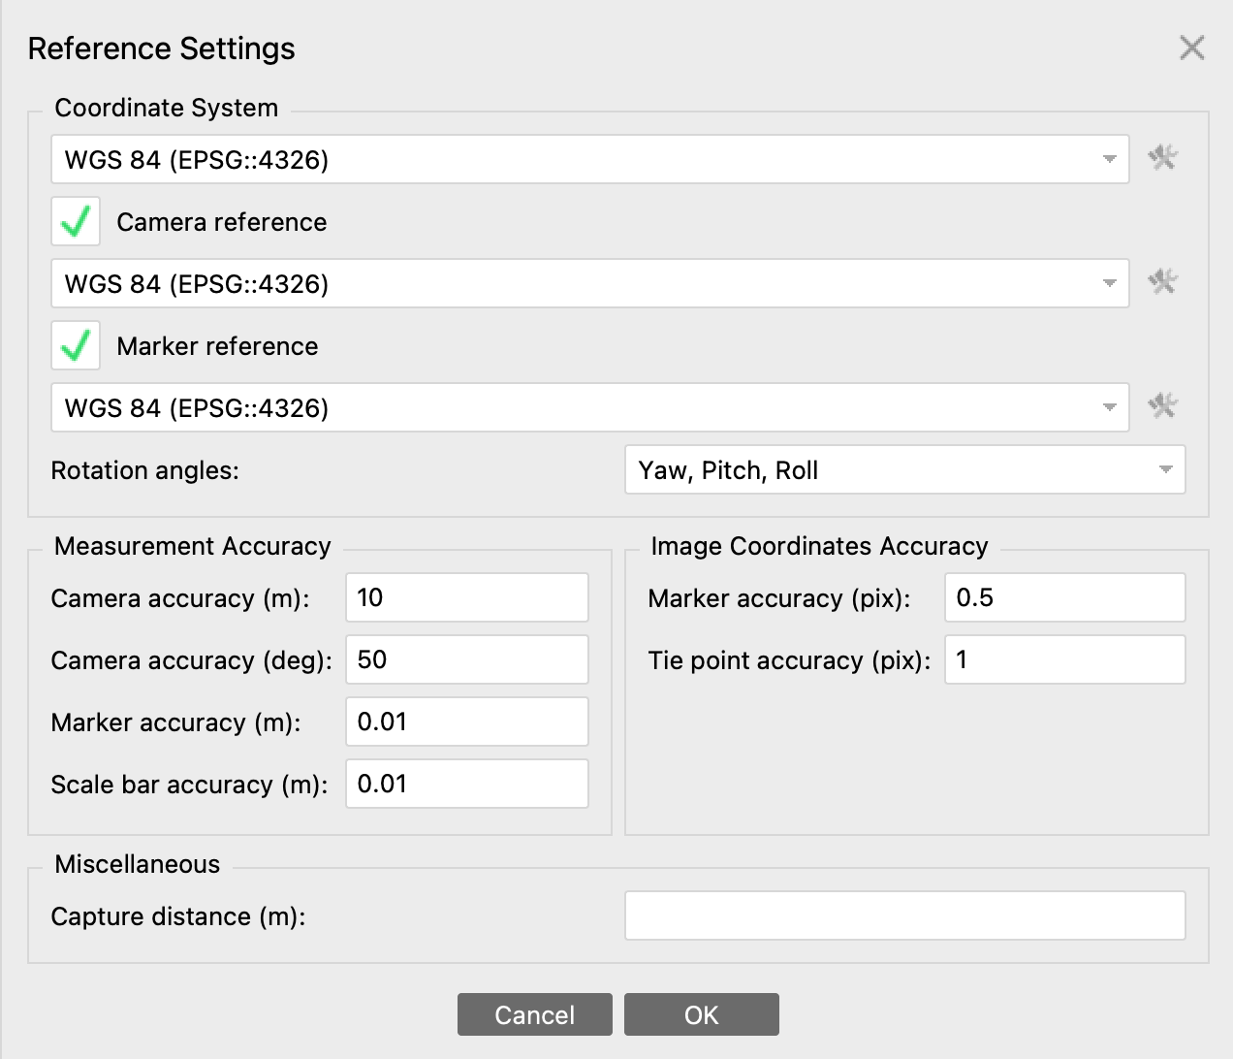Also specify the accuracy of your camera and marker (ground control points). In the example above, the marker accuracy is about 0.01 m, or 1 cm, because we used RTK GPS.

5) If camera GPS information has been successfully imported, you should see the locations of the images. If you don’t see them, click on the Camera icon.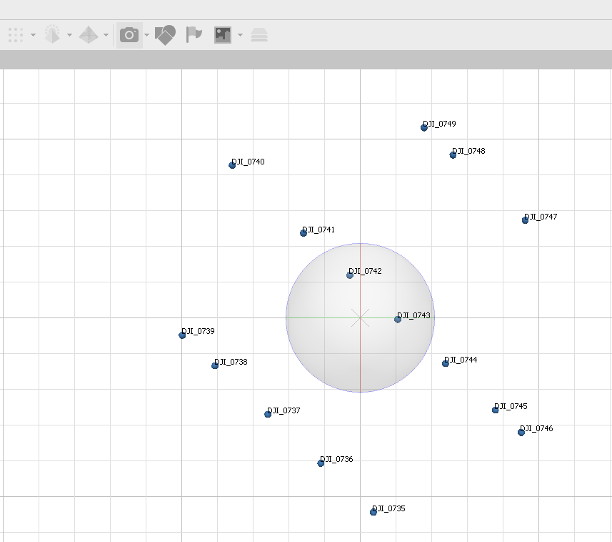

6) Go to Tools >> Camera Calibration

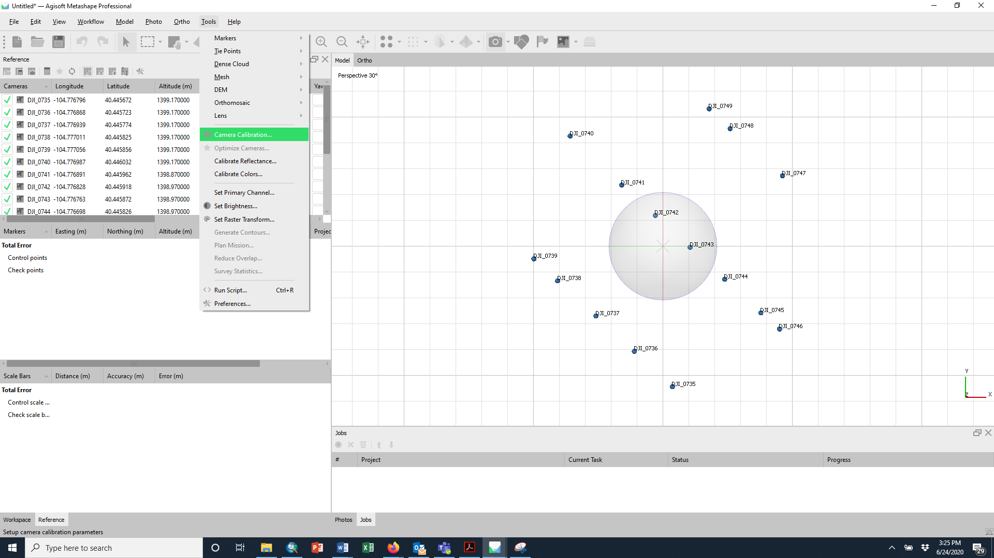

For the DJI Mavic 2, make sure “Enable Rolling Compensation” is checked.

7) Align Photos  
 Workflow >> Align Photos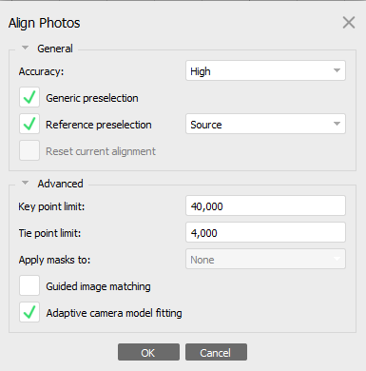

Check alignment by looking in the Workspace. You may have to check in the camera icon. 

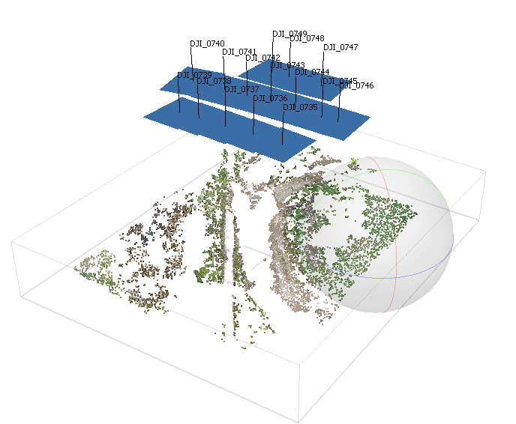

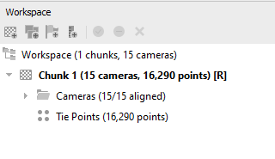

We are now done using the GPS locations of the cameras (if they were checked in Step 2). Select all cameras in the Reference Pane, right click >> uncheck. We will no longer use the drone locations. We will now use our Ground Control Points.

8) In the Reference screen, import the coordinates of the targets (also called ground control points [GCP])

Import

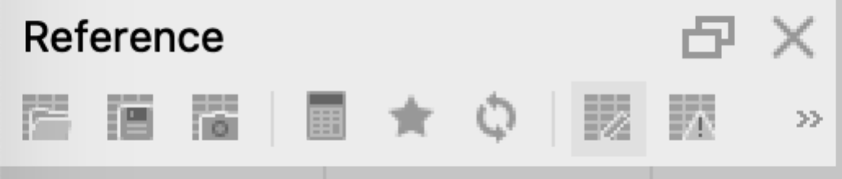

The ground control (GC) coordinates should be in .txt format as shown below (tab delimited). Make sure you choose the appropriate coordinate system at the top. For the DJI Mavic 2 coordinates, UTM zone 13N. For a local coordinate system, choose “Local Coordinates (m)”. Choose the appropriate columns such that the text imports correctly.

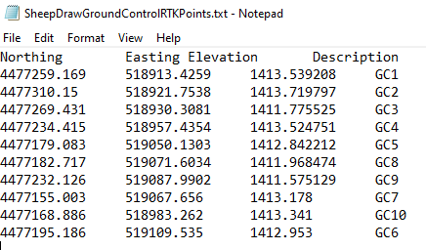

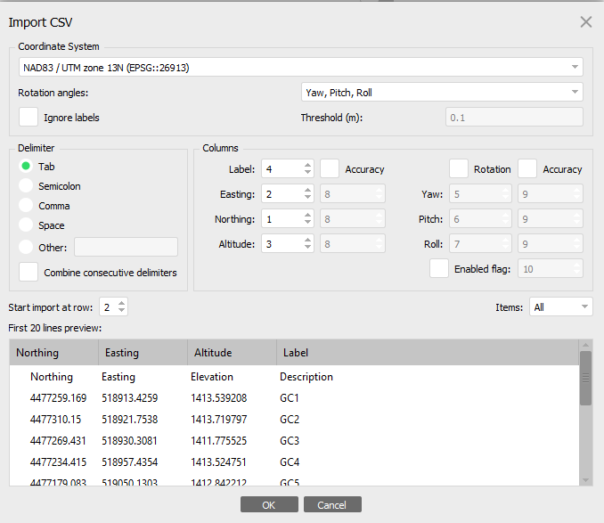

A dialog box will appear with the message “Can’t find match…”—just say “Yes to All”

Note, because there are two areas of interest at Sheep Draw, you will not use all the ground control points.

Double-click on each photo with GCP. A new window showing the photo will appear.

Zoom in on each target/GCP. Assign coordinates by: Right clicking on each target center >> Place Marker >> Choose the corresponding target from the ones that were imported above.

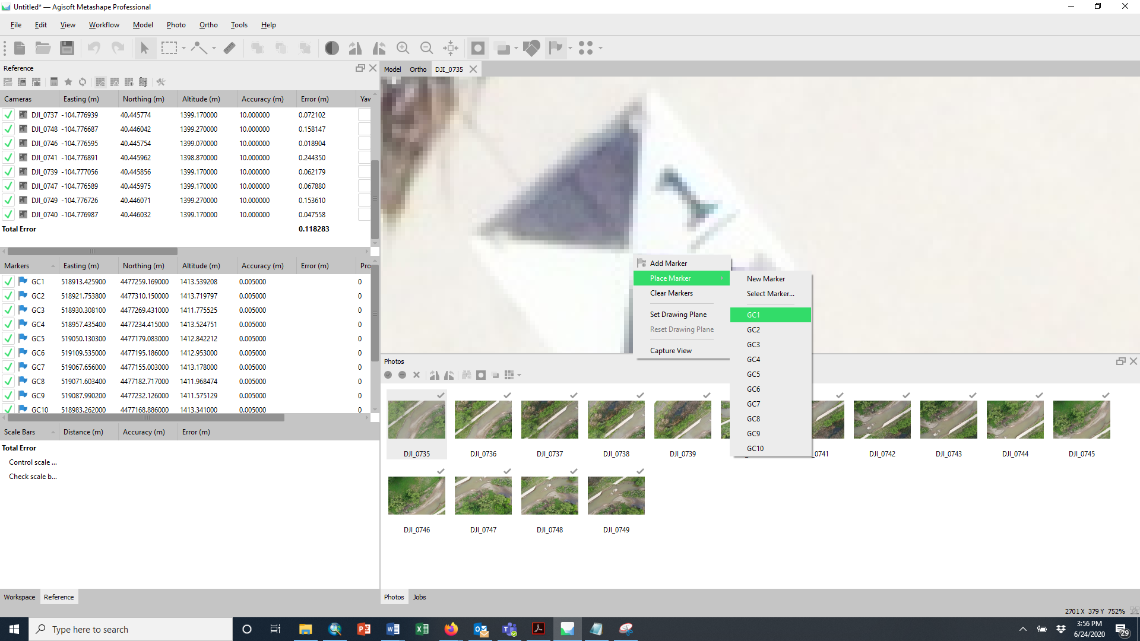

Another alternative is to first place the markers by right clicking on the image and choosing “Add Marker.” Choose the correct marker. Then in the Reference Pane, you can rename it by double clicking on the name in the Markers pane and import the text file afterward. Make sure the name matches your text file.

Once you have placed a marker, you can filter the photos by that marker to get Metashape’s best guess as to matching photos. In the Reference Pane, right click on the marker and click “Filter Photos by Marker.” The associated photos Metashape has found will show up in the photo viewer. You will get white flags for guesses. You will need to go through ALL the photos with the marker and reposition them in the correct location or confirm they are correct by dragging the flag to the correct place. You can always right-click >> Remove Marker if you make a mistake.

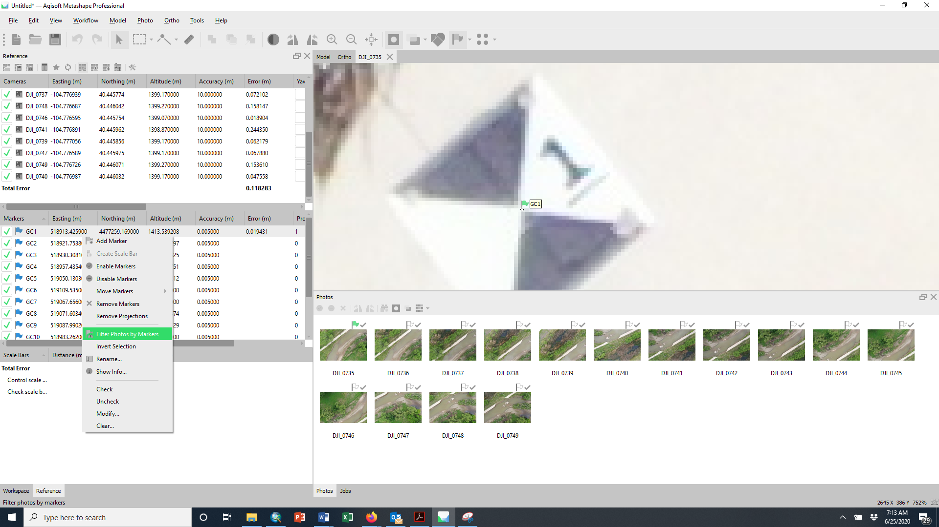

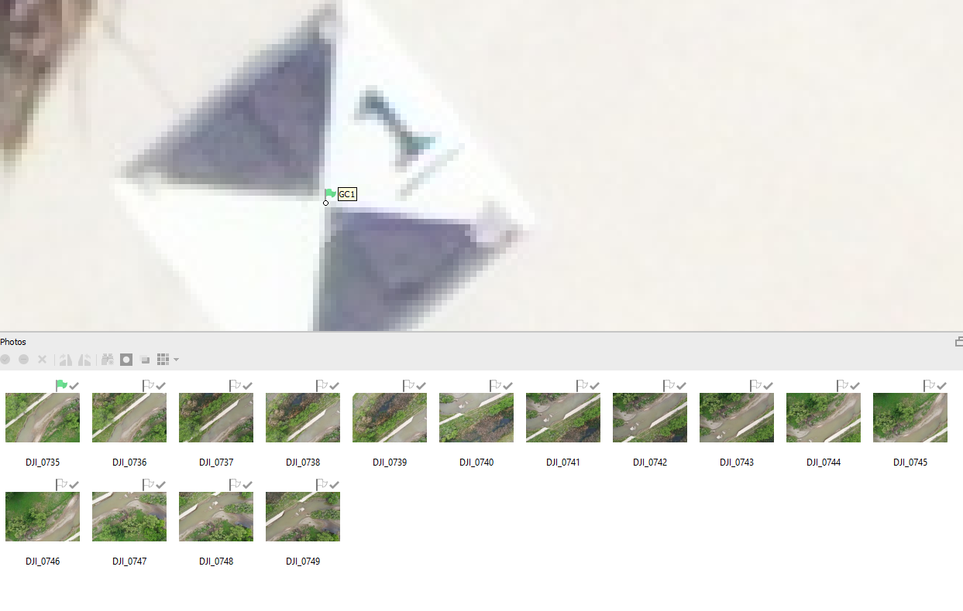

Work your way through the photos assigning or correcting the GCP in each photo. Click the Update button in the Reference pane to roughly georeference the model based on these points. This will expedite the process of placing the remaining GCPs.

To optimize the camera alignment and generate a camera calibration based on the GCPs, click the Optimize Cameras button in the Reference pane toolbar. Accept the default settings and make sure “Adaptive camera model fitting” is selected.

9) Errors  
At this point it is worth checking your errors. There are several sources of error to consider.

Scroll all the way to the right in the Markers pane, hopefully your errors will be under a meter. You can remove cameras with large errors, but we won’t for our purposes.

Your control points show Error (m) and Error (pix).

1. Error (m) - residual error per coordinate or in 3D space. That is distance between the input (source) and estimated positions of the marker.

2. Error (pix) - root mean square reprojection error for the marker calculated over all photos where marker is visible.

To view more errors, click on the very tiny View Errors icon.

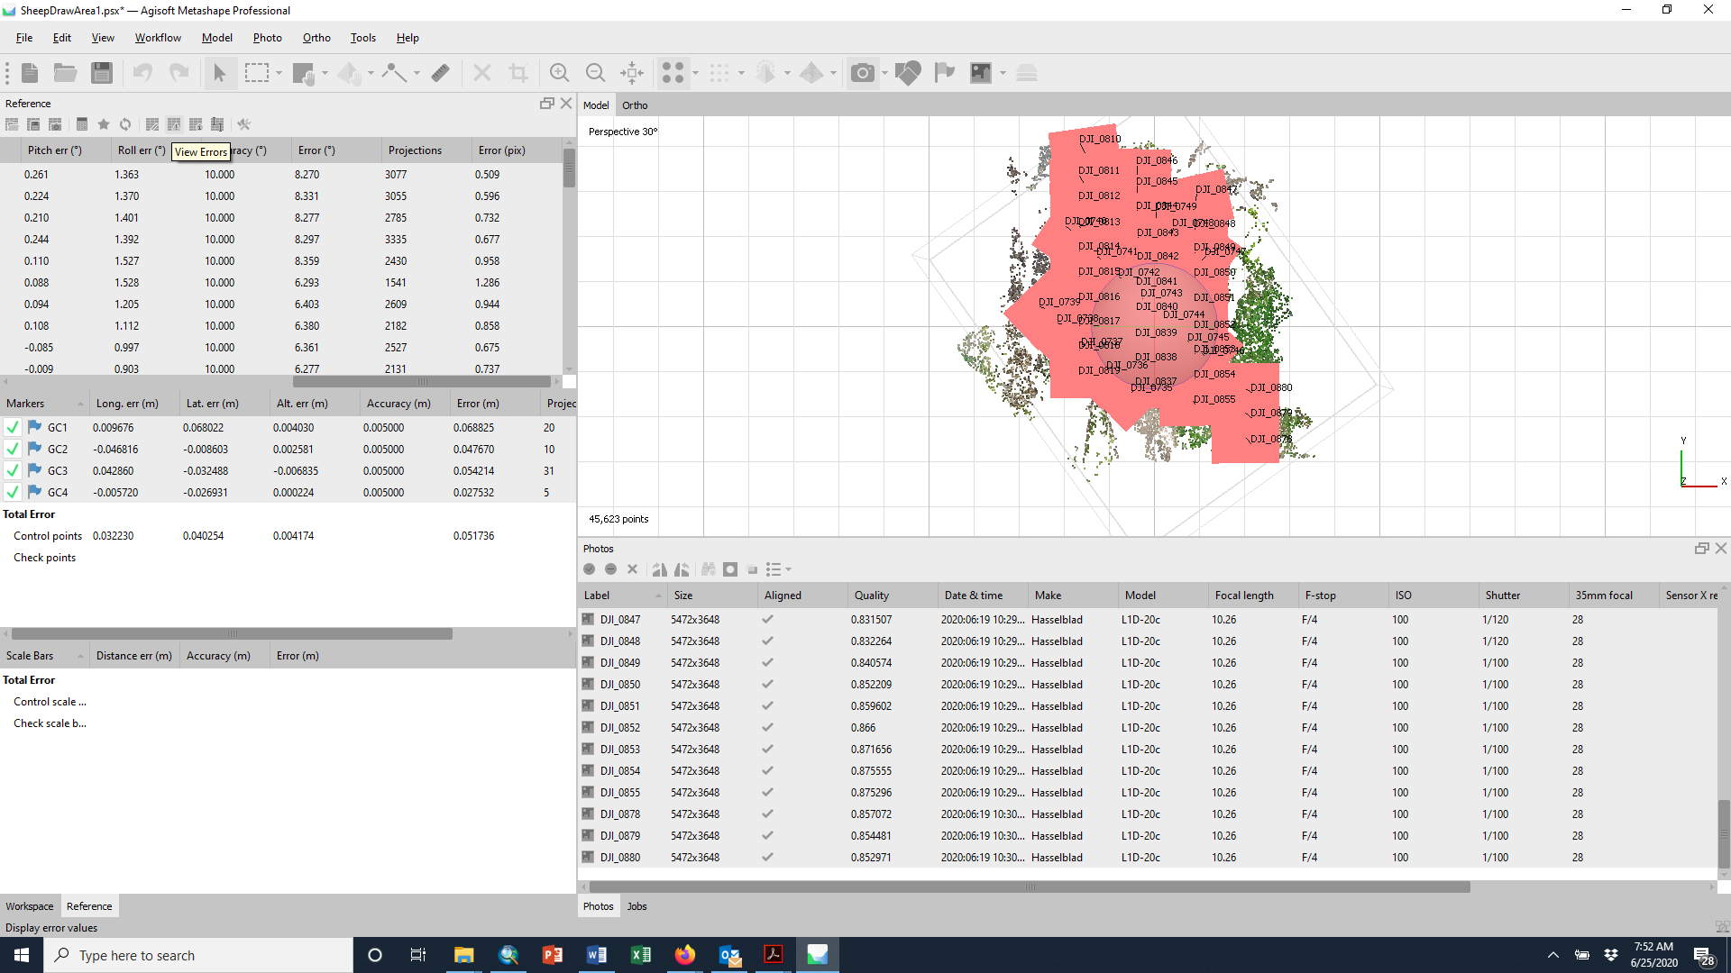

This will show the X, Y, and Z errors.

Lastly, you can build a report, Tools >> Survey Statistics. You can see how many images overlap in different regions (and more) and error of ground control points visually.

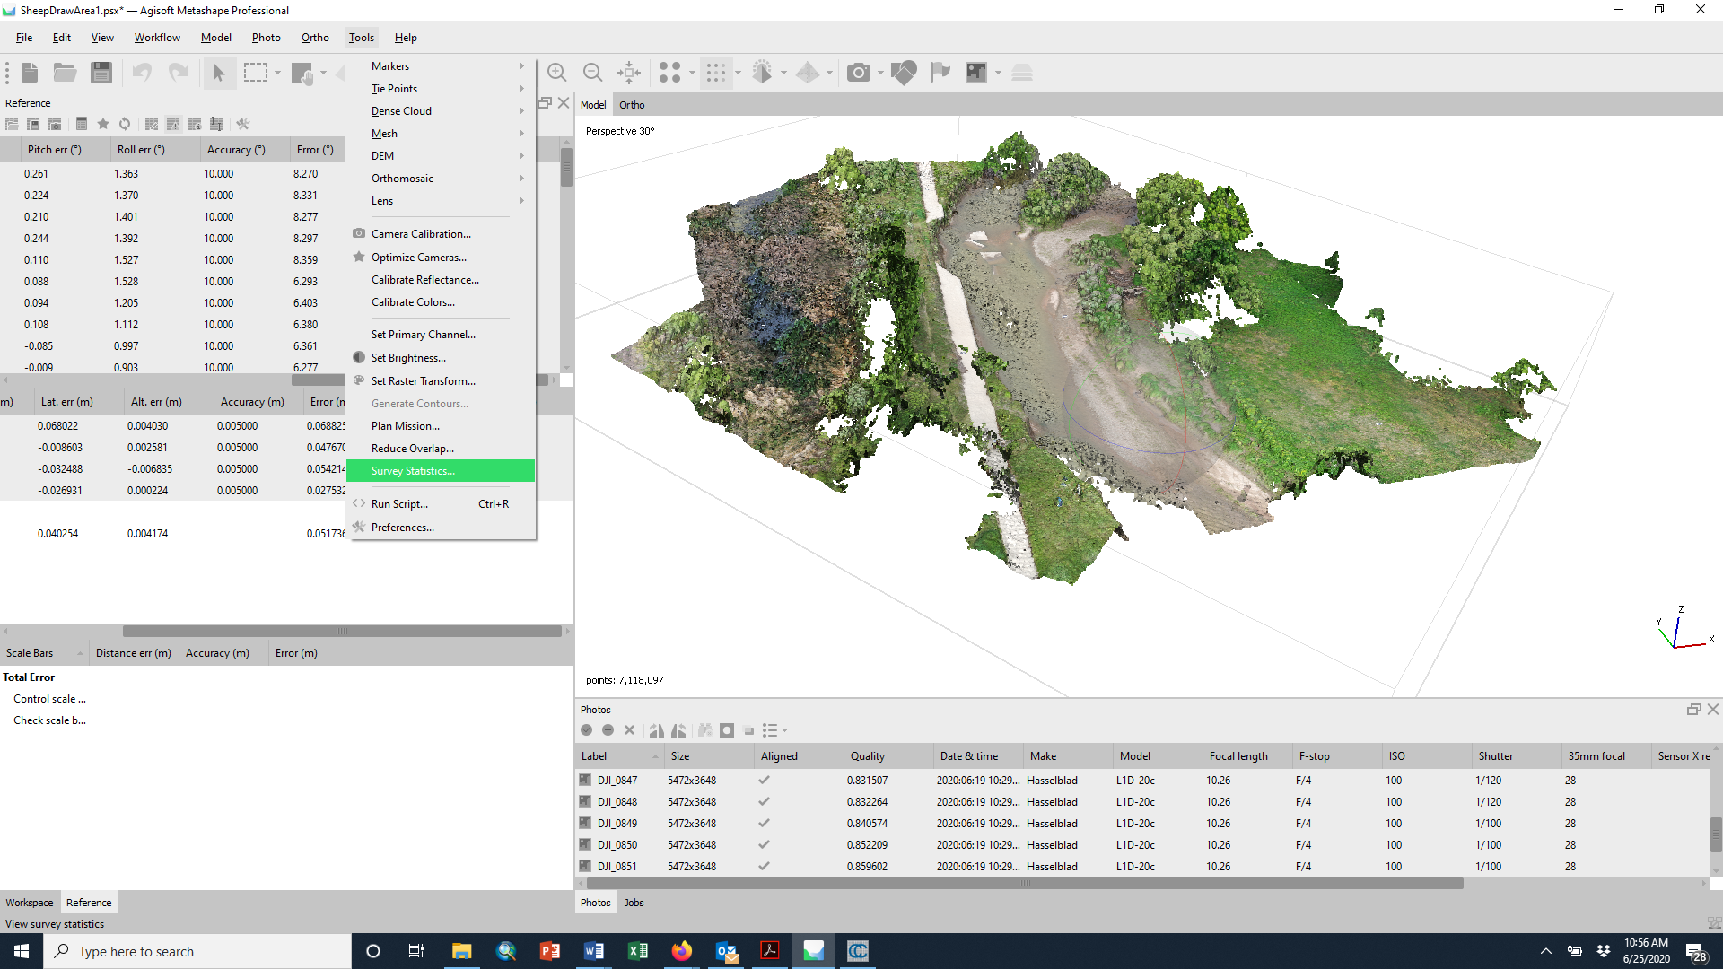

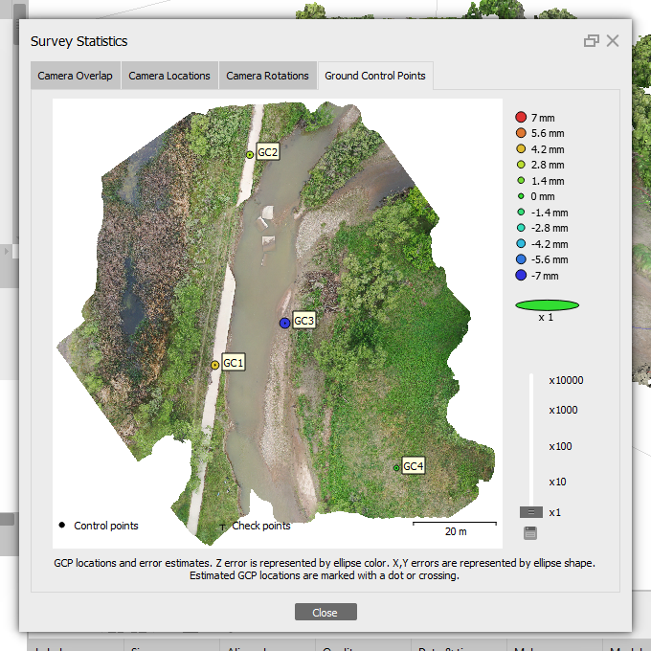

Save your project (.psx) periodocially just to make sure you do not lose work.

10) Build dense cloud  
 Workflow >> Build Dense Cloud  
Choose “Medium”

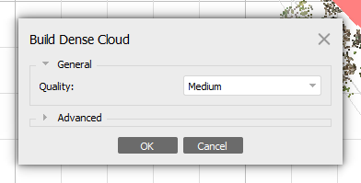

11) View dense cloud  
 Model >> View Mode >> Dense Cloud  
OR click the dense cloud icon

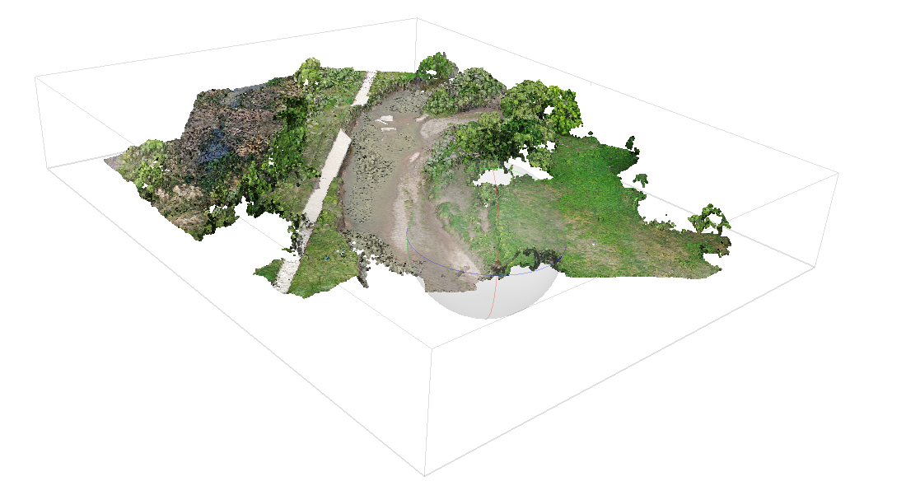

12) After the dense cloud is created, the points may need to be edited. Some portions of the model may be inaccurate, or just outside of the region of interest. This is an appropriate time to remove these points. Select points to delete by using one of the selection tools.

13) Save your project again and then export. To export point cloud:  
 File >> Export >> Export Points >> use XYZ Point Cloud (.txt) format for this project. Accept the default options and click Ok.

14) We will also want to create and export an orthophoto (high-resolution aerial image). For this, we will need a mesh. From the Workflow menu >> Build Mesh and choose Dense cloud. When this is complete, Workflow >> Build Orthomosaic.

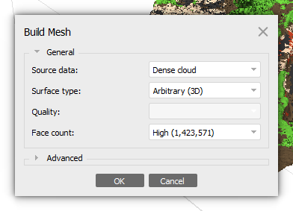

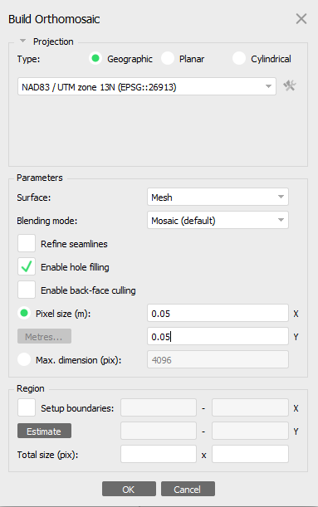

Choose a pixel size that isn’t rounded, e.g. 0.05 m. Export as as .tiff or .kmz. Notice you can view the orthoimage on the “Ortho” tab of the viewer.

15) Classification and Ground Model

Now you have a large point cloud in text format. Now what? There other features in MetaShape that might be appropriate in some cases. For example, you can create a textured mesh or a digital elevation model (raster). Because most scans have vegetation present, a raster of the entire cloud would average each raster cell and represent the average of anything captured in the scan. Hopefully, some ground points exist, despite dense vegetation. Alternatively, you may be interested in capturing the vegetation. As such, we want to CLASSIFY the cloud into ground and vegetation points (and maybe other things like buildings, etc.). MetaShape has a classification tool and there are other open source tools. We will use both, with the ultimate goal of separating ground points to create a digital elevation model that could be used for geomorphic analyses.

In MetaShape, click on the Tools menu >> Dense Cloud >> Classify Points.

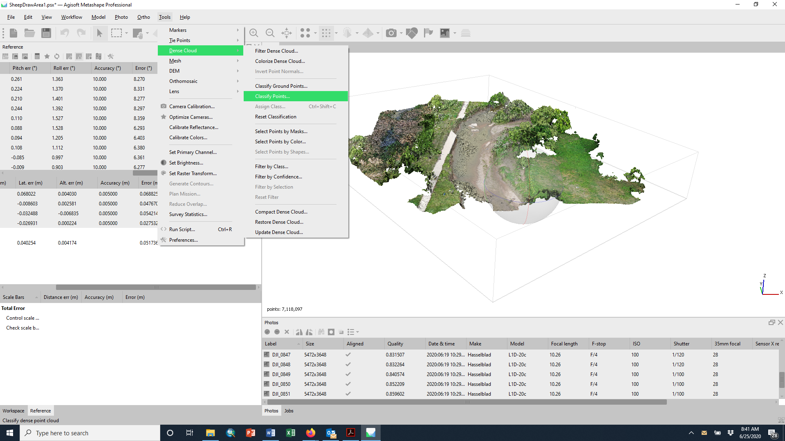

To view the results, click on dense cloud icon >> Dense Cloud Classes

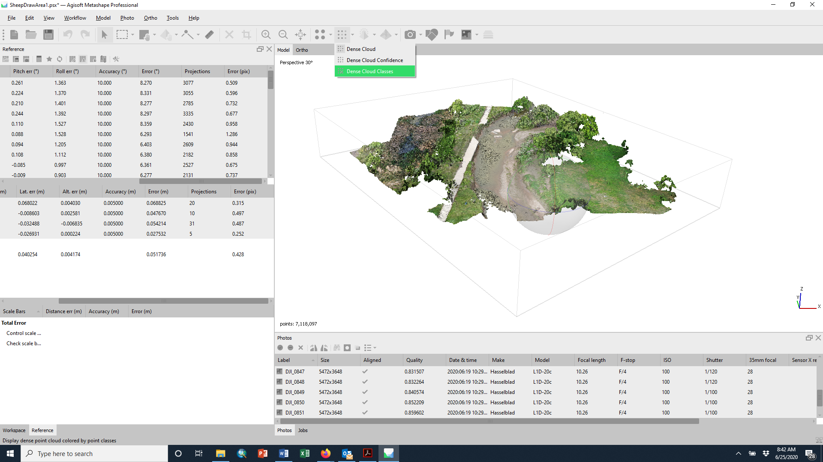

You can filter by class by Tools >> Dense Cloud >> Filter by Class

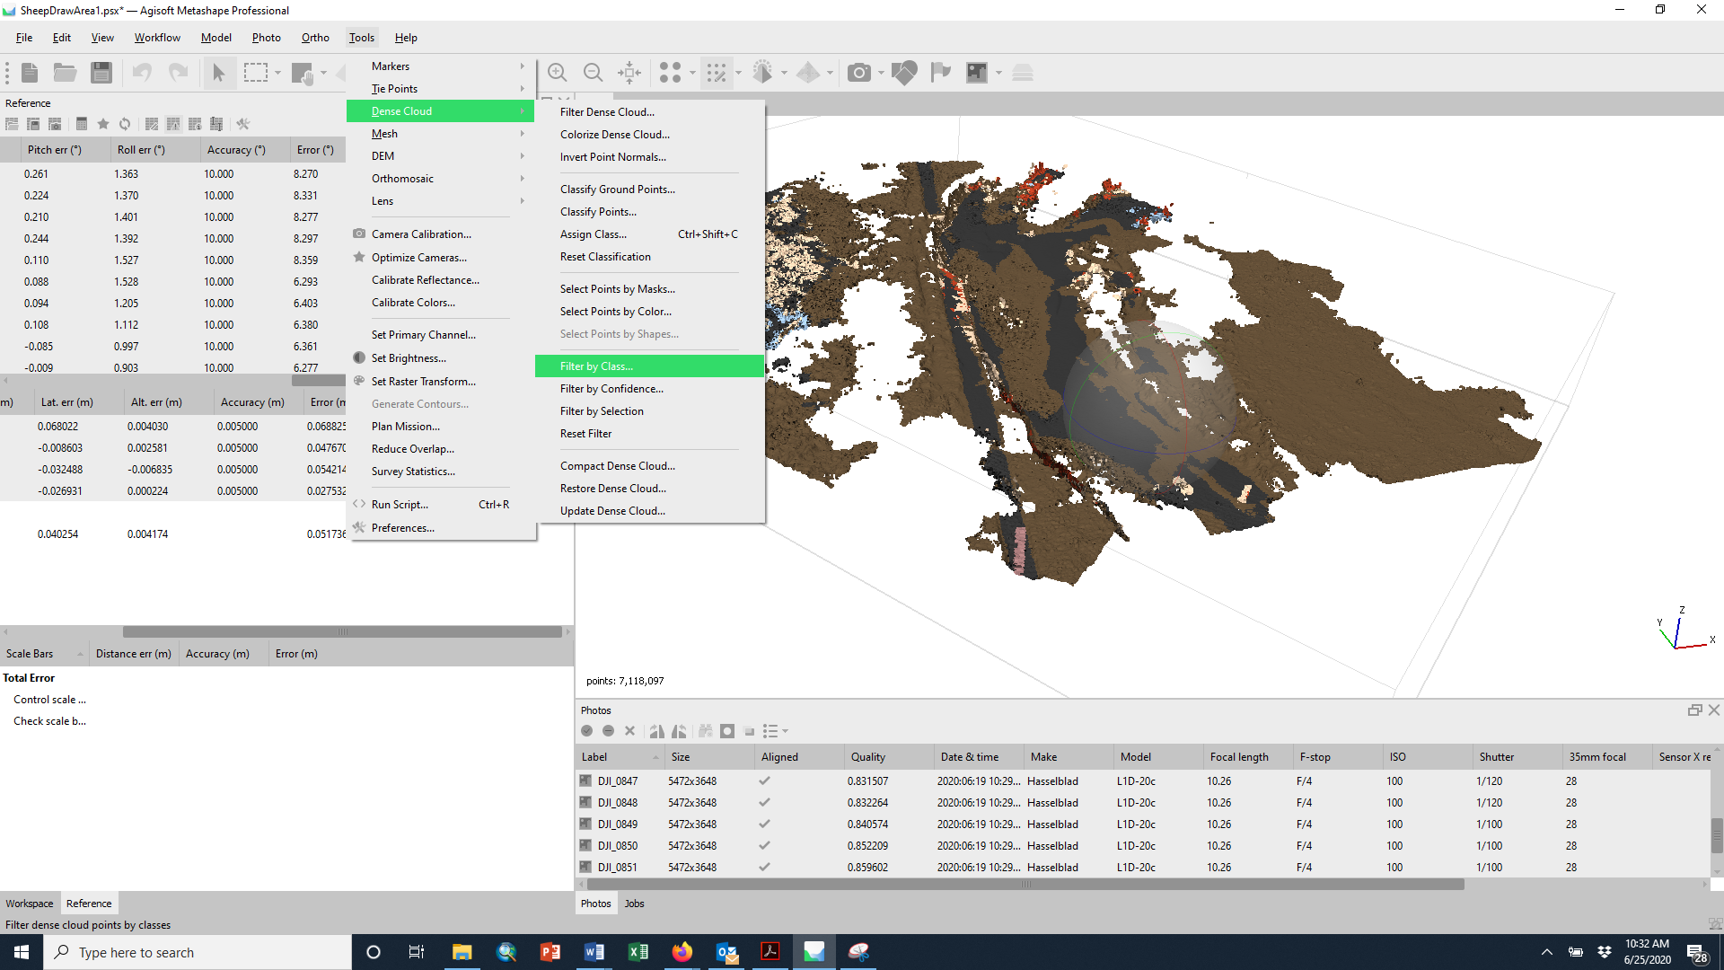

You can unselect vegetation classes and remove vegetation (play with different options and compare visually).

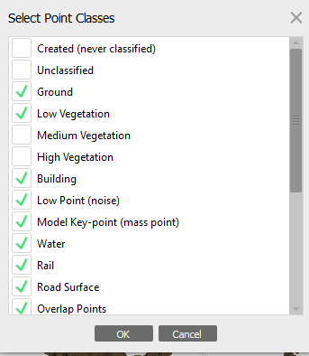

[More about the classification tool <https://agisoft.freshdesk.com/support/solutions/articles/31000148866-dense-cloud-classification>]

Now, you could choose to re-export the point cloud with just the classes you are interested in using.

16) CloudCompare is an open-source point cloud viewer and has many cool plugins. We will use several, including CANUPO classification. We will practice this plugin as well as revisiting a point cloud differencing tool in the second unit of the course. <http://nicolas.brodu.net/en/recherche/canupo/>